– Timeline of Key TMDL Implementation Activities

Figure A.1 Timeline of MSAR TMDL Implementation Activities, 2005-2025
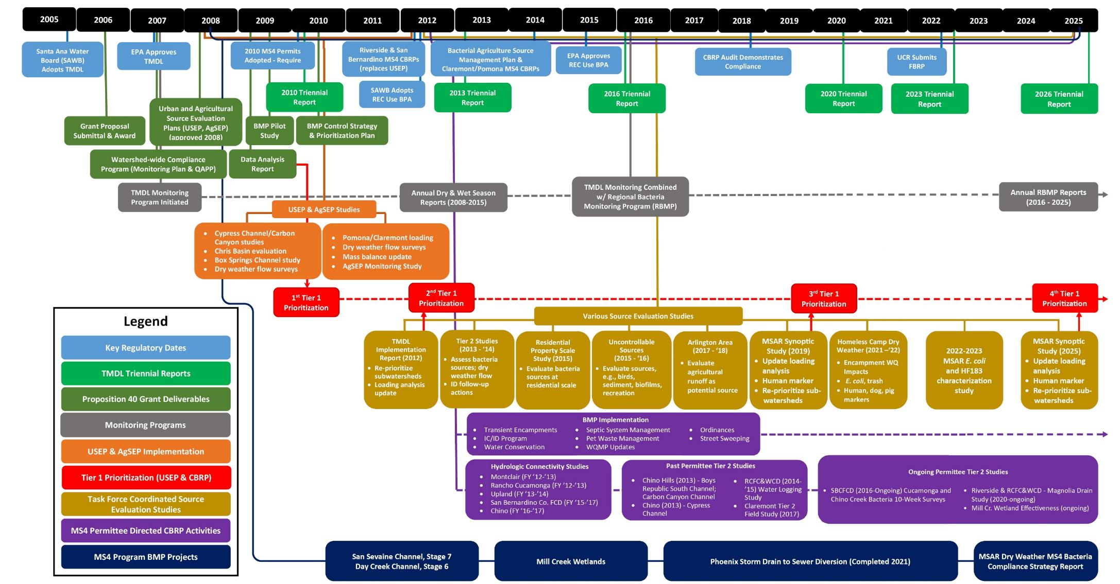

– MSAR Special Studies
Since the TMDLs became effective in 2007 numerous bacterial indicator-related special studies have been implemented in the watershed either collectively by the MSAR Task Force or by specific MS4 Permittees. The outcome of this extensive work, which has primarily focused on understanding bacterial indicator dynamics under dry weather conditions, provides the foundation for ongoing TMDL implementation activities in particular as related to compliance with the dry summer condition TMDLs. While these studies occurred outside the time frame of this 2023 Triennial Report, brief summaries of the findings from these earlier studies (with links to the study reports, where available) are provided here to provide a complete record.

MSAR Bacterial Indicator TMDL Data Analysis Report (2007-2008)
The first comprehensive analysis of bacterial indicators, bacteria sources and DWF sources in the MS4 within the MSAR watershed was conducted by the Task Force in 2007-2008. Sample locations included both the watershed-wide compliance sites and a number of Tier 1 sites (defined as sites where urban sources of DWF may directly discharge to a downstream impaired water). A key outcome of this report was a list of prioritized waterbodies for implementation of subsequent source evaluation studies. The findings are provided in the MSAR Bacterial Indicator TMDL Data Analysis Report (SAWPA 2009; https://www.sawpa.org/wp-content/uploads/2018/04/2009_Final-Data-Analysis-Report_033109.pdf.)

Urban Source Evaluation Studies (2009-2011)
As noted above, SAWPA (2009) identified priorities for additional mostly site-specific studies to evaluate urban sources of bacterial indicators. Findings from these early Task Force studies were documented in a series of technical memoranda, which are summarized below:
- Final Technical Memorandum – Dry Weather Runoff Controllability Assessment for Lower Deer Creek Subwatershed (Chris Basin) Special Study (SAWPA 2010b): Data collected in 2007 and 2008 resulted in the Lower Deer Creek subwatershed in the Cucamonga Creek watershed receiving a high priority ranking for subsequent bacteria mitigation work. This controllability assessment evaluated two potential options to control dry weather runoff from Chris Basin before it was discharged into mainstem Cucamonga Creek. The complete technical memorandum may be reviewed here: https://www.sawpa.org/wp-content/uploads/2018/04/2010_Chris-Basin-Final-TM.pdf.
- Final Technical Memorandum – Source Evaluation Activities in Carbon Canyon Creek and Cypress Channel (SAWPA 2010c): Data collected in 2007 and 2008 resulted in a high priority ranking for Cypress Channel for subsequent source evaluation activities (SAWPA 2009). In contrast, SAWPA (2009) established a very low priority ranking for Carbon Canyon Creek because of low bacteria concentrations as compared to other subwatersheds. The Task Force implemented source evaluation studies in each of these subwatersheds in 2009-2010 to better understand the basis for these findings. The resulting technical memorandum noted the following (complete technical memorandum may be reviewed here: https://www.sawpa.org/wp-content/uploads/2018/04/2010_Cypress_CarbonCyn_TM.pdf):
- Cypress Channel – potential sources of bacterial indicators to this waterbody were identified during a field study, resulting in recommendations for follow-up actions for both MS4 Permittees and Santa Ana Water Board staff.
- Carbon Canyon Creek - field study identified the presence of flow dissipation structures in the segment upstream of the Tier 1 sample location. These structures greatly reduced flow rates. It was hypothesized that these structures provide increased opportunity for natural reduction of bacteria via filtering processes through the structures and increased exposure to sunlight. It was concluded that the flow dissipation structures could be a potential BMP for use in other channels, where structurally appropriate.
- Final Submittal - Source Evaluation Project Activities for Middle Santa Ana River, TMDL Program Support, 2010-2011 (SAWPA 2011): The Task Force identified five source evaluation activities for implementation in 2010-2011. The findings from these five activities were summarized in the following series of technical memoranda (https://www.sawpa.org/wp-content/uploads/2018/04/2011_Source-Evaluation-Project-Activities.pdf):
- Box Springs Channel Follow-up Study - The Box Springs Channel (T1-BXSP) site was originally sampled in 2007‐ 2008. During that sample period, human source bacteria were regularly detected, and high bacterial indicator concentrations were present. Following a local investigation in 2008, a sanitary/storm sewer cross connection was identified and corrected. The purpose of this study was to conduct follow‐up sampling to evaluate current bacterial indicator levels and verify that human source bacteria were no longer present. The follow-up study confirmed human source bacteria were no longer present.
- Preliminary Characterization of Bacteria Loading from MS4 in Pomona and Claremont –The purpose of this task was to gather dry weather condition bacterial indicator data during the dry season to provide a preliminary characterization of potential bacteria loading and presence/absence of human sources of bacteria from the portion of the MSAR watershed located within the jurisdictions of the Cities of Pomona and Claremont (this portion of the MSAR watershed was not included in the original 2007-2008 data collection activity, as reported in SAWPA 2009).
- Survey of DWF from MS4 Outfalls to Major Tributaries - The purpose of this source evaluation study was to gain additional information regarding the variability of DWFs in stormwater channels/outfalls in the MSAR watershed. The information gained from this effort, combined with other available DWF data, supported characterizations of typical DWFs in the area and facilitated compliance analyses to provide input to the development of the CBRPs.
- Calculate Mass Balance for Dry Weather Conditions – The purpose of this activity was to quantify, to the extent possible, the mass balance of bacterial indicators under dry weather conditions based on known dry weather hydrology, source of flow, and available bacteria concentration data. The resulting mass balance characterizations supported development of the compliance analysis contained within the CBRPs.
- Calculate Site-specific Log Standard Deviation at Monitoring Sites – The USEPA uses a default log standard deviation (LSD) of 0.4 for E. coli when calculating single sample maximum criteria. A site‐specific LSD may be substituted for the default value where such data exist, which would result in different single sample maximum criteria. The potential to use site‐specific LSDs to establish site‐specific single sample criteria had been incorporated into the Basin Plan amendment under development by the Stormwater Quality Standards Task Force at that time. The purpose of this task was to calculate LSD values for MSAR watershed sample sites.

Tier 2 Source Evaluation Assessment
Based on the Tier 1 prioritization analysis developed as part of the 2013 MSAR Triennial Report, the MS4 Permittees in Riverside and San Bernardino Counties implemented Tier 2 (sample locations that are tributary to a downstream Tier 1 site) source evaluation studies within the drainage areas of the highest priority Tier 1 sites. These evaluations focused on identifying sources of bacteria within the stormwater networks of the MS4 facilities draining to these Tier 1 sites. The findings facilitated efforts within each MS4 Program to implement projects to manage sources of DWF and bacteria within the MS4 (SAWPA 2014; https://www.sawpa.org/wp-content/uploads/2018/04/2014_Tier-2-_2013-Evaluation_Final.pdf).

Uncontrollable Bacteria Sources Study
Implemented by the Riverside County MS4 Program, the Uncontrollable Bacteria Sources Study evaluated the potential importance of various non-MS4 sources of bacteria in the MSAR watershed (RCFC&WCD 2016; https://www.sawpa.org/wp-content/uploads/2018/04/2016_Uncontrollable-Bacteria-Sources-Final-Report.pdf). By process of elimination, the study’s findings suggested that the majority of E. coli in the impaired waters may be the result of releases from naturalized colonies in channel bottom sediment and biofilms. Fecal bacteria from a specific host released to the environment can settle to the channel bottom and survive within sediments or biofilms for weeks or months over a wide range of temperature and moisture conditions. Growth of these initially deposited fecal bacteria within channel bottom sediments and biofilms results in colonies, where the majority of the population may be considered naturalized, reproducing outside of a specific organism. The Basin Plan categorizes bacteria regrowth within sediment and biofilm as an uncontrollable source of fecal bacteria (Santa Ana Water Board 2019). The report concluded that additional study would be necessary to better understand the potential for naturalized bacteria colonies to contribute to bacteria concentrations in overlying waters and the transport process by which bacteria is released.
The Uncontrollable Bacteria Sources Study (RCFC&WCD 2016) evaluated a segment of Santa Ana River upstream from Riverside Avenue to the Rialto WWTP discharge to evaluate non-MS4 sources of bacteria in a reach where the only potential sources of dry weather flow are from two locations:
- Cactus Channel MS4 outfall (also known as the Rialto Channel) above the Rialto
WWTP - As part of the City of Rialto's on-going documentation of hydrologic disconnection, the City conducts photographic surveys of the Cactus Channel above the Rialto WWTP on a daily basis (e.g., City of Rialto 2018). Findings from these surveys show that dry weather flows rarely occur in the Cactus Channel.
- Drainage area in the City of Colton with an on-site detention basin located south of Agua Mansa Road, east of Riverside Avenue and west of the Cactus Channel - This drainage area only discharges to the Santa Ana River during very high rain events.
For the Uncontrollable Bacteria Sources Study samples were collected from near the RIX facility discharge downstream to the Santa Ana River at the Riverside Avenue Bridge (RCFC&WCD 2016). This site was selected because:
- The only documented source of water to this portion of the Santa Ana River during dry weather conditions was tertiary treated effluent from the Rialto WWTP and RIX Facility (approximately 56 cfs). Upstream of these POTWs the Santa Ana River bed was dry.
- Under dry weather conditions, the site is upstream of all sources of MS4-related flow to Santa Ana River Reach 3 and thus the MS4 could not be causing or contributing E. coli bacteria to the impaired waterbody and the E. coli observed at this location must be, for the most part, resulting from uncontrollable sources.

Residential Property Scale Bacteria Study
Implemented by the San Bernardino County MS4 Program, the Residential Property Scale Bacteria Water Quality Study was able to demonstrate support for the hypothesis that extreme variability in concentrations at MS4 outfalls is linked to the quantity and quality of irrigation excess runoff from individual properties (CDM Smith 2015; https://www.sawpa.org/wp-content/uploads/2018/04/2015_Residential-Property-Scale-Bacteria-Study-Interim-Data-Analysis.pdf). Unlike rainfall driven runoff, where rain is spread across the entire watershed, the primary source of DWF in an urban catchment at any given point in time is outdoor water use by a single or small group of properties. The statistically randomized study found that irrigation excess from a majority of properties
(n = 80) would be expected to meet WLAs in the TMDLs. The reason for very high bacteria concentrations at some sites may be partially due to the sampling method, whereby samples collected from a wetted street gutter had significantly greater bacteria concentrations than those collected from the edge of the lawn.

Arlington Study
The MSAR Task Force conducted a preliminary bacteria and flow source investigation in the Arlington Area of Riverside County in 2017 (SAWPA 2018; https://www.sawpa.org/wp-content/uploads/2018/04/FinalDeliverable_2018.pdf). The investigation sought to answer the following study questions: (a) What is the status of DWF leaving the Monroe Retention Basin; (b) What are the predominant sources of DWF in the Arlington Area; (c) What are the magnitude and sources of E. coli in observed DWF; and (d) Are the observed
E. coli from human sources?
This study confirmed that DWF from the MS4 is continuous both into and out of the Monroe Retention Basin, which is hydrologically connected to the Anza Drain Tier 1 Site. This study also confirmed that grove irrigation from agricultural land uses is contributing flow and bacteria to the MS4 in the Arlington Area, though grove irrigation is not the sole contributor. Controlling or reducing flows both in upstream agricultural land uses and downstream urban land uses would help reduce bacteria loads to/from the Monroe Retention Basin. Human source marker HF183 was quantifiable in only two of 21 samples analyzed. Human source bacteria were not detected in DWFs originating from agriculture land uses. The two samples where the human source marker was quantifiable were from mixed land use monitoring locations. Where detected, the concentrations were low and not persistent.

City of Claremont Tier 2 Field Study
The City of Claremont has the potential to contribute DWF to the Chino Creek subwatershed from only a very small area. This area, 397 acres, can potentially contribute DWF via an underground storm drain which is connected to the City of Pomona’s MS4 (City of Claremont 2017). This underground storm drain eventually discharges to San Antonio Creek about two miles upstream of its confluence with Chino Creek (four miles upstream of the Chino Creek at Central Avenue watershed-wide compliance site (WW-C7)). The remainder of DWFs from the City of Claremont is captured in retention basins.
The City of Claremont conducted a Tier 2 study in 2013 to characterize DWFs that have the potential to leave the City and enter the City of Pomona MS4 (City of Claremont 2017). Field surveys were conducted for eight weeks in the summer of 2013. No flow was recorded on six of eight site visits; in the other two visits, the estimated flow averaged less than 0.0018 cubic feet/second (cfs; ≈ 0.8 gallons/minute). Based on these DWF results, the total dry weather discharge found to emanate from the City is less than 2.8 gallons per acre per day (gal/ac/day). Based on these findings, it was determined that “dry weather flow from the City of Claremont is minimal and does not influence downstream concentrations” and per the City’s CBRP, “targeted E. coli reduction needed from the City of Claremont MS4 contribution was estimated to be negligible.”
The City of Claremont (2017) also reported reductions in DWF from ongoing coordination with the Golden State Water Company to improve outdoor water use efficiency (consistent with CBRP requirements to implement water conservation practices) and reduce DWF from areas that may potentially drain to Chino Creek. These efforts have been successful. Long-term monitoring data showed that the median annual flow measured by the USGS gauge in San Antonio Creek (#11073300) had declined by 75% over the last 15 years - from 0.75 cfs in 2002 to less than 0.2 cfs in 2016-17 (City of Claremont 2017). The City of Claremont contributes less than one-half of 1% of the total DWF measured at this stream gauge.

Riverside County MSAR Dry Weather HF183 and E. Coli Survey
In an effort to gather further information regarding the discharges from District facilities, the District completed monitoring at 15 of their Tier 1 outfalls in 2022–2023. The goal of the survey was to further characterize E.coli and HF183 concentrations in dry weather discharges.
E. coli concentrations were frequently elevated, with 64 of 77 samples containing concentrations that exceed the action level of 212 most probable number (MPN) per 100 milliliters (mL). 5-sample/30-day geometric means were also calculated for comparison with MSAR Bacteria TMDL objectives. A total of 11 5-sample/30-day geometric means were calculated: of these, 9 exceeded the 113 MPN/100mL action level.
HF183 was not detected in most samples (42 of 59 samples did not contain quantifiable HF183). Of the 17 of 59 samples with quantifiable HF183, 7 samples exceeded one or more action level. HF183 concentrations exceeded one or more action levels at three sites: T1-BXSP (four of five samples), T1-WLSD (two of five samples) and T1-SNCH (one of five samples). T1-BXSP had the most persistent elevated HF183 concentrations (quantified in five of five samples, above action level(s) in four of five samples).
In addition to characterizing HF183 and E. coli sources at each outfall, the flow status and magnitude was evaluated during each event. 10 of 15 outfalls had persistent dry weather flows, two of 15 outfalls were either low flowing or ponded (T1-EVL-AMB and T1-EVL-B2), and the three historically dry sites (T1-64SD, T1-NORNP, and T1-HIGH) remained dry during the sampling period.
Based on the monitoring data collected as part of this survey, Tier 1 outfalls were prioritized using a scoring system similar to that used in recent MSAR Synoptic Studies (SAWPA 2020). Sites T1-BXSP, T1-SNCH, and T1-WLSD were identified as high priority for follow up.

Riverside County MSAR Dry Weather MS4 Bacteria Compliance Strategy Report
Dry weather MS4 compliance strategies were evaluated for 13 priority municipal separate storm sewer system (MS4) outfalls to the Middle Santa Ana River (MSAR) to meet potential future permit numeric limits for fecal indicator bacteria in dry weather. Five abatement strategies were considered for each MS4 outfall including non-structural source control options (bacteria source reduction and non-stormwater flow source reduction), disinfection treatment, infiltration, and diversion to the sanitary sewer. Abatement strategies were evaluated for each outfall based on the technical feasibility of implementation, the certainty of meeting expected regulatory requirements, and the overall cost of the strategy.
Two or the 13 outfalls have consistently been observed to be dry since implementation of the Comprehensive Bacteria Reduction Plan and thus did not require development of an abatement strategy. Primary and secondary abatement strategies were identified for the other 11 outfalls. Bacteria source control using an advanced Illicit Discharge Detection and Elimination (IDDE) approach or demonstration of hydrologic disconnection was identified as the primary strategy for most outfalls. This approach provides a lower cost compliance option, with much lower environmental impact than structural controls, through an alternative pathway expected to be included in the revised MS4 Permit. The SWRCB and CASQA also recommend pursuing source control prior to treatment options. Where bacteria source control is not able to be achieved, low flow diversions (LFDs) to the sanitary sewer were found to provide a good combination of compliance certainty and cost where sanitary sewers are nearby and both the collection system and treatment plant have capacity. However, permitting challenges and acceptance of flows from sewer agencies may make LFDs not feasible for many outfalls. Implementation of LFDs at outfalls from open channels also may not address within channel targets. Infiltration may be feasible at some outfalls where dry weather flows are low and soil infiltration rates are high. At some outfalls, flows are already infiltrating into the floodplain at some distance from the MSAR. At these locations it may be possible to demonstrate that flows are disconnected and thus do not impact receiving water quality. UV treatment was not recommended due to higher cost, lower reliability, significant long-term operation and maintenance needs, and greater environmental impacts compared to other strategies.

– Triennial Report Key Findings
The 2013, 2016 and 2020 Triennial Reports included a number of important findings that have guided subsequent actions to support TMDL compliance in the MSAR watershed. Summaries of the key findings from each of these reports is provided below.

2013 Triennial Report
The second Triennial Report (Middle Santa Ana River Bacterial Indicator TMDL Implementation Report; SAWPA 2013) not only evaluated the status of compliance with urban WLAs and LAs as required by the TMDLs but also provided the results from source evaluation studies conducted as part of the implementation of the Riverside and San Bernardino County MS4 Program CBRPs. The complete report is available at: https://www.sawpa.org/wp-content/uploads/2018/04/2013-Triennial-Report_Tier-1-Source-Evaluation-Final.pdf. Key findings from this 2013 report include:
Status of Compliance - Dry Weather Conditions
- Bacterial indicator concentrations and frequency of exceedances remained generally constant at all watershed-wide compliance sites during the six years sampling had occurred to date. No stations reported a marked increase or decrease in concentration from 2007 to 2012.
- During each year of dry season sampling, the highest bacterial indicator concentrations were observed at the Mill‐Cucamonga Creek and Chino Creek sites.
- With the exception of 2009, for the period from 2007 through 2012 Prado Park Lake generally remained below the E. coli WLA (on an annual basis) during the dry season.
- Analyses of bacterial indicator data suggested that natural or uncontrollable sources of bacterial indicators may be important contributors to bacterial indicator concentrations at the watershed‐wide compliance sites.
- Seasonal increases in bacterial indicators were regularly observed at the watershed‐wide compliance monitoring sites. Understanding the cause of these increases may provide information regarding controllable and uncontrollable sources of bacterial indicators in the watershed.
Tier 1 Source Evaluation Data Analysis Activities
- DWF rates from MS4 outfalls were low in most places where there were no known sources of rising groundwater.
- Bacterial water quality observed in DWFs from MS4 outfalls was highly variable across the MSAR watershed.
- E. coli concentrations in samples that also had a detection of the Bacteroides human marker were higher than in samples with no Bacteroides human marker detection.
- Data results provided the basis for prioritizing MS4 subwatersheds for subsequent CBRP compliance activities within the MSAR watershed.
- In some weeks, a close correlation existed between the estimated E. coli concentration expected from blended MS4 outfall flows, and POTW discharges. However, in a number of cases, the observed E. coli concentrations were substantially higher than expected suggesting that additional sources of E. coli had not yet been accounted for.
- Data analysis identified the key MS4 outfalls within each impaired waterbody (based on DWFs and E. coli concentrations) where subsequent source evaluation work could provide the most benefit with regards to meeting bacterial indicator water quality objectives at watershed‐wide compliance sites.

2016 Triennial Report
The third Triennial Report (Middle Santa Ana River Bacterial Indicator TMDL Implementation Final Report) provided an update on the status of compliance with the TMDLs and also summarized findings from other studies completed in the watershed (SAWPA 2017). Below is a summary of the findings from that report (https://www.sawpa.org/wp-content/uploads/2018/04/2016_Triennial-Report-June-2017.pdf):
- The Permittees fulfilled the requirements established in the four base CBRP elements through: (1) revision and enforcement of city water conservation and stormwater ordinances; (2) deployment of a range of water quality BMPs to reduce DWF (e.g., through implementation of water conservation BMPs) or control sources of fecal bacteria within the MSAR watershed; (3) implementation of a source evaluation program and set of supplementary studies; and (4) completion of regional BMPs to provide additional treatment of DWFs.
- Prado Park Lake had bacteria concentrations that were consistently close to water quality objectives. In the 2015 dry season a significant reduction was observed (geometric mean of E. coli of 40 cfu/100 mL; see Figures 2-5 and 2-6), which might have been attributable to a revision in the way IEUA delivers treated effluent to the lake. Thus, there is reason to believe lower bacteria levels may continue in the future, which would support delisting this waterbody and removing it from the list of impaired waters in the future.
- Updates to the source contribution analysis for MS4 and POTW inputs to each of the impaired waters showed that the expected bacteria concentration at four of five of the watershed-wide compliance monitoring sites was below water quality objectives (only Mill-Cucamonga had estimated MS4+POTW blend concentrations over the water quality objective). However, monitoring data showed that exceedances of the water quality objectives continued to occur at varying frequencies at all of the sites.
- Since the TMDLs were adopted, there has been a continuous decline in POTW effluent discharges to each of the impaired waterbodies caused by indoor water conservation measures and increasing reuse of wastewater, such as in the IEUA service area. Per the source contribution analysis, this would naturally result in an increase in the estimated flow-weighted average concentration that may be expected at the downstream compliance monitoring sites. No such rise in fecal bacteria has been observed at any of the watershed-wide compliance monitoring sites.

2020 Triennial Report
The fourth Triennial Report (Middle Santa Ana River Bacteria Synoptic Study and TMDL Triennial Report) included the findings of a synoptic study designed to provide updated information on key sources of DWF in the MSAR watershed and data to update the priority for source evaluation activities at Tier 1 sites. Below is a summary of the key findings and recommendations for next steps by the Task Force and responsible parties from the report (SAWPA 2020a).

Key Findings
Taking into account the body of research related to TMDL implementation that had been completed to date in the MSAR watershed, the study report incorporated the following key findings.
- The MS4 Programs met the CBRP goals to significantly reduce DWF to the waterbodies named in the TMDLs, e.g.:
- The MS4 Programs have hydrologically-disconnected the majority (66%) of the upper MSAR watershed during dry weather conditions through infiltration in unlined flood control channels, retention basins, and other flow diversion projects. These areas no longer cause or contribute to exceedances of the water quality objectives for pathogen indicator bacteria (evaluated as concentrations of E. coli) in the downstream receiving waters during dry weather conditions.
- Long-term monitoring data shows DWFs from MS4 conveyance facilities are substantially lower continuing a downward trend that has been observed since 2007 (the first year of TMDL implementation).
- The City of Claremont has effectively eliminated dry weather runoff from its jurisdiction and is no longer causing or contributing to downstream exceedances.
- With the exception of the Chino Creek subwatershed, the MS4 Programs also met the bacteria load reduction goals established in the CBRPs as necessary to assure compliance with the bacteria concentration targets established by the TMDLs (in fact, bacterial loads were reduced from MS4 inflows to the Santa Ana River much more than was required by the CBRP). For Chino Creek, the MS4 Programs have achieved approximately 80% of the estimated bacteria load reduction needed to assure compliance with the bacteria concentration targets established by the TMDL.
- At Prado Park Lake a major engineering project has been completed that repaired and restored the MS4 conveyance system so that it properly bypasses the lake. Data from the watershed-wide compliance site at Prado Park Lake shows that water quality at this site often meets the TMDL E. coli targets. When sufficient data have been collected to demonstrate consistent long-term compliance, this site should be considered for de-listing. If not delisted when the MSAR TMDLs are revised, no dry weather WLA should be assigned to the MS4s for this waterbody, because no DWF is discharged to this waterbody from an MS4.
- Unidentified non-point sources now account for the majority (77%) of the total bacteria load in the Santa Ana River. As has been demonstrated, based on source analyses completed in 2007, 2012, and now 2019, the Santa Ana River would be in compliance with the TMDL targets and the state's new water quality standards for pathogen indicator bacteria were it not for the excessive loads from these unknown non-point sources which are not conveyed through the MS4.
- Sampling data from Reach 4 of the Santa Ana River shows that bacteria loads from unknown non-point sources contribute about 300 billion MPN/day, which is enough to consume nearly 100% of the total allowable load for E. coli bacteria in the receiving water.
Examples of de minimis discharges within the MS4 network continue to be evident in the watershed. During just the six-week study we observed DWF volume anomalies at two locations (San Antonio Channel and Anza Drain).
Another supplemental study in the Chino Creek watershed investigated the role of physical scour by collecting samples downstream of a large MW District water turnout (SBCFCD 2016). From June to August 2016, MWD delivered water to Orange County Water District by using turnout OC59 within San Antonio Channel (at Baseline Avenue in the City of Upland) and wheeling the water down Chino Creek and through Prado Basin to Reach 2 of the Santa Ana River. The average DWF in Chino Creek downstream from the turnout increased from ~1 cfs to over 70 cfs over 92 consecutive days. SBCFCD collected water quality samples during five events at multiple sites along a longitudinal profile from the turnout to the watershed-wide compliance site at Chino Creek at Central Avenue (WW-C7).
Results showed that the MWD water entered San Antonio Channel essentially free of fecal bacteria, but this did not translate to significant dilution at the downstream watershed-wide compliance monitoring site at WW-C3. Instead, the longitudinal sampling suggests that a large in-stream fecal bacteria source exists, which may come from scour of naturalized colonies in the channel bottom. Table C-X provides a simple enumeration of fecal bacteria load for the entire Chino Creek system during dry weather in the 2016 dry season. This analysis shows that more than 95 percent of the load at the watershed-wide compliance site likely originated from within the channel. This in-stream load of E. coli was theorized to be associated with shearing of natural colonies.
Table 3-6. Source Contribution Analysis for E. coli Load in Chino Creek during the MWD Turnout in the 2016 Summer Dry Season
Site | Distance to Turnout (mi) | Flow  (cfs) | Concentration (MPN/100 mL) | Load (MPN/Day)
OC59 | 0 | 73.4 | 2 | 4.0
San Antonio Channel at Walnut | 7 | 73.4 | 9 | 16.6
T1-CHINOCRK | 7.7 | 0.5 | 256 | 3.3
T1-BRSC¹ | 8.6 | 0.1 | 1205 | 3.8
T1-CCCH¹ | 10.3 | 0.5 | 65 | 0.7
T1-LLSC¹ | 11.4 | 0.003 | 522 | 0.03
Other In-Stream Sources² | N/A | N/A | N/A | 519.1
Chino Creek at Central Avenue (WW-C7) | 11.6 | 74.5 | 298 | 543.6
¹ Samples not collected during 2016 study; average flow rate/geomean concentration taken from 2019 Synoptic Study results
² Calculated load as difference between all upstream sources and downstream load at compliance site WW-C7

- Quantification of the load of HF183 gc in the MS4 provides insight into the extent of human fecal contamination from MS4 sources. The maximum measured load of HF183 from a Tier 1 MS4 site (8,282 gc/day in Week 3 from T1-MCSD) may be associated with approximately 1.5 grams/day of human feces (HF) based on pooled data from multiple studies translating gene copies of HF183 to mass of HF (Ahmed et al. 2016). Thus, a small amount of HF contamination can cause HF183 amplification downstream and contribute to a sharp rise in fecal bacteria concentrations at MS4 outfalls. This finding is important because it shows that source tracking and elimination of isolated cases of HF contamination can be highly effective in improving water quality at MS4 outfalls in the MSAR watershed. Evidence of this has been reported following prior Tier 2 investigations conducted by MS4 Permittees.
- The maximum load of HF183 from within the mainstem of the Santa Ana River (69,727 gc/day in week 3 from MISSION) is eight times greater than the maximum load of HF183 measured at any of the Tier 1 MS4 outfalls. This much larger human fecal load at the MISSION site was demonstrated to be entirely associated with a source that does not originate from within MS4 drainages, nor could it be attributed to non-viable genetic material from POTW effluent. This finding is important because efforts to mitigate sources of E. coli bacteria within MS4 jurisdictions alone will not be enough to attain the E. coli water quality objectives at downstream watershed-wide compliance sites.
- There appears to be lower (less frequent and smaller magnitude) human signal present in 2019 compared to the previous Synoptic Study performed in 2012. This indicates that recent efforts to regulate septic systems and better maintain sewer collection systems have been effective. The relative absence of significant human signal strongly suggests that the E. coli observed in the receiving waters is more likely coming from natural background sources (sediment, biofilms, wildlife) than from homeless encampments, water recreation activities, or other controllable anthropogenic sources.

Recommendations
The 2020 Triennial Report/Synoptic Study also included the following recommendations for consideration by the Task Force:
- Special Studies – The Task Force should consider the implementation of the following special studies to gather data to support the upcoming TMDL revision:
- Releases from Naturalized E. coli in Santa Ana River Bottom – This special study would be designed to collect site-specific data to assess the extent to which naturalized E. coli exists in the bottom sediments or biofilms of the Santa Ana River. This study would include collection of surface sediment and/or biofilm samples for enumeration of attached E. coli at multiple sites within the Santa Ana River during different seasons. Also, the study design should include collection of data that may facilitate quantification of key factors influencing colony formation and growth (e.g., nutrients, dissolved organic carbon, and temperature), as well as provide information regarding processes that drive the release of E. coli colonies to the overlying water.
- Mill Creek Wetlands Special Study – The purpose of this special study would be to evaluate the performance of MCW. Based on available data, it is currently difficult to fully quantify the water quality benefits of this wetlands. Findings from this study can also support development of future agreements regarding operation of the facility.
- Tier 2 Source Investigations – MS4 Programs should initiate Tier 2 source investigations as described below for each subwatershed:
  - Santa Ana River Reach 3 Subwatersheds – Three sites received a high priority ranking in the areas draining to the Santa Ana River watershed-wide compliance sites: Magnolia Center Storm Drain [T1-MCSD], Sunnyslope Channel [T1-SNCH] and ANZA Drain [T1-ANZA]. Of these three sites, it is recommended that a Tier 2 investigation be initiated as soon as possible within Magnolia Center Storm Drain drainage area given the persistent presence of the human marker HF183 (Note: The RCFC&WCD and City of Riverside initiated a Tier 2 investigation in this subwatershed soon after these findings were obtained – see Section 3.2.1.1.1 of this Triennial Report for an update on this effort).
  - Cucamonga Creek Subwatershed - For Cucamonga Creek, it is assumed that the Chris Basin Project will address a majority of the bacteria load reaching the Tier 1 CUCAMONGA site. However, it is recommended that a Tier 2 investigation be initiated by the Cities of Ontario and Eastvale in coordination with the implementation of the Chris Basin Project to verify expected bacterial load reductions following completion of that project. Implementation of these studies could also provide additional information from sites not sampled during the Synoptic Study (Eastvale Lines A and B) that may be needed to support the planned TMDL revision for this subwatershed.
  - Chino Creek Subwatershed - Consistent with CBRP implementation, additional
Tier 2 investigations are recommended within individual subwatersheds to further identify sources of bacteria and DWF in the MS4 and options to mitigate those sources.
- Water Quality Monitoring Program Enhancements – Addition of the Santa Ana River WW-MISSION site to the RBMP as part of the TMDL compliance monitoring program. Regular sample collection from this location will provide data to support the upcoming revision of the TMDLs by providing information on bacteria loads in the river that are not derived from an MS4 source.
- Preparation for TMDL Revision – The Task Force should begin work on a strategy for revision of the TMDLs, including developing the approach to revise the WLAs and LAs, identifying the components that should be revised, e.g., dry/wet seasons vs. weather, identifying any additional data needs to effectively revise the TMDL, and an approach for addressing the wet weather component of the TMDL given the allowable high flow suspension in the Basin Plan.
- Preparation for Potential Basin Plan Revision – In addition to developing a strategy for revisions of the TMDLs, the Task Force should also begin work on a strategy for a potential Basin Plan revision, if determined necessary. The Basin Plan revision strategy may include consideration of unidentified nonpoint sources, dry/wet seasons versus dry and wet weather, and implementation of the State Board’s Inland Surface Waters Plan.

2023 Triennial Report
The fifth Triennial Report (Middle Santa Ana River Bacteria Synoptic Study and TMDL Triennial Report) synthesized all previous synoptic surveys and special studies. Below is a summary of the key programs, findings, and recommendations for next steps by the Task Force and responsible parties from the report (SAWPA 2020a).

Key Findings
Taking into account the body of research related to TMDL implementation that had been completed to date in the MSAR watershed, the study report incorporated the following key findings.
- The MS4 Programs met the CBRP goals to significantly reduce DWF to the waterbodies named in the TMDL:
  - The MS4 Programs have hydrologically-disconnected the majority (66%) of the upper MSAR watershed during dry weather conditions through infiltration in unlined flood control channels, retention basins, and other flow diversion projects. These areas no longer cause or contribute to exceedances of the water quality objectives for pathogen indicator bacteria (evaluated as concentrations of E. coli) in the downstream receiving waters during dry weather conditions.
  - Long-term monitoring data shows DWFs from MS4 conveyance facilities are substantially lower continuing a downward trend that has been observed since 2007 (the first year of TMDL implementation).
  - The City of Claremont has effectively eliminated dry weather runoff from its jurisdiction and is no longer causing or contributing to downstream exceedances.
- With the exception of the Chino Creek subwatershed, the MS4 Programs also met the bacteria load reduction goals established in the CBRPs as necessary to assure compliance with the bacteria concentration targets established by the TMDL (in fact, bacterial loads were reduced from MS4 inflows to the Santa Ana River much more than was required by the CBRP). For Chino Creek, the MS4 Programs have achieved approximately 80% of the estimated bacteria load reduction needed to assure compliance with the bacteria concentration targets established by the TMDL.
- At Prado Park Lake a major engineering project has been completed that repaired and restored the MS4 conveyance system so that it properly bypasses the lake. Data from the watershed-wide compliance site at Prado Park Lake shows that water quality at this site often meets the TMDL E. coli targets. When sufficient data have been collected to demonstrate consistent long-term compliance, this site should be considered for delisting. If not delisted when the MSAR TMDL is revised, no dry weather WLA should be assigned to the MS4s for this waterbody, because no DWF is discharged to this waterbody from an MS4.
- Unidentified non-point sources now account for the majority (77%) of the total bacteria load in the Santa Ana River. As has been demonstrated, based on source analyses completed in 2007, 2012, and now 2019, the Santa Ana River would be in compliance with the TMDL targets and the state's new water quality standards for pathogen indicator bacteria were it not for the excessive loads from these unknown non-point sources which are not conveyed through the MS4.
- Sampling data from Reach 4 of the Santa Ana River shows that bacteria loads from unknown non-point sources contribute about 300 billion MPN/day, which is enough to consume nearly 100% of the total allowable load for E. coli bacteria in the receiving water.
- Examples of de minimis discharges within the MS4 network continue to be evident in the watershed. During just the six-week study we observed DWF volume anomalies at two locations (San Antonio Channel and Anza Drain).
- Quantification of the load of HF183 gene copies in the MS4 provides insight into the extent of human fecal contamination from MS4 sources. The maximum measured load of HF183 from a Tier 1 MS4 site (8,282 gc/day in Week 3 from T1-MCSD) may be associated with approximately 1.5 grams/day of human feces (HF) based on pooled data from multiple studies translating gene copies of HF183 to mass of HF (Ahmed et al. 2016). Thus, a small amount of HF contamination can cause HF183 amplification downstream and contribute to a sharp rise in fecal bacteria concentrations at MS4 outfalls. This finding is important because it shows that source tracking and elimination of isolated cases of HF contamination can be highly effective in improving water quality at MS4 outfalls in the MSAR watershed. Evidence of this has been reported following prior Tier 2 investigations conducted by MS4 Permittees.
- The maximum load of HF183 from within the mainstem of the Santa Ana River (69,727 gc/day in week 3 from MISSION) is eight times greater than the maximum load of HF183 measured at any of the Tier 1 MS4 outfalls. This much larger human fecal load at the MISSION site was demonstrated to be entirely associated with a source that does not originate from within MS4 drainages, nor could it be attributed to non-viable genetic material from POTW effluent. This finding is important because efforts to mitigate sources of E. coli bacteria within MS4 jurisdictions alone will not be enough to attain the E. coli water quality objectives at downstream watershed-wide compliance sites.
- There appears to be lower (less frequent and smaller magnitude) human signal present in 2019 compared to the previous Synoptic Study performed in 2012. This indicates that recent efforts to regulate septic systems and better maintain sewer collection systems have been effective. The relative absence of significant human signal strongly suggests that the E. coli observed in the receiving waters is more likely coming from natural background sources (sediment, biofilms, wildlife) than from homeless encampments, water recreation activities, or other controllable anthropogenic sources.
- Analysis of data from a new monitoring site in the SAR at Mission Boulevard demonstrated that majority of dry weather E. coli load observed within Reach 3 of the Santa Ana River comes from in-stream (non-MS4) sources in Santa Ana Reach 4.
- A study from 2020–2021 to assess homeless encampment activities and potential impacts to water quality and habitat found that a large portion of trash deposited in the Santa Ana River is a direct result of homeless encampment activities. Additionally, biohazardous waste (including human waste/diapers, pet waste and syringes/pipettes) were observed at least once per monitoring event day. SAWPA (2022c) provides the complete findings from the study including information on locations of homeless encampments, water quality results, trash assessments data and photographs from each monitoring site (https://sawpa.org/task-forces/regional-water-quality-monitoring-task-force/#geographic-setting).
- Monitoring of fecal bacteria in Chris Basin influent and effluent prior to the reconstruction of the channel bottom (2020-21) and following project completion showed a rise in E. coli loads from the Deer Creek inflow to the outflow to Cucamonga Creek in the majority of paired samples (i.e., median E. coli loads measured below Chris Basin were greater than E. coli loads entering Chris Basin). Thus, the effort to increase hydraulic residence time, potentially to reduce fecal bacteria, has not resulted in a reduction in E. coli load from Chris Basin.
- Results from follow up monitoring at Chris Basin in 2020 and 2022 showed (a) a significantly reduced load of E. coli entering Chris Basin via the Lower Deer Creek subwatershed in the afternoon relative to the morning; and (b) the observed increased load of bacteria coming from within Chris Basin was also reduced in the afternoon.

Recommendations
- Special Studies – The Task Force should consider the implementation of the following special studies to gather data to support the upcoming TMDL revision:
  - Releases from Naturalized E. coli in Santa Ana River Bottom – This special study would be designed to collect site-specific data to assess the extent to which naturalized E. coli exists in the bottom sediments or biofilms of the Santa Ana River. This study would include collection of surface sediment and/or biofilm samples for enumeration of attached E. coli at multiple sites within the Santa Ana River during different seasons. Also, the study design should include collection of data that may facilitate quantification of key factors influencing colony formation and growth (e.g., nutrients, dissolved organic carbon, and temperature), as well as provide information regarding processes that drive the release of E. coli colonies to the overlying water.
  - Mill Creek Wetlands Special Study – The purpose of this special study would be to evaluate the performance of Mill Creek Wetlands. Based on available data, it is currently difficult to fully quantify the water quality benefits of these wetlands. Findings from this study can also support development of future agreements regarding operation of the facility.
- Tier 2 Source Investigations – MS4 Programs should initiate Tier 2 source investigations as described below for each subwatershed:
  - Santa Ana River Reach 3 Subwatersheds – Three sites received a high priority ranking in the areas draining to the Santa Ana River watershed-wide compliance sites: Magnolia Center Storm Drain [T1-MCSD], Sunnyslope Channel [T1-SNCH] and ANZA Drain [T1-ANZA]. Of these three sites, it is recommended that a Tier 2 investigation be initiated as soon as possible within Magnolia Center Storm Drain drainage area given the persistent presence of the human marker HF183 (Note: Based on the results of the Synoptic Study, the RCFC&WCD and City of Riverside have already initiated the first steps in a Tier 2 investigation at this site).
  - Cucamonga Creek Subwatershed - For Cucamonga Creek, it is assumed that the Chris Basin Project (see Section 3.3.3) will address a majority of the bacteria load reaching the Tier 1 CUCAMONGA site. However, it is recommended that a Tier 2 investigation be initiated by the Cities of Ontario and Eastvale in coordination with the implementation of the Chris Basin Project to verify expected bacterial load reductions following completion of that project. Implementation of these studies could also provide additional information from sites not sampled during the Synoptic Study (Eastvale Lines A and B) that may be needed to support the planned TMDL revision for this subwatershed.
  - Chino Creek Subwatershed - Consistent with CBRP implementation, additional Tier 2 investigations are recommended within individual subwatersheds to further identify sources of bacteria and DWF in the MS4 and options to mitigate those sources.
- Water Quality Monitoring Program Enhancements – Addition of the Santa Ana River MISSION site to the RBMP as part of the TMDL compliance monitoring program. Regular sample collection from this location will provide data to support the upcoming revision of the TMDL by providing information on bacteria loads in the river that are not derived from an MS4 source.
- Preparation for TMDL Revision – The Task Force should begin work on a strategy for TMDL revision, including developing the approach to revise the WLAs and LAs, identifying the components that should be revised, e.g., dry/wet seasons vs. weather, identifying any additional data needs to effectively revise the TMDL, and an approach for addressing the wet weather component of the TMDL given the allowable high flow suspension in the Basin Plan.
- Preparation for Potential Basin Plan Revision – In addition to developing a strategy for TMDL revision, the Task Force should also begin work on a strategy for a potential Basin Plan revision, if determined necessary. The Basin Plan revision strategy may include consideration of unidentified nonpoint sources, dry/wet seasons versus dry and wet weather, and implementation of the State Board’s Inland Surface Waters Plan.

- Bacterial Indicator Data – Watershed Wide Monitoring Sites
This appendix provides time series plots of the results of bacterial indicator data collection at the Santa Ana River Mission Boulevard Bridge and five TMDL watershed-wide monitoring sites from 2016 through Fall 2025 (see Table 2-1 and Figure 2-1 for location information). Plots provide both the single sample and rolling geometric mean (based on five previous samples) results.

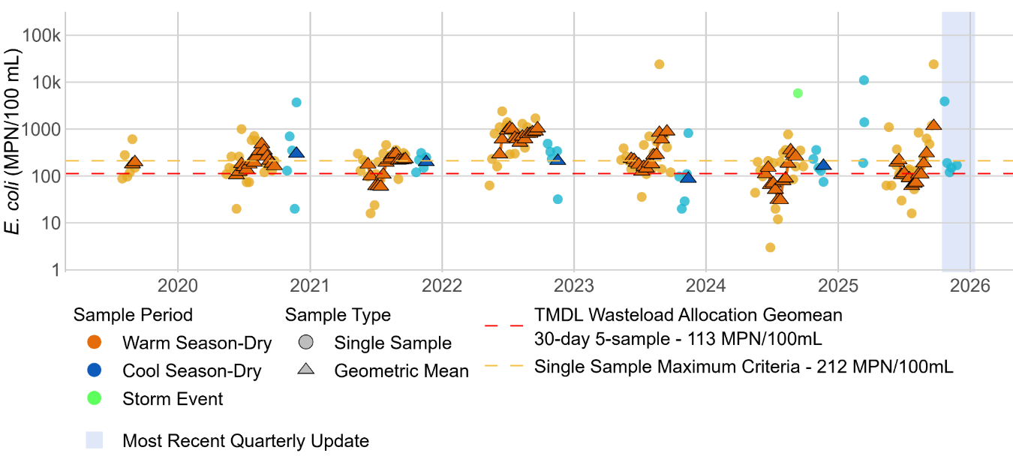
Figure C-1. Single Sample and Rolling Geometric Mean Results for E. coli at the Santa Ana River at Mission Boulevard Bridge Site (WW-MISSION) (2019–2025)

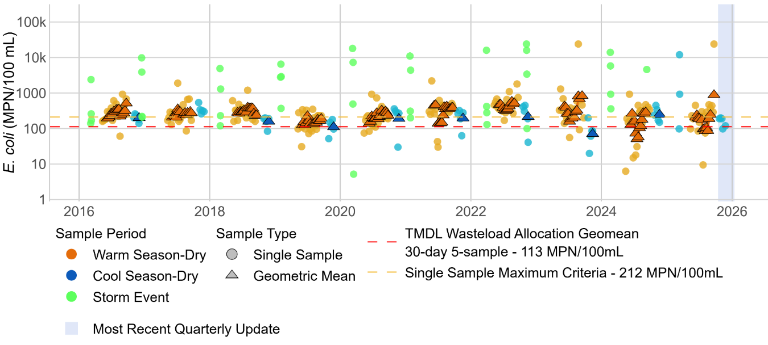
Figure C-2. Single Sample and Rolling Geometric Mean Results for E. coli at the Santa Ana River at MWD Crossing Site (WW-S1) (2016–2025)

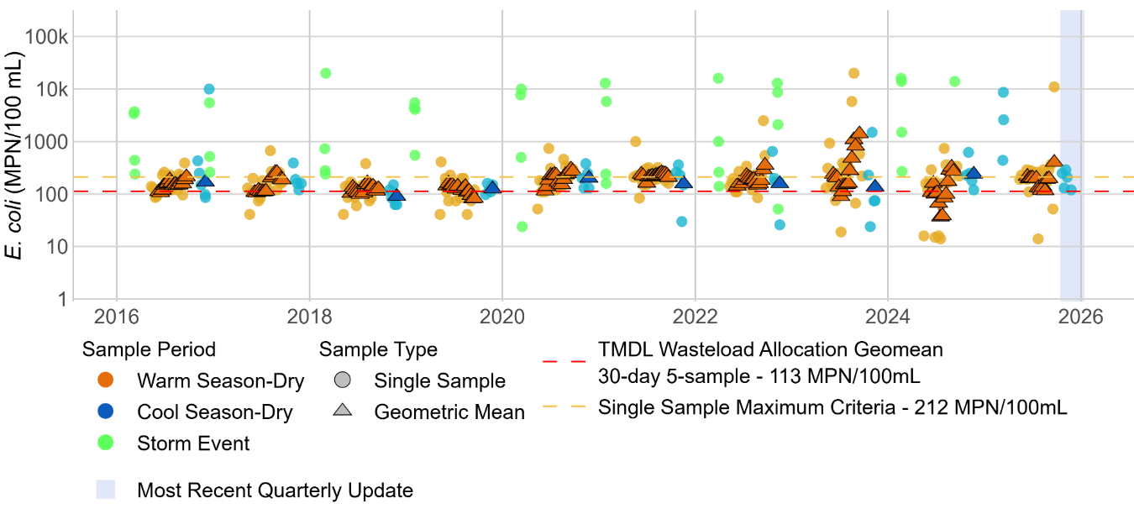
Figure C-3. Single Sample and Rolling Geometric Mean Results for E. coli at the Santa Ana River at Pedley Avenue Site (WW-S4) (2016–2025)

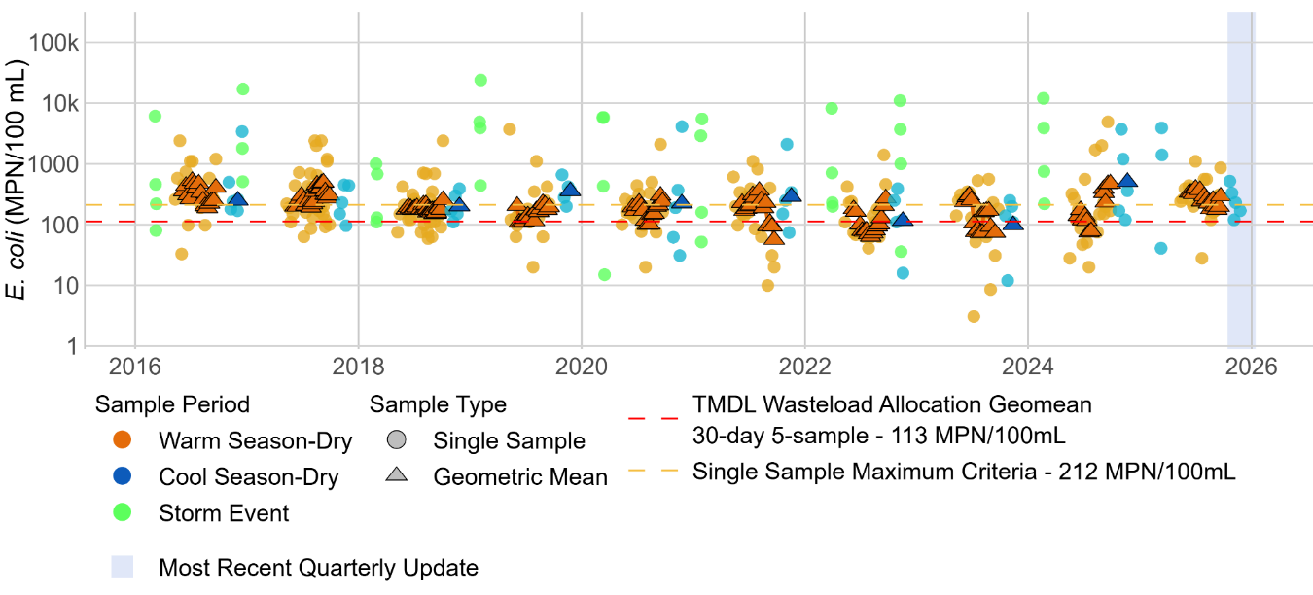
Figure C-4. Single Sample and Rolling Geometric Mean Results for E. coli at the Mill-Cucamonga Creek Site (WW-M6) (2016–2025)

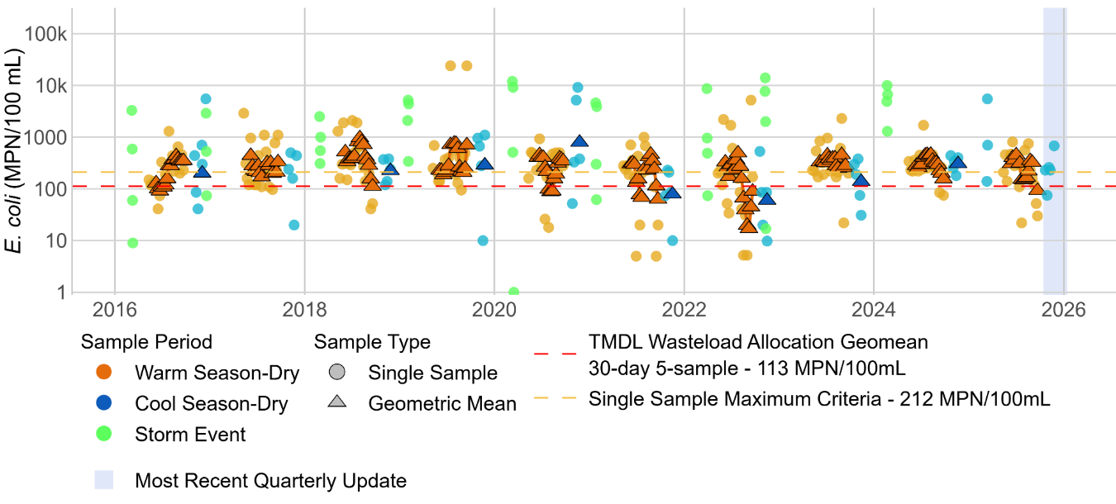
Figure C-5. Single Sample and Rolling Geometric Mean Results for E. coli at the Chino Creek at Central Avenue Site (WW-C7) (Spring 2020 – Fall 2022)

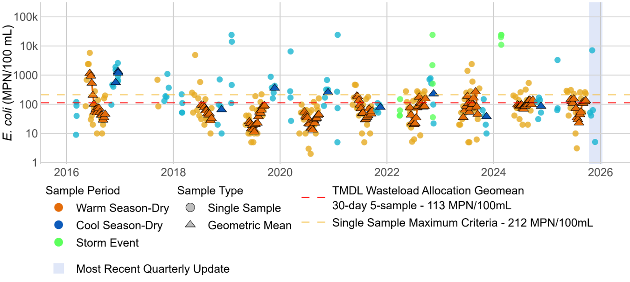
Figure C-6. Single Sample and Rolling Geometric Mean Results for E. coli at the Prado Park Lake Site (WW-C3) (2016–2025)

- Site Photographs

Tier 1 (T1) and Tier 2 (T2) Sites

Chino Creek Subwatershed
Figure E-1. Boys Republic South Channel (T1-BRSC)
Figure E-2. San Antonio Channel Upstream of Chino (T1-SACH)
Figure E-3. Chino Creek (T1-CHINOCRK)
Figure E-4. Carbon Canyon Creek Channel (T1-CCCH)
Figure E-5. Lake Los Serranos Channel (T1-LLSC)

Santa Ana River Reach 3 Subwatershed
Figure E-6. Box Springs Channel (T1-BXSP)
Figure E-7. Magnolia Center Storm Drain (T1-MCSD)
Figure E-8. Anza Drain (T1-ANZA)
Figure E-9. Sunnyslope Channel (T1-SNCH)
Figure E-10. San Sevaine Channel (T1-SSCH)
Figure E-11. Day Creek (T1-DAY)
Figure E-12 Eastvale D
Figure E-13. Eastvale E

Cucamonga Creek Subwatershed
Figure E-14. Cucamonga Creek Upstream of Hellman Avenue (T1-CUCAMONGA)
Figure E-15. Cucamonga Creek County Line Upstream (T2-CLCH)
Figure E-16. Cucamonga Creek at 60 Freeway (T2-HWY60)
Figure E-17. Chris Basin Outfall (T2-CHRIS)
Figure E-18. RP1 Effluent (Chino RP1)

Watershed-wide Compliance Sites
Figure E-19. Chino Creek at Central Avenue (WW-C7)
Figure E-20. Mill-Cucamonga Creek (WW-M6)
Figure E-21. Santa Ana River at MWD Crossing (WW-S1)
Figure E-22. Santa Ana River at Pedley Avenue (WW-S4)

Additional Mainstem Santa Ana River Sites
Figure E-23. Santa Ana River Reach 4 above South Riverside Avenue Bridge (P3-SBC1)
Figure E-24. Santa Ana River at Mission Boulevard (MISSION)

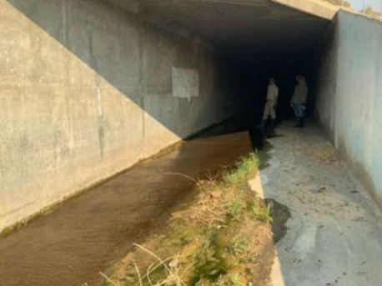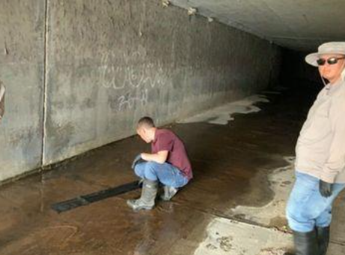
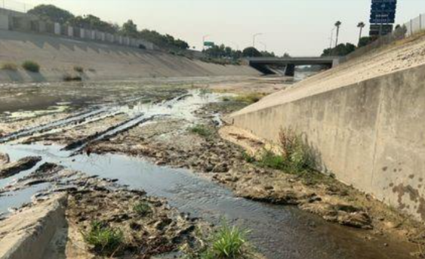
Top Left: Facing Upstream; Top Right: At Sampling location; Bottom: Facing Downstream
Figure E-1. Boys Republic South Channel (T1-BRSC), August 4, 2025
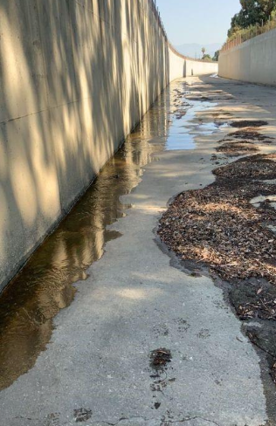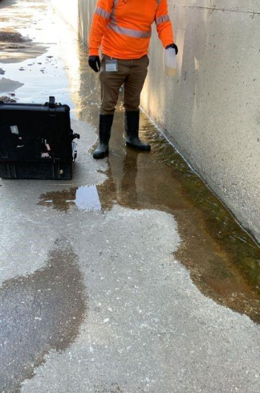
Left: Facing Upstream; Right: Facing Downstream
Figure E-2. San Antonio Channel Upstream of Chino (T1-SACH), August 11, 2025
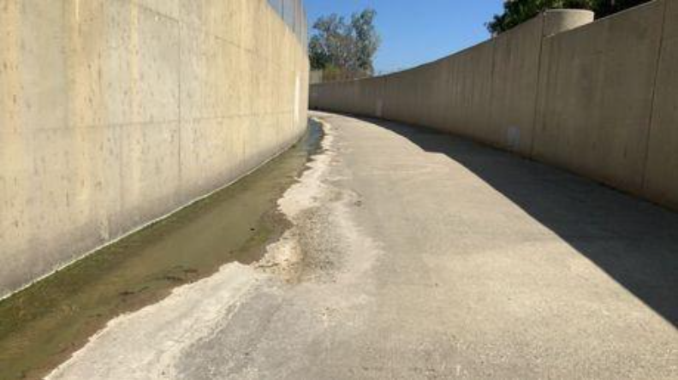
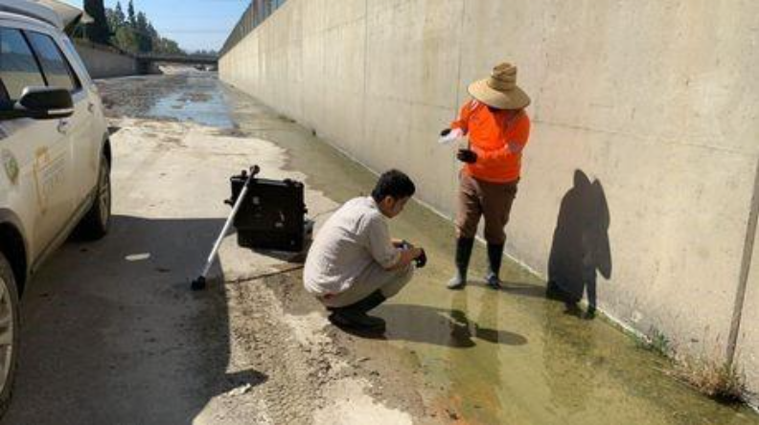
Top: Facing Upstream; Bottom: Facing Downstream
Figure E-3. Chino Creek Upstream of San Antonio Channel (T1-CHINOCRK), August 18, 2025

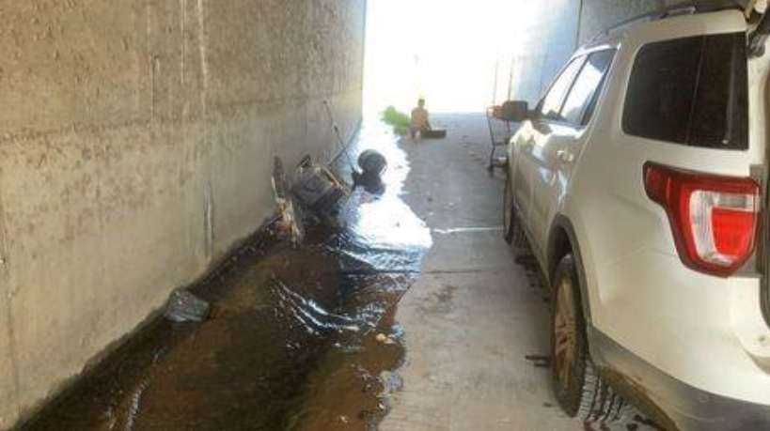
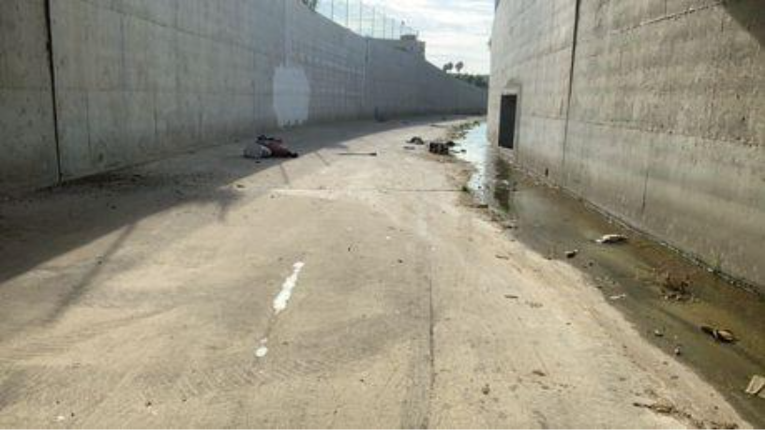
Top: Facing Upstream (with trash in the path of flow); Bottom: Facing Downstream
Figure E-4. Carbon Canyon Creek Channel (T1-CCCH), August 25, 2025

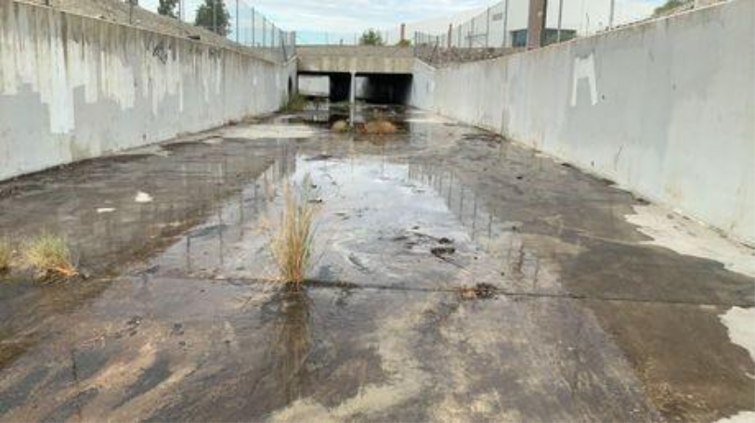
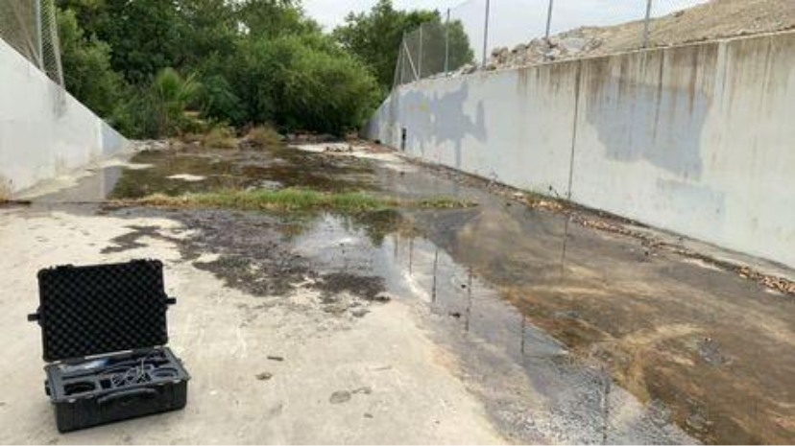
Top: Facing Upstream; Bottom: Facing Downstream
Figure E-5. Lake Los Serranos Channel (T1-LLSC), September 2, 2025

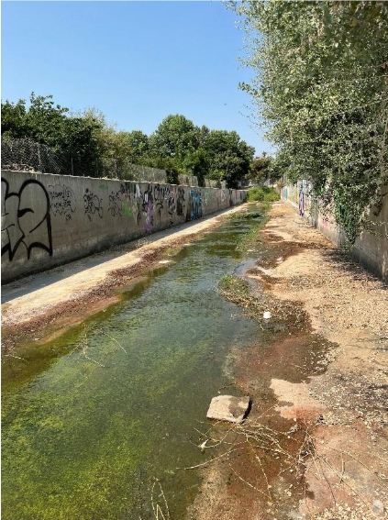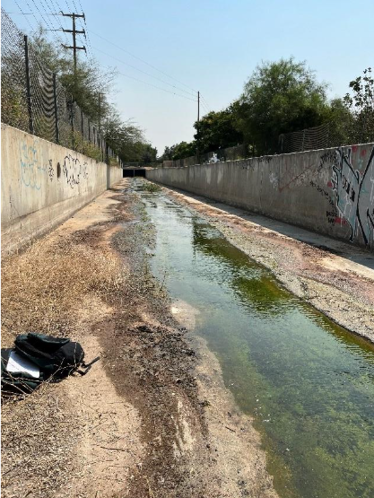
Top: Facing Upstream; Bottom: Facing Downstream
Figure E-6. Box Springs Channel (T1-BXSP), August 4, 2025

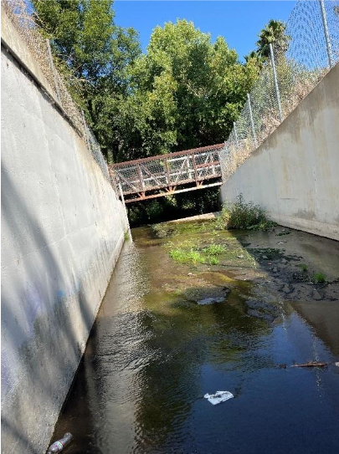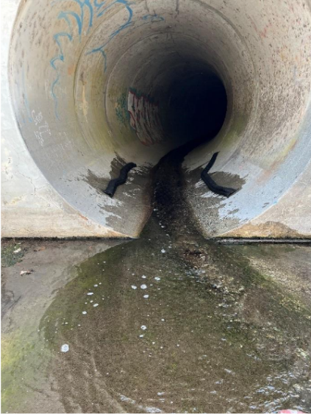
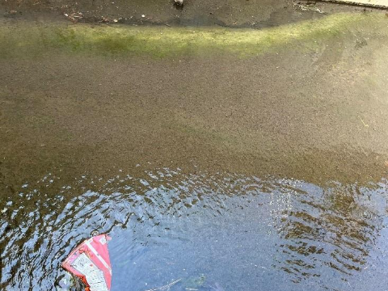
Top Left: Facing Downstream; Top Right: Facing Upstream; Bottom: Looking at the Sampling Site
Figure E-7. Magnolia Center Storm Drain (T1-MCSD), August 11, 2025

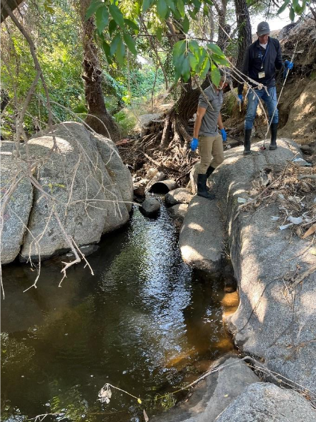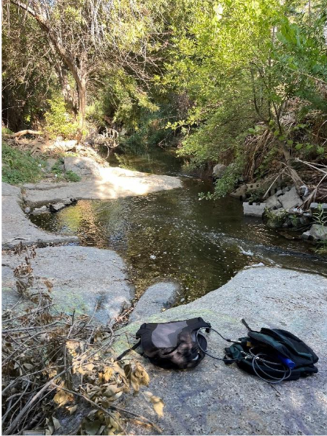
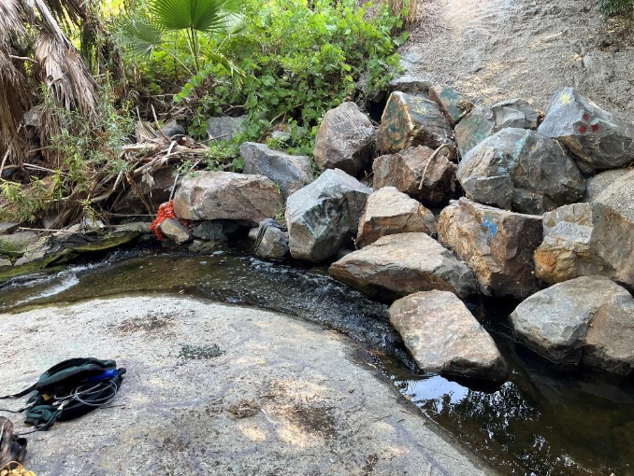
Top Left: Facing Upstream; Top Right: Facing Downstream; Bottom: Looking at Sampling Site
Figure E-8. Anza Drain (T1-ANZA), August 18, 2025

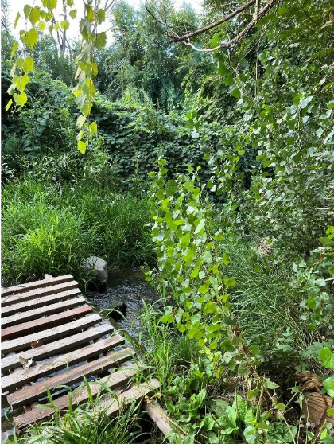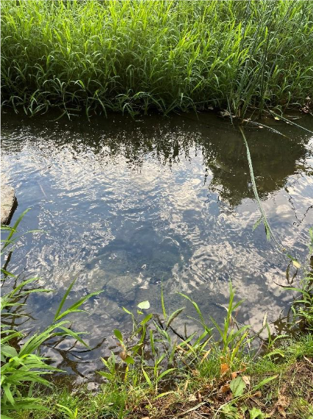
Left and Right: At Sampling Site
Figure E-9. Sunnyslope Channel (T1-SNCH), August 25, 2025
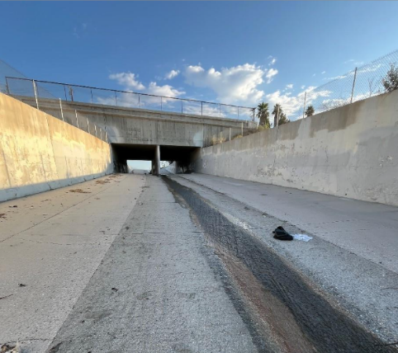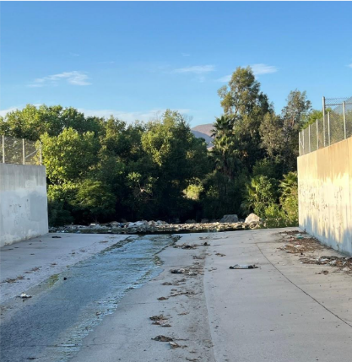
Left: Facing Upstream; Right: Facing Downstream;
Figure E-10. San Sevaine Channel (T1-SSCH), August 25, 2025
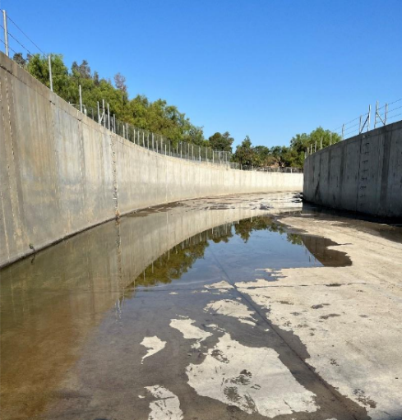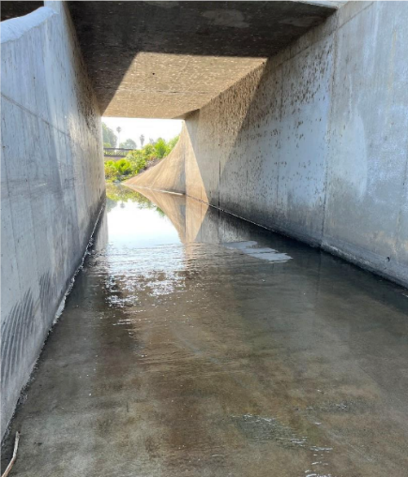
Left: Facing Downstream; Right: Facing Upstream
Figure E-11. Day Creek (T1-DAY), August 11, 2025
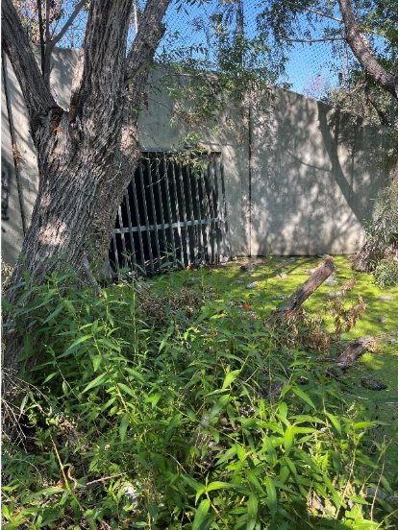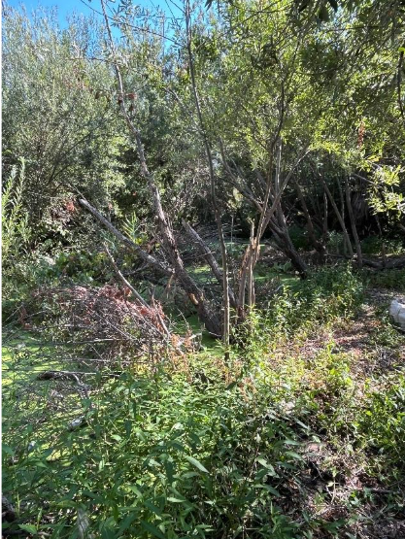
Top: Facing Upstream; Bottom: Facing Downstream
Figure E-12. Eastvale Street Site D (EVLD), August 7, 2025

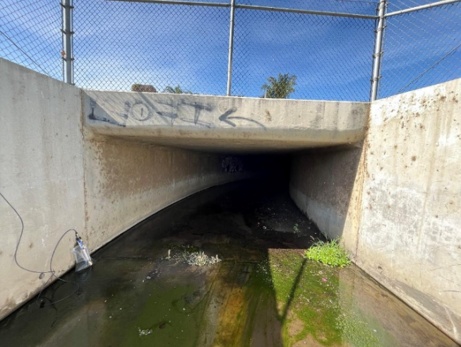
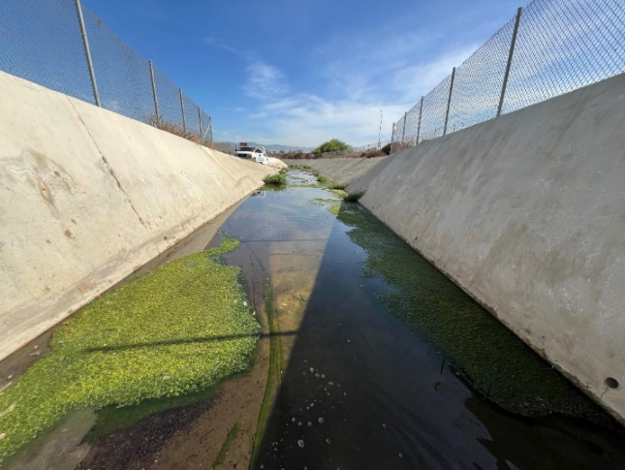
Top: Facing Upstream; Bottom: Facing Downstream
Figure E-13. Eastvale Street Site E (EVLE), August 21, 2025

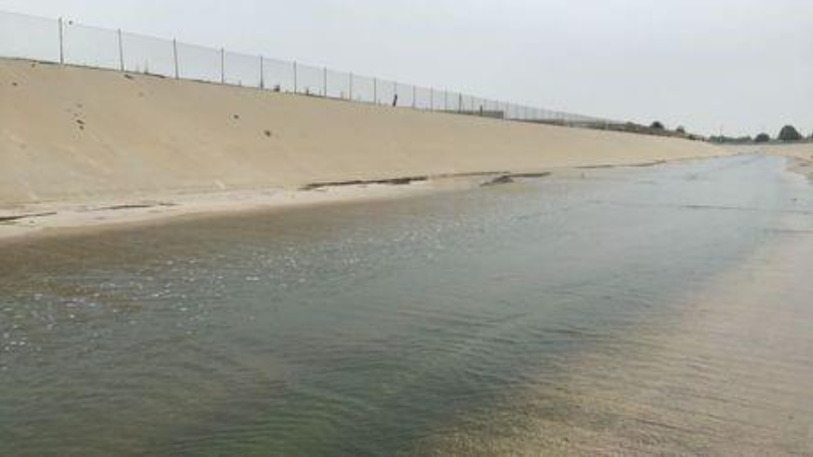
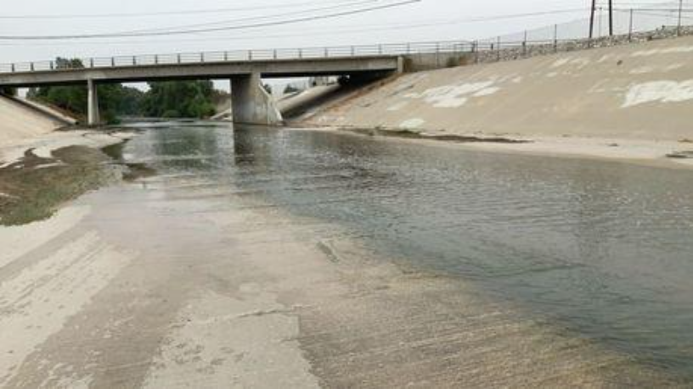
Top: Facing Upstream; Bottom: Facing Downstream
Figure E-14. Cucamonga Creek at Hellman Avenue (T1-CUCAMONGA), August 14, 2025

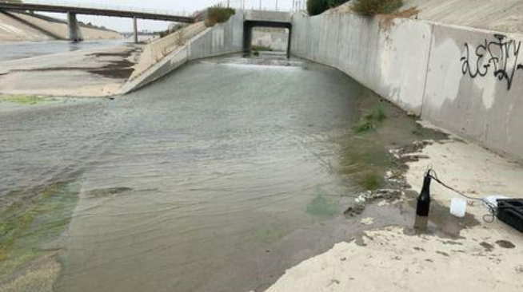
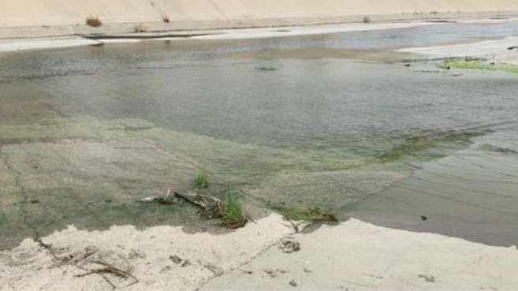
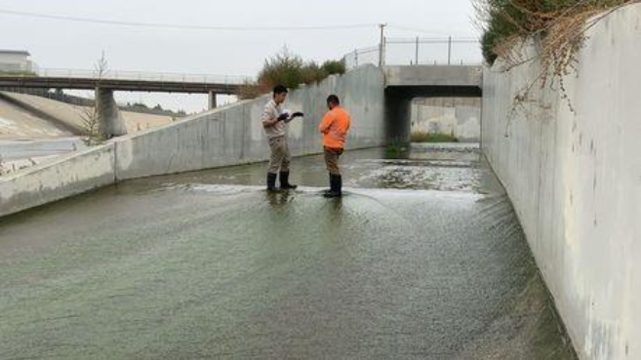
Top: Facing Upstream; Middle: Facing Downstream; Bottom: At Sampling Location
Figure E-15. Cucamonga Creek County Line Upstream (T2-CLCH), August 14, 2025

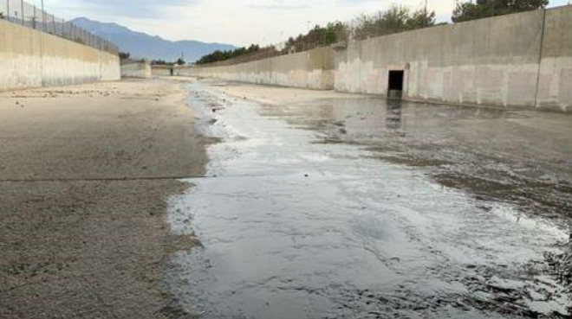
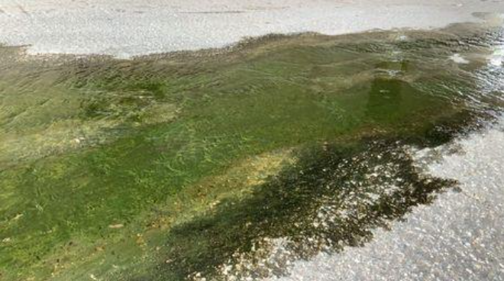
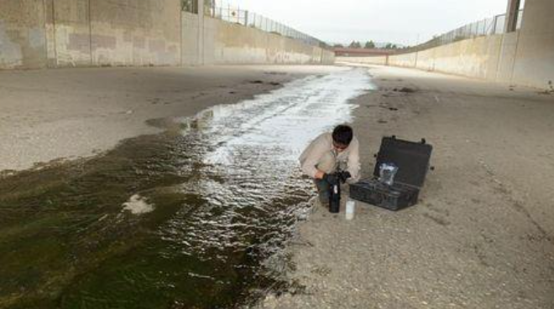
Top: Facing Upstream; Middle Photo: At Sampling Site Bottom: Facing Downstream
Figure E-16. Cucamonga Creek at 60 Freeway (T2-HWY60), August 28, 2025

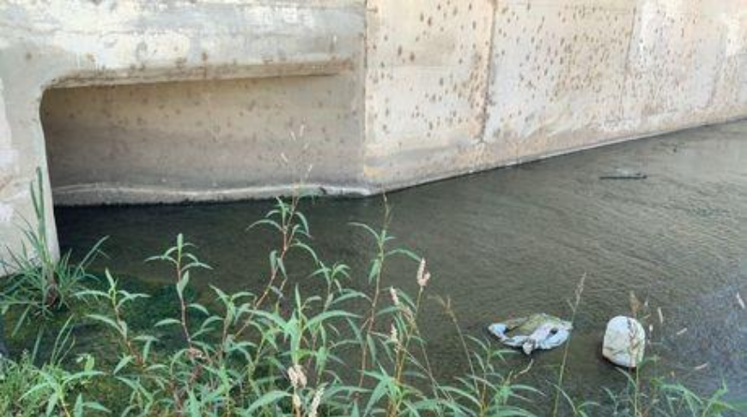
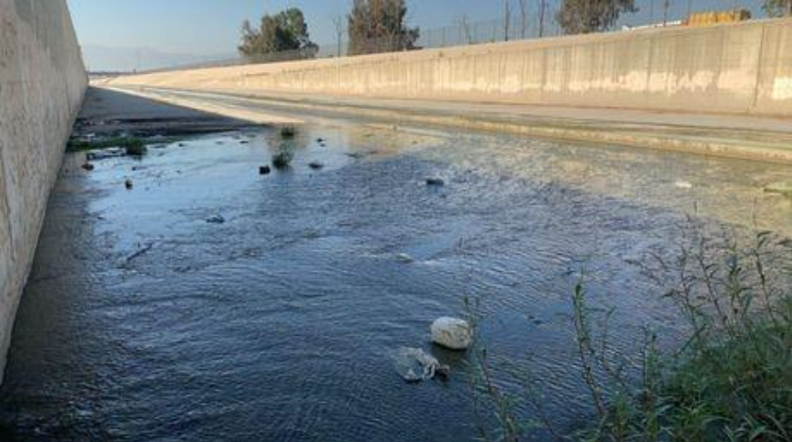
Top: At Sampling Location; Bottom: Facing Downstream
Figure E-17. Chris Basin Outfall (T2-CHRIS). August 7, 2025

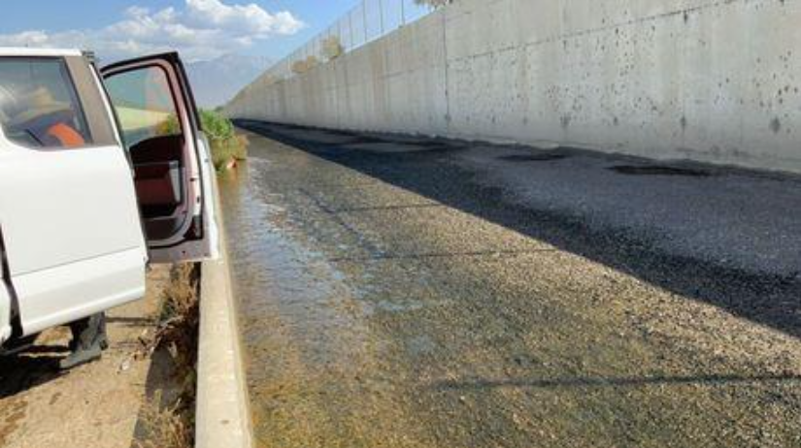
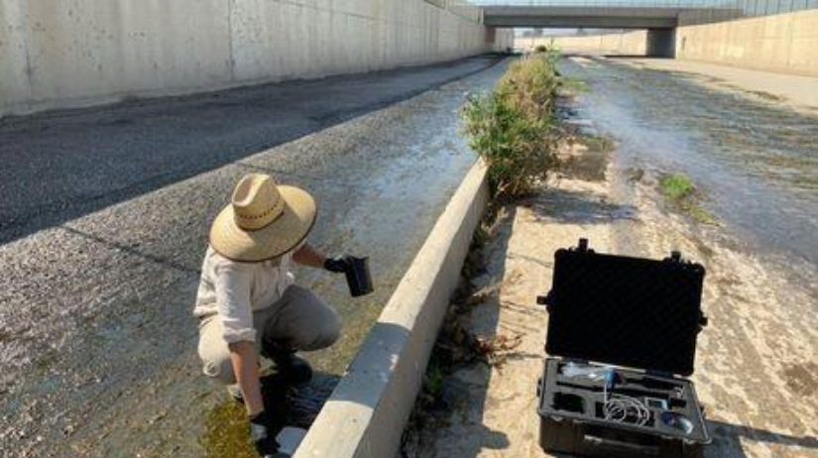
Top: Facing Upstream; Bottom: Facing Downstream
Figure E-18. RP1 Effluent (Chino RP1). September 4, 2025

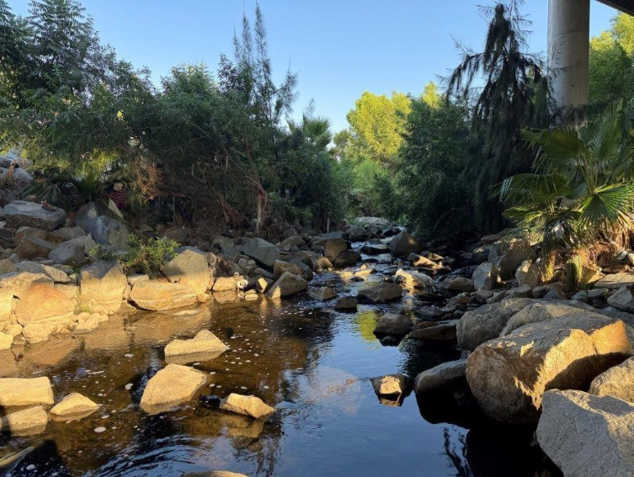
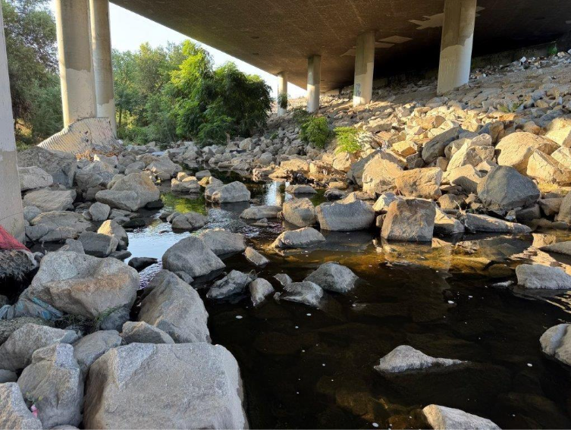
Top: Facing Upstream; Bottom: Facing Downstream
Figure E-19. Chino Creek at Central Avenue (WW-C7), August 11, 2025

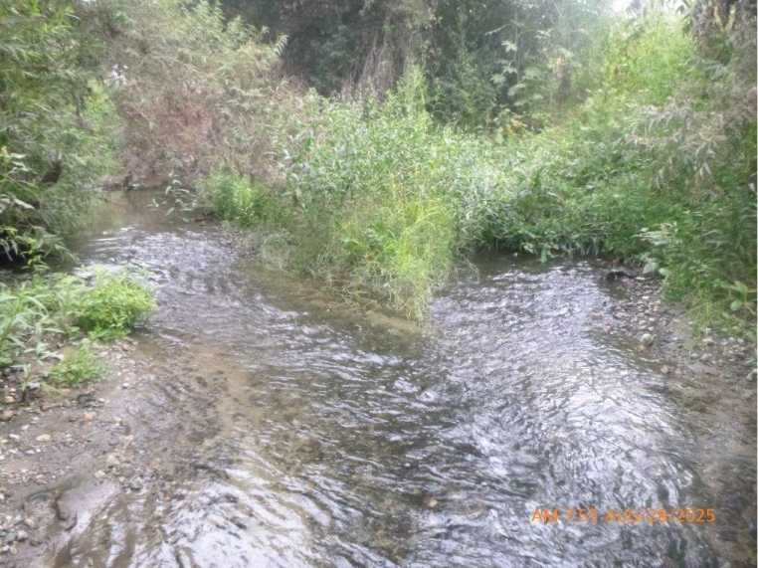
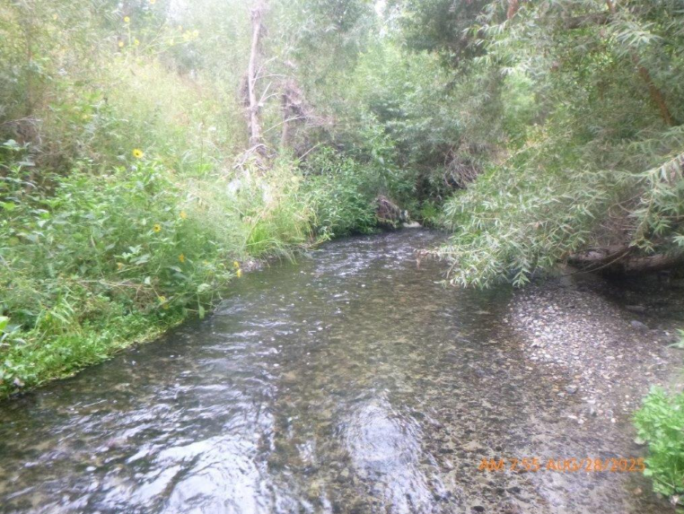
Top: Facing Upstream; Bottom: Facing Downstream
Figure E-20. Mill-Cucamonga Creek (WW-M6), August 28, 2025

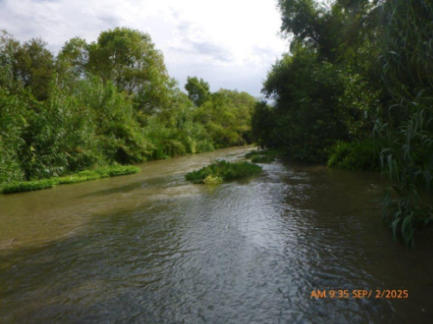
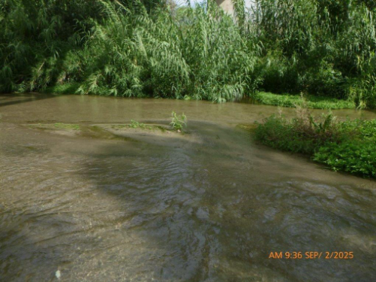
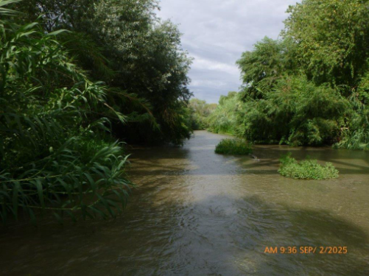
Top: Facing Upstream; Middle: At Sampling Site; Bottom: Facing Downstream
Figure E-21. Santa Ana River at Pedley Avenue (WW-S1). September 2, 2025

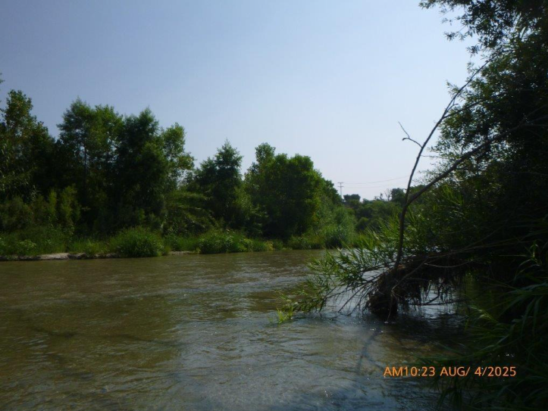
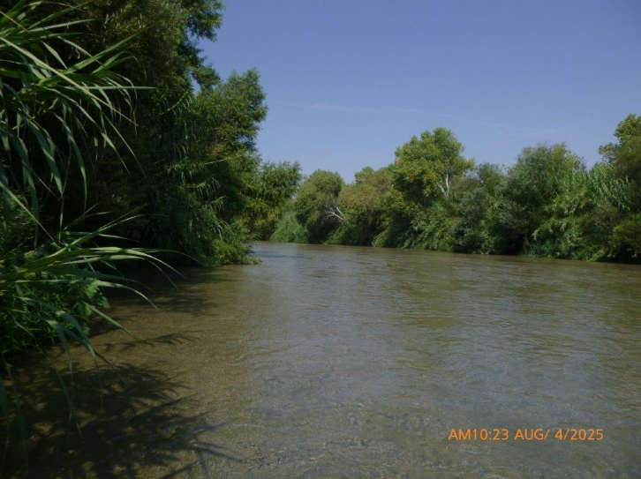
Top: Facing Upstream; Bottom: Facing Downstream
Figure E-22. Santa Ana River at MWD Crossing (WW-S4), August 4, 2025
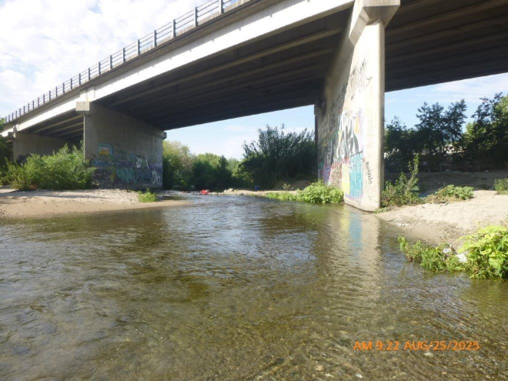
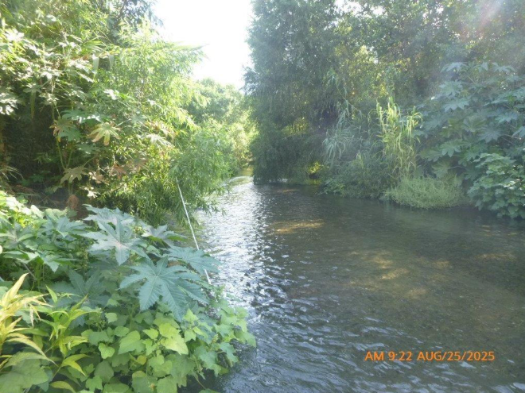
Top: Facing Upstream; Bottom: Facing Downstream
Figure E-23. Santa Ana River Reach 4 above South Riverside Avenue Bridge (P3-SBC1), August 25, 2025

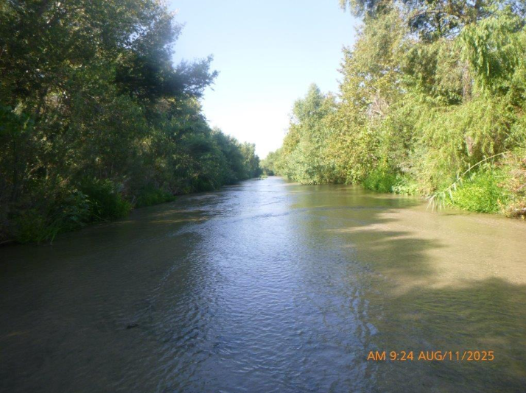
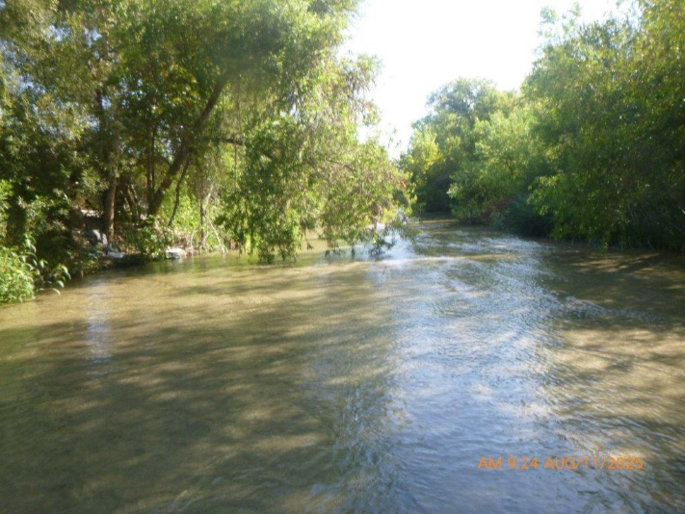
Top: Facing Upstream; Bottom: Facing Downstream
Figure E-24. Santa Ana River at Mission Boulevard (MISSION), August 11, 20225

– Water Quality Results
The following tables provide results from the 2025 Synoptic Study that was conducted from August 4 through September 4, 2025.
Table F-1. Field Estimated DWF at Tier 1 and Tier 2 Synoptic Study Sites
Site Type | Location | Dry Weather Flow (cfs)
Site Type | Location | Week 1  8/4 - 8/7 | Week 2  8/11 - 8/14 | Week 3  8/18 - 8/21 | Week 4  8/25 - 8/28 | Week 5  9/1 - 9/4
Tier 1 | T1-SACH | 0.01 | 0.08 | 0.01 | 0.19 | 0.01
Tier 1 | T1-CHINOCRK | 0.55 | 0.68 | 0.87 | 1.25 | 1.20
Tier 1 | T1-BRSC | 0.04 | 0.15 | 0.07 | 0.08 | 0.08
Tier 1 | T1-CCCH | 0.51 | 0.60 | 1.47 | 0.79 | 0.66
Tier 1 | T1-LLSC | 0.01 | 0.00 | 0.00 | 0.00 | 0.00
Tier 1 | T1-CUCAMONGA | 11.88 | 16.47 | 4.89 | 15.68 | 43.41
Tier 1 | T1-BXSP | 0.09 | 0.11 | 0.10 | 0.11 | 1.98¹
Tier 1 | T1-MCSD | 0.32 | 0.26 | 0.34 | 0.33 | 0.32
Tier 1 | T1-SNCH | 1.16 | 1.09 | 1.00 | 1.19 | 1.06
Tier 1 | T1-EVLD | 0.23 | 0.59 | 0.27 | 0.11 | 0.20
Tier 1 | T1-EVLE | 0.05 | 0.07 | 0.10 | 0.08 | 0.12
Tier 1 | T1-ANZA | 1.21 | 0.31 | 2.17 | 2.20 | 2.14
Tier 1 | T1-SSCH | 0.39 | 0.50 | 0.35 | 0.65 | 0.34
Tier 1 | T1-DAY | Dry | 0.09 | 0.08 | 0.11 | 0.06
Tier 2 | T2-CHRIS | 0.82 | 0.91 | 1.39 | 1.50 | 7.69
Tier 2 | T2-CLCH | 0.53 | 5.80 | 0.40 | 0.05 | 0.16
Tier 2 | T2-HWY60 | 0.06 | 0.24 | 0.13 | 0.16 | 0.31
¹ Site T1-BXSP was resampled on 9/4. The 9/4 discharge rate (2.0cfs) was used; the 9/2 discharge rate (7.4cfs) was excluded due to atypically high dry-weather flow.
Table F-2. E. coli in Water Samples at Synoptic Study Sites
Site Type | Location | E. Coli (MPN/100mL)
Site Type | Location | Week 1  8/4 - 8/7 | Week 2  8/11 - 8/14 | Week 3  8/18 - 8/21 | Week 4  8/25 - 8/28 | Week 5  9/1 - 9/4
Watershed-wide Compliance | WW-C7 | 560 | 230 | 750 | 230 | 160
Watershed-wide Compliance | WW-M6 | 560 | 180 | 120 | 160 | 170
Watershed-wide Compliance | WW-S1 | 75 | 290 | 230 | 470 | 370
Watershed-wide Compliance | WW-S4 | 120 | 290 | 170 | 170 | 290
Santa Ana River Mainstem | MISSION | 130 | 840 | 160 | 240 | 630
Santa Ana River Mainstem | P3-SBC1 | 52 | 31 | 74 | 98 | 180
Tier 1 | T1-SACH | >2,400 | 1,200 | 360 | 1,400 | 240
Tier 1 | T1-CHINOCRK | 410 | 230 | 980 | 630 | 2,900
Tier 1 | T1-BRSC | >2,400 | 4,900 | 1,700 | 13,000 | 1,900
Tier 1 | T1-CCCH | 41 | 240 | 52 | 120 | 20
Tier 1 | T1-LLSC | >2,400 | 2,900 | 640 | 2,900 | 180
Tier 1 | T1-CUCAMONGA | 12,000 | 260 | 440 | 140 | 270
Tier 1 | T1-BXSP | >2,400 | 1,200 | 5,200 | 10,000 | 1,400¹
Tier 1 | T1-MCSD | >2,400 | 6,100 | 7,700 | 3,900 | 5,800
Tier 1 | T1-SNCH | 190 | 230 | 490 | 62 | 160
Tier 1 | T1-EVLD | 4,900 | >24,000 | 7,300 | 5,200 | 10,000
Tier 1 | T1-EVLE | 1,200 | 4,600 | 610 | 1,200 | 1,500
Tier 1 | T1-ANZA | 79 | 31 | 10 | 31 | 86
Tier 1 | T1-SSCH | >2,400 | 430 | 930 | 24,000 | 350
Tier 1 | T1-DAY | Dry | 390 | >24,000 | 630 | 3,100
Tier 1 | Chino RP1 | 170 | 10 | 16 | 310 | 820
Tier 2 | T2-CHRIS | 13,000 | 1,700 | 1,700 | 1,300 | 580
Tier 2 | T2-CLCH | 120 | 170 | 610 | 1,000 | 1,000
Tier 2 | T2-HWY60 | 52 | 600 | 26 | 690 | 650
¹ Site T1-BXSP was resampled on 9/4. The 9/4 E. coli result (1400MPN/100mL) was used; the 9/2 E. coli result (18500MPN/100mL) was excluded due to atypically high dry-weather flow.

Table F-3. Turbidity Results at Synoptic Study Sites
Site Type | Location | Turbidity (NTU)
Site Type | Location | Week 1  8/4 - 8/7 | Week 2  8/11 - 8/14 | Week 3  8/18 - 8/21 | Week 4  8/25 - 8/28 | Week 5  9/1 - 9/4
Watershed-wide Compliance | WW-C7 | 3.4 | 5.3 | 1.6 | 1.6 | 5.4
Watershed-wide Compliance | WW-M6 | 1.5 | 0.5 | 1.1 | 1.3 | 1.6
Watershed-wide Compliance | WW-S1 | 1.4 | 1.4 | 1.0 | 1.7 | 1.3
Watershed-wide Compliance | WW-S4 | 1.0 | 2.9 | 2.0 | 1.7 | 1.0
Santa Ana River Mainstem | MISSION | 1.9 | 1.6 | 1.3 | 2.2 | 1.0
Santa Ana River Mainstem | P3-SBC1 | 0.04 | 0.4 | 0.5 | 0.5 | 0.5
Tier 1 | T1-SACH | 15.4 | 13.5 | 19.0 | 14.8 | 14.3
Tier 1 | T1-CHINOCRK | 8.0 | 7.5 | 7.1 | 8.9 | 8.2
Tier 1 | T1-BRSC | 6.6 | 5.7 | 6.6 | 6.6 | 4.0
Tier 1 | T1-CCCH | 5.7 | 5.8 | 8.7 | 5.3 | 4.7
Tier 1 | T1-LLSC | 6.2 | 7.5 | 6.2 | 8.6 | 9.9
Tier 1 | T1-CUCAMONGA | 6.8 | 7.3 | 9.1 | 6.1 | 7.6
Tier 1 | T1-BXSP | 4.1 | 0.6 | 0.0 | 0.0 | 0.0¹
Tier 1 | T1-MCSD | 5.4 | 0.3 | 0.0 | 0.0 | 0.0
Tier 1 | T1-SNCH | 0.0 | 0.0 | 0.0 | 0.0 | 0.0
Tier 1 | T1-EVLD | 2.4 | 8.7 | 4.4 | 0.0 | 12.9
Tier 1 | T1-EVLE | 13.9 | 4.1 | 0.0 | 0.0 | 0.0
Tier 1 | T1-ANZA | 2.2 | 2.1 | 0.6 | 0.0 | 0.0
Tier 1 | T1-SSCH | 1.4 | 1.3 | 0.0 | 0.0 | 0.0
Tier 1 | T1-DAY | Dry | 1.3 | 12.2 | 0.0 | 0.0
Tier 1 | Chino RP1 | 6.5 | 7.5 | 14.1 | 13.2 | 38.2
Tier 2 | T2-CHRIS | 27.7 | 16.4 | 10.5 | 9.6 | 1.2
Tier 2 | T2-CLCH | 7.0 | 6.8 | 25.2 | 6.3 | 12.1
Tier 2 | T2-HWY60 | 9.6 | 10.1 | 10.8 | 8.2 | 11.0
¹ Site T1-BXSP was resampled on 9/4. The 9/4 Turbidity result (0.0 NTU) was used; the 9/2 Turbidity result (130.0 NTU) was excluded due to atypically high dry-weather flow.
NTU = Nephelometric Turbidity Units

Table F-4. Dissolved Oxygen Results at Synoptic Study Sites
Site Type | Location | Dissolved Oxygen (mg/L)
Site Type | Location | Week 1  8/4 - 8/7 | Week 2  8/11 - 8/14 | Week 3  8/18 - 8/21 | Week 4  8/25 - 8/28 | Week 5  9/1 - 9/4
Watershed-wide Compliance | WW-C7 | 7.27 | 4.39 | 6.61 | 3.76 | 3.86
Watershed-wide Compliance | WW-M6 | 5.69 | 5.78 | 6.10 | 6.18 | 5.53
Watershed-wide Compliance | WW-S1 | 8.58 | 8.57 | 8.63 | 8.47 | 8.34
Watershed-wide Compliance | WW-S4 | 7.93 | 7.91 | 8.02 | 7.93 | 7.73
Santa Ana River Mainstem | MISSION | 8.58 | 8.0 | 8.23 | 8.27 | 8.19
Santa Ana River Mainstem | P3-SBC1 | 7.61 | 7.78 | 7.84 | 7.61 | 7.59
Tier 1 | T1-SACH | 8.88 | 7.08 | 7.13 | 6.12 | 7.96
Tier 1 | T1-CHINOCRK | 8.37 | 9.17 | 8.47 | 8.80 | 8.87
Tier 1 | T1-BRSC | 5.89 | 5.55 | 6.07 | 7.59 | 5.30
Tier 1 | T1-CCCH | 7.16 | 7.46 | 7.95 | 6.46 | 5.86
Tier 1 | T1-LLSC | 11.74 | 9.17 | 9.49 | 9.40 | 10.08
Tier 1 | T1-CUCAMONGA | 8.57 | 0.48 | 9.87 | 8.47 | 8.38
Tier 1 | T1-BXSP | 18.59 | 18.51 | 15.11 | 10.59 | 9.47¹
Tier 1 | T1-MCSD | 9.07 | 8.42 | 8.77 | 8.13 | 8.32
Tier 1 | T1-SNCH | 7.73 | 6.98 | 6.81 | 6.87 | 6.13
Tier 1 | T1-EVLD | 7.13 | 6.84 | 6.87 | 7.03 | 6.81
Tier 1 | T1-EVLE | 7.73 | 8.84 | 7.56 | 7.75 | 7.25
Tier 1 | T1-ANZA | 6.27 | 5.45 | 5.77 | 5.17 | 5.75
Tier 1 | T1-SSCH | 9.79 | 7.83 | 9.21 | 8.81 | 9.26
Tier 1 | T1-DAY | Dry | 10.59 | 9.63 | 11.51 | 9.27
Tier 1 | Chino RP1 | 9.15 | 10.33 | 7.50 | 8.18 | 7.20
Tier 2 | T2-CHRIS | 4.85 | 5.61 | 4.96 | 7.40 | 5.01
Tier 2 | T2-CLCH | 8.89 | 8.92 | 12.03 | 10.17 | 8.55
Tier 2 | T2-HWY60 | 6.74 | 9.83 | 7.20 | 7.88 | 7.57
¹ Site T1-BXSP was resampled on 9/4. The 9/4 Dissolved Oxygen result (9.5mg/L) was used; the 9/2 Turbidity result (8.0mg/L) was excluded due to atypically high dry-weather flow.
mg/L = milligrams per liter

Table F-5. pH Results at Synoptic Study Sites
Site Type | Location | pH
Site Type | Location | Week 1  8/4 - 8/7 | Week 2  8/11 - 8/14 | Week 3  8/18 - 8/21 | Week 4  8/25 - 8/28 | Week 5  9/1 - 9/4
Watershed-wide Compliance | WW-C7 | 8.3 | 7.9 | 7.8 | 7.5 | 7.5
Watershed-wide Compliance | WW-M6 | 7.5 | 7.6 | 7.6 | 7.6 | 7.6
Watershed-wide Compliance | WW-S1 | 7.9 | 7.9 | 7.9 | 7.9 | 7.8
Watershed-wide Compliance | WW-S4 | 8.0 | 8.0 | 8.0 | 8.0 | 8.0
Santa Ana River Mainstem | MISSION | 8.0 | 8.0 | 8.1 | 8.0 | 8.0
Santa Ana River Mainstem | P3-SBC1 | 7.6 | 7.5 | 7.6 | 7.4 | 7.5
Tier 1 | T1-SACH | 7.5 | 7.5 | 8.4 | 8.0 | 8.2
Tier 1 | T1-CHINOCRK | 7.7 | 8.0 | 9.8 | 8.3 | 8.3
Tier 1 | T1-BRSC | 7.8 | 7.6 | 9.2 | 7.5 | 8.2
Tier 1 | T1-CCCH | 8.2 | 8.2 | 8.7 | 7.5 | 7.4
Tier 1 | T1-LLSC | 8.2 | 8.0 | 8.9 | 7.5 | 7.6
Tier 1 | T1-CUCAMONGA | 6.8 | 7.0 | 5.1 | 6.5 | 5.5
Tier 1 | T1-BXSP | 9.3 | 9.4 | 9.1 | 8.6 | 8.5¹
Tier 1 | T1-MCSD | 8.5 | 8.6 | 8.6 | 8.5 | 8.6
Tier 1 | T1-SNCH | 7.8 | 7.8 | 7.9 | 7.7 | 7.9
Tier 1 | T1-EVLD | 7.7 | 8.1 | 8.1 | 8.1 | 8.1
Tier 1 | T1-EVLE | 8.1 | 8.3 | 8.2 | 8.1 | 8.0
Tier 1 | T1-ANZA | 8.0 | 8.1 | 8.2 | 8.0 | 8.1
Tier 1 | T1-SSCH | 8.5 | 8.6 | 8.5 | 8.4 | 8.5
Tier 1 | T1-DAY | Dry | 8.6 | 8.5 | 8.7 | 8.6
Tier 1 | Chino RP1 | 6.8 | 7.4 | 7.6 | 8.5 | 6.4
Tier 2 | T2-CHRIS | 7.0 | 7.6 | 7.8 | 8.3 | 6.2
Tier 2 | T2-CLCH | 6.9 | 7.7 | 6.6 | 8.0 | 6.3
Tier 2 | T2-HWY60 | 7.9 | 7.0 | 7.7 | 9.3 | 7.6
¹ Site T1-BXSP was resampled on 9/4. The 9/4 pH result (8.5) was used; the 9/2 pH result (8.3) was excluded due to atypically high dry-weather flow.

Table F-6. Specific Conductance Results at Synoptic Study Sites
Site Type | Location | Specific Conductance (µS/cm)
Site Type | Location | Week 1  8/4 - 8/7 | Week 2  8/11 - 8/14 | Week 3  8/18 - 8/21 | Week 4  8/25 - 8/28 | Week 5  9/1 - 9/4
Watershed-wide Compliance | WW-C7 | 1,086 | 1,188 | 533 | 1,126 | 1,099
Watershed-wide Compliance | WW-M6 | 896 | 875 | 872 | 835 | 816
Watershed-wide Compliance | WW-S1 | 1,071 | 1,065 | 1,067 | 1,065 | 1,021
Watershed-wide Compliance | WW-S4 | 1,032 | 1,029 | 1,025 | 1,024 | 1,035
Santa Ana River Mainstem | MISSION | 875 | 867 | 876 | 872 | 874
Santa Ana River Mainstem | P3-SBC1 | 876 | 864 | 877 | 766 | 865
Tier 1 | T1-SACH | 1,700 | 1,170 | 901 | 1,200 | 1,700
Tier 1 | T1-CHINOCRK | 1,200 | 487 | 1,090 | 1,040 | 1,070
Tier 1 | T1-BRSC | 1,250 | 1,340 | 1,290 | 1,080 | 1,220
Tier 1 | T1-CCCH | 1,340 | 1,310 | 1,330 | 1,250 | 1,300
Tier 1 | T1-LLSC | 1,450 | 487 | 1,590 | 956 | 1,150
Tier 1 | T1-CUCAMONGA | 813 | 748 | 757 | 812 | 468
Tier 1 | T1-BXSP | 647 | 734 | 661 | 718 | 578¹
Tier 1 | T1-MCSD | 1,351 | 826 | 846 | 853 | 887
Tier 1 | T1-SNCH | 943 | 935 | 927 | 929 | 923
Tier 1 | T1-EVLD | 668 | 750 | 743 | 952 | 768
Tier 1 | T1-EVLE | 732 | 735 | 698 | 764 | 1,007
Tier 1 | T1-ANZA | 996 | 1,538 | 1,520 | 1,522 | 1,511
Tier 1 | T1-SSCH | 584 | 477 | 607 | 603 | 575
Tier 1 | T1-DAY | Dry | 910 | 1,442 | 598 | 822
Tier 1 | Chino RP1 | 833 | 853 | 862 | 802 | 766
Tier 2 | T2-CHRIS | 626 | 602 | 549 | 597 | 391
Tier 2 | T2-CLCH | 666 | 714 | 813 | 899 | 897
Tier 2 | T2-HWY60 | 416 | 448 | 489 | 415 | 591
¹ Site T1-BXSP was resampled on 9/4. The 9/4 Specific Conductance result (578 µS/cm) was used; the 9/2 Specific Conductance result (728 µS/cm) was excluded due to atypically high dry-weather flow.
µS/cm = microsiemens/centimeter

Table F-7. Temperature Results at Synoptic Study Sites
Site Type | Location | Temperature (°C)
Site Type | Location | Week 1  8/4 - 8/7 | Week 2  8/11 - 8/14 | Week 3  8/18 - 8/21 | Week 4  8/25 - 8/28 | Week 5  9/1 - 9/4
Watershed-wide Compliance | WW-C7 | 19.8 | 21.6 | 21.2 | 22.5 | 23.0
Watershed-wide Compliance | WW-M6 | 22.4 | 21.7 | 22.3 | 22.0 | 22.1
Watershed-wide Compliance | WW-S1 | 20.0 | 20.1 | 19.0 | 19.8 | 22.6
Watershed-wide Compliance | WW-S4 | 23.4 | 22.5 | 21.7 | 22.4 | 22.0
Santa Ana River Mainstem | MISSION | 20.2 | 23.8 | 22.9 | 21.9 | 21.9
Santa Ana River Mainstem | P3-SBC1 | 23.6 | 25.4 | 25.6 | 25.4 | 23.7
Tier 1 | T1-SACH | 24.2 | 26.7 | 24.4 | 26.0 | 24.2
Tier 1 | T1-CHINOCRK | 24.6 | 26.9 | 28.9 | 26.6 | 24.8
Tier 1 | T1-BRSC | 21.9 | 23.7 | 23.2 | 24.0 | 23.2
Tier 1 | T1-CCCH | 23.1 | 26.6 | 25.9 | 26.3 | 24.1
Tier 1 | T1-LLSC | 22.7 | 26.9 | 27.8 | 28.4 | 25.0
Tier 1 | T1-CUCAMONGA | 22.6 | 21.8 | 23.9 | 23.2 | 26.1
Tier 1 | T1-BXSP | 27.3 | 29.1 | 26.9 | 27.8 | 25.6¹
Tier 1 | T1-MCSD | 22.5 | 22.8 | 22.6 | 23.6 | 23.0
Tier 1 | T1-SNCH | 17.8 | 19.3 | 18.0 | 19.8 | 19.9
Tier 1 | T1-EVLD | 23.4 | 23.2 | 23.9 | 23.9 | 24.5
Tier 1 | T1-EVLE | NR | 22.5 | 23.4 | 23.8 | 24.2
Tier 1 | T1-ANZA | 23.8 | 23.6 | 22.9 | 24.0 | 23.9
Tier 1 | T1-SSCH | 20.0 | 19.3 | 19.4 | 21.2 | 21.6
Tier 1 | T1-DAY | Dry | 24.2 | 21.3 | 23.5 | 22.5
Tier 1 | Chino RP1 | 27.1 | 26.0 | 29.0 | 25.6 | 30.2
Tier 2 | T2-CHRIS | 22.6 | 21.9 | 23.2 | 22.6 | 24.3
Tier 2 | T2-CLCH | 24.8 | 21.6 | 23.5 | 23.7 | 26.5
Tier 2 | T2-HWY60 | 26.5 | 25.3 | 28.4 | 25.0 | 28.7
¹ Site T1-BXSP was resampled on 9/4. The 9/4 Temperature result (25.6 °C) was used; the 9/2 Temperature result (24.0 °C) was excluded due to atypically high dry-weather flow.
NR = not recorded

– Sampling QA/QC Report

Introduction
This section provides the QA/QC evaluation for samples and data collected for the MSAR Synoptic Study from the week of August 4, 2025 through the week of September 1, 2025. Field samples were evaluated against data quality objectives (DQOs) outlined in the project QAPP (SAWPA, 2022b). The following data were collected for the 2025 Synoptic Study:
- Field measurements for the following constituents: Conductivity, dissolved oxygen, pH, turbidity, water temperature, and flow.
- Water quality samples for laboratory analysis of two constituents: E. coli and Bacteroides HF183.
- Sediment samples for laboratory analysis of two constituents: E. coli and Bacteroides HF183
Field data were checked to ensure that all required data were gathered and recorded. This check included a data review to ensure correct units of measurements were reported and that reported values were within expected ranges. Water quality data validation included a check to ensure that samples were delivered to laboratories within required holding times and that all sample handling and custody protocols were followed. Field/equipment blank and duplicate results were evaluated against various reporting requirements, and data were checked to ensure correct units of measurement were reported. The following sections summarize the results of the QA/QC evaluation for this study.

Field Measured Parameters
The MSAR Synoptic Study was conducted for five weeks during dry weather conditions in the dry season. Field measurements were planned at 15 Tier 1 sites, three Tier 2 sites, and six mainstem or MSAR watershed-wide compliance sites, (24 total sites over a five-week period for a total of 120 planned measurements). Field measurements consisted of temperature, pH, dissolved oxygen, specific conductivity, and turbidity using a multiparameter field meter, and flow measured by one of the three following methods: 1) cross-section velocity profile using a handheld velocity meter, 2) collect volumetric flow measurements using a flood bag and flood barriers to channel flow, or 3) cross-section velocity profile using the leaf float/orange peel method. DQOs for field parameters are presented in Table G-1.

Table G-1. Data Quality Objectives for Field Measurements
Parameter | Accuracy | Precision | Completeness
Conductivity | ± 5% | ± 5% | 90%
Dissolved Oxygen | ± 0.5 mg/L | ± 0.5 mg/L or 10%; whichever is greater | 90%
pH | ± 0.5 units | ± 0.5 or 5%; whichever is greater | 90%
Temperature | ± 0.5°C | ± 0.5 or 5%; whichever is greater | 90%
Turbidity | ± 10% or 0.1; whichever is greater | ± 10% or 0.1; whichever is greater | 90%
Flow (visual estimate) | ± 25% or 0.25; whichever is greater | ± 25% or 0.25; whichever is greater | 90%
Flow (via flow instrument) | ± 10% or 0.1; whichever is greater | ± 10% or 0.1; whichever is greater | 90%

Completeness
Table G-2 summarizes the completeness of field measurements collected during the study, defined as the percentage of targeted samples that were successfully collected. Field measurements that were not collected due to lack of flow (dry) are not considered missed as they are representative of site conditions. One site (T1-DAY) was dry during the first week of the study period and another site was targeted twice during the last week of the study period, resulting in the overall targeted samples count remaining at 120 samples. Field measurements met completeness data quality objectives with no exceptions.
Table G-2. Field Parameter Completeness Summary
Parameter | Targeted | Collected | % Complete | DQO (90%) Met?
Conductivity | 120 | 120 | 100% | Yes
Dissolved Oxygen | 120 | 120 | 100% | Yes
Flow | 120 | 120 | 100% | Yes
pH | 120 | 120 | 100% | Yes
Temperature | 120 | 119¹ | 99.2% | Yes
Turbidity | 120 | 120 | 100% | Yes
¹ Temperature was not recorded at T1-EVLE during week 1 of the study.

Accuracy and Precision
Field staff used a YSI ProDSS multiparameter probe (or equivalent) to collect in situ field measurements for conductivity, dissolved oxygen, pH, turbidity and water temperature at the sample locations during each sample event. Flow was measured with a Hach FH950 (or equivalent) or using alternative flow measurement methods where flow was very shallow (see SAWPA, 2019b). Field staff calibrated the water quality meters prior to the first sampling event and continued to check calibrations during each event to ensure that accuracy and precision of the measurements aligned with the DQOs outlined in Table G-1.

Laboratory Constituents
Targeted sample collection included collection of water samples for E. coli and Bacteroides analysis from the 24 sites described above, as well as additional Bacteroides samples from four POTWs. Sediment samples were planned to be collected for E. coli and Bacteroides analysis at Mainstem and TMDL compliance sites (6 sites, 30 samples total). There were no exceedances of holding time requirements for laboratory samples. DQOs for Laboratory constituents are outlined in Table G-3.
Table G-3. Data Quality Objectives for Laboratory Measurements
Parameter | Accuracy | Precision | Target Reporting Limits | Completeness
E. Coli | Positive results for target organisms. Negative results for non-target organisms | R_{log} within 3.27*mean R_{log} (section 9020B 18th, 19th, or 20th editions of Standard Methods) | 10 MPN/100mL | 90%
HF183 | Positive results that target DNA sequence associated with the organism (Bacteroides). Negative results for results below detection limit of assay | NA | 10 gene copies/reaction | 90%

Completeness
Table G-4 and Table G-5 describe the number of sediment and water samples targeted versus actual samples collected. For sediment samples, the overall completeness was 100% for both E.coli and HF183. For water samples, the overall completeness was 98.6% for HF183 samples and 100% for E. coli samples. Sediment and water samples met the DQO of 90% completeness.
Table G-4. Summary of Sediment Sample Collection Activity for MSAR Synoptic Study
Site Type | Site ID | Planned | Collected
Mainstem/TMDL Compliance | WW-MISSION | 5 | 5
Mainstem/TMDL Compliance | WW-S1 | 5 | 5
Mainstem/TMDL Compliance | WW-S4 | 5 | 5
Mainstem/TMDL Compliance | P3-SBC1 | 5 | 5
Mainstem/TMDL Compliance | WW-C7 | 5 | 5
Mainstem/TMDL Compliance | WW-M6 | 5 | 5
Total |  | 30 | 30

Table G-5. Summary of Water Sample Collection Activity for MSAR Synoptic Study
Site Type | Site ID | HF183 |  | E. Coli
Site Type | Site ID | Targeted | Collected | Targeted | Collected
POTW Treated Effluent | Rialto WWTP | 5 | 5 | 0 | 0
POTW Treated Effluent | Riverside RWQCP | 5 | 4 | 0 | 0
POTW Treated Effluent | RIX | 5 | 4 | 0 | 0
POTW Treated Effluent | RP1 | 5 | 5 | 0 | 0
Mainstem/TMDL Compliance | WW-MISSION | 5 | 5 | 5 | 5
Mainstem/TMDL Compliance | P3-SBC1 | 5 | 5 | 5 | 5
Mainstem/TMDL Compliance | WW-S1 | 5 | 5 | 5 | 5
Mainstem/TMDL Compliance | WW-S4 | 5 | 5 | 5 | 5
Mainstem/TMDL Compliance | WW-C7 | 5 | 5 | 5 | 5
Mainstem/TMDL Compliance | WW-M6 | 5 | 5 | 5 | 5
Tier 1 | T1-ANZA | 5 | 5 | 5 | 5
Tier 1 | T1-BXSP¹ | 6 | 6 | 6 | 6
Tier 1 | T1-SNCH | 5 | 5 | 5 | 5
Tier 1 | T1-SSCH | 5 | 5 | 5 | 5
Tier 1 | T1-DAY² | 4 | 4 | 4 | 4
Tier 1 | T1-MCSD | 5 | 5 | 5 | 5
Tier 1 | T1-EVLD | 5 | 5 | 5 | 5
Tier 1 | T1-EVLE | 5 | 5 | 5 | 5
Tier 1 | T1-BRSC | 5 | 5 | 5 | 5
Tier 1 | T1-CCCH | 5 | 5 | 5 | 5
Tier 1 | T1-SACH | 5 | 5 | 5 | 5
Tier 1 | T1-CHINOCRK | 5 | 5 | 5 | 5
Tier 1 | T1-LLSC | 5 | 5 | 5 | 5
Tier 1 | T1-CUCAMONGA | 5 | 5 | 5 | 5
Tier 1 | Chino RP1 | 5 | 5 | 5 | 5
Tier 2 | T2-CLCH | 5 | 5 | 5 | 5
Tier 2 | T2-HWY60 | 5 | 5 | 5 | 5
Tier 2 | T2-CHRIS | 5 | 5 | 5 | 5
Total |  | 140 | 138 | 120 | 120
¹ Atypical high dry weather flow was observed at Box Spring Channel on 9/2; additional sampling was conducted on 9/4 when dry weather flow returned to normal conditions
² Day Creek was dry for the first week of the study, resulting in 4 targeted samples instead of 5.

Accuracy – Field Blanks
Field blanks are collected to determine the accuracy of laboratory measurements and to evaluate potential points of contamination in the sample collection process. The QAPP requires that field blanks be collected for at least 5% of the total samples collected during the study period. The site for collection of blank samples was selected on a rotational basis. In total, 8 blank samples were collected per water sample constituent for the 5-week study. This resulted in 5.6% of the total sample count for HF183 and 6.7% of the total sample count for E. coli, in accordance with QAPP requirements.
Field blank results were non-detect for E. coli samples submitted to Babcock Laboratories and either non-detect or below the reporting limit for HF183 samples submitted to Orange County Public Health Water Quality Laboratory.
Laboratory blanks are also conducted by the respective labs and are provided in the laboratory reports.

Precision – Field Replicates
The QAPP requires field replicate samples to be collected for at least 5% of the total samples collected during the study period. The site selected for collection of replicate samples was selected on a rotational basis at the same site the field blank was collected. In total, 8 replicate samples per constituent were collected for water samples, and 2 replicate samples per constituent were collected for sediment samples. For water samples, this resulted in 5.6% of the total sample count for HF183 and 6.7% of the total sample count for E. coli. For sediment samples, this resulted in 6.7% of the total sample county for both E. coli and HF183.

A calculation of precision is required for E.coli samples. To determine the precision of the duplicate analysis for E. Coli the following method was used:
- Calculate the logarithm of each sample and associated duplicate ("laboratory pair")
- Determine the range for each laboratory pair (R_{log})
- Calculate the mean of the ranges (Mean R_{log})
- Calculate the precision criterion, where the precision criteria = 3.27 * Mean R_{log}
- Compare R_{log} for each duplicate pair with the calculated precision criterion for the data set to determine if R_{log} is less than the precision criterion.

Table G-6 and G-7 summarize the field duplicate analysis results for E. coli in water samples and sediment samples, respectively. All R_{log} values were below the precision criterion.

Table G-6. Results of Field Duplicates Analysis for E. coli Water Samples
Sample Date | Site ID | Sample Result  (cfu/100 ml) | Duplicate Result (cfu/100 ml) | Log of Sample Result (L₂) | Log of Duplicate Result (L₁) | Range of Logs  (L₁-L₂) or R_{log}) | DQO met? (<0.29)
8/4/2025 | T1-SNCH | 190 | 140 | 2.28 | 2.15 | 0.13 | Yes
8/7/2025 | T1-CUCAMONGA | 12,000 | 10,000 | 4.08 | 4.00 | 0.08 | Yes
8/11/2025 | T1-SSCH | 430 | 400 | 2.63 | 2.60 | 0.03 | Yes
8/14/2025 | T2-CLCH | 170 | 130 | 2.23 | 2.11 | 0.12 | Yes
8/18/2025 | T1-DAY | 24,000 | 24,000 | 4.38 | 4.38 | 0.00 | Yes
8/18/2025 | T1-CCCH | 52 | 52 | 1.72 | 1.72 | 0.00 | Yes
8/25/2025 | T1-BRSC | 13,000 | 16,000 | 4.11 | 4.20 | 0.09 | Yes
9/2/2025 | T1-BXSP | 13,000 | 24,000 | 4.11 | 4.38 | 0.27 | Yes
Mean R_{log} |  |  |  |  |  | 0.09
Precision Criterion (3.27*Mean R_{log}) |  |  |  |  |  | 0.29

Table G-6. Results of Field Duplicates Analysis for E. coli Sediment Samples
Sample Date | Site ID | Sample Result  (cfu/100 ml) | Duplicate Result (cfu/100 ml) | Log of Sample Result (L₁) | Log of Duplicate Result (L₂) | Range of Logs  (L₁-L₂) or R_{log}) | DQO met? (<0.41)
8/7/2025 | WW-M6 | 100 | 110 | 2.00 | 2.04 | 0.04 | Yes
9/2/2025 | WW-S4 | 970 | 1,600 | 2.99 | 3.20 | 0.21 | Yes
Mean R_{log} |  |  |  |  |  | 0.125
Precision Criterion (3.27*Mean R_{log}) |  |  |  |  |  | 0.41

Laboratory QAQC Samples
Laboratory QAQC samples were within acceptable ranges. Additional information on laboratory QAQC samples and procedures can be found in the laboratory reports.

See footnote 4 for Basin Plan definition of “uncontrollable”
The Basin Plan defines “uncontrollable sources” as: wildlife activity and waste; bacterial regrowth within sediment or biofilm; resuspension from disturbed sediment; concentrations (flocks) of semi-wild waterfowl; shedding during swimming (Santa Ana Water Board 2019).

