Middle Santa Ana River Bacterial Indicator TMDLs: 2026 Triennial Report
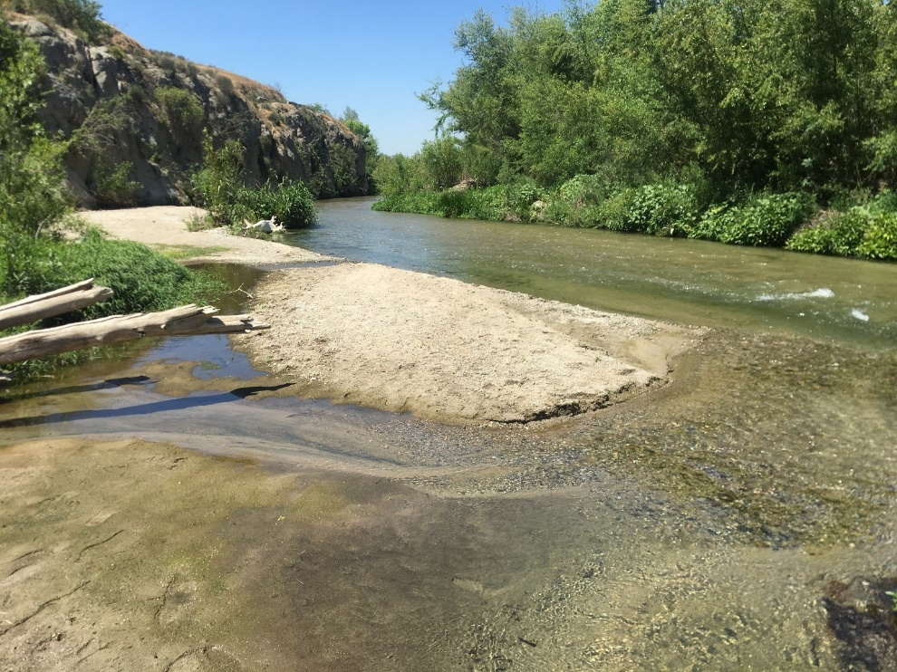

Submitted to:
Santa Ana Watershed Project Authority
11615 Sterling Avenue
Riverside, CA 92503

Prepared by:
GEI Consultants, Inc.
Essential Environmental and Engineering Systems
December 23, 2025 DRAFT

Table of Contents
Executive Summary 1
1. Introduction 1-1
1.1 Regulatory Background 1-1
1.2 MSAR TMDL Task Force 1-3
1.3 TMDL Implementation Requirements 1-3
1.3.1 MSAR TMDL Implementation Plan 1-3
1.3.2 Additional Implementation Requirements 1-4
1.3.3 TMDL Implementation Overview 1-6
1.4 TMDL Triennial Reports 1-7
2. Watershed-wide Monitoring Program 2-1
2.1 Program Overview 2-1
2.2 Water Quality Monitoring Program 2-2
2.2.1 Watershed‐wide Compliance Monitoring Sites 2-3
2.2.2 Water Quality Sampling Program 2-3
2.3 Summary of Bacteriological Conditions 2-7
2.3.1 Dry Weather Bacteria 2-7
2.3.2 Wet Weather Bacteria 2-9
2.4 Compliance with Wasteload Allocations 2-10
2.5 Compliance with Load Allocations 2-11
2.5.1 Agricultural Dischargers 2-11
2.5.2 Natural Sources 2-11
3. Synoptic Study Findings 3-1
3.1 Characterization of DWF in the MSAR Watershed 3-1
3.1.1 Hydrologic Disconnection 3-2
3.1.2 Change in DWF Rates 3-5
3.1.3 POTW Discharges to MSAR Waters 3-7
3.1.4 DWF in Cucamonga Creek 3-8
3.2 Characterization of E. Coli in the MSAR Watershed 3-9
3.2.1 Bacteria Load Analysis 3-10
3.2.2 Santa Ana River Subwatershed 3-13
3.2.3 Chino Creek Subwatershed 3-19
3.2.4 Cucamonga Creek Subwatershed 3-22
3.3 Bacteroides Analysis 3-26
3.3.1 Use of Microbial Source Tracking Techniques in the Synoptic Study 3-27
3.3.2 Evaluation of the HF183 Human Marker at Synoptic Study Sites 3-28
3.3.3 Relationship between E. coli Concentrations and Bacteroides Detections 3-32
3.4 Tier 1 Site Prioritization 3-35
3.4.1 Prioritization Analysis 3-35
3.4.2 Changes in Tier 1 Site Prioritization Over Time 3-40
3.5 Uncontrollable, Non-MS4 Bacteria Sources 3-42
4. TMDL Implementation Activities 4-1
4.1 CBRP Implementation for MS4 Sources 4-1
4.1.1 Mill Creek Wetlands - Constructed 4-1
4.1.2 Phoenix Storm Drain Diversion - Constructed 4-2
4.1.3 Sunnyslope Trash Retrofit Project - Planned 4-3
4.1.4 MSAR Multi-Benefit Water Quality Strategy 4-3
4.1.5 Bacteria Source Tracking in MS4 Drainage Areas 4-4
4.2 TMDL Implementation by Agriculture Dischargers 4-4
4.2.1 CAFOs 4-4
Non-CAFOs 4-6
4.2.2 Unsheltered Populations 4-6
5. TMDL Implementation - Next Steps 5-1
5.1 Dry Weather TMDL Implementation 5-1
5.2 Limited Revisions to MSAR TMDLs 5-2
6. References 6-1

List of Figures
Figure 2-1. Location of TMDL Compliance Monitoring Sites, Tier 1 Sites and POTWs in the MSAR Watershed 2-4
Figure 2-2. Dry Weather Seasonal Geomean E. coli Concentrations by Site and Season 2-8
Figure 2-3. Geomean of E. coli Concentrations for Grab Samples during Active Wet Weather and Post-Storm Events 2-9
Figure 2-4. E. coli Concentrations for Post-storm Samples Over Time After Return to Pre-Wet Weather Event Flow Conditions (2007-2025) 2-10
Figure 2-5. Grab Sample and Rolling Geomeans of E. coli Concentrations in the Santa Ana River Reach 3 at Mission Boulevard Bridge, WW-MISSION (2019-2025) 2-14
Figure 3-1. Map of Tier 1 Subwatersheds and Hydrologically Disconnected Drainage Areas during Dry Weather 3-3
Figure 3-2. Change in Measured DWF Rates from MS4 Outfalls Upstream of the Chino Creek and the Santa Ana River Compliance Monitoring Sites. 3-6
Figure 3-3. Average August POTW Effluent Flow to Impaired Waters (2007-2025) 3-7
Figure 3-4. Daily Effluent Flow from RP1 to Cucamonga Creek on Dates Concurrent with Tier 2 Source Investigation Sampling (2016-2025) 3-8
Figure 3-5. Range of E. coli Concentrations from 2025 Synoptic Study Sites 3-9
Figure 3-6. Comparison of 2025 Tier 1 Site E. coli Geomeans with Previous Studies 3-10
Figure 3-7. Median MS4 E. coli Load from Tier 1 Sites Tributary to the Chino Creek and the Santa Ana River Watershed-wide Compliance Sites 3-11
Figure 3-8. Historical E. coli Data at Magnolia Center Storm Drain Compared with Synoptic Study E. coli Results (T1-MCSD) 3-13
Figure 3-9. Estimated Seepage Loss in Santa Ana River Reach 4 3-14
Figure 3-10. Schematic Showing Known Bacteria Inputs, Dry Weather Inflows and POTW Effluent Discharges to the Santa Ana River in Relation to Downstream Compliance Monitoring Sites 3-16
Figure 3-11. Comparison of Estimated Blended E. coli Concentrations of MS4 Inflows with Downstream Watershed-wide Compliance Monitoring Data for Santa Ana River Sites 3-17
Figure 3-12. Relative Contributions during 2025 Synoptic Study of E. coli Loads (billion MPN/day) to Santa Ana River Reach 3 from Upstream Tier 1 MS4 Outfalls 3-18
Figure 3-13. E. coli Concentrations in Santa Ana River at Mission Boulevard (WW-MISSION) during Dry Weather (2019-2025, n=151) 3-18
Figure 3-14. Relative Loading from Tier 1 Sites to Total MS4 E. coli Load to the Santa Ana River Reach 3 Upstream from WW-S4 Compliance Monitoring Site 3-19
Figure 3-15. Schematic Showing Known Bacteria Inputs, Dry Weather Inflows and POTW Effluent Discharges to Chino Creek in Relation to Downstream Compliance Monitoring Site 3-20
Figure 3-16. Comparison of Estimated Blended E. coli Concentrations of MS4 Inflows with Downstream Watershed-wide Compliance Site Data for Chino Creek at Central Avenue 3-21
Figure 3-17. Relative Loading from Tier 1 Sites to Total MS4 E. coli Loads to the Chino Creek at Central Avenue Compliance Site 3-21
Figure 3-18. Schematic of Dry Weather Flow Retention and Key Inflows to Cucamonga Creek 3-23
Figure 3-19. USGS Gauge 15-Minute Interval Flow at Cucamonga Creek near Mira Loma on 2025 Synoptic Study Dates 3-25
Figure 3-20. Longitudinal Profile of Dry Weather E. coli Loads within Cucamonga Creek (n = 70; 2017-2025) 3-26
Figure 3-21. HF183 Geometric Mean Concentrations for Water Quality Samples Collected During the 2025 Synoptic Study 3-30
Figure 3-22. Box-Whisker Plots of E. coli Concentrations in Samples with/without Detection/Amplification of HF183 for MS4 and Mainstem Sites 3-33
Figure 3-23. DWF Generation Rates at Each Tier 1 Site on Synoptic Study Sample Dates 3-37
Figure 3-24. E. coli Loads at Each Tier 1 Site on Synoptic Study Sample Dates 3-37
Figure 3-25. Concentration of Detected HF183 at Tier 1 and 2 Sites 3-38
Figure 3-26. Bacteria Prioritization Score for Tier 1 and 2 Sites 3-40
Figure 4-1. Sampling Locations to Assess Effectiveness of the Mill Creek Wetlands 4-1
Figure 4-2. Strategic Vision for a Multi-Benefit Water Quality Strategy in the MSAR 4-3
Figure 5-1. Framework for Study to Advance Understanding of In-Stream Fecal Bacteria Sources in Reach 3 of the SAR. 5-2

List of Tables
Table 1-1. MSAR Watershed Phase 1 TMDL Implementation Plan 1-4
Table 2-1. MSAR TMDLs Watershed-wide Monitoring Sites 2-3
Table 2-2. Summary of Water Sample Collection Activity during 2023-2025 Period 2-4
Table 2-3. Wet Event Samples Classified as Either Active Wet Weather or Post-Storm in the MSAR Watershed 2-6
Table 2-4. Dry Weather Exceedance Frequencies of WLAs/LAs for E. coli during the 2023, 2024 and 2025 Warm Seasons 2-10
Table 2-5. Dry Weather Compliance with WLAs/LAs for E. coli during the 2023, 2024, and 2025 Cool Seasons 2-11
Table 3-1. Categorized Acreage in Each Jurisdiction within the MSAR Watershed 3-4
Table 3-2. Comparison of Average DFW Measurements at Tier 1 Sites from 2007–2025 3-5
Table 3-3. CBRP Estimate of Required DWF Reduction Compared to Observed DWF Reduction Since 2007 3-6
Table 3-4. Comparison of Median E. coli Load Estimates at Tier 1 Sites in 2007, 2012, 2019, and 2025 3-12
Table 3-5. Summary of Data Sources (2017-2025) Used to Support Tier 2 Source Investigation in the Cucamonga Creek Subwatershed 3-24
Table 3-6. Summary of E. coli Sample Results in Cucamonga Creek Subwatershed, Tier 2 Source Investigations (2016-2025) (see Figures 3-5 and 4-8 for site locations) 3-24
Table 3-7. HF183 Results for POTW Effluent Samples 3-29
Table 3-8. HF183 Results at Watershed-wide Compliance Sites and Other Non-Compliance Sites in the Mainstem Santa Ana River 3-31
Table 3-9. HF183 Results at Tier 1 and Tier 2 Sites 3-32
Table 3-10. Student T-Test Results Comparing E. coli Concentrations in Samples with/without Detection Human Marker HF183 for all Tier-1 and 2 Sites 3-34
Table 3-11. Student T-Test Results Comparing E. coli Concentrations in Samples with/without Detection of Human Marker HF183 for Mainstem Samples 3-34
Table 3-12. Tier 1 and Tier 2 Sites for Prioritization 3-35
Table 3-13. HF183 Criteria Scores 3-36
Table 3-14. Relative Rank Results for each Prioritization Criterion and the Final Composite Score for each Tier 1 Site 3-39
Table 3-15. Concentrations of E. coli in bottom sediment from MSAR TMDL waters and tributaries 3-43
Table 4-1. Estimate of Reduction in E. coli Load Resulting from Implementation of the Mill Creek Wetlands BMP, 2017-2025 4-2
Table 4-2. Changes in Number of Dairies and Animal Units in Chino Basin Area of the Santa Ana Region, 1999 – 2025 4-5

Appendices
Appendix A: Timeline of Key TMDL Implementation Activities
Appendix B: Previous MSAR Special Studies
Appendix C: Triennial Report Key Findings
Appendix D: Bacterial Indicator Data – Watershed Wide Monitoring Sites

Acronyms
Acronym | Definition
AgSEP | Bacterial Indicator Agricultural Source Evaluation Plan
Basin Plan | Water Quality Control Plan for the Santa Ana River Basin
BASMP | Bacterial Indicator Agricultural Source Management Plan
BDL | Below Detection Limit
BMP | Best Management Practice
BXSP | Box Springs Channel
CAFO | Concentrated Animal Feeding Operation
CBRP | Comprehensive Bacteria Reduction Plan
CBW | Chino Basin Watermaster
CC WRP | Carbon Canyon Water Reclamation Plant
cfs | Cubic feet per second
cfu | Colony Forming Units
CIMP | Coordinated Integrated Monitoring Program
DAMP | Drainage Area Management Plan
DOC | Dissolved Organic Carbon
DWF | Dry Weather Flow
E. coli | Escherichia coli
ESGV | East San Gabriel Valley
ESGVWMP | East San Gabriel Valley Watershed Management Program
FBRP | Facility Bacteria Reduction Plan
gal/ac/day | gallons per acre per day
gc | Gene Copies
HF | Human Feces
IEUA | Inland Empire Utilities Agency
LA | Load Allocation
lbs | Pounds
Los Angeles Water Board | Los Angeles Regional Water Quality Control Board
LSD | Log Standard Deviation
MBB | Mission Boulevard Bridge
MCSD | Magnolia Center Storm Drain
MCW | Mill Creek Wetland
mL | milliliter
MPC | Milk Producers Council
MPN | Most Probable Number
MS4 | Municipal Separate Storm Sewer System
MSAR | Middle Santa Ana River
MSB | Market Street Bridge
MST | Microbial Source Tracking
MSWMP | Municipal Storm Water Management Plan
NA | Not Applicable
ND | Non-detect
NM | Not Measured
NPDES | National Pollutant Discharge Elimination System
n | Number
O&M | Operation and Maintenance
PHNX | Phoenix Storm Drain
POTW | Publicly-owned Treatment Works
QAPP | Quality Assurance Project Plan
QMRA | Quantitative Microbial Risk Assessment
qPCR | Quantitative Polymerase Chain Reaction
RAA | Reasonable Assurance Analysis
RBMP | Regional Bacteria Monitoring Program
RCFC&WCD or District | Riverside County Flood Control & Water Conservation District
REC1 | Water Contact Recreation
REC2 | Non-contact Water Recreation
RTA | Rapid Trash Assessment
Santa Ana Water Board | Santa Ana Regional Water Quality Control Board
SAWPA | Santa Ana Watershed Project Authority
SBCFCD | San Bernardino County Flood Control District
SNCH | Sunnyslope Channel
State Water Board | State Water Resources Control Board
SWQDv | Storm Water Quality Design Volume
T1 | Tier 1
Task Force | MSAR Watershed TMDL Task Force
TMDL | Total Maximum Daily Load
TSS | Total Suspended Solids
UC Riverside | University of California Riverside
USEP | Urban Source Evaluation Plan
USEPA | United States Environmental Protection Agency
USGS | United State Geological Survey
VBB | Van Buren Bridge
WDR | Waste Discharge Requirements
WLA | Wasteload Allocation
WMP | Watershed Management Plan
WQBEL | Water Quality Based Effluent Limitation
WQMP | Water Quality Management Plan
WWTP | Wastewater Treatment Plant

Executive Summary
Background
On August 26, 2005, the Santa Ana Regional Water Quality Control Board (Santa Ana Water Board) adopted Middle Santa Ana River (MSAR) Bacterial Indicator Total Maximum Daily Loads (TMDL) (“MSAR TMDL”) for Reach 3 of the Santa Ana River, Mill Creek (in the Prado area), Reach 1 of Cucamonga Creek, Reaches 1 and 2 of Chino Creek, and the Prado Park Lakes. The adopted TMDLs became effective on May 16, 2007, following approval by the United States Environmental Protection Agency.
Task 3 of the Phase 1 TMDL Implementation requires preparation of a Triennial Report every three years. Five Triennial Reports have been prepared since the TMDLs became effective (2010, 2013, 2016, 2020 and 2023). The purpose of this sixth Triennial Report is to assess the data collected for the preceding three year period (2023-2025) and evaluate progress towards achieving the wasteload allocations (WLA) and load allocations (LA) in the MSAR TMDLs. This evaluation of progress includes an update on work being conducted by urban dischargers and agricultural operators in the watershed to reduce or eliminate sources of Escherichia coli (E. coli)
Watershed-wide Monitoring Program
The TMDLs require implementation of a watershed-wide monitoring program that will provide data needed to review and update the TMDLs and evaluate compliance with the TMDL WLAs and LAs. The MSAR Task Force began implementation of this monitoring program in 2007. In 2016, the watershed-wide monitoring activities specific to the TMDLs were incorporated into a new Regional Bacteria Monitoring Program (RBMP), which is implemented through Santa Ana Watershed Project Authority’s (SAWPA) Regional Water Quality Monitoring Task Force.
The RBMP regularly samples five TMDL watershed-wide compliance monitoring sites. These sites which have been sampled since 2007 include: Mill-Cucamonga Creek; Chino Creek at Central Avenue; Prado Park Lake; Santa Ana River Reach 3 at MWD Crossing; and Santa Ana River Reach 3 at Pedley Avenue. In 2021 an additional monitoring site was added: Santa Ana River Reach 3 at Mission Avenue (upper end of Reach 3). The monitoring program collects field measurements (including flow) and bacterial indicator data during dry weather conditions, collecting 25 samples/year from each watershed-wide monitoring site. In addition, the program samples one wet weather event each year at each of the compliance sites
This report summarizes the long-term patterns observed for E. coli geometric means over the entire period of record from 2007-2025. In addition, the report summarizes the frequency of compliance with WLAs/LAs (geometric mean and single sample values) under dry weather conditions for the most recent reporting period, 2023-2025. As has been observed during other reporting periods, exceedances of the dry summer condition WLAs/LAs at the TMDL compliance monitoring sites occur fairly frequently. However, as has been shown in previous Triennial Reports, after accounting for known sources of bacteria and dry weather flow, there is an unaccounted for reservoir of E. coli bacteria, at least in the Santa Ana River Reach 3 portion of the watershed. The specific source(s) of these bacteria remains unclear.
TMDL Implementation Activities
TMDL implementation activities are regularly carried out by entities with applicable WLAs and LAs. In addition, the MSAR Task Force or SAWPA may authorize watershed-wide studies in the MSAR watershed that provide information that supports TMDL implementation. This report provides a summary of the primary TMDL-related activities that have occurred during the reporting period. Key activities include:
- Riverside County MS4 Program – Report provides findings from projects implemented by Riverside County Flood Control & Water Conservation District: (a) Tier 1 drone survey and MST sampling for outfalls to Reach 3 of the SAR; and (b) creation of a dry weather bacteria TMDL compliance strategy.
- San Bernardino County MS4 Program – The Triennial Report provides a detailed analysis of findings from TMDL-related studies: (a) eight years of Tier 2 source investigation work in the Cucamonga Creek subwatershed; and (b) demonstration that the Mill Creek Wetlands regional treatment project removes more than 90 percent of the E. coli load in dry weather flows diverted through the wetlands.
- City of Claremont and City of Pomona – Updates on ongoing TMDL-related activities (BMP implementation and stormwater capture projects) are reported for these Municipal Separate Storm Sewer System (MS4) Permittees in the portion of the MSAR watershed that is located in Los Angeles County.
- University of California Riverside – The Triennial Report summarizes TMDL implementation activities conducted by this Small MS4. These activities include: (a) participation in the TMDL monitoring program; and (b) preparation and implementation of the University’s Facility Bacteria Reduction Plan that addresses dry summer condition WLAs applicable to lands within the jurisdiction of the university.
- Concentrated Animal Feed Operations (CAFO) – The report documents the continued decline in the number of dairies in the MSAR watershed. These dairies, which through their representatives participate in the MSAR Task Force, are subject to the TMDL requirements incorporated in the current General Order that permits their operation.
- Non-CAFO Agricultural Operators – Similar to dairies, the acreage of land used for irrigated agriculture or dry land farming continues to decline in the watershed. Agricultural facilities not located in the Arlington Greenbelt area (with the exception of Altman Plants) continue to participate through their representatives in the MSAR Task Force and implement the BMPs established in the Bacterial Indicator Agricultural Source Management Plan.
Bacterial Indicator Source Analysis
This 2026 Triennial Report updates previous bacteria source contribution analyses prepared for the MSAR watershed. The latest analysis incorporates dry weather flow and bacterial indicator data collected during the 2023-2025 dry seasons. These new data were primarily acquired through implementation of MS4 Permittee-directed Tier 2 source evaluations as part of Comprehensive Bacteria Reduction Plan (CBRP) implementation and a 5-week Synoptic Study in Aug-Sept of 2025. Updated source contribution analysis results are provided for each of the three key subwatersheds: Santa Ana River Reach 3, Cucamonga Creek and Chino Creek. Key findings for each subwatershed include:
- Santa Ana River Reach 3 - The majority of the E. coli load observed in Reach 3 of the Santa Ana River has been demonstrated to come from in-stream sources upstream of Mission Boulevard in Santa Ana Reach 4. The most important finding from this updated source contribution analysis is the refinement to the expected downstream E. coli concentration when the upstream bacteria load based on the 2019-2025 data from WW-MISSION is incorporated. By accounting for the upstream boundary inflow at the WW-MISSION site, the flow weighted average E. coli concentration of all inflows to the Santa Ana River Reach 3 at MWD Crossing site would be approximately 380 MPN/100 mL (see Figure 4-6), which is within the range of measured E. coli at this TMDL compliance monitoring site (see Section 2.3). Thus, the previously unaccounted for bacteria load within Reach 3 of the Santa Ana River has been effectively quantified as coming from DWF and bacteria sources outside of flow/sources contributed by urban runoff from MS4s.
- Cucamonga Creek – Tier 2 surveys in 2023-2025 found several important E. coli source areas upstream of the Cucamonga Creek transition to Mill-Cucamonga Creek for further source investigation and potential control including Chris Basin outfall and County Line Channel. During the 2025 Synoptic Study, HF183 was found in the Mill-Cucamonga Creek at low levels in only one of five weeks.
- Chino Creek – The majority of E. coli loads (75 percent on average) to Chino Creek come from upstream of the confluence with San Antonio Channel, primarily from City of Pomona MS4 areas. All other Tier 1 MS4 outfalls to Chino Creek were determined to be low priority. Despite not meeting the WLA/LAs for E. coli, there were no detections of human HF 183 markers in this waterbody.
TMDL Implementation – Next Steps
In addition to moving forward with proposed limited revision to the MSAR TMDLs to extend the compliance date for meeting the wet winter condition WLAs and LAs, the report recommends additional studies. In particular:
- Conduct Tier 1 source evaluations on a triennial basis, consistent with the triennial report schedule. Tier 1 evaluations have historically been conducted about every 5-7 years. However, due to the evolving nature of source contributions and the increase in human sources of bacteria observed in the 2025 Synoptic Study, it is recommended that Tier 1 source evaluations be conducted more frequently.
- Conduct studies to identify and further quantify instream sources of E. coli, especially in the vicinity of Mission Avenue at the transition from Santa Ana River Reach 4 to Reach 3. This source represents more than 75 percent of the total E. coli load to Reach 3 of the SAR.
- Improve temporal resolution of weather data by increasing the number of monitored storms per year and decreasing the samples count per storm. Additionally, move the focus of sample collection to post-storm monitoring to evaluate conditions when REC1 activities are likely to resume.
- Initiate implementation studies in the revised TMDL (anticipated to be adopted in 2026) involving evaluation of controllability of wet weather sources and evaluation of applicability of high flow suspension.
- Initiate planning for Task 4 in the revised TMDL (anticipated to be adopted in 2026) to implement preliminary wet weather controls in advance of more comprehensive watershed management plan or wet weather CBRP development.

Introduction

Regulatory Background
On August 26, 2005, the Santa Ana Regional Water Quality Control Board (Santa Ana Water Board) adopted Middle Santa Ana River (MSAR) Bacterial Indicator Total Maximum Daily Loads (TMDL) (“MSAR TMDL”) for Reach 3 of the Santa Ana River, Mill Creek (in the Prado area), Reach 1 of Cucamonga Creek, Reaches 1 and 2 of Chino Creek, and the Prado Park Lakes (Santa Ana Water Board 2005b; Resolution No. R8-2005-0001). The adopted TMDLs were approved by the State Water Resources Control Board (State Water Board) on May 15, 2006 (State Water Board 2006; Resolution No 2006-030) and by the United States Environmental Protection Agency (USEPA) Region 9 on May 16, 2007.
The MSAR TMDLs established fecal coliform and Escherichia coli (E. coli) wasteload allocations (WLA) for urban Municipal Separate Storm Sewer System (MS4) and Confined Animal Feeding Operation (CAFO) discharges and load allocations (LAs) for agricultural and natural sources:
- Fecal coliform: 5‐sample/30‐day logarithmic mean (or geometric mean) less than 180 organisms/100 mL and not more than 10 percent of the samples exceed 360 organisms/100 milliliters (mL) for any 30‐day period.
- E. coli: 5‐sample/30‐day logarithmic mean (or geometric mean) less than 113 organisms/100 mL and not more than 10 percent of the samples exceed 212 organisms/100 mL for any 30‐day period.
The TMDLs establish different season-based compliance dates for these WLAs and LAs as follows:
- Dry Summer Conditions (April 1 through October 31, herein referred to as the Dry Season) – WLAs/LAs should be complied with as soon as possible, but no later than December 31, 2015; and
- Wet Winter Conditions (November 1 through March 31, herein referred to as the Wet Season) – WLAs/LAs should be complied with as soon as possible, but no later than December 31, 2025
The TMDLs identify the following entities responsible for compliance with WLAs and LAs in the MSAR watershed: Counties of Riverside and San Bernardino, Cities of Ontario, Chino, Chino Hills, Montclair, Rancho Cucamonga, Upland, Rialto, Fontana, Corona, Norco, Riverside, Claremont and Pomona, Agricultural Operators (including both CAFOs and irrigated and dry-land farming) and the United States Forest Service.
Since TMDL adoption, a portion of the Riverside County area has become the newly incorporated Cities of Eastvale and Jurupa Valley. In addition, the State Water Board identified four additional entities responsible for compliance with WLAs through adoption of the General Permit for Waste Discharge Requirements (WDR) for Storm Water Discharges from Small MS4s (State Water Board 2017; Resolution No. 2013-0001-DWQ, as amended in 2017): University of California Riverside (UC Riverside), California Institute for Men (Chino, CA); California Institute for Women (Chino CA); and California Rehabilitation Center (Norco, CA).
In 2012, the Santa Ana Water Board adopted changes to the recreation water quality standards in the Water Quality Control Plan for the Santa Ana River Basin (Basin Plan), based on the work and recommendations of the Stormwater Quality Standards Task Force (Santa Ana Water Board 2012c; Resolution No. R8-2012-0001). That Basin Plan amendment was subsequently approved by the State Water Board on January 21, 2014 (State Water Board 2014; Resolution No. 2014-0005) and by USEPA on April 8, 2015. This Basin Plan amendment included several key elements that are relevant to the MSAR TMDLs:
- Revised bacteria quality objectives applicable to freshwaters (e.g., fecal coliform water quality objectives were replaced by E. coli objectives)
- Changes to the recreation use designations for specific fresh waters, including removal of the REC1 beneficial use from Cucamonga Creek Reach 1 through an approved Use Attainability Analysis
- Specific implementation strategies pertaining to the revised standards for freshwaters including:
- Intended application of Single Sample Maximum values in REC1 freshwaters with a Water Contact Recreation (REC1) beneficial use;
- Antidegradation targets for freshwaters with a Non-contact Water Recreation (REC2) only beneficial use, including Cucamonga Creek Reach 1;
- Controllable and uncontrollable sources of bacteria; and
- High flow suspension of recreation standards under specified conditions.
In 2018, the State Water Board amended the Water Quality Control Plan for Inland Surface Waters to establish new statewide water quality standards for pathogen indicator bacteria (Resolution No. 2018-0038, August 7, 2018). Both the 2012 Santa Ana Water Board Basin Plan amendment and 2018-adopted State Water Board statewide bacteria water quality standards provisions have the potential to impact the underlying basis for the 2005-adopted MSAR TMDLs. However, until the MSAR TMDLs are revised to incorporate these statewide requirements, the requirements established in the existing MSAR TMDLs continue to apply.

MSAR TMDL Task Force
The MSAR Watershed TMDL Task Force (“Task Force”) is a multi-agency collaborative effort organized by the Santa Ana Water Project Authority (SAWPA). Formed in January 2006 after approval of the MSAR TMDLs in May 2005, the Task Force coordinates water quality improvement activities designed to support compliance with the MSAR TMDLs. Specifically, the Task Force:
- Serves as a forum for Task Force participants to report to the Santa Ana Water Board regarding progress being made towards compliance with WLAs and LAs;
- Collectively implements watershed-wide monitoring efforts, as required by the MSAR TMDLs;
- Supports activities designed to manage or eliminate sources of bacterial indicators in local waterbodies, including coordinating implementation activities for the Riverside and San Bernardino County MS4 Program Comprehensive Bacteria Reduction Plans (CBRPs).
SAWPA, through its administrative role in supporting the MSAR Task Force, actively maintains a Task Force website where the work of the Task Force is documented: https://sawpa.org/task-forces/middle-santa-ana-river-watershed-tmdl-task-force/.

TMDL Implementation Requirements
This section summarizes the implementation requirements established in the adopted TMDLs and subsequent requirements established through discharge permits.

MSAR TMDL Implementation Plan
Table 5-9y in MSAR TMDL Resolution No. R8-2005-0001 (Santa Ana Water Board 2005b) Basin Plan Table 6-1y) summarizes the Phase 1 TMDL Implementation Plan, identifying six tasks and the entities responsible for implementation. Table 1-1 summarizes these Phase 1 tasks. The TMDL Implementation Plan section of the adopted resolution provides detailed descriptions of requirements and schedules associated with each of these tasks/subtasks.
Table 1-1. MSAR Watershed Phase 1 TMDL Implementation Plan
Task/Subtasks¹ |  | Responsible Entity
1 – Revise Existing Waste Discharge Requirements |  | Santa Ana Water Board staff
2 - Identify Agricultural Operators |  | Santa Ana Water Board staff
3 – Watershed-wide Bacterial Indicator Monitoring Program | - Seasonal Reports (May 31; December 31)  - Triennial Reports | Urban and Agricultural Dischargers
4 – Urban Discharges | - 4.1 - Develop and Implement Bacterial Indicator Urban Source Evaluation Plan (USEP)  - Dependent on findings from Task 4.1 implement the following:  - 4.2 - San Bernardino County MS4: Revise Municipal Storm Water Management Program (MSWMP)  - 4.3 - Riverside County MS4: Revise Drainage Area Management Plan (DAMP)  - 4.4 - San Bernardino County MS4: Revise Water Quality Management Plan (WQMP)  - 4.5 Riverside County MS4: Revise WQMP | Urban Dischargers (cities and unincorporated communities)
5 - Agricultural Dischargers | - 5.1 Develop and Implement Bacterial Indicator Agricultural Source Evaluation Plan (AgSEP);  - 5.2 - Dependent on Task 5.1 results, Develop and Implement Bacterial Indicator Agricultural Source Management Plan (BASMP) | Agricultural Operators (includes CAFOs and irrigated and dry land farming)
6 – Review of TMDL/WLAs/LAs |  | Santa Ana Water Board
¹ Excerpted from Table 5-9y in the adopting resolution or Table 6-1y in the Basin Plan

Additional Implementation Requirements

Urban Dischargers
When the MSAR TMDLs were adopted in 2005, the San Bernardino and Riverside County MS4s were authorized to discharge urban runoff under MS4 Permits R8-2002-0012 and R8-2002-0011, respectively (Santa Ana Water Board 2002a, 2002b). Accordingly, the Phase 1 TMDL Implementation Plan tasks applicable to urban discharges, and summarized in Table 1-1 above, were based on the requirements of these MS4 Permits.
In 2010, the Santa Ana Water Board adopted new MS4 Permits for the portions of Riverside and San Bernardino Counties within the Santa Ana River watershed (Santa Ana Water Board 2010a, 2010b; Order Nos. R8-2010-0033 and R8-2010-0036, respectively). These 2010 MS4 Permits significantly updated the MSAR TMDL requirements applicable to MS4s within the MSAR watershed in Riverside and San Bernardino Counties. Specifically, the 2010 Permits required development of CBRPs designed to achieve compliance with the urban WLAs for the dry season (April 1 through October 31). Similarly, when the Los Angeles Regional Water Quality Control Board (Los Angeles Water Board) adopted a new MS4 Permit in 2012, it required the Cities of Claremont and Pomona to submit CBRPs to the Santa Ana Water Board for the portions of their cities located within the MSAR watershed (Los Angeles Water Board 2012; Order No. R4-2012-0175).
The Santa Ana Water Board approved CBRPs submitted by Riverside and San Bernardino County MS4 Programs on February 10, 2012 (Santa Ana Water Board 2012a, 2012b; Resolution Nos. R8-2012- 0015 and R8-2012-0016, respectively) (Riverside County 2011; San Bernardino County Flood Control District [SBCFCD] 2011). The Santa Ana Water Board also approved CBRPs for Claremont and Pomona on March 14, 2014 (Santa Ana Water Board 2014a, 2014b; Resolution Nos. R8-2014-0030 and R8-2014-0031, respectively) (City of Claremont 2014; City of Pomona 2014). The resolutions approving the CBRPs state that the approved CBRP “will serve as the final Water Quality Based Effluent Limitations (WQBEL) for bacterial indicators during the dry season (annually April 1 through October 31).”
As noted above, the State Water Board amended the MS4 Permit applicable to Phase II Small MS4s to include MSAR TMDL implementation requirements for four Small MS4s in the MSAR watershed. In accordance with these requirements, UC Riverside is a participant in the TMDL monitoring program and recently submitted its Facility Bacteria Reduction Plan (FBRP) to the Santa Ana Water Board (September 26, 2022). Similar to a CBRP, the FBRP is designed to achieve compliance with the urban WLAs applicable to the dry season (see discussion of FBRP in Section 3.2.2.1).
The Small MS4 General Permit (State Water Board 2013, Attachment G) includes MSAR TMDL implementation requirements for three additional facilities: California Institute for Men (Chino, CA); California Institute for Women (Chino, CA); and California Rehabilitation Center (Norco, CA). These entities are not participants of the MSAR Task Force; no information is available on TMDL implementation activities being carried out by these facilities to comply with the Small MS4 Permit TMDL requirements.

Agricultural Operators
The “agricultural operator” group includes CAFOs with applicable WLAs and irrigated and dry land farming activities with applicable LAs. At the time of TMDL adoption, CAFOs were permitted under General Order 99-11 (Santa Ana Water Board 1999). This permit has since been superseded by the following General Orders: R8-2007-0001, 2013-0001 and 2018-0001 (Santa Ana Water Board 2007, 2013 and 2018, respectively). Each of these Orders has included TMDL implementation requirements consistent with the TMDLs Implementation Plan (e.g., see Table 1-1). Farming activities within the MSAR watershed are not currently regulated under any Order.

TMDL Implementation Overview
Implementation of many MSAR TMDL activities occurs through the collaborative work of the MSAR Task Force, especially the TMDL’s watershed-wide monitoring requirements and various studies to understand sources of bacterial indicators. Soon after the TMDLs became effective, much of the early work was supported by the Middle Santa Ana River Pathogen TMDL BMP Implementation Proposition 40 grant project administered by SAWPA on behalf of the Task Force and funding partners RCFC&WCD and SBCFCD. In addition, implementation of TMDL activities occurs locally through implementation of: (a) CBRPs by the urban MS4 Permittees; (b) UC Riverside’s FBRP; (c) the BASMP prepared by the agricultural community; and (d) compliance with CAFO General Order requirements.
Appendix A provides a figure that summarizes key activities that have occurred over time through implementation of the MSAR TMDLs, from adoption in 2005 through 2025 (Figure A.1). This figure provides a timeline of activities categorized as follows:
- Key regulatory dates/events
- TMDL Triennial Reports
- Proposition 40 grant project deliverables
- Monitoring programs
- USEP and AgSEP
- Tier 1 prioritization (through USEP and CBRP implementation)
- Task Force-coordinated source evaluation studies
- MS4 Permittee directed CBRP activities
- MS4 Program Best Management Practice (BMP) projects
Deliverables resulting from implementation of the Proposition 40 grant project may be found here: https://sawpa.org/task-forces/middle-santa-ana-river-watershed-tmdl-task-force/#resourcesb8a6-4b67. These deliverables initiated the required TMDL watershed-wide monitoring program and provided the initial data that resulted in the first prioritization of Tier 1 sites for subsequent source evaluation activities.
Appendix B provides a brief summary of key studies completed through implementation of the USEP (SAWPA 2007a), AgSEP (SAWPA 2007b) and CBRP. Outcomes from these various activities have resulted in periodic revisions to the prioritization of Tier 1 sites for subsequent source evaluation studies in the MSAR watershed.
As noted above, the TMDL requires the preparation of Triennial Reports every three years. The findings from the assessment completed for each of these reports has been important to guide future TMDL implementation activities. Appendix C summarizes key findings from the previously submitted Triennial Reports.

TMDL Triennial Reports
TMDL Task 3 requires preparation of a Triennial Report that assesses the data collected for the preceding three-year period and evaluates progress towards achieving the WLAs and LAs in the MSAR TMDLs. Five Triennial Reports have been prepared to date and their key findings are summarized in Appendix C. The contents of each report are as follows:
- 2007-2009 Triennial Report (SAWPA 2010a):
  - A water quality and TMDL compliance assessment based on data collected from the 2007 effective date of the TMDLs through 2009
  - Findings from the first watershed-wide assessment conducted at multiple sites in the MSAR watershed (reported in SAWPA 2009, see Section 2.1.4.1)
  - Wet weather findings from storm event sampling of agricultural runoff (as required by the AgSEP)
- 2010 -2012 Triennial Report (SAWPA 2013):
  - Evaluation of the status of compliance with urban WLAs and LAs as required by the TMDLs
  - Results from source evaluation studies conducted as part of the implementation of the Riverside and San Bernardino County MS4 Program CBRPs
- 2013-2015 Triennial Report (SAWPA 2017):
  - Updated assessment of compliance with the TMDL WLAs and LAs
  - Summary of findings from Tier 1 and Tier 2 source evaluation studies conducted in the watershed by the Task Force and MS4 Permittees
- 2016-2019 Triennial Report (SAWPA 2020a):
  - Updated assessment of compliance with the TMDL WLAs and LAs
  - Findings from a synoptic study conducted in the MSAR watershed to provide updated information on the status of dry weather flow (DWF) and bacterial indicators within each MSAR subwatershed
- 2020-2022 Triennial Report (SAWPA 2023):
  - Updated assessment of compliance with the TMDL WLAs and LAs
  - Synthesis of historical source tracking data collected in the MSAR watershed.
  - Analysis of data from a new monitoring site in the SAR at Mission Boulevard that demonstrated that majority of dry weather E. coli load observed within Reach 3 of the Santa Ana River comes from in-stream (non-MS4) sources in Santa Ana Reach 4.
  - A summary of findings from a 2020-21 study developed to assess homeless encampment activities and potential impacts to water quality and habitat. (SAWPA 2020b).

Watershed-wide Monitoring Program

Program Overview
Task 3 in the Phase 1 TMDL Implementation Plan required responsible entities with assigned WLAs and LAs to submit a proposed watershed-wide monitoring program that, “…will provide data necessary to review and update the TMDLs,” and collect and analyze data that “shall address, at a minimum, determination of compliance with the TMDLs, WLAs and LAs.” (Santa Ana Water Board 2005b). When developing the monitoring program, the MSAR TMDLs further stated the following regarding selection of monitoring sites and collection of water quality data:
“At a minimum, the stations specified in Tables 5-9z and 5-9aa and shown in Figure 5-6, at the frequency specified in Tables 5-9z and 5-9aa, shall be considered for inclusion in the proposed monitoring plan. If one or more of these monitoring stations are not included, the rationale shall be provided and proposed alternative monitoring locations shall be identified in the proposed monitoring plan.”
When the MSAR Task Force developed the watershed-wide monitoring program two key factors were used to select watershed sites: (a) sites should be located on waterbodies that are impaired and thus incorporated into the TMDLs; and (b) sites should be located in reaches of the impaired waterbodies where REC1 activity is likely to occur, i.e., there is an increased risk from exposure to pathogens (SAWPA 2008).
Using the impaired waters list, recreational use data that had already been developed by the SAWPA Stormwater Quality Standards Task Force, and recommendations from Santa Ana Water Board staff participating in the MSAR Task Force, six sites were selected for inclusion in the initial MSAR TMDL watershed-wide monitoring program:
- Icehouse Canyon Creek;
- Chino Creek at Central Avenue;
- Santa Ana River at Pedley Avenue;
- Santa Ana River at MWD Crossing;
- Prado Park Lake at Lake Outlet; and
- Mill Creek at Chino-Corona Road.
All six of these sites were either already recommended monitoring locations in the MSAR TMDLs or were located very close to recommended sites. As required, the approved Monitoring Plan and supporting Quality Assurance Project Plan (QAPP) provided the rationale for not including other sites recommended for consideration by the TMDLs (see Section 2.2, SAWPA 2022a).
The Santa Ana Water Board formally approved the watershed-wide monitoring program Monitoring Plan and QAPP in April 2008 (Santa Ana Water Board 2008; Resolution No. R8-2008-0044). The watershed-wide monitoring program’s Monitoring Plan and QAPP were routinely updated as the TMDL monitoring program evolved based on knowledge gained during implementation. With the concurrence of the MSAR Task Force and Santa Ana Water Board, monitoring at Icehouse Canyon Creek was discontinued after the 2008-2009 wet season.
As noted in Section 1.1, the Santa Ana Water Board adopted a Basin Plan amendment to revise recreation water quality standards on June 15, 2012 (Santa Ana Water Board 2012c). The Basin Plan amendment required establishment of a comprehensive Regional Bacteria Monitoring Program (RBMP) for the Santa Ana Region to support implementation of the revised recreation standards. To facilitate the efficient use of resources and coordinate data collection in the watershed, the existing MSAR TMDL watershed-wide monitoring program was incorporated into the RBMP. The Santa Ana Water Board approved the original RBMP Monitoring Plan and QAPP on March 11, 2016 (Santa Ana Water Board 2016; Resolution No. R8-2016-0022). The Monitoring Plan and QAPP are routinely updated with the most recent versions updated in 2022 (SAWPA 2022a, and 2022b).
Prior to the establishment of the RBMP, the MSAR Task Force prepared two monitoring reports each year as required by the TMDL Implementation Plan (Task 3): Dry Season Report (December 31) and Wet Season Report (May 31). When the MSAR TMDL monitoring program was incorporated into the RMBP this biannual reporting requirement was modified into a single annual watershed report to be submitted by June 30 each year. The first RBMP annual report was submitted in June 2017 and included water quality monitoring results during the 2016 dry season and 2016-2017 wet season. The most recent annual report (SAWPA 2025), previous reports, and access to the online data viewer are available online at the SAWPA website.

Water Quality Monitoring Program
Sampling began at the TMDL watershed-wide monitoring sites in fall 2007. This section provides an overview of the current program and focuses on the past three years of data (2020-2022), especially data collected under dry weather conditions. Previous data may be reviewed at the monitoring program’s data dashboard: https://sarwqmdashboard.org/.

Watershed‐wide Compliance Monitoring Sites
Since 2007, sample collection has occurred at the following five locations: Chino Creek at Central Avenue (WW-C7), Mill-Cucamonga Creek (WW-M6), Santa Ana River at MWD Crossing (WW-S1), Santa Ana River at Pedley Avenue (WW-S4) and Prado Park Lake (WW-C3) (Figure 2-1). The MSAR Task Force added the WW-MISSION monitoring site in 2020 to characterize bacterial indicators flowing from Santa Ana River Reach 4 into Reach 3 during dry weather conditions. The Task Force recognized the need for additional data collection based on findings from the 2019 Synoptic Study that found that (a) the DWF at the WW-MISSION site does not include any flow from an MS4; and (b) the majority of E. coli load observed in Santa Ana River Reach 3 results from in-stream bacteria sources (SAWPA 2023). The original five monitoring locations and the additional monitoring location added in 2020 are presented in Table 2-1. The RBMP Monitoring Plan provides additional information about each of these monitoring locations (SAWPA 2022a, Attachment A)
Table 2-1. MSAR TMDLs Watershed-wide Monitoring Sites
Site ID | Site Description | Type | County | Latitude | Longitude
WW-M6 | Mill-Cucamonga Creek below Wetlands | Compliance | San Bernardino | 33.9268 | -117.6250
WW-C7 | Chino Creek at Central Avenue | Compliance | San Bernardino | 33.9737 | -117.6889
WW-C3 | Prado Park Lake | Compliance | San Bernardino | 33.9400 | -117.6473
WW-S1 | Santa Ana River Reach 3 at MWD Crossing | Compliance | Riverside | 33.9681 | -117.4479
WW-S4 | Santa Ana River Reach 3 at Pedley Avenue | Compliance | Riverside | 33.9552 | -117.5327
WW-MISSION | Santa Ana River Reach 3 at Mission Avenue | Non-MS4 Boundary Inflow | Riverside | 33.9906 | -117.3951

Water Quality Sampling Program
The RMBP Monitoring Plan and QAPP (SAWPA 2022a, b) provide detailed information regarding the collection and analysis of field data and water quality samples. The Monitoring Plan establishes the yearly ongoing monitoring frequency for dry weather events. Dry weather condition samples are collected during two periods: (a) weekly over 20 consecutive weeks, generally from May to September during the TMDL-defined dry season (April 1 - October 31); and (b) weekly over 5 consecutive weeks generally from late October through early December during the TMDL-defined wet season (November 1 – March 31). In addition, one multi-sample wet weather event is monitored each year.
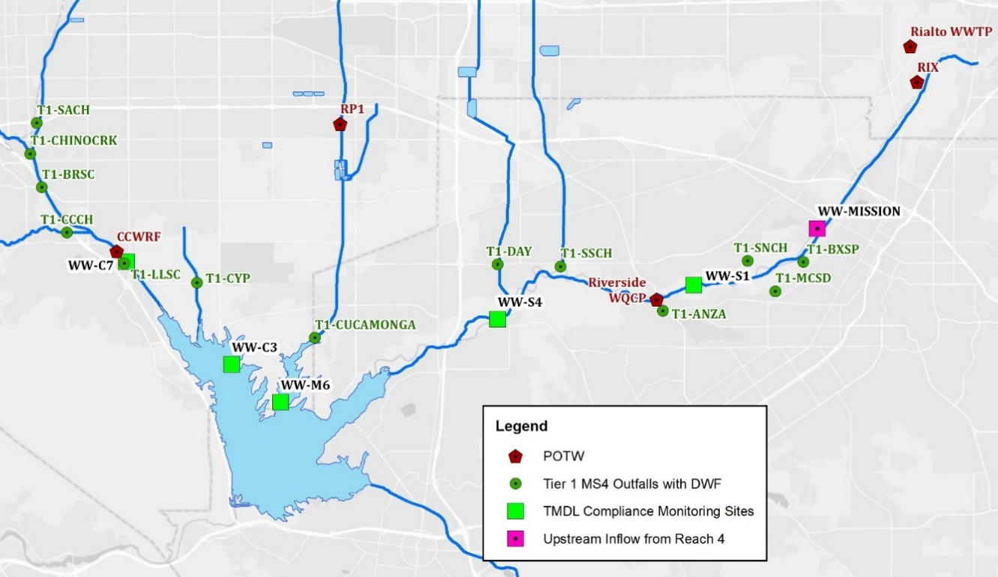
Figure 2-1. Location of TMDL Compliance Monitoring Sites, Tier 1 Sites and POTWs in the MSAR Watershed
During each sample event, the sample team gathers field measurements (flow, temperature, electrical conductivity, pH, dissolved oxygen, and turbidity) and collects water samples for laboratory analysis of E. coli and total suspended solids (TSS). Table 2-2 summarizes data collection efforts for the dry and wet seasons for the past three-year period (2023-2025); all planned samples were collected. The dry weather data are used to assess compliance with the dry season TMDL targets, assess the role of in-stream sources, and provide the basis for comparing the downstream E. coli load to measurements from upstream sources to support this report’s source contribution analysis (Section 4).
Table 2-2. Summary of Water Sample Collection Activity during 2023-2025 Period
Type | Planned Sample Days (2023-2025) | Sites | Collected Samples (2023 – 2025)
Dry weather, warm season | 60 | 6 | 360
Dry weather, cool season | 15 | 6 | 90
Wet event ¹ | 12 | 5 | 60
¹ Includes wet weather events beginning Nov 8, 2022 [2022-23 wet season], Feb 20, 2024, and March 11, 2025. Counts include samples determined to be collected “post-storm” as part of the targeted weather event (see text).

As noted above, a single wet weather event is sampled each year. Each event involves the collection of four grab samples: (a) the first sample is collected during active wet weather; and (b) three follow-up samples are collected at approximately 24, 48, and 72 hours after collection of the first sample. The scheduling of sample collection at uniform time intervals after the initial sample is collected has the potential to result in the collection of some follow-up samples during wet weather, especially during longer duration storms or when multiple rain events occur within the 96-hour sampling event.
To determine whether a sample was collected during wet weather or post-storm, flow data were evaluated. Specifically, United State Geological Survey (USGS) gauge data at 15-minute intervals were used to estimate the time that passed from when flow returned to a pre-wet weather event flow condition to when a post-storm sample was collected. This hydrograph analysis using best professional judgement was conducted for all storm events sampled by the MSAR Task Force since 2007 to determine which follow-up samples were collected during active wet weather or post-storm (if flow had returned to pre-wet weather event conditions). Based on this analysis, the amount of time that passed from when flow returned to pre-event conditions to the time of collection of a post-storm sample has been estimated for all wet weather events sampled.
Table 2-3 provides a summary of the classifications of all wet weather event samples (15 wet weather events from 2007-2025) - either collected during active wet weather or collected post-storm – for monitoring locations on Chino Creek, Mill-Cucamonga Creek and Santa Ana River Reach 3. For samples collected post-storm, Table 2-3 also reports the estimated time that had passed since flow had returned to pre-wet weather conditions. Specifically, the values in the “Post-storm Samples” columns show the time in hours for each sample collected since active wet weather ceased and flow returned to pre-event levels (sample collection times are listed in chronological order). For example, in the first row a wet weather event was sampled on 12/7/2007. In Chino Creek, based on the hydrologic analysis, two of four samples collected during the event were collected during active wet weather (12/7/2007 and 48 hours later on 12/9/2007). Flow conditions in Chino Creek returned to pre-wet weather event levels one hour before the third wet weather event sample was collected. A fourth event sample was collected 24 hours after the return to pre-event runoff.
The hydrologic analysis found that in some cases, additional wet weather runoff occurred between the time the third and fourth samples were collected. In these cases, the hours shown for the fourth sample are less than the hours shown for the third sample (e.g., see the Chino Creek and Mill-Cucamonga Creek Results for the 11/20/2010 wet weather event). The analysis also found that duration of wet weather events can vary somewhat (e.g., note that for the wet weather sample event that began on 2/1/2019, flow at all sites did not return to pre-wet weather conditions during the entire wet weather sample event). This type of information is of critical importance when evaluating compliance with wet weather condition TMDL WLAs and LAs.
Table 2-3. Wet Event Samples Classified as Either Active Wet Weather or Post-Storm in the MSAR Watershed
Event (Date of Collection of First Sample) | Chino Creek |  | Mill-Cucamonga Creek |  | Santa Ana River¹
Event (Date of Collection of First Sample) | Wet Samples | Post-storm Samples (Hours since active wet weather) | Wet Samples | Post-storm Samples (Hours since active wet weather) | Wet Samples | Post-storm Samples (Hours since active wet weather)
12/7/2007 | 2 | 1,24 | 1 | 36,60,84 | 2 | 13, 37
12/15/2008 | 2 | 3,27 | 2 | 20,19 | 3 | 4
10/14/2009 | 1 | 46,69,93 | 2 | 8,12 | 1 | 20,43,67
11/20/2010 | 1 | 23,48,10 | 1 | 8,33,8 | 2 | 7,31
12/12/2011 | 1 | 43,67,18 | 1 | 32,56,12 | 1 | 24,47,72
12/13/2012 | 1 | 4,28,53 | 1 | 5,29,53 | 1 | 14,38,62
2/28/2014 | 1 | 10,20,40 | 1 | 1,25,49 | 1 | 6,30,54
12/2/2014 | 1 | 2,11,35 | 2 | 17,41 | 3 | 9
3/6/2016 | 1 | 5,29,54 | 1 | 8,17,41 | 2 | 19,44
12/15/2016 | 1 | 5,29,53 | 2 | 15,39 | 3 | 24
2/27/2018 | 1 | 24,47,5 | 4 | NA | 2 | 42,66
2/1/2019 | 4 | NA | 4 | NA | 4 | NA
3/10/2020 | 3 | 14 | 3 | 48 | 3 | 10
1/25/2021 | 3 | 7 | 2 | 9,33 | 2 | 10,6
3/29/2022 | 1 | 13,37,60 | 1 | 21,44,68 | 2 | 21,44
11/8/2022 | 1 | 2,26,49 | 1 | 3,26,49 | 3 | 24
2/20/2024 | 2 | 13,38 | 2 | 27,51 | 2 | 11,34
3/11/2025 | 2 | NA ² | 2 | NA ² | 2 | NA ²
¹ Analysis based on USGS flow gauge data at MWD Crossing and assumed to represent conditions at both the WW-S1 and WW-S4 sites
² Weather forecasts met mobilization criteria to begin the wet event on 3/11/25; however, rainfall did not occur until 3/13/25. Samples collected on March 3/11/25 and 3/12/25 are classified as dry rather than post-storm.
NA = not applicable

Summary of Bacteriological Conditions

Dry Weather Bacteria
To illustrate long-term trends, Figure 2-2 depicts the dry weather E. coli geomean for warm and cool seasons, for each of the watershed-wide TMDL compliance monitoring sites, for each year of sampling, from 2007 through 2025. Appendix D provides additional plots of single sample and rolling geometric mean results for the most recent period, 2023-2025. Key findings for each of the impaired waters include:
- Chino Creek – Week to week variability of 2-3 orders of magnitude suggests an intermittent bacterial indicator source(s) of concern. In addition, there may be intermittent environmental conditions that cause significant variability in rates of in-stream decay. To better understand these patterns, SBCFCD conducted 12 synoptic Tier 1 source evaluations at all MS4 outfalls to Chino Creek in 2023-2024 (see Section 4.3.3).
- Mill-Cucamonga Creek - Warm season E. coli concentrations decreased in the mid-2010s and have remained at low levels since then. This pattern may potentially be attributed to benefits obtained from construction of Mill Creek Wetlands (MCW) completed in 2015 (see Section 3.2.1.2.3).
- Santa Ana River Reach 3 (MWD Crossing and Pedley Avenue) – Rising E. coli loads within Reach 4 are likely causing a rise in E. coli concentrations at the downstream TMDL compliance monitoring locations in Reach 3 (see Section 4.3.1). Quantification of this load has been possible through the inclusion of the watershed-wide monitoring site at Mission Avenue (WW-MISSION).
- Prado Park Lake – Since completion of the Prado Park Lake pipeline reconstruction project in 2017, E. coli geomeans during the warm season remain below TMDL numeric WLAs 82 percent of the time. Elevated E. coli concentrations noted in the cool season in past have been mitigated with conditions meeting TMDL in 2023-2025.

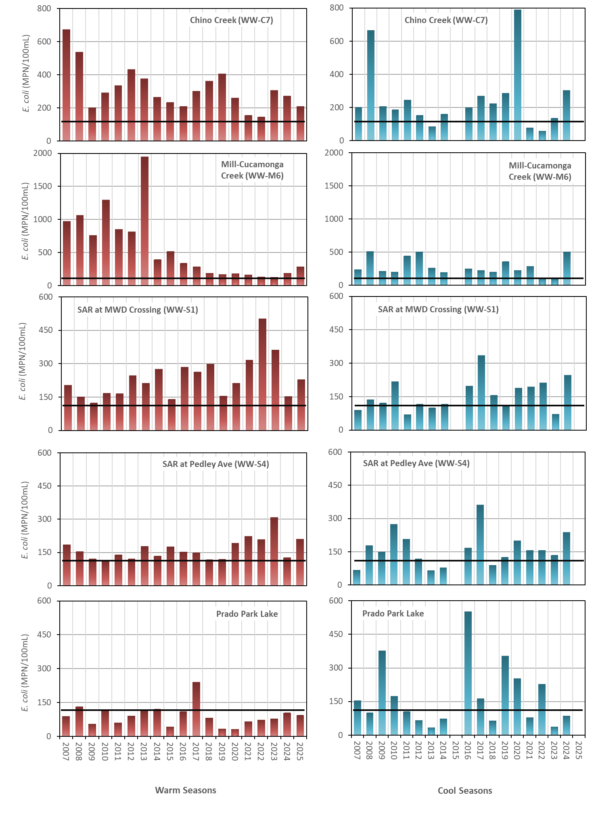
Note: Samples per year are as follows: Warm Season n = 20/year; Cool Season n=11/year before 2016 and 5/year after 2016
WLA and LA for these sites are 113 MPN/100mL and are represented by the black bar.
Figure 2-2. Dry Weather Seasonal Geomean E. coli Concentrations by Site and Season

Wet Weather Bacteria
As shown in Table 2-3, four grab samples over a 4- or 5-day period comprising a single wet event were parsed into two categories for all sampled wet weather events from 2007 through 2025: (a) active wet weather; or (b) post-storm. E. coli concentrations have significantly higher geometric mean concentrations when collected during active wet weather versus being collected under post-storm conditions (Figure 2-3). When considering the elevated flow during active wet weather, an even greater difference in fecal bacteria load is expected when compared to post-storm conditions.
Most of the sampled storm events in impaired waters exceed the 0.5 inches of rainfall threshold to trigger a temporary high flow suspension of recreational use and as such would not be subject to treatment. The Basin Plan states that termination of the temporary high flow suspension occurs 24 hours after the end of the storm event.
A more focused analysis of the full set of post-storm samples shows that E. coli concentrations decline most sharply within the first 24 hours following a return to a pre-event flow condition for all the impaired waters (Figure 2-4). Thus, it is possible that controls implemented to address dry weather E. coli loads may also provide protection for potential swimmers 24 hours post-storm.
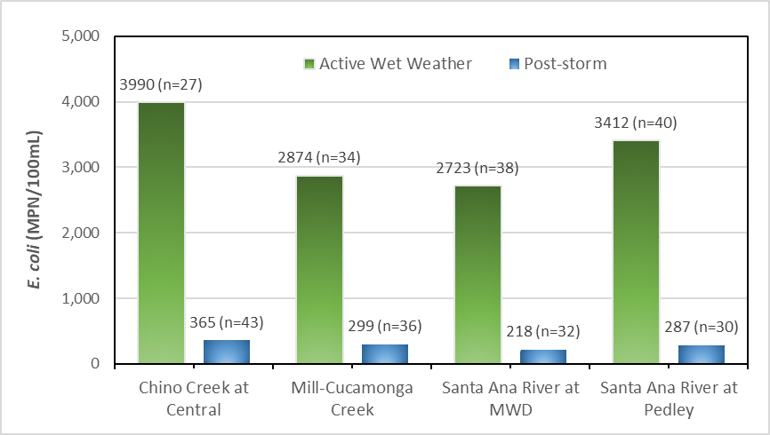
Note: Figure includes 18 storm events from 2007-2025)
Figure 2-3. Geomean of E. coli Concentrations for Grab Samples during Active Wet Weather and Post-Storm Events
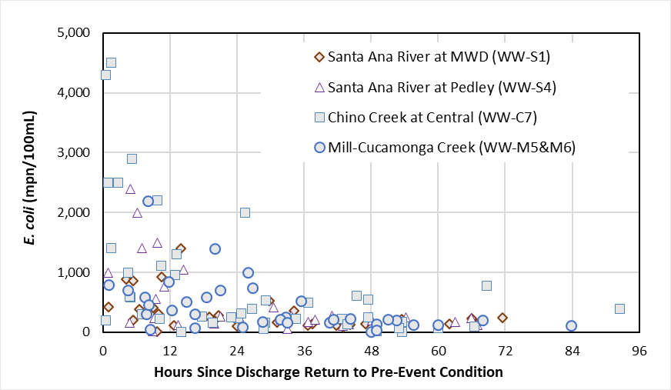
Figure 2-4. E. coli Concentrations for Post-storm Samples Over Time After Return to Pre-Wet Weather Event Flow Conditions (2007-2025)

Compliance with Wasteload Allocations
Tables 2-4 and 2-5 summarize the frequency of compliance with geometric mean and single sample WLAs for E. coli (geometric mean maximum: 113 MPN/100 mL; single sample maximum: 212 MPN/100 mL) during dry weather in 2023, 2024 and 2025 warm and cool seasons.
Table 2-4. Dry Weather Exceedance Frequencies of WLAs/LAs for E. coli during the 2023, 2024 and 2025 Warm Seasons
Site | Geometric Mean Criterion  Exceedance Frequency (%) |  |  | Single Sample Value  Exceedance Frequency (%)
Site | 2023 | 2024 | 2025 | 2023 | 2024 | 2025
Prado Park Lake | 31% | 19% | 40% | 30% | 15% | 35%
Chino Creek | 100% | 100% | 92% | 70% | 90% | 60%
Mill-Cucamonga Creek | 50% | 83% | 100% | 45% | 35% | 70%
SAR @ MWD Crossing | 100% | 69% | 62% | 75% | 55% | 55%
SAR @ Pedley Ave. | 86% | 38% | 100% | 60% | 45% | 45%

Table 2-5. Dry Weather Compliance with WLAs/LAs for E. coli during the 2023, 2024, and 2025 Cool Seasons
Site | Geometric Mean Value (Compliance Status)¹ |  |  | Single Sample Value  Exceedance Frequency (%)
Site | 2023 | 2024 | 2025 | 2023 | 2024 | 2025
Prado Park Lake | 38 (Complies) | 86 (Complies) | N/A² | 0% | 0% | 20%
Chino Creek | 138 (Exceeds) | 306 (Exceeds) | N/A² | 40% | 80% | 80%
Mill-Cucamonga Creek | 98 (Complies) | 504 (Exceeds) | N/A² | 20% | 60% | 60%
SAR @ MWD Crossing | 71 (Complies) | 248 (Exceeds) | N/A² | 0% | 60% | 0%
SAR @ Pedley Ave. | 136 (Exceeds) | 238 (Exceeds) | N/A² | 40% | 60% | 40%
¹ Only one geometric mean can be calculated from the five-sample cool season data set – table provides that value
² Five samples not collected within 30-day period due to weather condition

Compliance with Load Allocations

Agricultural Dischargers
The MSAR TMDLs contain LAs for discharges from agricultural runoff (see Table 5-9y in the TMDLs or Table 6-1x in the Basin Plan). The TMDL LAs applicable to these sources are the same as the WLAs applicable to discharges of urban runoff including stormwater and CAFOs. The TMDL watershed‐wide compliance monitoring program is intended to evaluate compliance with both WLAs and LAs; Section 2.4 above summarizes the status of compliance with these allocations and will not be repeated here.

Natural Sources
The LAs applicable to natural sources of bacterial indicators are also the same as the WLAs (see Table 5-9y in the TMDLs or Table 6-1x in the Basin Plan); and, as noted above, the watershed‐wide compliance monitoring program evaluates compliance with all MSAR TMDL WLAs and LAs.
While Section 2.4 above provides the findings from the watershed-wide monitoring compliance program, the MSAR Task Force has periodically assessed contributions from non-urban/agricultural sources of bacteria that may be natural. These previous assessments have suggested that a significant source(s) of unaccounted for bacteria are present in the impaired waters. The following sections summarize these previous findings as well as findings from the most recent analysis completed for this report. Section 4’s Bacterial Indicator Source Analysis further evaluates the importance of these findings within the context of compliance with the MSAR TMDLs WLAs and LAs.

Unaccounted Sources of Bacteria - Previous Findings (2007-2019)
The technical report supporting the adoption of the MSAR TMDLs concluded: (a) open space and wilderness areas were not significant sources of bacterial indicators under the dry weather conditions investigated; and (b) it was unknown if there was survival and reproduction of bacterial indicators in the sediments of the impaired waterbodies and that this lack of information needed to be investigated (Santa Ana Water Board 2005a).
The MSAR Task Force and MS4 Programs have conducted numerous studies since TMDL adoption that have included a bacteria mass balance analysis for the MSAR watershed. These analyses repeatedly suggest that there is a significant pool of “unaccounted for” bacteria in the watershed, i.e., the source is not DWF from urban or agricultural sources. In particular:
- Using data from 2007-2009 (SAWPA 2009), Riverside and San Bernardino County prepared CBRPs that included a bacterial load analysis that demonstrated the potential for “unaccounted for” bacteria in the impaired waters. Potentially of more significance, the CBRP analysis demonstrated that even if upstream MS4s achieved all their targeted load reductions, the receiving waters would still not achieve the E. coli WLAs in the MSAR TMDLs.
- The 2013 Triennial Report, which updated the bacteria load analysis using a much larger data set, found (SAWPA 2013):
“Recent analyses of bacterial indicator data from selected watershed‐wide compliance sites coupled with an updated compliance analysis from recent Tier 1 source evaluation activities suggest that natural or uncontrollable sources of bacterial indicators may be important contributors to bacterial indicator concentrations at the watershed‐wide compliance sites.” (Section 4.1, pg. 4-1)
- Similarly, the 2016 Triennial Report reported (SAWPA 2017):
“by process of elimination, the Uncontrollable Bacteria Sources Study suggested that the majority of E. coli in the impaired waters may be from releases from naturalized colonies in channel bottom sediment and biofilms. Fecal bacteria from a specific host released to the environment can settle to channel bottom and survive within sediments or biofilms for weeks or months over a wide range of temperature and moisture conditions. Growth of these initially deposited fecal bacteria within channel bottom sediments and biofilms results in colonies, where the majority of the population may be considered naturalized, reproducing outside of a specific organism. The BPA [Basin Plan amendment] determined that bacteria regrowth within sediment and biofilm is an uncontrollable source of fecal bacteria. As noted in Section 3.3, additional study would be necessary to better understand the potential for naturalized bacteria colonies to contribute to bacteria concentrations in overlying waters and the transport process by which bacteria is released. (Section 5, pgs. 5-1 – 5-2)
- Most recently, the 2020 MSAR Synoptic Study/Triennial Report made the following findings (SAWPA 2020a):
“[c]onsistent with the many iterations of the source contribution analyses completed over a number of years, studies have shown that sources of fecal bacteria exist in the MSAR watershed that cannot be attributed solely to MS4 discharges. Historically, the basis for quantifying non-MS4 sources has involved a process of elimination, subtracting measured inflows from the MS4 from measured loads within the receiving waters.” (Section 3.1.5, page 3-26)
“Unidentified non-point sources now account for the majority (77%) of the total bacteria load in the Santa Ana River. As has been demonstrated, based on source analyses completed in 2007, 2012, and now 2019, the Santa Ana River would be in compliance with the TMDL targets and the state's new water quality standards for pathogen indicator bacteria were it not for the excessive loads from these unknown non-point sources which are not conveyed through the MS4.” (Section 4.1,
page 4-2)
“Sampling data from Reach 4 of the Santa Ana River shows that bacteria loads from unknown non-point sources contribute about 300 billion MPN/day, which is enough to consume nearly 100% of the total allowable load for E. coli bacteria in the receiving water.” (Section 4.1, page 4-2)
Collectively, these various studies demonstrated with increased certainty the significance of “unaccounted for” or potentially “uncontrollable” sources of bacteria in the MSAR watershed.

Unaccounted for Sources of Bacteria - 2019-2025 Assessment
DWF in Santa Ana River Reach 3 is almost entirely comprised of tertiary treated effluent from publicly owned treatment works (POTW) located in upstream Reach 4. In this upstream reach, a distinctive condition exists. Above the wastewater facilities, Santa Ana River Reach 4 is generally dry during dry weather conditions. Flow begins in Reach 4 downstream of the Rialto Channel (which discharges treated effluent from the Rialto Wastewater Treatment Plant [WWTP] to the Santa Ana River) and the City of Colton and San Bernardino RIX facility. Downstream of the RIX facility the flow typically increases to a rate of over 50 cubic feet per second (cfs).
Extensive, regular field observations over the past 18 years have investigated MS4 outfalls along the mainstem of Reaches 3 and 4 of the Santa Ana River and identified no hydrologically connected inflows from MS4s to the river upstream from Box Springs Channel (BXSP) to the dry condition near the Rialto WWTP discharge (distance of 5.7 miles). This portion of the Santa Ana River is a losing stream (i.e., flow seeps through channel bottom to underlying unsaturated zone) and would be completely dry in its natural condition without the addition of POTW effluent (Barry 2017). The existence of this subsurface condition would also make it implausible that a localized source of groundwater contamination (e.g., failing septic systems or leaking sewer pipeline) would contribute to DWF in the mainstem of the Santa Ana River. Thus, all DWF volume at the boundary or transition between Reach 4 to Reach 3 should be attributed to POTW effluent.
Water quality sampling at the Rialto WWTP and RIX has shown consistently no detection of E. coli in treated effluent discharged to the Santa Ana River. Thus, any E. coli measured within the Santa Ana River below these POTWs is attributed to in-stream sources. Previous Triennial Reports identified a large, unaccounted for load of E. coli and hypothesized an in-stream source (Section 2.5.2.1). Routine dry weather sampling at the Mission Boulevard Bridge (WW-MISSION) was incorporated into the TMDL watershed-wide monitoring program (through the RBMP) to better understand bacteria conditions before flow reaches Santa Ana River Reach 3.
Results from 2019-2025 show that E. coli concentrations at WW-MISSION exceed the concentration-based LA in 72 of 94 (77%) rolling geomeans in 2019-2025 period (Figure
2-5). Considering that DWF from Reach 4 represents the majority of flow volume at downstream TMDL compliance monitoring sites in Reach 3 (WW-S1 and WW-S4), understanding the nature and potential controllability of instream sources of bacteria is critically important in TMDL implementation (Section 4.3.1). This is because existing data strongly suggest that a compliance strategy that focuses only on elimination of all MS4 DWF and associated bacteria load to Santa Ana River Reach 3 would not result in attainment of water quality objectives.
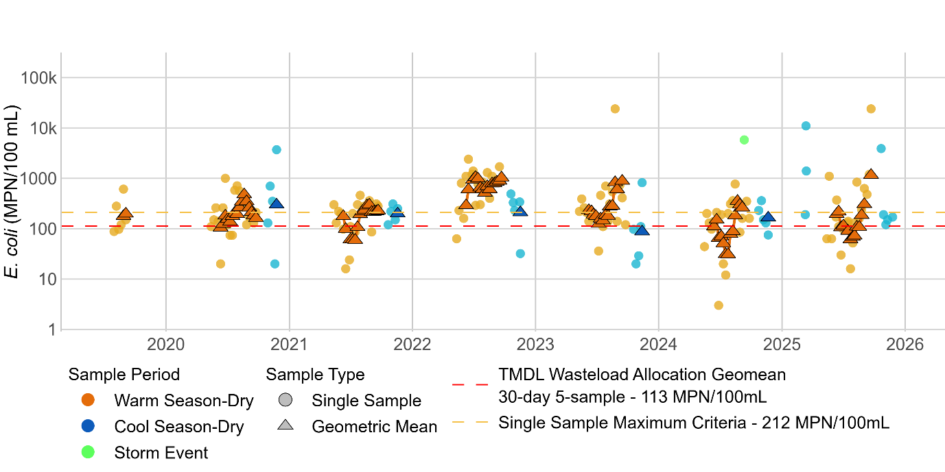
Figure 2-5. Grab Sample and Rolling Geomeans of E. coli Concentrations in the Santa Ana River Reach 3 at Mission Boulevard Bridge, WW-MISSION (2019-2025)

Synoptic Study Findings
This section provides the findings from Tier 1 and 2 source evaluation conducted over the 2023-2025 period, including the 2025 Synoptic Study. Findings are presented in the following three sections:
- Section 3.1: Characterization of Dry Weather Flow in the MSAR Watershed – This section reports on dry weather flow conditions during the 2025 Synoptic Study in relation to previous studies. DWF in Cucamonga Creek is presented as a separate subsection to highlight the extreme temporal variability of POTW discharges that requires a different approach for bacteria source contribution analysis in Mill-Cucamonga Creek.
- Section 3.2: Characterization of E. coli in the MSAR Watershed – This section reports on current sources of E. coli in each of the MSAR waters, including a comparison to previous analyses. In addition, this section updates previous E. coli loading analyses on a subwatershed basis and evaluates sources of bacteria, including both MS4 and non-MS4 sources.
- Section 3.3: Bacteroides Analyses – This section summarizes the findings from the analysis of all samples for the human marker HF183.
- Section 3.4: Tier 1 Prioritization Analysis – Based on the findings in Sections 3.1 and 3.2, this section provides the outcome of the prioritization of Tier 1 MS4 outfalls for additional work to mitigate controllable sources of E. coli. The resulting prioritization updates previous prioritization analyses completed for the MSAR watershed.

Characterization of DWF in the MSAR Watershed
The primary source of DWF in impaired waters in the MSAR watershed is treated effluent from five POTWs (see Table 1-2). This regular DWF is supplemented by numerous other non-POTW sources, including:
- Turnouts of imported water by the Metropolitan Water District (MWD);
- Well blow-offs;
- Water transfers;
- Inputs from rising groundwater, where present;
- Urban water waste from excess irrigation and other outdoor water uses;
- Other authorized discharges (as defined by the MS4 or Santa Ana Region General Waste Discharge Requirements (WDR) for insignificant (de minimis) discharges (R8-2015-0004); and
- Non-permitted, prohibited discharges.
Each of these non-POTW sources of flow in the watershed has the potential to transport bacteria to or within an impaired waterbody. Thus, it is important to understand the relative role of each of these categories of DWF. Additionally, some sources of bacteria are not transported to receiving waters through DWF, e.g., fecal deposition from wildlife, re-suspension of bacteria in channel bottom sediments, shedding from swimmers, or activities around transient encampments.
The 2025 Synoptic Study focused sample collection only on tributary waterbodies that are known to contribute DWF to the impaired waters. Areas that do not contribute DWF were excluded from the study; these sites were identified based on findings from previous studies in the watershed (e.g., SAWPA 2009, 2013, 2017, 2020, RCFC&WCD 2023, 2025) and knowledge gained by MS4 Permittees over time.

Hydrologic Disconnection
The MSAR watershed covers approximately 477,000 acres, including the Temescal Creek watershed (which is not listed as impaired for bacterial indicators). Table 3-1 summarizes how this acreage is categorized by jurisdiction. Figure 3-1 illustrates the categorization of the drainage areas upstream of Synoptic Study Tier 1 sites, including the portions of the watershed that are either hydrologically disconnected or not drained by an MS4 network.
The extent of hydrologically disconnected areas has been refined over time through the implementation of source evaluation studies. For example, in 2012 DWFs were evaluated at a total of 30 Tier 1 sites. In 2019, the number of Tier 1 outfalls with DWF was reduced
to 14. In 2025, 11 Tier 1 outfalls with DWF were evaluated to represent the total inflow from MS4 sources to the MSAR TMDL waters. The combined drainage area of these 14 sites that contribute urban DWF to an impaired downstream waterbody is approximately 78,000 acres (or about 16% of the MSAR watershed. This contributing drainage area includes a mix of urban and agricultural land uses, intersects multiple jurisdictions, and experience different non-MS4 discharges during dry weather. The remaining 84% of the MSAR watershed includes other drainage areas described as follows (see Figure 3-1):
- Hydrologically disconnected during dry weather conditions (45%);
- Not tributary to an impaired waterbody (e.g., Temescal Creek) (28%); and
- Limited drainage infrastructure or evidence of DWF connectivity (10%). These areas include riparian zones where no MS4 infrastructure is present and the agricultural area in the Chino basin (e.g., around Prado Lake).
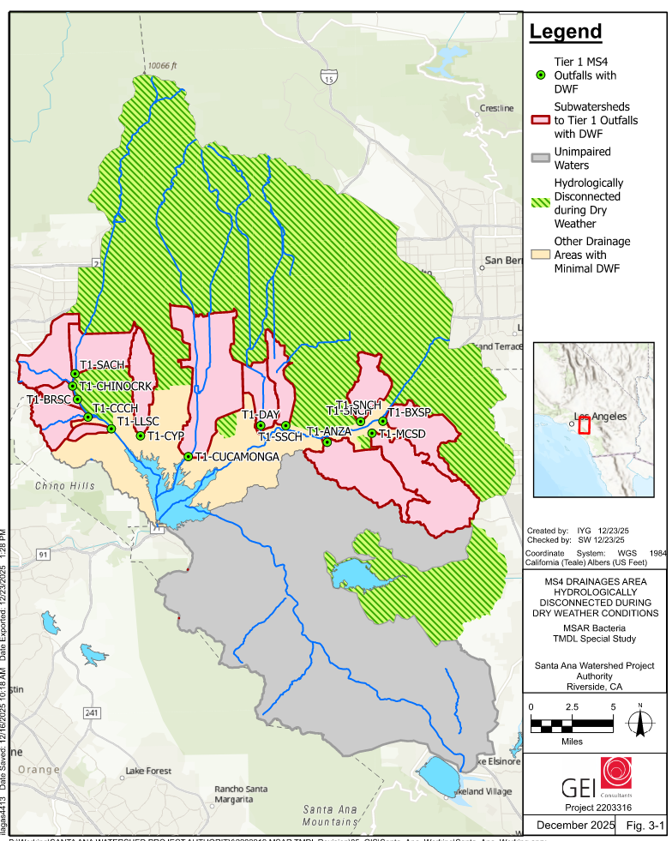
Figure 3-1. Map of Tier 1 Subwatersheds and Hydrologically Disconnected Drainage Areas during Dry Weather

Table 3-1. Categorized Acreage in Each Jurisdiction within the MSAR Watershed
Jurisdiction | Active DWF | Other Areas | Temescal Watershed | Hydrologically Disconnected | Prado Park Lake Watershed | Grand Total
San Bernardino County
Chino | 4,453 | 5,565 | - | 5,304 | 3,898 | 19,220
Chino Hills | 6,728 | 7,561 | - | 53 | 124 | 14,467
Colton | - | - | - | 4,936 | - | 4,936
Fontana | 897 | 35 | - | 26,677 | - | 27,609
Grand Terrace | - | - | - | 1,792 | - | 1,792
Montclair | 730 | 1 | - | 2,813 | - | 3,544
Ontario | 15,609 | 490 | - | 12,438 | 3,420 | 31,958
Rancho Cucamonga | 1 | 1 | - | 29,765 | - | 29,767
Rialto | - | - | - | 11,342 | - | 11,342
San Bernardino | - | - | - | 717 | - | 717
Unincorporated | 1,458 | 29 | - | 43,814 | - | 45,301
Upland | - | - | - | 10,030 | - | 10,030
Riverside County
Corona | 0 | 516 | 21,370 | - | 976 | 22,862
Eastvale | 2,670 | 4,064 | - | 996 | 674 | 8,404
Jurupa Valley | 10,252 | 4,245 | - | 13,443 | - | 27,940
Lake Elsinore | - | - | 13,261 | - | - | 13,261
Moreno Valley | - | - | - | 2,035 | - | 2,035
Norco | - | 6,421 | 2,371 | - | 169 | 8,961
Riverside | 23,094 | 3,359 | 12,013 | 13,137 | - | 51,602
Unincorporated | 785 | 1,543 | 83,537 | 35,014 | 2,952 | 123,830
Los Angeles County
Claremont | - | - | - | 2,882 | - | 2,882
Diamond Bar | 519 | - | - | - | - | 519
Pomona | 6,091 | 24 | - | 418 | - | 6,533
Unincorporated | - | - | - | 5,913 | - | 5,913
Orange County
Unincorporated | 0 | - | 2,151 | - | - | 2,151
Grand Total | 73,287 | 33,853 | 134,703 | 223,517 | 12,214 | 477,575

Change in DWF Rates
Although DWF rates increased from 2019 to 2025 at each of the compliance sites, flow rates have overall declined from 2007 to present (Table 3-2, Figure 3-2) Individual flow rates per site visit are provided in Appendix B. This summary does not include Mill-Cucamonga Creek because the extreme temporal variability of RP1 effluent discharge rate makes it infeasible to support a flow balance using singe point in time measurements (see Section 3.2.4 for more detailed summary of DWF and bacteria in Mill-Cucamonga Creek watershed).
Table 3-2. Comparison of Average DFW Measurements at Tier 1 Sites from 2007–2025
Compliance Site | Tier 1 Site | Average MS4 Dry Weather Flow (cfs)
Compliance Site | Tier 1 Site | 2007 | 2012 | 2019 | 2025
Chino Creek at Central Avenue (WW-C7) | T1- CHINOCRK - Chino Creek above SACH | NM | 1.70 | 0.53 | 0.91
Chino Creek at Central Avenue (WW-C7) | T1- BRSC - Boys Republic South Channel | NM | 0.44 | 0.13 | 0.08
Chino Creek at Central Avenue (WW-C7) | T1-CCCH - Carbon Canyon Creek | 6.50 | 4.52 | 0.46 | 0.81
Chino Creek at Central Avenue (WW-C7) | T1-SACH - San Antonio Channel¹ | 0.70 | 0.01 | 0.01 | 0.06
Chino Creek at Central Avenue (WW-C7) | T1-LLSC – Lake Los Serranos Channel | NM | 0.02 | 0.003 | 0.002
Chino Creek at Central Avenue (WW-C7) | OTHER (2007 estimate)² | 1.70 | N/A | N/A | N/A
Chino Creek at Central Avenue (WW-C7) | Subtotal (WW-C7) | 9.1 | 6.68 | 1.13 | 1.86
Santa Ana River at MWD Crossing  (WW-S1) | T1-MCSD – Magnolia Center Storm Drain | NM | 0.91 | 0.33 | 0.31
Santa Ana River at MWD Crossing  (WW-S1) | T1-SNCH – Sunnyslope Channel | 2.00 | 2.42 | 0.39 | 1.10
Santa Ana River at MWD Crossing  (WW-S1) | T1-BXSP – Box Springs Channel³ | 1.80 | 1.19 | 0.13 | 1.57
Santa Ana River at MWD Crossing  (WW-S1) | OTHER (2007 estimate)² | 0.9 | N/A | N/A | N/A
Santa Ana River at MWD Crossing  (WW-S1) | Subtotal (WW-S1) | 4.70 | 4.52 | 0.86 | 2.98
Santa Ana River at Pedley Avenue  (WW-S4) | T1-ANZA – Anza Drain | 2.60 | 3.29 | 1.35 | 1.60
Santa Ana River at Pedley Avenue  (WW-S4) | T1-SSCH – San Sevaine Channel | 1.30 | 0.50 | 0.36 | 0.45
Santa Ana River at Pedley Avenue  (WW-S4) | T1-DAY – Day Creek | 0.5 | 0.22 | 0.19 | 0.08
Santa Ana River at Pedley Avenue  (WW-S4) | OTHER (2007 estimate)² | 1.00 | N/A | N/A | N/A
Santa Ana River at Pedley Avenue  (WW-S4) | Subtotal (WW-S4) | 6.00 | 4.02 | 1.91 | 2.13
¹ Values from the September 3, 2019 sampling event were excluded from the average because an upstream valve to capture recycled water for groundwater recharge was not functioning properly on this date.
² 2007 estimate for unmonitored areas was based on an assumed DWF rate of 100 gallons/acre/day.
³ Values from September 2, 2025 sampling event were excluded from the average due to apparent release of water during the site visit. Investigation into this flow source is ongoing and City of Riverside Flow measured during a supplemental site visit on September 4 was instead used in estimated average for T1-BXSP.
DWF reductions achieved over the past 18 years continue to exceed the targeted DWF reduction needed to comply with WLAs for MS4s (Figure 3-2, Table 3-3). The observed decline in DWF at the Tier 1 MS4 outfalls is the result of better water management/conservation and coordination between water purveyor and stormwater agencies.

Figure 3-2. Change in Measured DWF Rates from MS4 Outfalls Upstream of the Chino Creek and the Santa Ana River Compliance Monitoring Sites.
Table 3-3. CBRP Estimate of Required DWF Reduction Compared to Observed DWF Reduction Since 2007
MSAR Watershed Compliance Site ¹ | CBRP – Estimated DWF Reduction from 2007 Rates to Comply with WLAs (cfs) | Measured DWF Reduction in 2025 from 2007 Rates (cfs)
Chino Creek (WW-C7) | 1.19 | 7.24
Santa Ana River at MWD Crossing (WW-S1) | 0.47 | 1.72
Santa Ana River at Pedley Avenue (WW-S4) | 0.32 | 3.87
¹ Extreme temporal variability of RP1 effluent discharge rate makes it infeasible to support a flow balance using singe point in time measurements in the Mill-Cucamonga Creek drainage area.
Reference: RCFC&WCD 2011; SBCFCD 2011

POTW Discharges to MSAR Waters
POTW effluent comprises the majority of total flow in the impaired waters and must be accounted for in the source contribution analysis. In recent years, POTW effluent discharge rates to Chino Creek, Cucamonga Creek, and the Santa Ana River have declined as a result of increased recycling of POTW effluent to serve reuse projects. Figure 3-3 shows long-term decreasing trends of dry season POTW effluent discharge (cfs) at the five discharge locations upstream of the TMDL compliance monitoring locations.
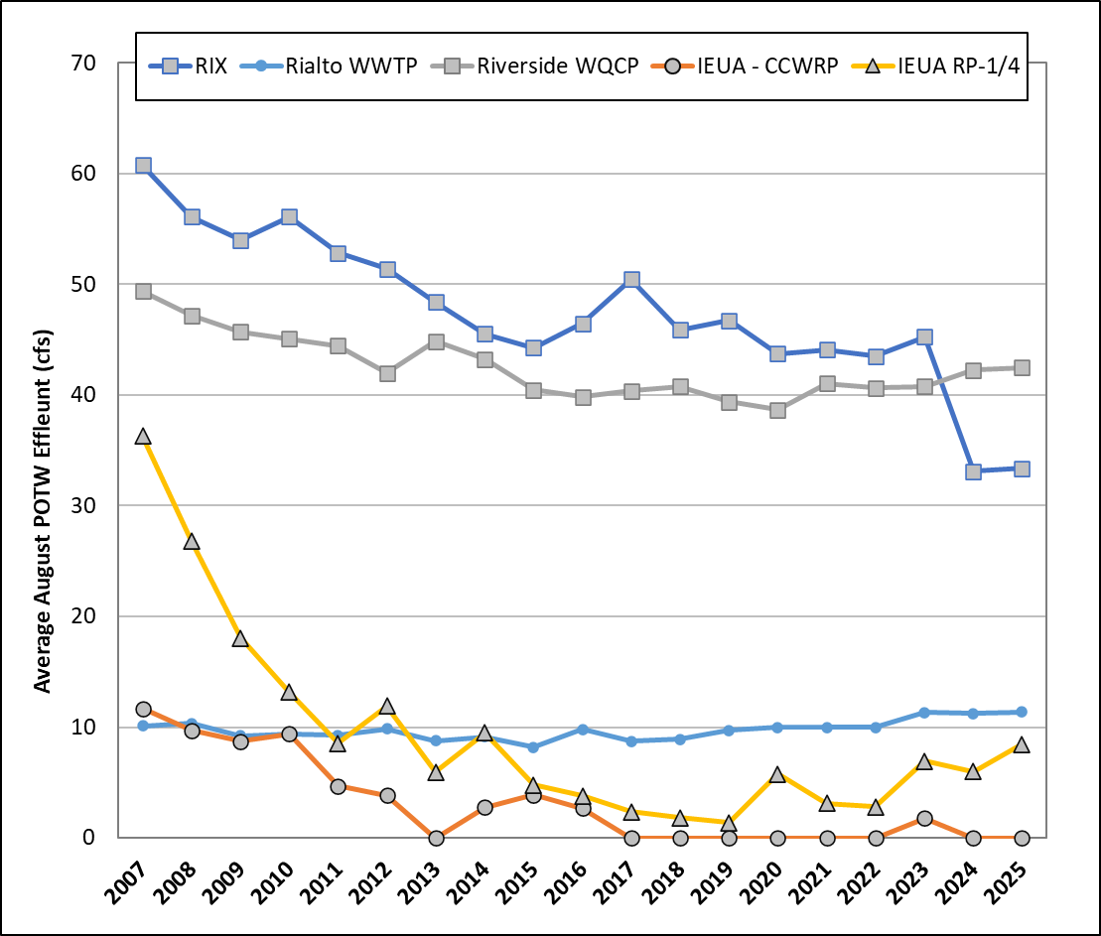
Figure 3-3. Average August POTW Effluent Flow to Impaired Waters (2007-2025)
Other de minimis discharges to MS4s occur in the MSAR watershed upstream of Tier 1 sites (see above for examples of de minimis discharge types), but these are intermittent and not reported at the daily or sub-daily timesteps needed to accommodate inclusion in the source contribution analysis. Examples of these discharges occurred during the 2025 Synoptic Study:
- Box Springs Channel – On September 2, 2025, a large increase in flow was observed at T1-BXSP. During that event, flow was measured at 7.43 cfs. During the previous four sample events, DWF rates ranged from 0.09 to 0.11 cfs (see Table B-1). A supplemental site visit on September 4, 2025, estimated a DWF rate of 1.98 cfs. The source of this discharge is unknown and follow-up investigation is underway by RCFC&WCD and the City of Riverside.

DWF in Cucamonga Creek
The dry weather hydrologic condition of the investigated segment of Cucamonga Creek is distinctive in that it is typically an effluent-dominated waterbody with extreme temporal variability in RP1 discharge rate. This variability is caused primarily by variable recycled water demand from RP1 within the IEUA system. IEUA’s RP1 treated effluent varied from 0 to 25 cfs on sampled dates between 2017 and 2025. Thus, daily average effluent rate should not be used in mass balance analysis, and it may be infeasible to conduct a true snapshot synoptic survey of the creek without incorporating controlled discharge rates at RP1 (a study design element that has not been considered to date).
Figure 3-4 shows the reported daily effluent discharged from RP1 to Cucamonga Creek from 2016 through 2025. This discharge ranged from 0 to 25 cfs on dates when Tier 2 bacteria source evaluation sampling was conducted. Thus, flow in Cucamonga Creek is usually effluent dominated, but at times the flow is comprised predominantly of urban dry weather runoff from MS4s. These sources of flow have very different expected bacteria concentrations, especially given that the tertiary treated RP1 effluent is disinfected prior to discharge to Cucamonga Creek.

Figure 3-4. Daily Effluent Flow from RP1 to Cucamonga Creek on Dates Concurrent with Tier 2 Source Investigation Sampling (2016-2025)

In addition to RP1 discharges, regular O&M activities at IEUA’s Turner Basins have occurred during Tier 2 source investigations resulting in periods of flow bypass or dewatering which significantly increased the measured rate of DWF at T2-Hwy60. Lastly, other potential causes of temporal variability in DWF within Cucamonga Creek include flows contributed by well blow-offs, releases from other downstream recharge basins (e.g., Ely Basins) or runoff from fire-fighting-related activities.
Given these sources of DWF variability, a large dataset is needed to characterize the wide range of flow and bacteria conditions that can occur with different operational and environmental factors. SBCFCD’s long-term Tier 2 dataset from this watershed now includes up to 80 sample dates at some sites from over nine dry season periods (2016-2018, 2020-2024). This dataset is supported by 11 sample dates associated with synoptic studies conducted through the MSAR TMDL Task Force in 2019 and 2025. Findings from this comprehensive dataset are used to develop an E. coli source contribution analysis in Section 3.2.4 below.

Characterization of E. Coli in the MSAR Watershed
Analysis of E. coli concentration data from the 2025 Synoptic Study showed that bacterial water quality in DWF within impaired waters and at Tier 1 sites is highly variable and exceeds the geomean WLA for E. coli of 113 MPN/100 mL at 21 of 23 sites (Figure 3-5). Most of the Tier 1 sites had at least one sample with an E. coli concentration greater than 500 MPN/100 mL (exceptions include T1-ANZA with maximum of 86 MPN/100 mL and T1-CCCH with maximum of 240 MPN/100 mL). Figure 3-6 presents the changes in geomean concentrations at each Tier 1 site from 2012 to 2025. Concentrations have increased at some sites (e.g., T1-BRSC) and decreased at others (T1-ANZA).
Note: y-axis is in log scale
Figure 3-5. Range of E. coli Concentrations from 2025 Synoptic Study Sites

Note: Sites T2-HWY60 and T2-CHRIS include data from SBCFCD 10-week surveys in 2016-2018, 2020-2024.
Figure 3-6. Comparison of 2025 Tier 1 Site E. coli Geomeans with Previous Studies

Bacteria Load Analysis
This study provides the opportunity to update previous estimates (SAWPA 2013, 2017, 2020) of total MS4 loading of E. coli to impaired waters during dry weather. The potential for DWF at a Tier 1 site to impact water quality at a downstream compliance site can be evaluated through a bacteria load analysis, which considers both the DWF volumes and E. coli concentrations. Table 3-4 reports median loads for each Tier 1 site based on the DWF rates and E. coli geomean concentrations measured over the 5-week Synoptic Study in 2025. In total, E. coli loads at Tier 1 MS4 outfalls to Reach 3 of the SAR and Chino Creek have declined since 2007 (Figure 3-7). For Reach 3 of the SAR, bacteria load reductions have exceeded CBRP goals of 15 and 10 billion CFU/day for MS4s sources upstream of the WW-S1 and WW-S4 compliance monitoring sites, respectively. This is despite the large increase in E. coli load observed at T1-MCSD in the 2025 dry season. For Chino Creek, approximately 75% of the estimated 37 billion CFU/day bacteria load reduction target for MS4 sources has been achieved.

Figure 3-7. Median MS4 E. coli Load from Tier 1 Sites Tributary to the Chino Creek and the Santa Ana River Watershed-wide Compliance Sites

Since the 2012 CBRP was developed, notable reductions in E. coli load were measured at T1-ANZA, T1-SNCH, T1-SSCH, T1-BRSC, and T1-CCCH. The observed bacteria load reductions result from both reduced DWF (from better water management and coordination between water purveyor and stormwater agencies) and reduced E. coli, e.g., through focused deployment of Tier 2 inspections that have successfully identified and eliminated illicit connections and illegal discharges within the MS4s.
Conversely, a significant rise in E. coli load was observed at T1-MCSD relative to 2012. Historical data shows that E. coli concentrations have generally risen over time and E. coli concentrations observed in samples collected in 2019-2025 are substantively greater than observed in 2012 (Figure 3-8). Specifically, the geometric mean from synoptic studies increased from 234 MPN/100 mL in 2012 to 4,087 MPN/100 mL in 2019 and 4,801 MPN/100mL in 2025. The load analysis indicates a 7.8-fold rise in E. coli loading between 2012 and 2025 (38.1 billion MPN/day in 2025 versus 4.9 billion MPN/day in 2012).
In the following subsections, source contribution analysis relates measured E. coli inflows to MSAR waters with downstream measurements at the TMDL compliance monitoring locations.

Table 3-4. Comparison of Median E. coli Load Estimates at Tier 1 Sites in 2007, 2012, 2019, and 2025
Compliance Site | Tier 1 Site | Median E. coli Load (Billion MPN/Day)
Compliance Site | Tier 1 Site | 2007 (Baseline) | 2012 | 2019 | 2025
Chino Creek at Central Avenue  (WW-C7) | T1-CHINOCRK | NM | 22.2 | 14.3 | 19.3
Chino Creek at Central Avenue  (WW-C7) | T1-BRSC | NM | 6.9 | 4.8 | 3.7
Chino Creek at Central Avenue  (WW-C7) | T1-CCCH | 22.0 | 7.5 | 0.7 | 1.9
Chino Creek at Central Avenue  (WW-C7) | T1-SACH | 7.0 | 0.1 | 0.1 | 0.3
Chino Creek at Central Avenue  (WW-C7) | T1-LLSC | NM | 0.001 | 0.1 | 0.01
Chino Creek at Central Avenue  (WW-C7) | OTHER (2007 est.)¹ | 24.0
Chino Creek at Central Avenue  (WW-C7) | Subtotal (WW-C7) | 53.0 | 36.7 | 20.1 | 25.2
Chino Creek at Central Avenue  (WW-C7) | Reduction from CBRP Baseline | n/a | -16.3 | -32.9 | -27.8
Santa Ana River at MWD Crossing  (WW-S1) | T1-MCSD | NM | 4.9 | 35.3 | 38.1
Santa Ana River at MWD Crossing  (WW-S1) | T1-SNCH | 9.0 | 15.6 | 7.0 | 6.1
Santa Ana River at MWD Crossing  (WW-S1) | T1-BXSP | 75.0 | 25.5 | 3.1 | 12.2
Santa Ana River at MWD Crossing  (WW-S1) | OTHER (2007 est.)¹ | 10.0
Santa Ana River at MWD Crossing  (WW-S1) | Subtotal (WW-S1) | 94.0 | 46.1 | 46.0 | 56.4
Santa Ana River at MWD Crossing  (WW-S1) | Reduction from CBRP Baseline | n/a | -47.9 | -48.0 | -37.6
Santa Ana River at Pedley Avenue  (WW-S4) | T1-ANZA | 31.0 | 16.9 | 7.3 | 1.7
Santa Ana River at Pedley Avenue  (WW-S4) | T1-SSCH | 10.0 | 29.3 | 4.6 | 7.9
Santa Ana River at Pedley Avenue  (WW-S4) | T1-DAY | 7.0 | 1.9 | 1.3 | 3.1
Santa Ana River at Pedley Avenue  (WW-S4) | OTHER (2007 est.)¹ | 14.0
Santa Ana River at Pedley Avenue  (WW-S4) | Subtotal (WW-S4) | 62.0 | 48.2 | 13.1 | 12.7
Santa Ana River at Pedley Avenue  (WW-S4) | Reduction from CBRP Baseline | n/a | -13.8 | -48.9 | -49.3
¹ 2007 estimate for unmonitored areas based on E. coli concentration of 600 MPN/100 mL, which was the geomean of all MS4 outfall samples in 2007

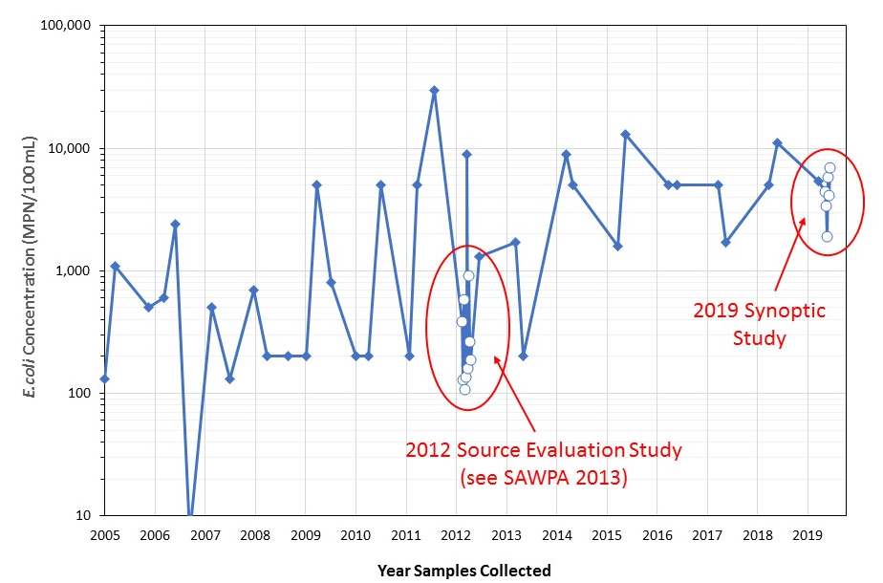
Note: MS4 Program Core Samples = blue-filled diamonds; synoptic study sampled = open circles
Figure 3-8. Historical E. coli Data at Magnolia Center Storm Drain Compared with Synoptic Study E. coli Results (T1-MCSD)

Santa Ana River Subwatershed
When DWF from MS4s is blended with tertiary treated POTW effluent (compliant with the facility’s E. coli effluent limit),, a mass balance calculation can approximate the expected E. coli concentrations (C_{MS4+POTW}) within each impaired water (omitting any instream losses or gains), as follows:
$$C_{MS4+POTW}= \frac{\left[\sum_{i}^{j}{\left(Q_{MS4}*C_{MS4}\right)}\right]}{\left(Q_{MS4}+ Q_{POTW}\right)}$$
This source contribution analysis approach applies only to Reach 3 of the SAR because 1) no POTW effluent was discharged to Chino Creek during the 2025 synoptic study period, and 2) extreme temporal variability of RP1 discharges to Cucamonga Creek makes a snapshot in time synoptic sampling event infeasible (see Section 3.1.4 above for more detailed characterization). For SAR Reach 3, the source contribution analysis compares estimated flow-weighted concentration (C_{MS4+POTW}) of inflows with downstream measurements collected on the same day. This approach is equivalent to the analyses completed for the CBRPs (RCFC&WCD 2011; SBCFCD 2011) and subsequent TMDL Triennial Reports (SAWPA 2013, 2017, 2020).
Figure 3-10 provides a schematic of the Santa Ana River Reach 3 subwatershed, including sources of flow to the river. The source evaluation analysis for this subwatershed involves computation of a flow-weighted average E. coli concentration from MS4 outfalls and the three POTWs that discharge treated effluent in this subwatershed: City of Riverside’s RWQCP, City of Colton and San Bernardino RIX facility, and the City of Rialto WWTP. Upstream of these discharges the Santa Ana River is dry. This effluent travels approximately 5 miles down the Santa Ana River riverbed with no additional inflows from MS4s during dry weather conditions to the WW-MISSION monitoring location. The addition of a sampling station at Mission Boulevard (WW-MISSION) characterizes instream sources from Reach 4 to Reach 3 of the SAR for inclusion in the estimation of expected downstream E. coli concentration at WW-S1 and WW-S4. Six Tier 1 MS4 outfalls accounted for the DWF and associated E. coli bacteria from MS4 sources during the 2025 Synoptic Study.
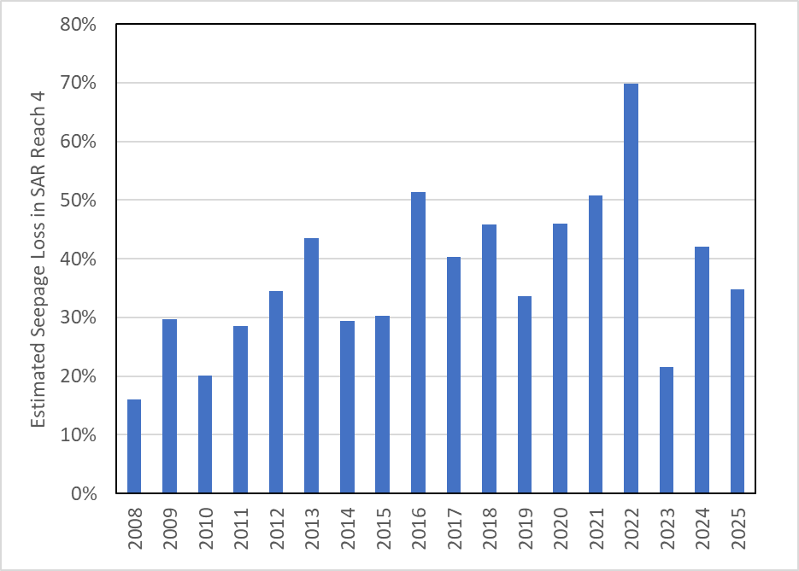
The 2020 source contribution analysis assumed DWF rates at WW-MISSION were equal to the daily metered POTW effluent from Rialto WWTP and RIX . This assumption neglected channel bottom seepage losses within Reach 4 of the Santa Ana River prior to the transition from Reach 4 to Reach 3 at Mission Boulevard. For the 2025 source contribution analysis, infiltration losses were approximated by comparing daily metered POTW discharges with downstream flow gauge records (USGS Station #11066460). Figure 3-9 shows that percent of losses of POTW effluent range from 15-70 percent with the greatest losses in dry hydrologic years.
Figure 3-9. Estimated Seepage Loss in Santa Ana River Reach 4
Given the importance of DWF losses due to infiltration , an alternative approach was developed to no longer rely upon POTW effluent rates at the discharge point. Instead, the DWF rate associated with POTW discharges that arrives at WW-MISSION was estimate as follows: Q_{POTW} = Q_{USGS} – Q_{MS4}, where Q_{MS4} is the sum of measured DWF at T1-MCSD, T1-BXSP, and T1-SNCH and Q_{USGS} is the daily average flow for the sample data. The average Q_{MS4} in 2025 Synoptic study was 1.77 cfs.
Medians of weekly calculations of flow-weighted average E. coli concentration during the 2025 Synoptic Study were 403 MPN/100 mL at WW-S1 and 163 MPN/100 mL at WW-S4. These estimates are significantly greater than calculated values reported in previous Triennial TMDL reports that did not account for in-stream sources upstream from upstream of Mission Boulevard. In fact, after accounting for increased E. coli within the SAR upstream of WW-MISSION, estimated downstream concentrations exceeded measured concentrations (Figure 3-11). In other words, the Task Force has now identified with confidence the source that was previously reported as “unaccounted”. As was noted in the 2023 Triennial TMDL report, the majority of E. coli load to Reach 3 during dry weather is associated with instream sources. During the five-week 2025 Synoptic Study, this in-stream source represented ~70 percent of the total load of E. coli to Reach 3 of the SAR based on medians (Figure 3-12). Ongoing collection of routine samples at the WW-MISSION site validates the persistent nature of this source and show that samples collected during the 2025 Synoptic Study were representative of the range of measured E. coli over the period of record from 2019 – 2025 (Figure 3-13).
For the remaining ~30 percent of E. coli load to Reach 3 of the SAR, the relative role of the six monitored Tier 1 MS4 outfalls (upstream of WW-S4 compliance sites) varied week to week (Figure 3-14). Persistently high concentrations were observed in T1-MCSD, T1-BXSP, T1-SSCH, and T1-DAY; however, low DWF volumes limited the influence on downstream blended concentration in the case of T1-SSCH and T1-DAY. A significantly different condition involving a large release of water was observed at T1-BXSP on 9/2/25 (week 5 of the synoptic study) that increased the DWF rate from 0.09 - 0.11 cfs measured in weeks 1-4 to 7.4 cfs. E. coli loads increased 200-fold from a week 1-4 average of 12 billion MPN/day to over 2300 billion MPN/day. In previous synoptic surveys, the potential for large water releases to cause fecal bacteria to be mobilized has been noted (see summary for Chino Creek in Appendix C). RCFC&WCD field crews resampled T1-BXSP during week 5 on 9/4/25. The increased DWF condition persisted at the site on 9/4/25 with measured flowrate of 2.0 cfs; however, E. coli load was reduced to 68 billion MPN/day. Results from re-sampling on 9/4/25 were used to represent week 5 at T1-BXSP in source contribution analyses below (also see Section 3.1.3 above) and to support prioritization (see Section 4).
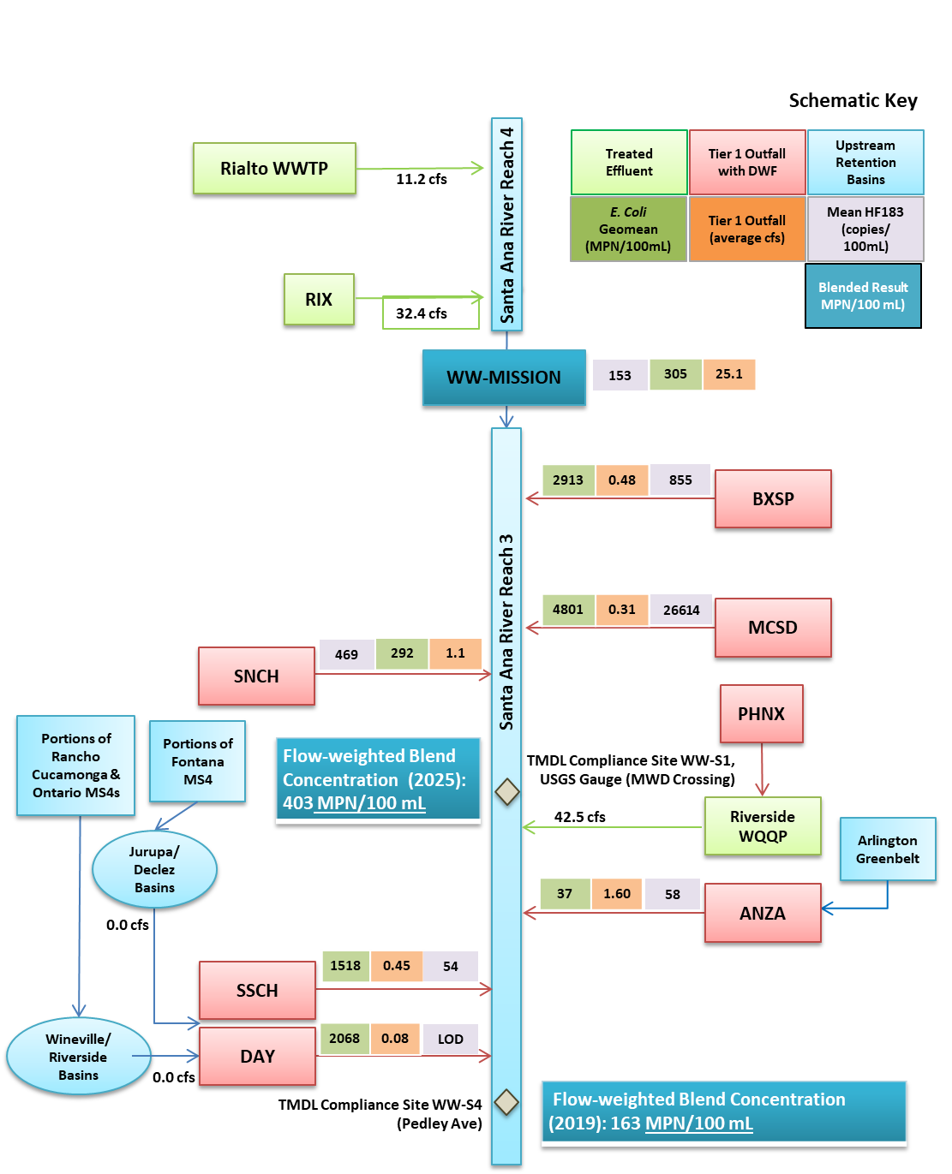
Figure 3-10. Schematic Showing Known Bacteria Inputs, Dry Weather Inflows and POTW Effluent Discharges to the Santa Ana River in Relation to Downstream Compliance Monitoring Sites
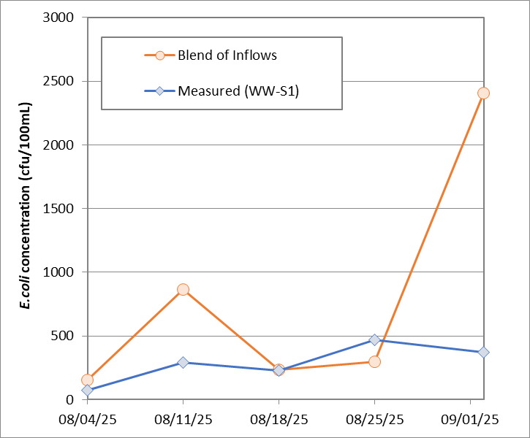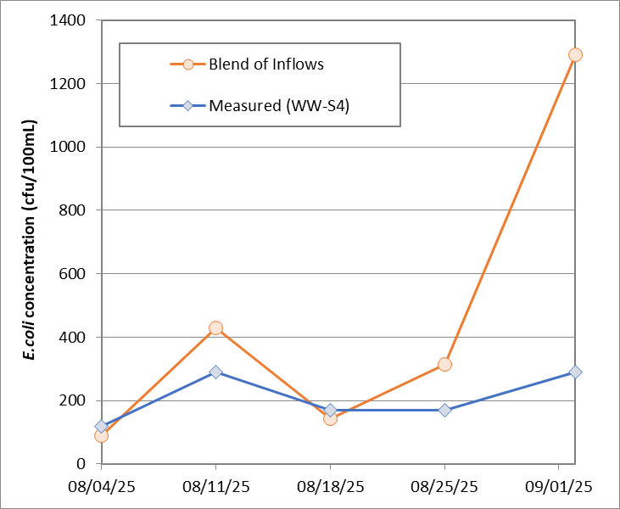
Figure 3-11. Comparison of Estimated Blended E. coli Concentrations of MS4 Inflows with Downstream Watershed-wide Compliance Monitoring Data for Santa Ana River Sites
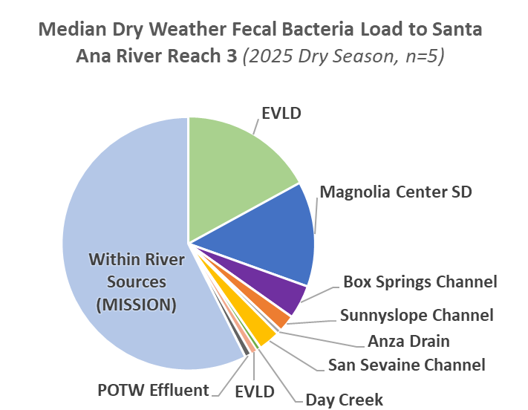
Note: EVLD and EVLE discharge downstream of TMDL compliance monitoring sites.
Figure 3-12. Relative Contributions during 2025 Synoptic Study of E. coli Loads (billion MPN/day) to Santa Ana River Reach 3 from Upstream Tier 1 MS4 Outfalls
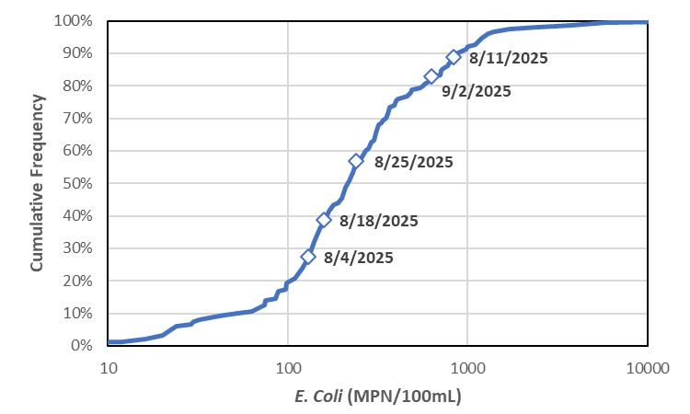
Figure 3-13. E. coli Concentrations in Santa Ana River at Mission Boulevard (WW-MISSION) during Dry Weather (2019-2025, n=151)
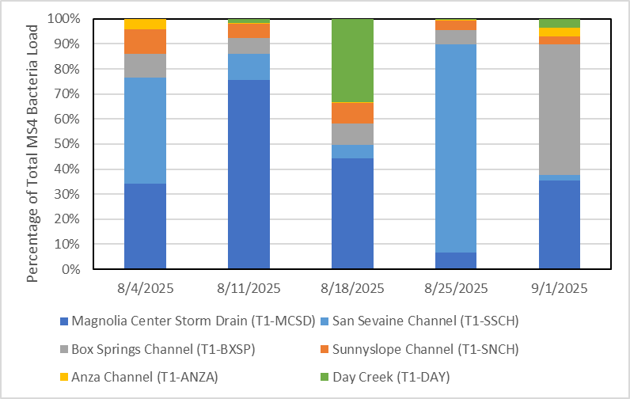
Note: this figure does not account for loads from EVLD and EVLE.
Figure 3-14. Relative Loading from Tier 1 Sites to Total MS4 E. coli Load to the Santa Ana River Reach 3 Upstream from WW-S4 Compliance Monitoring Site

Chino Creek Subwatershed
Figure 3-15 provides a schematic of the Chino Creek subwatershed, including sources of flow (e.g., POTWs and Tier 1 sites) and flow diversions. DWF from most of the Chino Creek subwatershed does not reach the downstream compliance site at Central Avenue (WW-C7) because of diversions. For example, DWF in San Antonio Channel, the largest tributary to Chino Creek, is diverted into a series of retention basins that span from San Antonio Dam in the upper part of the subwatershed to Brooks Basin in the City of Montclair. Downstream of the diversion to Brooks Basin, there are five MS4 outfalls to Chino Creek that comprise nearly all the DWF (see Figure 3-15).
During the 2025 dry season and the Synoptic Study, IEUA’s Carbon Canyon WRP, the only source of treated effluent to Chino Creek, discharged no effluent to Chino Creek. Consequently, the source evaluation analysis for the Chino Creek watershed involves computation of a flow-weighted concentration for the five Tier 1 MS4 outfalls with DWF. The estimated blended E. coli concentration was found to be greater than the concentration of E. coli at the downstream watershed-wide compliance monitoring site at Central Avenue in three of the five sampled dates (Figure 3-16). On the other two dates, the downstream measured E. coli was higher than blend of inflows by a small margin. This finding suggests that in-stream processes generally yield a net decay in fecal bacteria between upstream sources and the impaired portion of Chino Creek, and that non-MS4 sources of E. coli in Chino Creek are likely to be minimal during dry weather. Figure 3-17 shows that T1-CHINOCRK and T1-BRSC account for at least 80 percent of total MS4 E. coli load to Chino Creek during the 2025 Synoptic Study period.
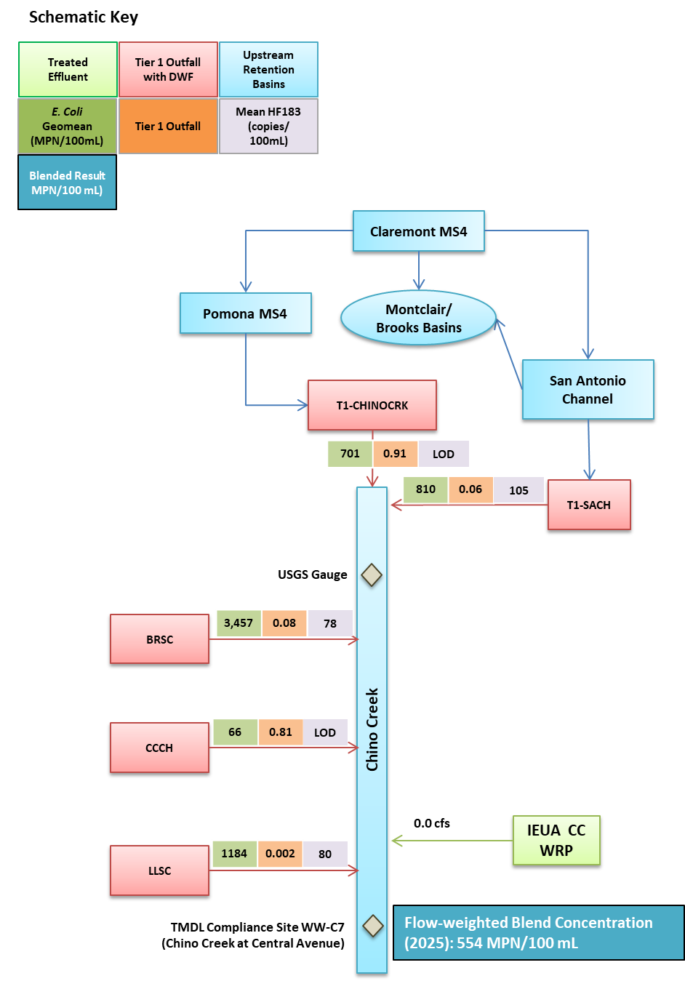
Figure 3-15. Schematic Showing Known Bacteria Inputs, Dry Weather Inflows and POTW Effluent Discharges to Chino Creek in Relation to Downstream Compliance Monitoring Site
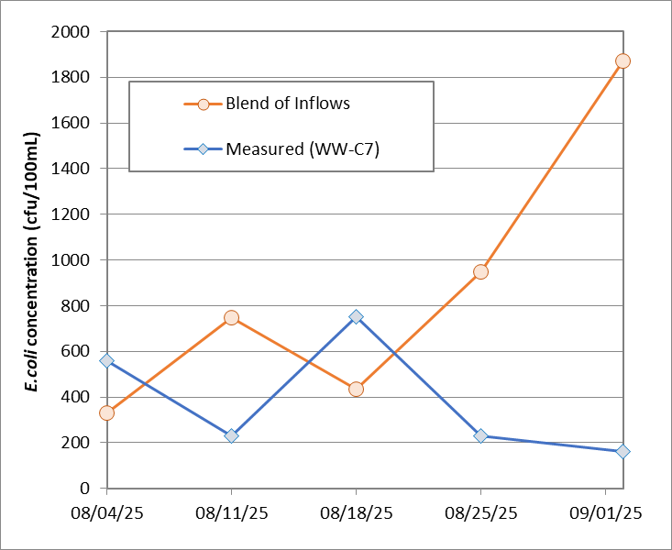
Figure 3-16. Comparison of Estimated Blended E. coli Concentrations of MS4 Inflows with Downstream Watershed-wide Compliance Site Data for Chino Creek at Central Avenue
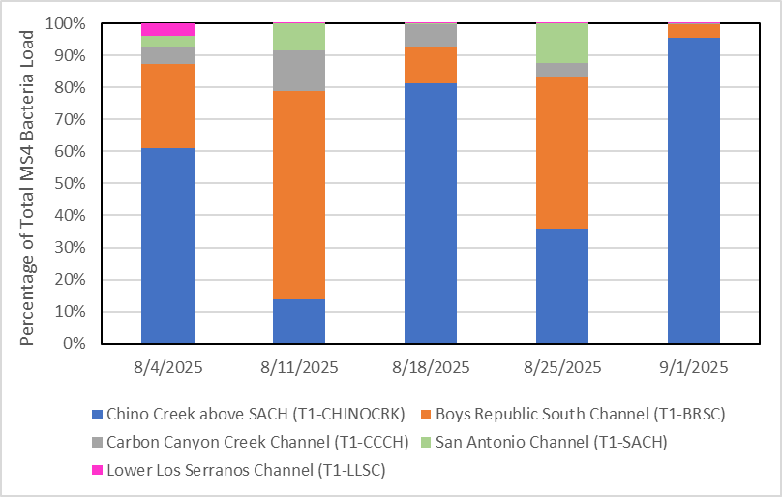
Figure 3-17. Relative Loading from Tier 1 Sites to Total MS4 E. coli Loads to the Chino Creek at Central Avenue Compliance Site

Cucamonga Creek Subwatershed
On April 8, 2015, USEPA approved the use attainability analysis that removed the water contact recreation beneficial use (REC1) use from Cucamonga Creek Reach 1., ,. Prior to this regulatory decision, numerous drainages that discharge to Cucamonga Creek Reach 1 were classified as Tier 1 sites; thus, the 2012 source contribution analysis included an evaluation of nine MS4 outfalls that discharged into Cucamonga Creek between 23rd Street in Upland at the upper end of the reach and Hellman Avenue Bridge, at the lower end of the reach. With the de-designation of REC1, all outfalls into the concrete lined segment of Cucamonga Creek became Tier 2 and the only Tier 1 site in this subwatershed is where Cucamonga Creek Reach 1 drains into Mill-Cucamonga Creek downstream of Hellman Avenue (T1-CUCAMONGA).
Per the objectives of the Synoptic Study, flow and bacteria data from the T1-CUCAMONGA site were used to prioritize the site along with all other Tier 1 sites in the watershed (see Section 3.3 below). While useful from an overall watershed standpoint, the findings from this site on their own do not provide information regarding where to prioritize future DWF/E. coli mitigation activities within the Cucamonga Creek subwatershed. To assist with that evaluation, upstream Tier 2 surveys led by SBCFCD (referred to as “10-week surveys”) and results from the 2019 and 2025 synoptic studies are used to support a source contribution analysis within the Cucamonga Creek watershed.
Since 2017, SBCFCD has collected weekly fecal bacteria samples over a 10 consecutive week period under dry weather conditions from within Cucamonga Creek. Samples are collected at various sites along a longitudinal profile to evaluate bacteria source loads and guide implementation of the CBRP. Figure 3-18 illustrates the location of Tier 2 sample sites upstream of the Tier 1 site. Table 3-5 summarizes data sources used to support the analysis. DWF and E. coli data were evaluated over the 2016 to 2025 time period. Table 3-6 presents summary bacterial indicator statistics from the nine years of data collection. Sites listed in the table (rows) are ordered from upstream to downstream.
Source contribution analysis for the Mill-Cucamonga Creek compliance site (WW-M6) considers (a) bacterial loading assessment from the single Tier 1 site (T1-CUCAMONGA); and (b) accounting for the diversion, treatment, and discharge of bacteria load from the MCW control measure located upstream of the compliance site. Results from the downstream TMDL compliance monitoring site on Mill-Cucamonga Creek (WW-M6) are from sampling performed during the same 10-week periods when SBCFCD was also conducting its Tier 2 source investigations or during the 2019 and 2025 synoptic studies, though not necessarily on the same sampling dates.
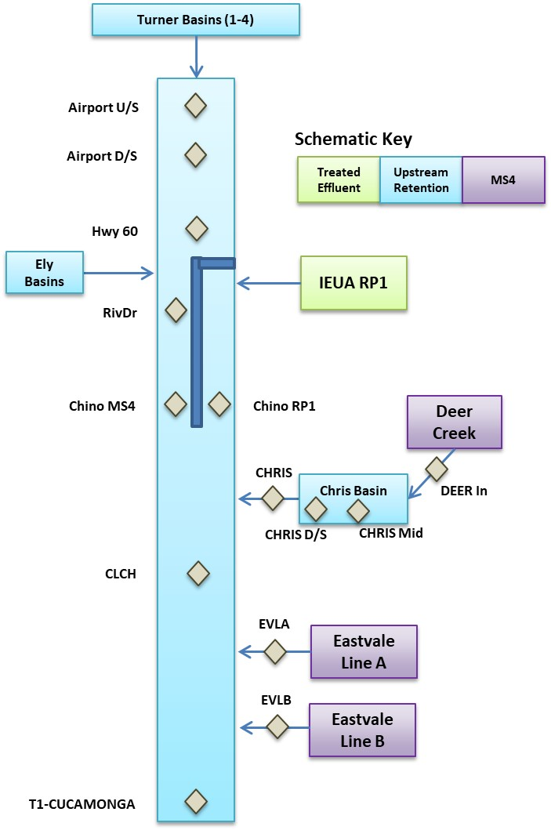
Note: blue bar indicates curbed section of the stream where RP1 discharge is isolated from DWF from MS4 systems.
Figure 3-18. Schematic of Dry Weather Flow Retention and Key Inflows to Cucamonga Creek

Table 3-5. Summary of Data Sources (2017-2025) Used to Support Tier 2 Source Investigation in the Cucamonga Creek Subwatershed
Data Type | Source | Locations (See Figure 3-4)
E. coli Concentration and Flow Measurement | SBCFCD 10-week Studies¹ | Airport U/S, Airport D/S, Hwy 60, RivDr Chino MS4, Chino RP1, DEER In, CHRIS Mid, CHRIS D/S, CHRIS, CLCH, T1-CUCAMONGA¹, BASEFLOW, MCW IN, MCW OUT
E. coli Concentration and Flow Measurement | RBMP | P4-SBC1², WW-M6³
E. coli Concentration and Flow Measurement | Synoptic Surveys | Hwy60, Chino RP1, CHRIS, CLCH, EVLA, EVLB, T1-CUCAMONGA¹
RP1 Flow | IEUA | RP1
Recharge Basins | IEUA | Turner 1-4 and Ely Basins
In-stream Flow | USGS | Cucamonga Creek at Merrill Ave (Station# 11073495)
¹ BASEFLOW, MCW IN AND MCW OUT sites are downstream of T1-CUCAMONGA (see Figure 4-1
² Co-located sites, upstream side of Hellman Avenue Bridge: T1-CUCAMONGA, HELLMAN, and P4-SBC1
³ TMDL compliance monitoring site downstream of T1-CUCAMONGA in Mill-Cucamonga Creek (see Figure 4-8)
Table 3-6. Summary of E. coli Sample Results in Cucamonga Creek Subwatershed, Tier 2 Source Investigations (2016-2025) (see Figures 3-5 and 4-8 for site locations)
Site | No. of Samples (Period)¹ | E. coli Geomean (MPN/100 mL) | Median Flow (cfs) | Median E. coli Load (MPN/Day)
Airport U/S | 70 (2017-2024) | 27 | 0.3 | 0.2
Airport D/S | 70 (2017-2024) | 273 | 0.3 | 1.7
Hwy 60 | 85 (2016-2025) | 59 | 0.7 | 0.8
RivDr | 70 (2017-2024) | 203 | 3.9 | 21.4
Chino MS4² | 70 (2017-2025) | 290 | 3.6 | 32.7
Chino RP1² | 84 (2017-2025) | 49 | 0.9 | 1.8
DEER In | 69 (2017-2024) | 476 | 0.8 | 25.0
CHRIS | 85 (2016-2025) | 859 | 0.9 | 23.2
CLCH U/S | 65 (2017-2024) | 181 | 7.1 | 63.7
CLCH | 5 (2025) | 416 | 0.4 | 3.9
EVLA⁴ | 10 (2020) | 2,068 | 0.05 | 3.0
EVLB⁴ | 7 (2020) | 3,526 | 0.01 | 0.2
T1-CUCAMONGA⁵ | 85 (2016-2025) | 327 | 5.7 | 81.8
BASEFLOW | 70 (2017-2024) | 374 | 5.5 | 66.3
MCW IN | 70 (2017-2024) | 476 | 2.3 | 36.9
MCW OUT | 74 (2016-2024) | 101 | 0.7 | 0.9
¹ Summary data is based on sampling during dry season only
² Curb separating MS4 flow from RP1 effluent terminates at Chino Avenue; samples are collected prior to the two sources of flow mixing
³ Includes samples collected during second round in afternoon on synoptic sampling event days, no other Tier 2 sites were sampled in afternoons (e.g., CHRIS outfall to Cucamonga Creek based on samples only collected in morning hours only)
⁴ Samples collected from MS4 outfall; not within mainstem of Cucamonga Creek
⁵ Also known as HELLMAN or P4-SBC1
Flow gauge data in Cucamonga Creek (USGS Sta 11073495) shows the sub-hourly temporal variability in DWF rate, plotted for days of the 2025 Synoptic Study in Figure 3-19. This condition makes it nearly impossible to collect bacterial indicator data in such a way as to achieve a representative point in time snapshot over the course of a synoptic sampling event. Instead, evaluations of source contributions relied upon summary statistical metrics, specifically the median and range of the 25th to 75th percentiles of bacterial load over many samples collected in the 2017-2025 period.
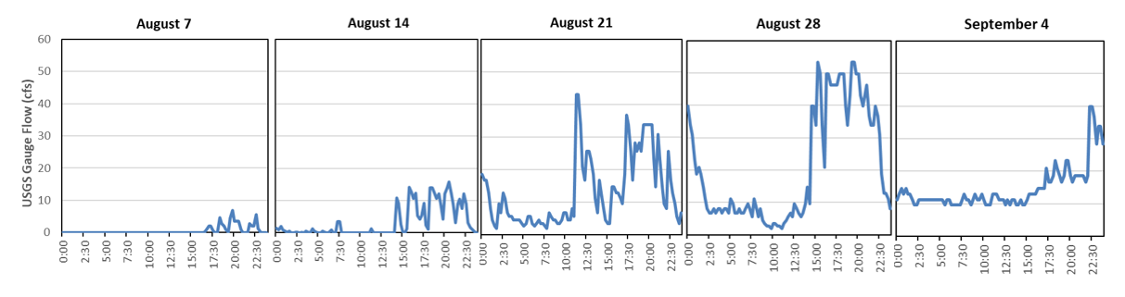
Note: USGS Gauge Station ID # 11073495
Figure 3-19. USGS Gauge 15-Minute Interval Flow at Cucamonga Creek near Mira Loma on 2025 Synoptic Study Dates
Figure 3-20 plots the results for each mainstem Cucamonga Creek sampling site along a longitudinal profile (x-axis provides the distance upstream of the TMDL compliance monitoring site, WW-M6). The longitudinal profile portrays changes to the load of bacteria within the channel as flows come into the creek from upstream of Ontario Airport (just downstream of the Turner Basin dry weather diversion) to the downstream TMDL compliance monitoring site. Generally, the E. coli load rises as new bacteria sources come into the creek that exceed bacteria losses from natural decay. Several key findings were noted, including:
- DWF rates and E. coli load in the upper segments of Cucamonga Creek are minor. The first significant rise in flow and load occurs between Highway 60 and Chino Avenue. There are no significant drainage outfalls from the City of Ontario to Cucamonga Creek in this segment. The rise in DWF rate could be attributed to RP1 discharge that is not effectively contained on the east side of the creek by the curb structure. Comparing flow measurements on either side of the curb at Chino Avenue suggests that a portion of RP1 effluent migrates (through openings in the curb) to the Cucamonga Creek low flow section. In-stream sources of E. coli such as releases from natural colonies in the channel bottom may be mobilized by the highly variable RP1 discharges on either side of the curb structure.
- The rise in E. coli load from Chino Avenue MS4 site to upstream of the County Line is primarily associated with outflow from Chris Basin to Cucamonga Creek based on a persistent signal and long-term dataset.
- Inflow loads from County Line Channel and Eastvale MS4 outfalls explain the rise in load within Cucamonga Creek within Riverside County to Hellman Avenue (T1-CUCAMONGA).
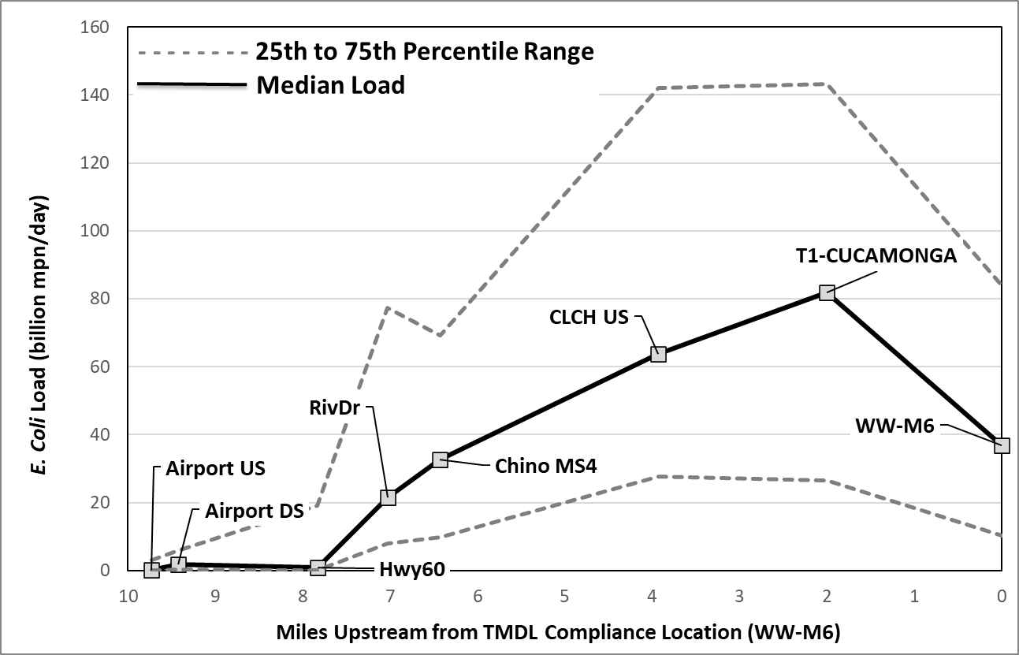
- Lastly, A reduction of E. coli load (~40 billion MPN/day) between T1-CUCAMONGA and the TMDL compliance monitoring site at WW-M6 is shown in the figure. This apparent reduction is largely attributed to removal of bacteria within the MCW (see Section 4.1.1).
Figure 3-20. Longitudinal Profile of Dry Weather E. coli Loads within Cucamonga Creek (n = 70; 2017-2025)

Bacteroides Analysis
Elevated levels of FIB have been observed in waterbodies in the MSAR watershed; however, not all sources of bacteria are known. Regulatory agencies commonly assess the microbial river water quality by determining the concentration of FIB using culture-based assays for total coliforms, fecal coliforms and E. coli, because these assays are quick, economical, and considered the gold standard for monitoring (Li et al. 2020). However, FIB measurements cannot determine whether the bacteria originate from human, animal, or natural sources (i.e., plants, sediments, etc.; Litton et al. 2010). Understanding the sources and categories of FIB is important so that the various contributions of FIB can be determined and public health risks can be assessed (Soller et al. 2010, 2014, Gitter et al. 2023).

Use of Microbial Source Tracking Techniques in the Synoptic Study
An important objective of the Synoptic Study was to use MST techniques to determine the extent to which human sources may or may not be contributing to elevated
E. coli concentrations in the samples collected. The USEPA recommends the use of MST techniques for the following purposes:
- TMDL support tool
- Prioritization of impaired sites for remediation
- Evaluation of BMPs
- Support of stormwater discharge management
- Assessment of potential waterborne health risks (Shanks 2018).
Consistent with USEPA, the human bacteria marker was analyzed for the Synoptic Study solely to provide information and to support ongoing efforts to implement CBRP requirements to mitigate controllable sources of E. coli. The microbial source analysis provides no information regarding compliance with Basin Plan E. coli objectives to protect the REC1 beneficial use. Thus, any results from the Synoptic Study microbial source analysis are informational only and have no bearing on compliance with water quality objectives or TMDL WLAs.
Host-associated genetic markers that allow for the identification of human gut bacteria, Bacteroides, by qPCR have been widely used and approved by USEPA, standard method, 1696 (SM 1696; USEPA 2019). The human-host Bacteroides HF183 marker (or human marker) can also be quantified using newer PCR technology, the droplet digital PCR (ddPCR) technique (Hart et al., 2022). This technology is a modification of the SM 1696, using the same primer/probe sequences as the qPCR assay that target the HF183 16S rRNA gene cluster of Bacteroides, but uses a ddPCR platform (BioRad, Hercules, CA). The ddPCR approach has demonstrated greater tolerance for environmental inhibitors and provides direct quantification of the genes when compared to qPCR (Hart et al., 2022). An important characteristic of molecular assays, including ddPCR, is that they detect DNA from both viable and non-viable cells, including extracellular DNA, and thus, do not discriminate between living and dead microorganisms (Bae et al., 2008; Steinbacher et al., 2025). The ddPCR assay was used in the 2025 Synoptic Study to determine the concentration of the human-host Bacteroides HF183 marker in water or channel bottom sediment samples. To facilitate understanding of the findings from this study, the following section provides additional information regarding sample collection, laboratory analysis, and data interpretation (also see the Study Plan and QAPP for the Synoptic Study for additional information; SAWPA (2025). Data results are provided in subsequent sections.

Evaluation of the HF183 Human Marker at Synoptic Study Sites
As described above, water samples were collected from the study sites to determine (a) E. coli concentrations; and (b) the concentration of the Bacteroides HF183 human marker. The approximate concentration of the HF183 gene is determined directly by counting the total number of positive reactions, and Poission distribution, as described below.
A 100mL grab samples of surface water was collected in IDEXX bottles and concentrated using polycarbonate filters as described previously (SM 1696; USEPA 2019). Purified total DNA was extracted via a commercial kit as described previously (USEPA 2019). Purified DNA extracts (5uL) were analyzed by ddPCR as described previously (Cao et al., 2105). Each ddPCR run included two no-template controls (NTC), extraction controls, filter blanks, and positive controls as described by Cao et. al., 2015 to obtain high quality data. All samples were run in duplicates. Samples are considered positive for the human marker HF183 when at least four droplets throughout the two duplicate wells are positive. All ddPCR reactions were run in duplicates, including field blanks. Both positive controls that contain reference DNA material and negative controls that contain no DNA material were run in duplicate for proper implementation of the ddPCR assay to obtain high quality data. No low levels of the human marker were detected in any of the negative controls.
For the purposes of this study, the concentration of the HF183 in positive samples is reported as gene copies (gc)/100mL. The Limit of Detection (LOD) for the HF183 assay is reported at approximately 50 gene copies (gc)/100mL. Samples with estimated results less than LOD, (if the HF183 gene was amplified in less than four droplets) are reported as Not Detected, in place of concentration (Cao et al., 2105).
For all samples, the concentration of the HF183 gene is determined directly by counting the total number of positive reactions, and Poission distribution is used to calculate the absolute concentration of the genes (Cao et al., 2105; Curtis et al., 2024). For ddPCR, the concentration is determined by a direct statistical count, unlike qPCR, which relies on relative quantification based on standard curve. Therefore, ddPCR removes the run-to-run variability and bias associated with standard curves.
Specifically, for the Synoptic Study, the frequencies and mean concentrations were reported using the following accepted approach (Cao et al. 2016):
- A positive sample is any sample in which the HF183 gene was amplified in any of the two ddPCR replicates.
- A negative sample is a sample where the results are less than LOD (approximately 50gc/100mL)
- Where results were reported as Not Detected, HF183 concentration was not calculated
- The mean concentration was calculated by summing the results (gene copies/reaction) from all positive samples and dividing by the total number of positive samples observed during the study.
For this study, the mean concentration of gene copies is provided as a quantifiable estimation of the human marker, HF183, that can be compared within a given watershed or overtime. This is additional information was used to prioritize sites; it has no implications towards compliance with water quality objectives or TMDLs.

Bacteroides HF183 Gene Concentrations in POTW Effluent Samples
The human marker HF183 gene was LOD in the analyzed POTW effluent samples (Table 3-7). In these samples, the concentration of HF183 gene was too low to be amplified and quantified using the described ddPCR assay.
Table 3-7. HF183 Results for POTW Effluent Samples
Site Type | Site ID | HF183 Results (gene copies/100mL)¹
Site Type | Site ID | Week1 | Week 2 | Week 3 | Week 4 | Week 5
POTW Effluent | Rialto WWTP | LOD | LOD | LOD | LOD | LOD
POTW Effluent | RIX | LOD | Not Tested | LOD | LOD | LOD
POTW Effluent | Riverside WQCP | LOD | Not Tested | LOD | LOD | LOD
POTW Effluent | RP1 | Not-Detected | LOD | LOD | LOD | LOD
¹Week 1=8/4-8/7/2025; Week 2=8/11-8/14/2025; Week 3=8/18/-8/21/2025; Week 4=8/25/-8/28/2025; Week 5=9/02/-9/04/2025
LOD = limit of detection, approximately 50 gene copies/100mL

Bacteroides HF183 Gene Concentrations at Watershed-wide and Mainstem Santa Ana River Sites
The human marker at the watershed wide compliance sites and mainstem Santa Ana River sites was detected at a frequency of approximately 40% with a range of 112-129,564 gc/100ml of HF183, with a mean concentration of 13,523.1 gc/100mL (Table 3-8).
Across the watershed wide compliance sites HF183 was detected at a frequency of approximately 45%, with concentrations ranging from 112 to 129,564 gc/100mL. The detection patterns varied by site, Chino Creek at Central Ave (WW-C7) yielded no detections throughout the 5-week sampling period; Mill-Cucamonga Crk (WW-M6) yielded a single detection (approximately 178gc/100mL at Week 5); and SAR@MWD Crossing (WW-S1) and SAR@ Pedley Ave (WW-S4) showed consistent detections following Week 1. (Table 3-8).
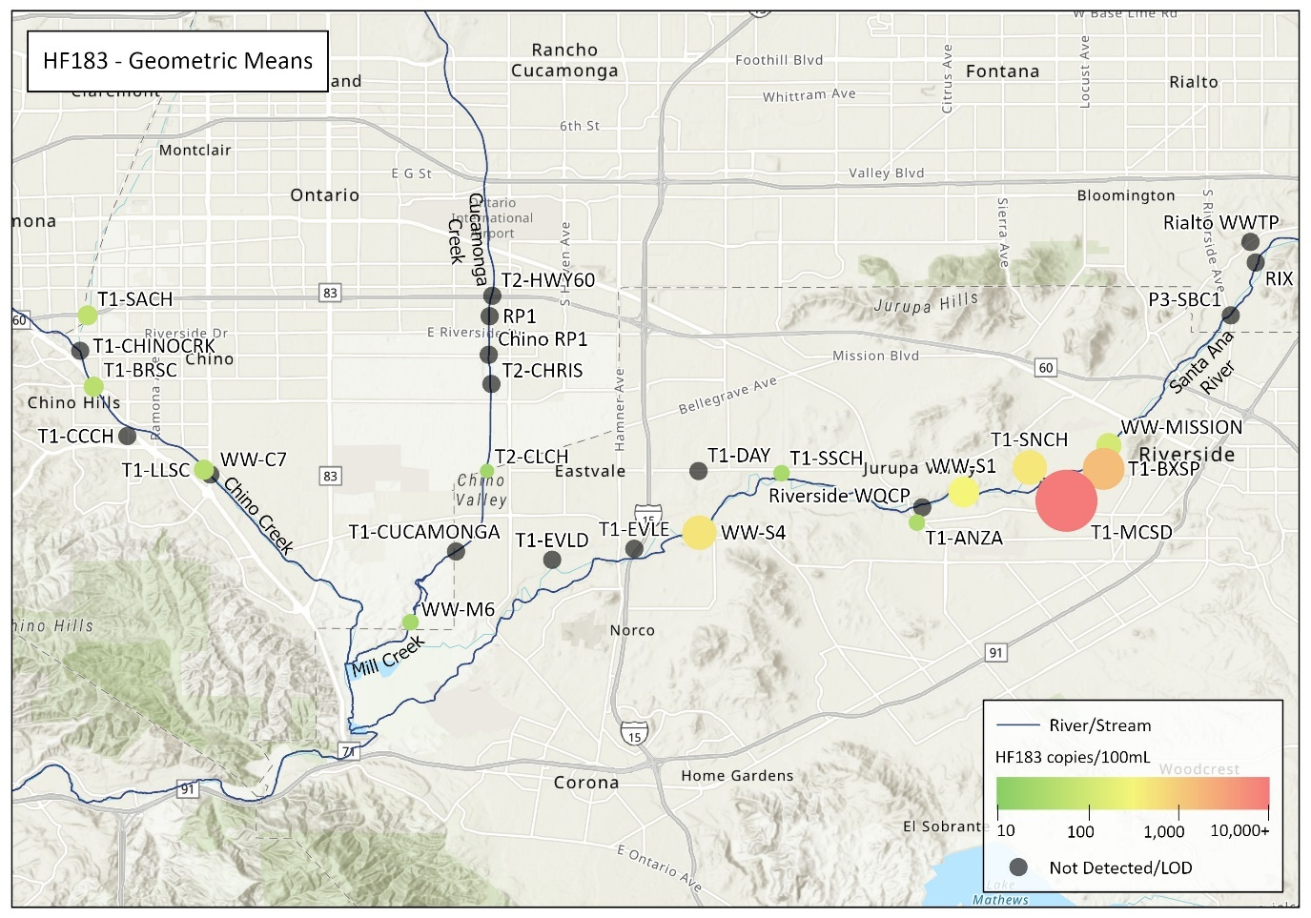
Notably, at Santa Ana River Reach 3, two distinctly elevated detections of HF183 occurred at SAR@ Pedley Ave WW-S4 (approximately 129,564 gc/100mL at Week 4), and at SAR@ MWD Crossing WW-S1 (approximately 30,271 gc/100mL at Week 5). While both of these Reach 3 sites are downstream of Tier 1 inflows, they yielded elevated human marker concentrations, indicating a concentrated human marker source at these locations. The WW-S4 yielded a disproportionately higher concentration of the human marker that was approximately 4 times greater when compared to the WW-S1 concentration, indicating a localized contamination source for the human marker HF183. A heatmap of HF183 geometric mean concentrations is provided in Figure 3-21.
Figure 3-21. HF183 Geometric Mean Concentrations for Water Quality Samples Collected During the 2025 Synoptic Study
Upstream from MS4 inflows, detections of HF183 were observed at WW-MISSION in 3 of 5 weeks, with a range of 221-445 gc/100mL. In contrast, Reach 4 (P3-SBC1) showed no detections of the human marker, HF183, during the 5 weeks sampling period (Table 3-8). Thus, a localized source between the Riverside Drive and Mission Avenue bridges may exist. Field observations documented homeless encampments upstream and downstream of Mission.

Table 3-8. HF183 Results at Watershed-wide Compliance Sites and Other Non-Compliance Sites in the Mainstem Santa Ana River
Site Type | Site ID | HF183 Results (gene copies/100mL)¹
Site Type | Site ID | Week 1 | Week 2 | Week 3 | Week 4 | Week 5 | Geomean¹
Watershed-wide Compliance | WW-C7 | LOD | LOD | LOD | LOD | LOD | LOD
Watershed-wide Compliance | WW-M6 | LOD | LOD | LOD | LOD | 177.9 | 27
Watershed-wide Compliance | WW-S1 | LOD | 112.1 | 156.6 | 210.7 | 30,270.8 | 309
Watershed-wide Compliance | WW-S4 | LOD | 157.8 | 207.2 | 129,564.2 | 415.7 | 535
Santa Ana River Mainstem | MISSION | 338.4 | 444.8 | LOD | LOD | 220.9 | 116
Santa Ana River Mainstem | P3-SBC1 | LOD | LOD | LOD | LOD | LOD | LOD
¹Week 1=8/4-8/7/2025; Week 2=8/11-8/14/2025; Week 3=8/18/-8/21/2025; Week 4=8/25/-8/28/2025; Week 5=9/02/-9/04/2025
² For geometric mean calculation purposes, 0.5* LOD was used for LOD samples and 0.1* the LOD was used for Non-Detect results
LOD = limit of detection, approximately 50 gene copies/100mL
Recent studies have shown that in addition to defecation, human activities such as wading, bathing, handwashing, and laundry can contribute to HF183 concentrations (Li et al. 2022), although to a lesser extent. Sewage exfiltration can also be a potential source of human marker (Schiff et al., 2023; Schiff et al., 2025). Both of these types of sources can account for the elevated HF183 and E. coli concentrations observed during the 2025 Synoptic Study.

Bacteroides HF183 Gene Concentrations at Tier 1 Sites
For Tier 1 sites the human marker was detected at a frequency of approximately 32% with the concentrations ranging from 73 to 33,413 gc/100mL of human marker, HF183 (Table 3-9). The human marker was not detected at Chino, Carbon Canyon (CCCH), and Cucamonga Creeks, and at Eastvale MPD Line D &E (Table 3-9). However, the human marker HF183 was consistently detected at Box Springs (T1-BXSP), Magnolia Center (T1-MCSD), and Sunnyslope Channel (SNCH; Table 3-9). The human marker concentration was the highest at Magnolia Center (T1-MCSD) and at Box Springs (T1-BXSP), with geometric mean concentration of approximately 26,614 gc/100ML and 1,574 gc/100mL respectively. A heatmap of HF183 geometric mean concentrations at Tier 1 and Tier 2 sites is provided in Figure 3-20.
Bacteroides HF183 Gene Concentrations at Tier 2 Sites
For Tier 2 sites the human marker was detected at a lower frequency when compared to Tier 1 sites because Tier 2 sites were located within the Cucamonga Creek watershed, where HF183 was minimally present. The frequency of detection of the human marker, HF183 was approximately 10% due to HF183 detection on 8/21/25 at County Line Channel (T2-CLCH, 128gc/100mL; Table 3-9). At the remaining Tier 2 sites, the human marker was not detected during the five week sampling period.
Table 3-9. HF183 Results at Tier 1 and Tier 2 Sites
Site Type | Site ID | HF183 Results (gene copies/100mL)¹
Site Type | Site ID | Week1 | Week 2 | Week 3 | Week 4 | Week 5 | Geomean²
Tier 1 | T1-SACH | 2,036 | LOD | LOD | LOD | LOD | 60
Tier 1 | T1-CHINOCRK | LOD | LOD | LOD | LOD | 178 | LOD
Tier 1 | T1-BRSC | LOD | 151 | LOD | 249 | LOD | 51
Tier 1 | T1-CCCH | LOD | LOD | LOD | LOD | LOD | LOD
Tier 1 | T1-LLSC | 536 | LOD | LOD | LOD | LOD | 46
Tier 1 | T1-CUCAMONGA | Not Detected | LOD | LOD | LOD | LOD | LOD
Tier 1 | T1-BXSP | 238 | 801 | 755 | 910 | 33,413, 3,477³ | 1,574
Tier 1 | T1-MCSD | 123,768 | 14,540 | 30,145 | 15,346 | 16,040 | 26,614
Tier 1 | T1-SNCH | 330 | 134 | 540 | 1,565 | 609 | 469
Tier 1 | T1-EVLD | Not Detected | LOD | LOD | LOD | LOD | LOD
Tier 1 | T1-EVLE | Not Detected | LOD | LOD | LOD | LOD | LOD
Tier 1 | T1-ANZA | 109 | LOD | LOD | LOD | LOD | 34
Tier 1 | T1-SSCH | LOD | 73 | LOD | LOD | LOD | 31
Tier 1 | T1-DAY | LOD | LOD | LOD | LOD | LOD | LOD
Tier 2 | T2-CHRIS | Not Detected | LOD | LOD | LOD | LOD | LOD
Tier 2 | T2-CLCH | Not Detected | LOD | 128 | LOD | LOD | 25
Tier 2 | T2-HWY60 | Not Detected | LOD | LOD | LOD | LOD | LOD
Tier 2 | T2 – CHINO RP1 | Not Detected | LOD | LOD | LOD | LOD | LOD
¹ Week 1=8/4-8/7/2025; Week 2=8/11-8/14/2025; Week 3=8/18/-8/21/2025; Week 4=8/25/-8/28/2025; Week 5=9/02/-9/04/2025
² For geometric mean calculation purposes, 0.5* LOD was used for LOD samples and 0.1* the LOD was used for non-detect samples
³ T1-BXSP additional sample collected 9/4/25 HF183.
LOD = limit of detection, approximately 50 gene copies/100mL

Relationship between E. coli Concentrations and Bacteroides Detections
Microbial decay and persistence of microorganisms are driven by environmental conditions including water matrix properties, sunlight, temperature, pH, humidity, salinity, predation, and organic matter (Ahmed et al., 2019). Bacteroides persistence in surface waters varies considerably, ranging from 1 to 14 days depending on environmental conditions, with an average of 3–4 days. This is influenced by temperature, ultraviolet inactivation, and predation by other microorganisms (Kreader, 1998; Bell et al., 2009; Boehm et al., 2020; Ahmed et al., 2019). Temperature particularly affects decay rates, with Bacteroides persisting longer at lower temperatures than at higher temperatures (Bell et al., 2009).
The variability in both human marker and E. coli concentrations observed across the Tier 1 sites reflects these environmental decay patterns. While previous studies documented similar variability in receiving waters (Gedalanga et al., 2019; Litton et al., 2010), unique MS4 conditions may influence the decay patterns and the variability observed in this study.
The relationship between the human marker and E. coli concentrations shows the effectiveness of using the combination of bacterial indicators as paired measurements to assess potential health risks to recreational users. The E. coli data were divided into two datasets:
- E. coli concentrations where HF183 was not detected
- E. coli concentrations where HF183 was detected and quantified
Figure 3-22 compares these datasets for (a) all Santa Ana River sites (Watershed-wide compliance and Mainstem River sites); and (b) all MS4 sites (Tier 1 and Tier 2). The difference in the stratified datasets was shown to be statistically significant (p value < 0.05) for MS4 sites (Table 3-10) and for receiving water sites (Table 3-11).
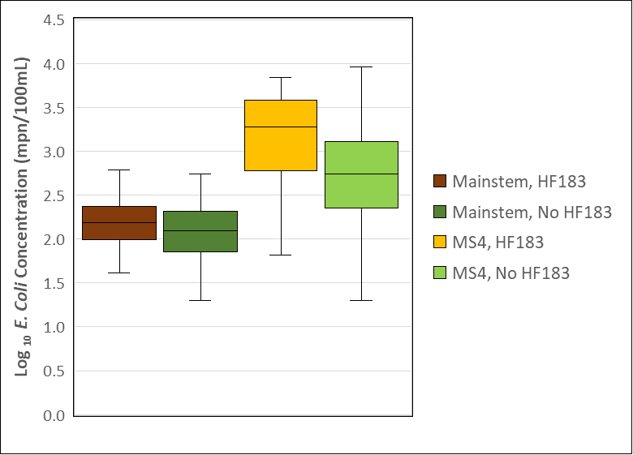
Note: y-axis is in Log₁₀ scale.
Figure 3-22. Box-Whisker Plots of E. coli Concentrations in Samples with/without Detection/Amplification of HF183 for MS4 and Mainstem Sites
Table 3-10. Student T-Test Results Comparing E. coli Concentrations in Samples with/without Detection Human Marker HF183 for all Tier-1 and 2 Sites
E. coli Data Set | n | E. coli Geomean (MPN/100 mL) | P-Value¹
Human Marker HF183 Detected | 22 | 1,763 | 0.009*
Human Marker HF183 Not Detected | 68 | 597 | 0.009*
¹ Statistically significant, p-value < 0.05

Table 3-11. Student T-Test Results Comparing E. coli Concentrations in Samples with/without Detection of Human Marker HF183 for Mainstem Samples
E. coli Data Set | n | E. coli Geomean (MPN/100 mL) | P-Value
Human Marker HF183 Detected | 12 | 288 | 0.029
Human Marker HF183 Not Detected | 18 | 161 | 0.029
¹ Statistically significant, p-value < 0.05
The geomean of E. coli concentration was approximately 3 times greater in MS4 samples where human source was detected (Table 3-10). Additionally, the geomean of E. coli concentration was approximately 1.8 times greater in the Santa Ana River (Mainstem) samples where a human source was detected (Table 3-11). The findings from these analyses suggest that the presence of human sources can impact the concentration and loading of FIB and significantly increase the E. coli concentrations at the Santa Ana River.
During the five (5) week sampling period a positive correlation between HF183 and E. coli concentrations at Magnolia Center Storm Drain (T1-MCSD) was observed. High concentrations of the human marker were persistently identified at the Magnolia Center Storm Drain site (T1-MCSD) where the geometric mean concentration was 26,614 gc/100MLwith an estimated highest concentration at 123,768 gc/100mL. High E. coli concentrations corresponded with the high gene copy numbers at T1-MCSD, especially during weeks 4 and 5, when E. coli concentrations were 10,000 and 18,500 MPN/100 mL, respectively. Notably, a positive correlation between HF183 and the E. coli concentrations at Box Springs (T1-BXSP) was observed. Relatively high concentrations of the human marker were persistently identified at Box Springs (T1-BXSP) where the geometric mean concentration was 3,477 gc/100mL HF183, with an estimated highest concentration at 33,413 gc/100mL. High E. coli concentrations corresponded with the high gene copy numbers at T1-BXSP, with an E. coli geometric mean of 4,801 MPN/100mL.
Few exceptions to the correlation of HF183 and E. coli concentration do exist. For example, at Cucamonga Creek (T1-CUCAMONGA), high concentrations of E. coli were observed, but the human marker HF183 was consistently absent. The same pattern was observed at Day Creek (T1-DAY) and San Sevaine Channel (T1-SSCH), where the highest concentration of E. coli (24,000 MPN/100 mL) was observed but HF183 was low to not detected.

Tier 1 Site Prioritization

Prioritization Analysis
Based on the findings from the Synoptic Study, Tier 1 sites were prioritized for further source evaluation activities. This is the fourth prioritization of Tier 1 sites since implementation of the TMDL began in 2007. Previous prioritizations were completed in 2009 (SAWPA 2009), following implementation of the first MSAR watershed TMDL-related studies in 2007-2008, 2013, as an outcome of the 2012 Tier 1 source evaluation study (SAWPA 2013), and 2020, as an outcome of the 2019 synoptic study.
The 2025 prioritization update was performed on the complete set of Tier 1 sites (six sites in Bernardino County and eight sites in Riverside County). An additional four Tier 2 sites within the Cucamonga Creek watershed were also included in the 2025 prioritization analysis. These Tier 2 sites are all nested within the drainage area to T1-CUCAMONGA. A description of the 18 sites included in the 2025 synoptic study is provided in Table 3-12.
Table 3-12. Tier 1 and Tier 2 Sites for Prioritization
Waterbody | Site ID | Description | Lat | Long
Santa Ana River | T1-ANZA | Anza Drain | 33.9586 | -117.4631
Santa Ana River | T1-BXSP | Box Springs Channel | 33.9758 | -117.4035
Santa Ana River | T1-SNCH | Sunnyslope Channel | 33.9762 | -117.4271
Santa Ana River | T1-SSCH | San Sevaine Channel | 33.9743 | -117.5064
Santa Ana River | T1-DAY | Day Creek | 33.9750 | -117.5329
Santa Ana River | T1-MCSD | Magnolia Center Storm Drain | 33.9655 | -117.4154
Santa Ana River | T1-EVLD | Eastvale Line D | 33.9467 | -117.5797
Santa Ana River | T1-EVLE | Eastvale Line E | 33.9502 | -117.5534
Chino Creek | T1-BRSC | Boys Republic South Channel | 34.0020 | -117.7261
Chino Creek | T1-CCCH | Carbon Canyon Creek Channel | 33.9862 | -117.7154
Chino Creek | T1-SACH | San Antonio Channel | 34.0247 | -117.7281
Chino Creek | T1-CHINOCRK | Chino Creek upstream of San Antonio Channel | 34.0134 | -117.7305
Chino Creek | T1-LLSC | Lake Los Serranos Channel | 33.9754 | -117.6910
Mill-Cucamonga Creek | T1-CUCAMONGA | Cucamonga Creek at Hellman | 33.94936 | -117.61034
Mill-Cucamonga Creek | T2-CLCH | County Line Channel | 33.97501 | -117.60044
Mill-Cucamonga Creek | T2-HWY60 | Cucamonga Creek at Hwy 60 | 34.03098 | -117.59887
Mill-Cucamonga Creek | T2-CHRIS | Chris Basin outflow to Cucamonga Creek | 34.00277 | -117.59906
Mill-Cucamonga Creek | Chino RP1 | East bank of Cucamonga Creek upstream of Chino Avenue | 34.01218 | -117.59990
For this prioritization, the relative rankings of each site based on application of four criteria were used to create a composite bacteria prioritization score (BPS) for Tier 1 or 2 sites. These criteria included:
- Criterion 1 – Median urban DWF generation rate (gal/ac/day) from the subwatershed that drains to the Tier 1 or 2 site. Figure 3-23 illustrates DWF generation rates at each Tier 1 or 2 site over the study period. Days with no flow were included in the analysis as zeros. This criterion is changed from prior BPS estimates by using the median rather than average DWF rate. This change prevented skewed averages associated with measured DWF during a few site visits that was substantially higher in just 1 of 5 weeks as is apparent in Figure 3-29. In such instances, the source of DWF is presumed to be associated with a point source discharge rather than urban stormwater.
- Criterion 2 - Median E. coli loading (MPN/day). Figure 3-24 illustrates E. coli loads observed at each Tier or 2 1 site over the study period. This criterion is unchanged relative to previous prioritization analyses.
- Criterion 3 – Geometric mean concentrations of human Bacteroides HF183. Criteria scores were assigned based on Table 3-13 below. Figure 3-25 illustrates the geometric mean HF183 Bacteroides marker concentration at each Tier 1 or 2 site. This approach for criterion 3 is changed from previous prioritization analysis that employed a frequency of detection for HF183.
Table 3-13. HF183 Criteria Scores
HF183 Geometric Mean Result (copies/100mL) | Associated Criteria Score
ND/LOD | 0
<100 | 25
100-1,000 | 50
1,000-10,000 | 75
10,000+ | 100
- Criterion 4 - Risk of exposure rating (low or high) with regards to recreation activity. The first three criteria are computed from data collected during the five week of consecutive monitoring at each Tier 1 or 2 site from the week of August 4, 2025 through the week of September 2, 2025. For the risk of exposure criterion, each site was assigned either a low (0) or high score (100) based on the following principles, regardless of the degree of hydrologic connectivity observed during field visits:
- Low – Completely concrete-lined MS4 channel that outfalls to a concrete-lined receiving waterbody segment.
- High – Natural channel characteristics are present anywhere within MS4 channel and/or the Tier 1 outfall discharges to a natural channel segment of a receiving waterbody.
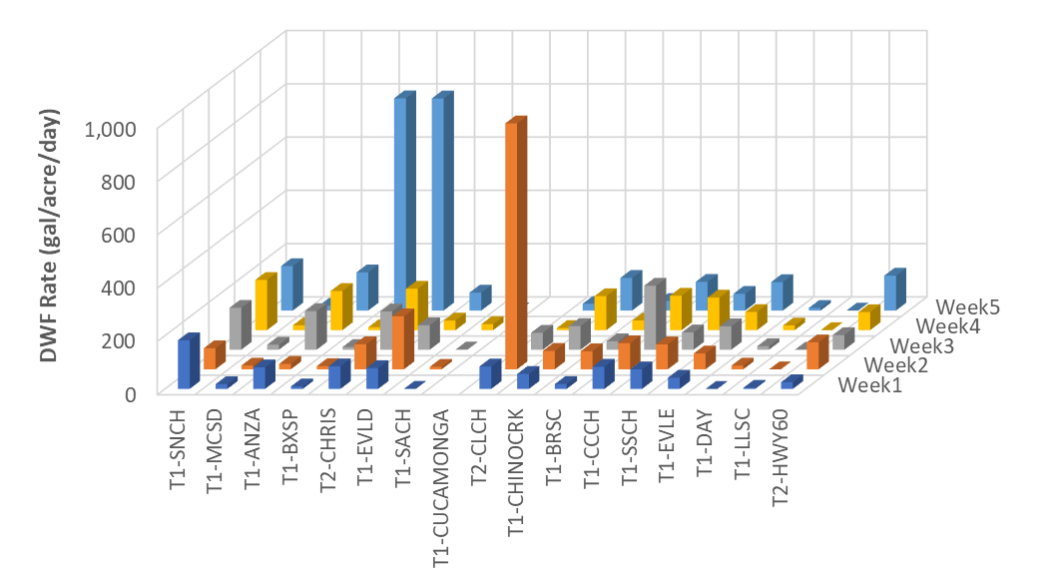
Figure 3-23. DWF Generation Rates at Each Tier 1 Site on Synoptic Study Sample Dates
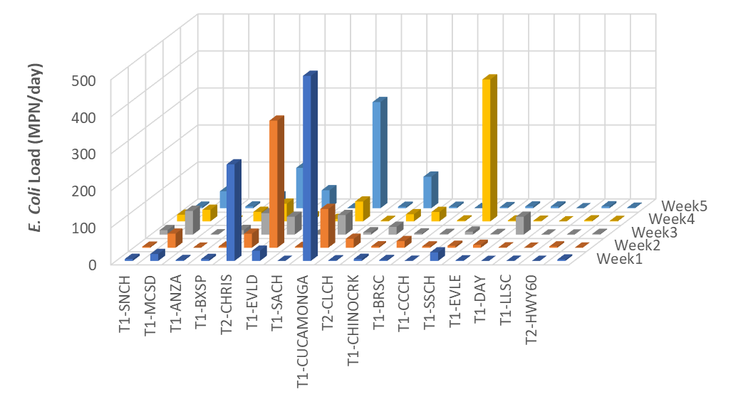
Note: Week 1 at T1-CUCAMONGA truncated in plot – value is 3,488 MPN/day
Figure 3-24. E. coli Loads at Each Tier 1 Site on Synoptic Study Sample Dates

Note: Sites with no data bars indicate results were ND/LOD for 5 of 5 samples.
Figure 3-25. Concentration of Detected HF183 at Tier 1 and 2 Sites
The composite Bacteria Prioritization Score (BPS) was computed through completion of the following calculation/categorization activities:
- For Criteria 1 and 2, determine the relative rank of the site among the 18 Tier 1 or 2 sites. This ranking was determined by (a) calculating the median criterion value at each site over the five-week sample period; and then (b) normalizing the relative rank of the range of observed average values to a range of 0 to 100.
- For Criteria 3, scores were assigned based on Table 3-13.
- For Criterion 4 (risk of exposure), sites with high risk (sites with at least some natural characteristics) were given a score of 100 and sites with low risk (concrete-lined, engineered sites) are given a score of zero.
- To calculate the composite BPS for each site, weighting factors were applied as multipliers to each of the four criteria:
- Criterion 1: Median DWF generation rate = 0.3 (30% weight)
- Criterion 2: Median E. coli load = 0.3 (30% weight)
- Criterion 3: HF183 score = 0.3 (30% weight)
- Criterion 4: Risk of exposure = 0.1 (10% weight)
The composite BPS for each Tier 1 site is computed as the sum-product of the rank value of each criterion multiplied by the appropriate weighting factor (see above), e.g., BPS = [(Criteria 1 * weighting factor) + (Criteria 2 * weighting factor) + (Criteria 3 * weighting factor) + (Criteria 4 * weighting factor)]. The resulting score is rounded to the nearest whole number. For example, the BPS score for the T1-MCSD site is calculated as follows:
BPS = [(25 * 0.3) + (36 * 0.3) + (100 * 0.3) + (100 * 0.1)] = 58
Table 3-14 provides the normalized criteria scores for each criterion for each site and the resulting composite BPS score (right hand column). Figure 3-26 categorizes the sites as high (BPS score = 55-100; red), Medium (BPS score = 25-55, yellow) or Low (BPS score = 0-25, green) priority.
Table 3-14. Relative Rank Results for each Prioritization Criterion and the Final Composite Score for each Tier 1 Site
Tier 1 Site | Normalized Score (0 to 100) for Prioritization Criteria |  |  |  | Composite BPS
Tier 1 Site | Criterion 1  Urban DWF (gal/acre/day)  Weight = 0.3 | Criterion 2  E. coli Loading (MPN/Day)  Weight = 0.3 | Criterion 3  Bacteroides Concentration (MPN/100mL)  Weight = 0.3 | Criterion 4  Risk of Exposure  Weight = 0.1 | Composite BPS
T1-MCSD | 100 | 5 | 100 | 100 | 58
T1-SNCH | 25 | 36 | 50 | 100 | 57
T1-CUCAMONGA | 75 | 100 | 0 | 0 | 53
T2-CHRIS | 88 | 2 | 0 | 100 | 45
T1-ANZA | 13 | 12 | 25 | 100 | 44
T1-BXSP | 94 | 55 | 75 | 0 | 40
T1-EVLD | 63 | 46 | 0 | 0 | 33
T1-SSCH | 6 | 0 | 25 | 0 | 27
T1-CHINOCRK | 38 | 4 | 0 | 0 | 26
T1-CCCH | 69 | 18 | 0 | 0 | 25
T2-CLCH | 31 | 4 | 25 | 0 | 20
T1-BRSC | 81 | 2 | 25 | 0 | 18
T1-DAY | 56 | 8 | 0 | 0 | 16
T1-EVLE | 50 | 2 | 0 | 0 | 16
T2-HWY60 | 19 | 2 | 0 | 100 | 14
T1-SACH | 0 | 0 | 25 | 0 | 9
T1-LLSC | 44 | 3 | 25 | 0 | 8
Chino-RP1 | n/a ² | 1 | 0 | 0 | 0
¹ Estimate of DWF generation rate for T1-CUCAMONGA is sum of DWF at three upstream Tier 2 sites with no POTW effluent (T2-Hwy60, T2-CHRIS, and T2-CLCH) divided by the drainage area to these three MS4 drainage areas
² DWF at this site is entirely from RP1 discharge and thus no contains no discharge from urban MS4 systems.

Changes in Tier 1 Site Prioritization Over Time
The 2025 Synoptic Study results are compared to outcomes from previous prioritization analyses completed for the Riverside and San Bernardino MS4 Programs CBRPs (RCFC&WCD 2011; SBCFCD 2011) and 2013 Triennial Report (SAWPA 2013) (Table 3-15). Sites categorized as high priority in 2025 are similar to those conducted in 2019 but are substantially different from previous analyses. Changes in the prioritization may be attributed to effective CBRP implementation in some subwatersheds (e.g., T1-BRSC, Boys Republic South Channel) or issues that have arisen from potentially new bacteria sources in other subwatersheds (e.g., T1-MSCD, Magnolia Center Storm Drain). Other considerations that affected the changes in prioritization included:
- Transition of all sites upstream of Cucamonga Creek at Hellman (T1-CUCAMONGA) from Tier 1 to Tier 2 sites (result of removal of REC1 beneficial use on Cucamonga Creek upstream of Hellman Avenue);
- Differences in the prioritization methods over the three independent analyses (e.g., use of bacteria load instead of concentration, use of HF183 geometric mean concentrations rather than presence/absence, and consideration of potential area contributing to DWF rather than just the average DWF rate).

Note: red = high priority; yellow = medium priority; green = low priority
Figure 3-26. Bacteria Prioritization Score for Tier 1 and 2 Sites

Table 3-15. Changes to Prioritization Category for Tier 1 or 2 Subwatersheds with Active DWF Since TMDL Implementation Initiated in 2007 (NM = Not Measured)
Tier 1 or 2 Site | Prioritization Outcome
Tier 1 or 2 Site | CBRP¹ (Based on 2007-2008 Data) | 2013 Triennial Report² (Based on 2012 Data) | 2020 Triennial Report³ (based on 2019 Data) | 2025 Synoptic Study Findings
T1-MCSD | NM | Low | High | High
T1-SNCH | Low | Low | High | High
T1-ANZA | Low | High | High | Moderate
T1-CUCAMONGA | NM | NM | High | Moderate
T1-EVLD | NM | High | NM | Moderate
T1-SSCH | Moderate | High | High | Moderate
T1-BXSP | High | Low | Moderate | Moderate
T1-CHINOCRK | NM | High | Moderate | Moderate
T2-CHRIS⁴ | High | High | NM | Moderate
T1-BRSC | NM | High | Moderate | Low
T1-DAY | Moderate | Low | Moderate | Low
T1-CCCH | Low | Low | Moderate | Low
T1-SACH | Moderate | Low | Low | Low
T1-LLSC | NM | Low | Low | Low
T1-EVLE | NM | High | NM | Low
T1-EVLB | NM | High | NM | NM
T1-EVLA | NM | High | NM | NM
T1-TEMESCAL | Low | NM | NM | NM
T2-CLCH⁴ | High | Low | NM | Low
T2-CFRN⁴ | NM | Low | NM | NM
T2-CNRW⁴ | NM | Low | NM | NM
T2-Hwy60⁴ | Low | Low | NM | Low
Chino-RP1 | NM | NM | NM | Low
¹ RCFC&WCD 2011; SBCFCD 2011
² SAWPA 2013
³ SAWPA 2020
⁴ Re-categorized as Tier 2 after REC1 use removed from Cucamonga Creek Reach 1 (see text)

Uncontrollable, Non-MS4 Bacteria Sources
Consistent with the many iterations of the source contribution analyses completed over a number of years, studies have shown that sources of fecal bacteria exist in the MSAR watershed that cannot be attributed solely to MS4 discharges. Historically, the basis for quantifying non-MS4 sources has involved a process of elimination, subtracting measured inflows from the MS4 from measured loads within the receiving waters.
In 2015, RCFC&WCD implemented the Uncontrollable Bacteria Sources Study (RCFC&WCD 2016), which evaluated the potential for uncontrollable sources of E. coli to influence E. coli concentrations in the MSAR watershed. For example, this study found that E. coli levels were higher in biofilm/sediment samples than levels in overlying water samples by as much as four orders of magnitude, indicating that biofilm/sediment behave as a reservoir for E. coli. In contrast, the outcome from investigations into other potential uncontrollable sources, e.g., feral pigs, did not point to any predominant sources responsible for elevated levels of E. coli. The following sections discuss different potential types of non-MS4 sources of bacteria to the MSAR watershed.
Previous studies of uncontrollable sources in MSAR watershed were inconclusive and suggested the in-stream loading could not be attributed to a specific host species (human, dog, bird, pig, or horse). By process of elimination, the 2020 Triennial TMDL report hypothesized that colonization in SAR bottom sediment and releases to overlying water could be an important source for further study.
Fecal bacteria from a specific host released to the environment can settle to the channel bottom and survive within sediments or biofilms for weeks or months over a wide range of temperature and moisture conditions (Balzer et al 2010). Colonization by these initially deposited fecal bacteria within channel bottom sediments and biofilms results in colonies, where the majority of the population may be considered naturalized (Ishii et al. 2007; Byappanahalli et al. 2012; Ran et al. 2013). Processes including sloughing, desorption, and shearing can release naturalized bacteria from sediment and biofilms to the water column (Litton et al. 2011; Byappanahalli et al. 2003; Jamieson et al. 2005; Reeves et al. 2003; Solo-Gabriele and Perkins 1997; Whitman and Nevers 2003). Scour events can occur during dry weather conditions in the MSAR watershed, as evidenced by sharp increases in flow rate from de minimis discharges. Importantly, resuspension of bacteria from sediment and regrowth of bacteria in sediment/biofilms are identified as examples of uncontrollable bacteria sources in the Basin Plan (Santa Ana Water Board 2025).
The 2015 Uncontrollable Bacteria Sources Study (RCFC&WCD 2016) found that fecal indicator bacteria in sediment or biofilms from MSAR TMDL tributaries including Anza Channel, Eastvale Line E, and Sunnyslope Channel. E. coli sediment concentrations (as CFU/100g) were 1-2 orders of magnitude higher than in overlying water (as MPN/100mL). This finding demonstrates that naturalized E. coli in tributary streams and flood control channels may explain a significant portion of fecal bacteria loading to the TMDL waters. To supplement the 2015 sampling, bottom sediment samples were collected from flowing MSAR TMDL waters for measurement of fecal indicator bacteria concentration during the 2025 Synoptic Study (Table 3-15). Similar ratios of sediment to overlying water E. coli concentration were observed within the receiving waters as were observed in tributaries, suggesting that the conditions exist to support colonization within the mainstem of the SAR, Mill-Cucamonga Creek, and Chino Creek. E. coli concentrations in bottom sediment of TMDL waters were greatest in the SAR at Mission Avenue (WW-MISSION) and comparable to concentrations of colonies measured in tributary urban streams or flood control channels in 2015. Thus, previous estimation of the potential for this source to explain concentrations in overlying water are validated by site specific data, as follows:
- The potential total population of naturalized E. coli in the top one centimeter (cm) of bottom sediments contained in this segment of the Santa Ana River is estimated to be 800 billion MPN based on a typical value of 80,000 CFU/g of sediment/biofilm (Table 3-16) multiplied by an approximated mass of 1,000,000 kg (68,000 m² * 0.01 meter of sediment * 1,500 kg/m³ bulk density). Thus, average in-stream load at the MISSION site of 162 billion MPN/day could be explained by a shedding rate of ~20 percent per day from the top cm of river bottom sediments.
Table 3-15. Concentrations of E. coli in bottom sediment from MSAR TMDL waters and tributaries
Study | Waterbody | Site | Site E. coli Geomean |  | Ratio
Study | Waterbody | Site | Sediment (CFU/100g) | Water (MPN/100mL) | Ratio
2025 Synoptic Study | Santa Ana River Upstream  Santa Ana River Downstream | P3-SBC1 | 40,248 | 80 | 505
2025 Synoptic Study | Santa Ana River Upstream  Santa Ana River Downstream | WW-MISSION | 193,752 | 378 | 513
2025 Synoptic Study | Santa Ana River Upstream  Santa Ana River Downstream | WW-S1 | 76,484 | 328 | 233
2025 Synoptic Study | Santa Ana River Upstream  Santa Ana River Downstream | WW-S4 | 36,896 | 222 | 166
2025 Synoptic Study | Chino Creek | WW-C7 | 41,023 | 282 | 145
2025 Synoptic Study | Mill-Cucamonga Creek | WW-M6 | 38,330 | 201 | 191
2015 Uncontrollable Sources Study¹ | John Bryant Park | Resusp01 | 24,403 | 106 | 231
2015 Uncontrollable Sources Study¹ | Eastvale Line E | Resusp02 | 165,100 | 971 | 170
2015 Uncontrollable Sources Study¹ | Sunnyslope Channel | Resusp03 | 2,623 | 162 | 16
¹ Data obtained from RCFC&WCD, 2016.

TMDL Implementation Activities
The findings from previous prioritization analyses have provided the basis for the development and implementation of BMP projects in the subwatersheds with the highest priority rankings. Implementation projects include measures implemented to address MS4 and other non-point sources within the 2023-2025 period are summarized in Sections 4.1 and 4.2, respectively.

CBRP Implementation for MS4 Sources
Detailed summaries of MS4 program implementation within the MSAR bacteria TMDL watershed area included in annual countywide stormwater program reports. Several key highlights are reported below for work completed or underway in the 2023-2025 period.

Mill Creek Wetlands - Constructed
The RBMP has shown a steady decline in E. coli concentrations at the Mill-Cucamonga Creek compliance site (WW-M6). Data collected in the SBCFCD 10-week surveys shows that this may be largely attributable to effective bacteria removal in the Mill Creek Wetlands (MCW). The MCW is a seven cell, 52 acre, surface wetland complex that treats a portion of dry and wet weather runoff from Cucamonga Creek. A diversion structure in the west bank sidewall of Mill-Cucamonga Creek captures a portion of the total flow, while the un-diverted flow remains within the mainstem of Mill-Cucamonga Creek to support riparian habitat (Figure 4-1). Tier 2 sampling sites are located at the inflow and outflow from the MCW as well as upstream and downstream of the diversion.
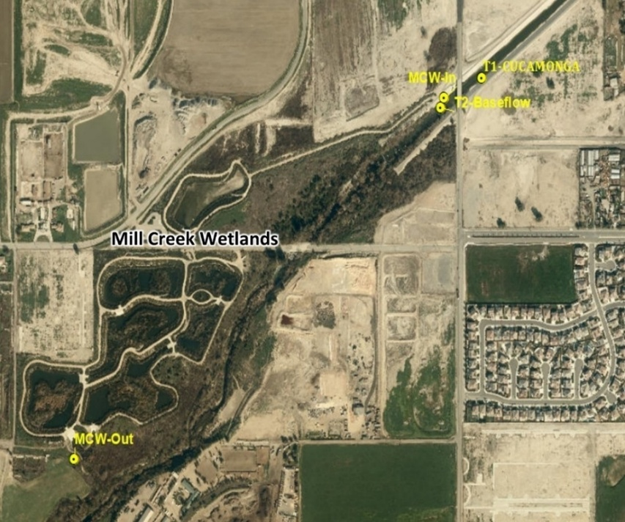
Figure 4-1. Sampling Locations to Assess Effectiveness of the Mill Creek Wetlands
Downstream of Hellman Avenue, a portion of DWF is diverted to the Mill Creek Wetlands for treatment. The remainder is required to stay within Mill-Cucamonga Creek to support riparian habitat. The diversion flow restrictions are documented in a streambed alteration agreement. This agreement is based on older DWF records during a period when RP1 discharge rates were 5-10 times greater than current conditions. Currently, diversions to the MCWs occur on a regular basis, but no continuous metering is conducted on this flow split; therefore, it is challenging to balance upstream and downstream volumes.
Extensive monitoring data (n=70) from the influent and effluent flows and bacterial loads demonstrated an over 90 percent reduction in E. coli load within MCW (Table 3-6). Some of the achieved E. coli load reduction is associated with volume mitigation from losses associated with infiltration or evapotranspiration. A reduction in the concentration in the outflows to levels below the TMDL WLAs were consistently observed. This return of treated effluent with lower E. coli concentration helps to reduce concentrations within Mill-Cucamonga Creek at the compliance monitoring location and has resulted in improved water quality at WW-M6 in recent years (e.g., see Figure 2-2). Further reductions toward the concentration based WLA could be achieved by maximizing the amount of DWF that can be diverted and treated in the wetlands.
Table 4-1. Estimate of Reduction in E. coli Load Resulting from Implementation of the Mill Creek Wetlands BMP, 2017-2025
Mill Creek Wetlands | Median Flow  (cfs) | E. coli Geomean Concentration  (MPN/100 mL) | E. coli Load  (Billion MPN/Day)
Influent | 2.1 | 476 | 24.8
Effluent | 0.7 | 101 | 1.6
Median Removal (%) in MCW | 69% | 79% | 93%
Note: n = 70

Phoenix Storm Drain Diversion - Constructed
The Phoenix Avenue Storm Drain-to-Sewer Diversion Project was completed in July 2021 and operational as of September 9, 2021. This project was the first stormwater-diversion-to-sewer project in Riverside County and serves as a pilot project for future diversions that will be able to address the MSAR TMDL.

Sunnyslope Trash Retrofit Project - Planned
The Sunnyslope Trash Retrofit Project is located near the Rubidoux Nature Center. The project proposes to retrofit the old channel by placing metal trash grates at the downstream end of the channel. The trapezoidal channel will be modified to a rectangular channel near the two most downstream channel access ramps. The metal grates will be designed within the rectangular channel in a way that they will hinge open with the force of the flows to avoid compromising the channel capacity during a 100-year storm event. The channel trash retrofit will help meet objectives to prevent trash and associated bacteria from getting into the Santa Ana River. This will also benefit the critical habitat of the vulnerable Santa Ana Sucker fish. RCFC&WCD will be responsible for operation and maintenance of the trash screening devices and removal of collected material. This project is funded and scheduled for construction in 2026-27.

MSAR Multi-Benefit Water Quality Strategy
RCFC&WCD and the MSAR MS4 Permittees created a broad strategy specific to Reach 3 of the SAR entitled “Toward a Middle Santa Ana River Multi-Benefit Water Quality Strategy”. The goal of this effort is to define an equitable vision for stakeholders to achieve progress towards the beneficial uses of the SAR Reach 3, improve water quality, enhance recreation, improve ecological function, attract waterfront development, increase access to parks, open spaces and greenways. This long term vision brings together multiple considerations including beneficial uses, flood control and groundwater recharge considerations, economic considerations for waterfront development, recreation for walking, running and cycling, and habitat protection and restoration. Rather than starting from scratch, this vision document seeks to integrate multiple individual efforts by stakeholders into a common framework for collective action. Figure 3-12 provides an initial vision for the project.
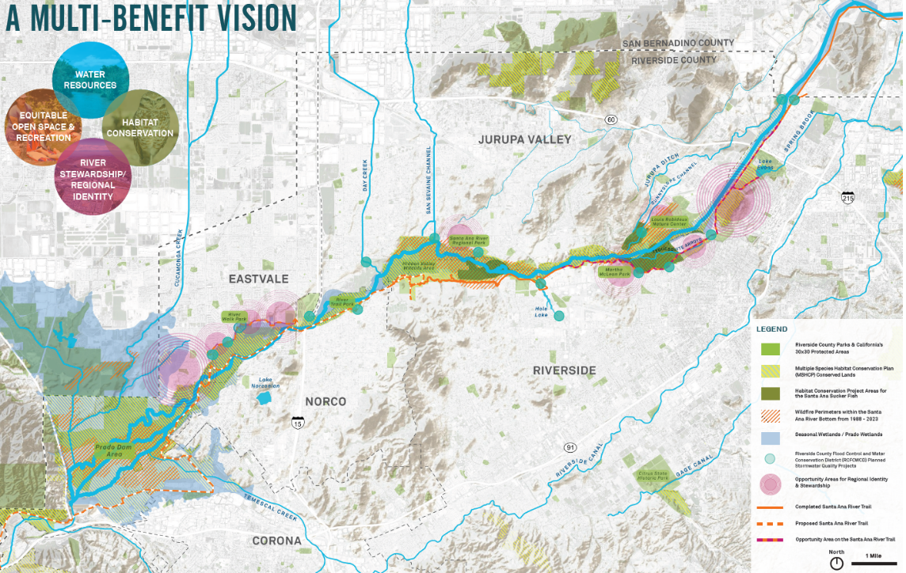
Figure 4-2. Strategic Vision for a Multi-Benefit Water Quality Strategy in the MSAR
.

Bacteria Source Tracking in MS4 Drainage Areas
A key focus of the CBRPs is to implement an inspection program to identify and eliminate sources of controllable fecal bacteria from MS4 drainage areas. Section 3 above summarizes the implementation of bacteria source evaluation over the 2023-2025 period. These results will be used by the MS4 stakeholder group to support investigations within MS4 networks to identify and eliminate sources. Implementation will be accomplished through enhancement to existing IDDE programs.

TMDL Implementation by Agriculture Dischargers
Prior to this reporting period, required tasks in the TMDL associated with agricultural sources were completed including development and implementation of an Agricultural Source Evaluation Plan (AgSEP), approved on April 18, 2008 (Resolution No. R8-2008-0044) and Bacterial Indicator Agricultural Source Management Plan (BASMP), a final BASMP was submitted to the Santa Ana Water Board in December 2014 (CBW Agricultural Pool 2014). This document was prepared on behalf of all agricultural operators in the MSAR watershed except “citrus growers and nurseries in the Arlington Greenbelt Area, with the exception of Altman Plants” (CBW Agricultural Pool 2014, see section prior to the table of contents). Per the BASMP, the agricultural operators not covered by the BASMP would comply with TMDL requirements separately from the other agricultural operators in the watershed.

CAFOs
For CAFOs, compliance with the dry weather condition WLAs is accomplished through implementation of the prohibition against discharge of any DWF from a permitted facility (see BASMP Section 2.3.1; CBW Agricultural Pool 2014). Per the current CAFO General Order these discharge prohibitions are found in Section II.A (Santa Ana Water Board 2018; R8-2018-0001). Moreover, the number of CAFOs has been declining steadily since the adoption of the TMDLs in 2005 (Table 4-2). When the TMDLs were adopted the TMDL Staff Report stated that Chino Dairy Preserve in the MSAR watershed had more than 300,000 animal units (Santa Ana Water Board 2005a), down from the 320,000 reported in the 1999 CAFO General Order (Table 4-2). As of 2021 the number of animal units had declined to approximately 54,000, a reduction of more than 80%. The number of dairies is expected to continue to decline in the future (Pat Boldt, personal communication, November 2022).

Table 4-2. Changes in Number of Dairies and Animal Units in Chino Basin Area of the Santa Ana Region, 1999 – 2021
Year | Dairies | Animal Units | Source
1999 | 297 | 320,000 | Santa Ana Water Board 1999; Order 99-11
2005 | N/A | 300,000 | TMDL Staff Report (Santa Ana Water Board 2005a)
2007 | 137 | 185,000 | Santa Ana Water Board 2007; General Order (R8-2007-0001)
2010 | 116 | 135,560 | Personal communication, Pat Boldt (November 2022)
2013 | 99 | 116,000 | Santa Ana Water Board 2013; General Order R8-2013-0001
2018 | 84 | 78,000 | Santa Ana Water Board 2018; General Order R8-2018-0001
2020 | 68 | 67,946 | Personal communication, Pat Boldt (November 2022)
2021 | 56 | 54,117 | Personal communication, Pat Boldt (November 2022)
2022
2023
2024
NA = not available
For wet weather conditions, the Section II.B.1 of the CAFO General Order establishes Technology-based Effluent Limitations that limit the discharge of stormwater from dairy facilities. In particular, CAFO General Order requires that discharges of waste in stormwater runoff from production areas (as defined in Attachment G of the Order) and in process wastewater are authorized only under the following conditions (II.B.1.b): Containment structures have been designed, constructed, operated and maintained to contain all manure, litter, process wastewater, and the runoff and the direct precipitation from all rainfall events up to and including a 25-year, 24-hour rainfall event from the production area.

Non-CAFOs
The BASMP provided an analysis of non-CAFO agricultural land use in the MSAR watershed, in particular in relation to the potential discharge of DWF to receiving waters (CBW Agricultural Pool 2014). Based on 2012 land use data, the analysis found that the total effective acreage of non-CAFO agricultural land use in the MSAR watershed was approximately 9,200 acres or just 1.9 percent of the total MSAR watershed (746 square miles). Of the remaining effective acreage of non-CAFO agricultural land use in the MSAR watershed, about half is located within the Inland Empire Utilities Agency (IEUA) management boundary and half is located outside. Areas within the IEUA boundary are more likely to continue to transition to urban land uses in the future because much of this acreage is owned by developers and only being leased for agricultural use.
Non-CAFO agricultural operators in coordination with dairy industry representatives (MPC and CBW) completed the relevant required Phase 1 TMDL implementation tasks in a timely manner (Task 5.1 – AgSEP; Task 5.2 - BASMP). As noted above, the BASMP was prepared on behalf of all agricultural operators in the MSAR watershed except “citrus growers and nurseries in the Arlington Greenbelt Area, with the exception of Altman Plants” (CBW Agricultural Pool 2014). In 2017 the MSAR Task Force conducted a preliminary bacteria and flow source investigation in the Arlington Greenbelt Area of Riverside County. This study found that furrow irrigation practices from agricultural land uses in the Arlington Greenbelt area contributed a significant part of the flow and bacteria to the MS4 in the drainage system that outfalls to Reach 3 of the SAR at T1-ANZA (SAWPA 2018; also see Appendix B.6).

Unsheltered Populations
The MSAR MS4 Permittees continue to actively engage with multiple internal and external agencies regarding the needs of the unsheltered population and related water quality issues from their habitation in the Santa Ana River. Efforts have led to housing former unsheltered individuals, engaged unsheltered individuals with housing resources, providing a path to public benefits for unsheltered individuals, providing mental health resources, and legal services. Additionally, an extensive amount of trash has been removed from the Santa Ana River. Some of these actions have included the removal of potentially dangerous shelters constructed by unsheltered populations within the River bottom.

TMDL Implementation - Next Steps
This report highlights findings from an extensive series of Tier 1 studies, Tier 2 source investigations, special studies and targeted monitoring to evaluate the effectiveness of regional treatment projects. As demonstrated by studies conducted in the Chino Creek and Mill-Cucamonga Creek subwatersheds, substantial progress has been made towards meeting the TMDLs WLAs and LAs applicable to dry season conditions. Given the findings from these various efforts and potential implementation requirements in the anticipated revision of the MSAR TMDL (see Phase 2 program of implementation in draft TMDL Technical Report), the following sections identify next steps for TMDL implementation.

Dry Weather TMDL Implementation
Recommendations for additional studies to be implemented during dry weather to support MSAR TMDLs implementation include:
- Updated Comprehensive Tier 1 Source Evaluation – Tier 1 source evaluations that include a comprehensive synoptic sampling and analysis of DWF and E. coli at MS4 outfalls to impaired waters have been conducted by the MSAR Task Force about once every 5-7 years (2007, 2012, 2019, and 2025). In addition, since 2017 SBCFCD has collected data annually from multiple sites within Chino Creek and Cucamonga Creek. These data have provided an important update on status of bacteria loads to impaired waters for this Triennial Report. Going forward, it is recommended that:
  - MSAR Task Force consider implementing comprehensive Tier 1 source evaluations at least once in each triennial reporting period. This will provide a good data set to support all future Triennial Reports.
  - Future Tier 1 source evaluation studies consider evaluation of other factors that may influence bacteria loading estimates, e.g., (a) to coordinate sample collection with operations at recharge basins and POTWs; and (b) to gather data to allow evaluation of potential diurnal differences in bacteria concentrations.
  - Future Tier 1 source evaluation studies also include samples collected at the compliance sampling locations to support source contribution analysis.
- Tier 2 Source Investigations – several Tier 1 MS4 outfalls were determined to be moderate or high priority with regard to impact to recreational use during dry weather conditions. Cities within these drainage areas can enhance current illicit discharge detection and elimination (IDDE) activities with the objective of identifying specific sources and taking actions to eliminate if sources are found to be controllable.
- Identification of In-stream Sources of Bacteria Loads - The findings presented in this report have shown that in-stream sources of E. coli are a significant contributor to E. coli loads in downstream impaired waters, especially near the transition from SAR Reach 4 to Reach 3. Understanding the origin of these sources is critical to compliance with the TMDL targets applicable under dry summer conditions. Specifically:
  - The majority of E. coli load observed within Reach 3 of the Santa Ana River has been demonstrated to come from in-stream sources upstream of Mission Boulevard in Santa Ana Reach 4. It is plausible, that a program that successfully identifies and eliminates the predominant source(s) of these E. coli could have enough of an impact to bring Santa Ana River Reach 3 into attainment with water quality objectives. Based on studies conducted over several years, it is unlikely that sources of E. coli derived from humans (including homeless encampments), feral pigs, dogs or horses can explain all observed E. coli loads where Santa Ana River 4 transitions to Reach 3. However, to date analyses of different potential warm-blooded sources have been conducted independently rather than jointly, e.g., through implementation of one comprehensive study. Given the importance of understanding the source(s) of these bacteria, it is recommended that the Task Force continue to implement special studies in the Santa Ana River segment upstream of Mission Boulevard Bridge, and, in particular, implement a comprehensive study that looks at multiple potential bacteria sources in water and sediment. A framework for a study of in-stream sources in the SAR is presented in Figure 5-1.
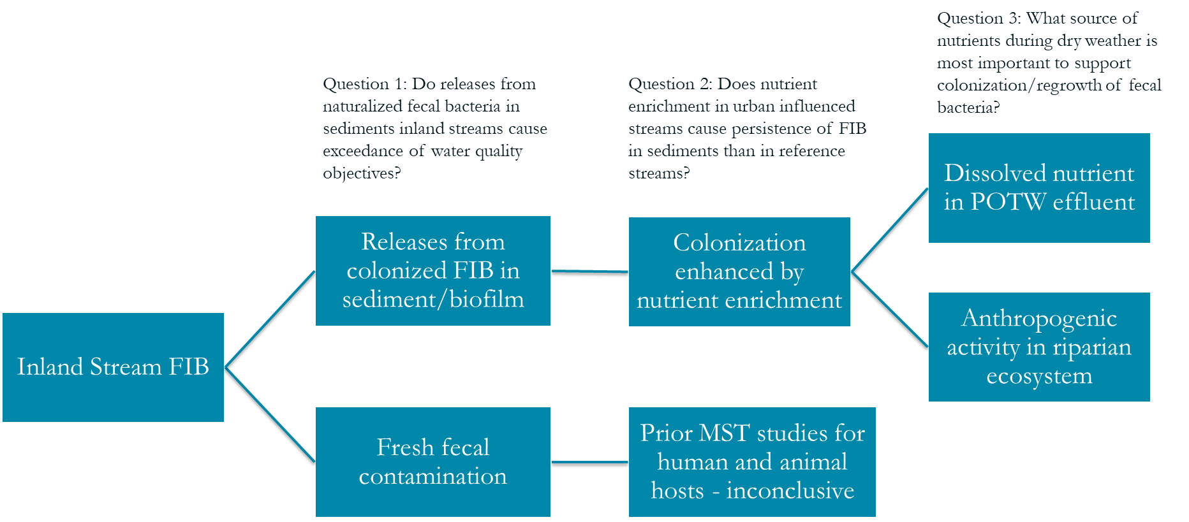
Figure 5-1. Framework for Study to Advance Understanding of In-Stream Fecal Bacteria Sources in Reach 3 of the SAR.

Limited Revisions to MSAR TMDLs
The MSAR Task Force in collaboration with the Santa Ana Water Board began the process to make limited revisions to the MSAR TMDL, primarily to extend the wet winter condition compliance date. Extension of this compliance date is intended to provide opportunity for the MSAR Task Force to (a) identify and implement needed special studies; (b) develop a better understanding of wet weather sources of bacterial indicators; (c) allow time to develop and implement either an alternative Watershed Management Plan (an expected option under the next Regional MS4 Permit – currently planned for adoption in 2023) or Comprehensive Bacteria Reduction Plans for wet conditions.
The MSAR Task Force is currently working with the Santa Ana Water Board to develop the Technical Report and Substitute Environmental Document to support the Basin Plan amendment to make the proposed limited TMDL revisions. Elements planned for inclusion in the TMDL revisions include: (a) revised wet winter conditions compliance date; (b) establishment of new tasks for implementation in the TMDLs consistent with the revised compliance date; and (c) a schedule for implementation of the planned new tasks. In the upcoming triennial period, MSAR Task Force tasks involving wet weather should be aligned with the tasks identified in the draft TMDL revision including:
- Evaluate Controllability of Wet Weather Source
- Evaluate Applicability of High Flow Suspension
- Implement Preliminary Wet Weather Water Quality Controls

References
Ahmed, W., B. Hughes and V.J. Harwood. 2016. Current Status of Marker Genes of Bacteroides and Related Taxa for Identifying Sewage Pollution in Environmental Waters. Integrative Biology Faculty and Staff Publications, University of South Florida. 360.
Barry, E. 2017. Spatial Variability and Implications of Surface Water Infiltration on Critical Habitat Along the Santa Ana River, California. Senior Thesis, Pomona College Geology Department. April 2017.
Boehm, A.B., J.A. Soller. 2020. Refined Ambient Water Quality Thresholds for Human-associated Fecal Indicator HF183 for Recreational Waters with and without Co-occurring Gull Fecal Contamination. Microbial Risk Analysis. Volume 16. 2020.
Chino Basin Watermaster (CBW) Agricultural Pool. 2014. Bacterial Indicator Agricultural Source Management Plan. Prepared by CDM Smith on behalf of the CBW Agricultural Pool. December 2014.
City of Claremont. 2014. Comprehensive Bacteria Reduction Plan. Prepared by CDM Smith on behalf of the City of Claremont. January 14, 2014.
City of Pomona. 2014. Comprehensive Bacteria Reduction Plan. Prepared by CDM Smith on behalf of the City of Claremont. January 14, 2014.
Gedalanga, P., L. Nguyen and C. Puga. 2019. Microbial Source Tracking at the Santa Ana Watershed. California State University, Fullerton. June 2019
Gitter, A., Gidley, M., Mena, K. D., Ferguson, A., Sinigalliano, C., Bonacolta, A., & Solo-Gabriele, H. (2023). Integrating microbial source tracking with quantitative microbial risk assessment to evaluate site specific risk based thresholds at two South Florida beaches. Frontiers in microbiology, 14, 1210192.
Hart, J. J., Jamison, M. N., McNair, J. N., Woznicki, S. A., Jordan, B., & Rediske, R. (2022). Using Watershed Characteristics for Improving Fecal Source Identification. bioRxiv, 2022-06.
Li, J., Zhu, Y., Wu, X., & Hoffmann, M. R. (2020). Rapid detection methods for bacterial pathogens in ambient waters at the point of sample collection: a brief review. Clinical Infectious Diseases, 71(Supplement_2), S84-S90.
Los Angeles Regional Water Quality Control Board (Los Angeles Water Board). 2012. Waste Discharge Requirements for Municipal Separate Storm Sewer Storm Sewer System (MS4) Discharges within the Coastal Watersheds of Los Angeles County, Except those Discharges Originating from the City of Long Beach MS4. Order No. R4-2012-0175. NPDES Permit No. CAS004001. Los Angeles Water Board. November 8, 2012.
Riverside County. 2011. Comprehensive Bacteria Reduction Plan. Prepared by CDM on behalf of the RCFC&WCD. June 28, 2011.
Riverside County Flood Control & Water Conservation District (RCFC&WCD). 2016. Middle Santa Ana River Watershed: Uncontrollable Bacterial Sources Study. Prepared by CDM Smith on behalf of RCFC&WCD. June 2016.
San Bernardino County Flood Control District (SBCFCD). 2011. Comprehensive Bacteria Reduction Plan. Prepared by CDM Smith on behalf of the SBCFCD. June 28, 2011.
Santa Ana Regional Water Quality Control Board (Santa Ana Water Board). 1999. General Waste Discharge Requirements for Concentrated Animal Feeding Operations (Dairies and Related Facilities) within the Santa Ana Region, Order No. 99-11, NPDES No. CAG018001. Santa Ana Water Board Resolution 99-11. August 20, 1999.
Santa Ana Water Board. 2002a. Waste Discharge Requirements for the San Bernardino County Flood Control District, the County of San Bernardino, and the Incorporated Cities of San Bernardino County within the Santa Ana Region Area-Wide Urban Storm Water Runoff. Order No. R8-2002-0012. April 26, 2002.
Santa Ana Water Board. 2002b. Waste Discharge Requirements for the Riverside County Flood Control and Water Conservation District, the County of Riverside, and the Incorporated Cities of Riverside County within the Santa Ana Region Areawide Urban Runoff. Order No. R8-2002-0011. October 25, 2002.
Santa Ana Water Board. 2005a. Staff Report on Bacterial Indicator Total Maximum Daily Loads in the Middle Santa Ana River Watershed. Santa Ana Water Board. February 3, 2005.
Santa Ana Water Board. 2005b. Resolution Amending the Water Quality Control Plan for the Santa Ana River Basin to Incorporate Bacterial Indicator Total Maximum Daily Loads (TMDLs) for Middle Santa Ana River Watershed Waterbodies. Santa Ana Water Board Resolution R8-2005-0001. August 26, 2005.
Santa Ana Water Board. 2007. General Waste Discharge Requirements for Concentrated Animal Feeding Operations (Dairies and Related Facilities) within the Santa Ana Region, Order No. R8-2007-0001, NPDES No. CAG018001. Santa Ana Water Board. September 7, 2007.
Santa Ana Water Board. 2008. Resolution Approving Plans and Schedules Submitted by the Middle Santa Ana River Watershed TMDL Task Force Pursuant to the Middle Santa Ana River Watershed Bacterial Indicator Total Maximum Daily Loads Specified in the Water Quality Control Plan for the Santa Ana River Basin. Santa Water Board Resolution R8-2008-0044. April 18, 2008.
Santa Ana Water Board. 2010a. National Pollutant Discharge Elimination System (NPDES) Permit and Waste Discharge Requirements for the Riverside County Flood Control and Water Conservation District, the County of Riverside, and the Incorporated Cities of Riverside County within the Santa Ana Region Area-Wide Urban Runoff Management Program. Santa Water Board Resolution R8-2010-0033. January 29, 2010.
Santa Ana Water Board. 2010b. National Pollutant Discharge Elimination System (NPDES) Permit and Waste Discharge Requirements for the San Bernardino County Flood Control District, the County of San Bernardino, and the Incorporated Cities of San Bernardino County within the Santa Ana Region Area-Wide Urban Storm Water Runoff Management Program. Santa Water Board Resolution R8-2010-0036. January 29, 2010.
Santa Ana Water Board. 2012a. Resolution Approving the Dry Weather Comprehensive Bacteria Reduction Plan Submitted Pursuant to the National Pollutant Discharge Elimination System (NPDES) Permit and Waste Discharge Requirements for the Riverside County Flood Control and Water Conservation District, the County of Riverside, and the Incorporated Cities of Riverside County within the Santa Ana Region, Order No. R8-2010-0033, NPDES No. CAS618033. Santa Ana Water Board Resolution R8-2012-0015. February 10, 2012.
Santa Ana Water Board. 2012b. Resolution Approving the Dry Weather Comprehensive Bacteria Reduction Plan Submitted Pursuant to the National Pollutant Discharge Elimination System (NPDES) Permit and Waste Discharge Requirements for the San Bernardino County Flood Control District, the County of San Bernardino, and the Incorporated Cities of San Bernardino County within the Santa Ana Region, Order No. R8-2010-0036, NPDES No. CAS618036. Santa Ana Water Board Resolution R8-2012-0016. February 10, 2012.
Santa Ana Water Board. 2012c. Resolution Approving Amendments to the Basin Plan Pertaining to Bacteria Quality Objectives and Implementation Strategies, Recreation Beneficial Uses, the Addition and Deletion of Certain Waters Listed in the Basin Plan and Designation of Appropriate Beneficial Uses, and Other Minor Modifications. Santa Ana Water Board Resolution R8-2012-0001. June 15, 2012.
Santa Ana Water Board. 2013. General Waste Discharge Requirements for Concentrated Animal Feeding Operations (Dairies and Related Facilities) within the Santa Ana Region, Order No. R8-2013-0001, NPDES No. CAG018001. Santa Ana Water Board. June 7, 2013.
Santa Ana Water Board. 2014a. Resolution Approving the Dry Weather Comprehensive Bacteria Reduction Plan Submitted Pursuant to the National Pollutant Discharge Elimination System (NPDES) Permit and Waste Discharge Requirements for the City of Claremont, Order No. R8-2013-0043, NPDES No. CA8000410. Santa Ana Water Board Resolution R8-2014-0030. March 14, 2014.
Santa Ana Water Board. 2014b. Resolution Approving the Dry Weather Comprehensive Bacteria Reduction Plan Submitted Pursuant to the National Pollutant Discharge Elimination System (NPDES) Permit and Waste Discharge Requirements for the City of Pomona, Order No. R8-2013-0043, NPDES No. CA8000410. Santa Ana Water Board Resolution R8-2014-0031. March 14, 2014.
Santa Ana Water Board. 2016. Resolution Approving the Santa Ana River Watershed Monitoring Program Proposal Submitted Pursuant to the Middle Santa Ana River Watershed Bacterial Indicator Total Maximum Daily Loads and the REC1 Beneficial Use Standard Basin Plan Amendments. Santa Ana Water Board Resolution R8-2016-0022. March 11, 2022.
Santa Ana Water Board. 2018. General Waste Discharge Requirements for Concentrated Animal Feeding Operations (Dairies and Related Facilities) within the Santa Ana Region, Order No. R8-2018-0001, NPDES No. CAG018001. Santa Ana Water Board. December 7, 2018.
Santa Ana Water Board. 2025. Water Quality Control Plan for Santa Ana River Region. Santa Ana Water Board. October 2025 (as amended).
Santa Ana Watershed Project Authority (SAWPA). 2007a. Middle Santa Ana River Bacterial Indicator TMDL Urban Source Evaluation Plan. Prepared by CDM on behalf of SAWPA and the MSAR Task Force. November 28, 2007.
SAWPA. 2007b. Middle Santa Ana River Bacterial Indicator TMDL Agricultural Source Evaluation Plan. Prepared by CDM Smith on behalf of SAWPA, Milk Producers Council, and Chino Basin Watermaster Agricultural Pool. November 28, 2007.
SAWPA. 2008. Middle Santa Ana River Water Quality Monitoring Plan. Prepared by CDM on behalf of SAWPA and the MSAR Task Force. April 2008.
SAWPA. 2009. Middle Santa Ana River Bacterial Indicator TMDL Data Analysis Report. Prepared by CDM on behalf of SAWPA and the MSAR Task Force. March 2009.
SAWPA. 2010a. Middle Santa Ana River Watershed Bacterial Indicator TMDL: Triennial Report. Prepared by CDM on behalf of SAWPA and the MSAR Task Force. February 15, 2010.
SAWPA. 2010b. Final Technical Memorandum - Dry Weather Runoff Controllability Assessment for Lower Deer Creek Subwatershed (Chris Basin) Special Study. Prepared by CDM on behalf of SAWPA and the MSAR Task Force. September 30, 2010.
SAWPA. 2013. Middle Santa Ana River Bacterial Indicator TMDL Implementation Report. Prepared by CDM Smith on behalf of SAWPA and the MSAR Task Force. February 2013.
SAWPA. 2017. Middle Santa Ana River Bacterial Indicator TMDL Implementation Final Report. Prepared by CDM Smith on behalf of SAWPA and the MSAR Task Force. June 2017.
SAWPA. 2018. Technical Memorandum: Tier 2 Arlington Area Bacteria and Flow Source Investigation. Prepared by AMEC Foster Wheeler on behalf of SAWPA and the MSAR Task Force. January 2018.
SAWPA. 2020a. Middle Santa Ana River Bacteria Synoptic Study and TMDL Triennial Report. Report prepared by GEI Consultants, CDM Smith and Essential Environmental and Engineering Systems on behalf of the MSAR Task Force. February 2020.
SAWPA. 2020b. Assessment of Water Quality Monitoring and Habitat Impacts of Homelessness in the Upper Santa Ana River Watershed Report. Report prepared by GEI Consultants and CWE on behalf of SAWPA. September 2020.
SAWPA. 2022a. Santa Ana River Watershed Bacteria Monitoring Program: Monitoring Plan, Version 3.0. Prepared by CDM Smith and CWE on behalf of the SAWPA Regional Water Quality Monitoring Task Force. May 2022.
SAWPA. 2022b. Santa Ana River Watershed Bacteria Monitoring Program: QAPP, Version 3.0. Prepared by CDM Smith and CWE on behalf of the SAWPA Regional Water Quality Monitoring Task Force. May 2022.
SAWPA. 2023. Middle Santa Ana River Bacteria Synoptic Study and TMDL Triennial Report. Report prepared by GEI Consultants and CDM Smith on behalf of the MSAR Task Force. February 2023.
State Water Resources Control Board (State Water Board). 2006. Approving an Amendment to the Water Quality Control Plan for the Santa Ana Region (Basin Plan) to Incorporate a Total Maximum Daily Load for Bacterial Indicators for Middle Santa Ana River Watershed Water Bodies. State Water Board Resolution 2006-0030. May 15, 2006.
State Water Board. 2014. Amend the Water Quality Control Plan for the Santa Ana River Basin to Revise Recreational Standards for Inland Fresh Surface Waters in the Santa Ana Region. State Water Board Resolution 2014-0005. January 21, 2014.
State Water Board. 2017. National Pollutant Discharge Elimination System (NPDES) General Permit for Waste Discharge Requirements (WDRs) for Storm Water Discharges from Small Municipal Separate Storm Sewer Systems (MS4s). State Water Board Water Quality Order 2017-XXXX-DWQ, amending Order 2013-0001-DWQ. December 19, 2017.
Steinbacher, S. D., Leifels, M., Kolm, C., Lindner, G., Demeter, K., Kirschner, A. K., ... & Farnleitner, A. H. (2025). Comparative evaluation of decay characteristics of commonly used genetic faecal markers crAssphage and Bacteroides in complex river water microcosms. International Journal of Hygiene and Environmental Health, 271, 114713)

The WLAs and LAs for fecal coliform are no longer applicable following USEPA’s 2015 approval of the 2012-adopted Basin Plan amendment to revise bacterial indicator objectives in the Santa Ana Region for inland freshwaters (Resolution No. R8-2012-0001). See discussion on next page.
Current Task Force members include San Bernardino County Flood Control District (representing County of San Bernardino and Cities of Ontario, Chino, Chino Hills, Montclair, Rancho Cucamonga, Upland, Rialto, and Fontana); County of Riverside; Cities of Claremont, Corona, Eastvale, Jurupa Valley, Norco, Pomona and Riverside; and Agricultural Operators (represented by the Chino Basin Watermaster) and University of California Riverside.
SAWPA is a Joint Powers Authority of five member agencies that supports water resources planning: Eastern Municipal Water District, Inland Empire Utilities Agency, Orange County Water District, San Bernardino Valley Municipal Water District, and Western Municipal Water District.
https://www.sawpa.org/wp-content/uploads/2018/04/2010_Triennial-Report.pdf.
https://www.sawpa.org/wp-content/uploads/2018/04/2013-Triennial-Report_Tier-1-Source-Evaluation-Final.pdf
https://www.sawpa.org/wp-content/uploads/2018/04/2016_Triennial-Report-June-2017.pdf
https://sawpa.org/wp-content/uploads/2020/05/Final-Synoptic-Study-Report_021020_BabcockLabQAQC-Report-Appended_051920.pdf
https://sawpa.gov/wp-content/uploads/2023/02/MSAR-TMDL-2023-Triennial-Report_Final_021123.pdf.
https://sawpa.org/task-forces/regional-water-quality-monitoring-task-force/#geographic-setting
Note: The timing of the follow-up samples was changed in the 2021 update to the MP and QAPP. Previously, collection of post-storm samples occurred 48, 72, and 96 hours after collection of the first sample.
A pipeline that carries stormwater under Prado Park Lake was replaced in 2017; this project restored the original MS4 conveyance that ensured that stormwater properly bypasses the lake. During the construction project, the lake was dry.
Baseflow associated with spring snowmelt can cause extended dry weather runoff from upper reaches to Reach 3 in some months of the year.
Note: To date there has been no study conducted to estimate the relative roles of different types or sources of DWF in the MSAR watershed. Generally, it has been assumed that the majority of day to day DWF reaching a Tier 1 site is from excess irrigation runoff. However, spikes in DWF (e.g., from well blow offs, water transfers or illicit discharges) do occur periodically. Determining the relative role of these various sources of DWF at any given Tier 1 site and their potential impact on E. coli loading would likely require implementation of a short-term intensive site-specific study.
Some of the change in number of Tier 1 sites between 2012 and 2019 is attributable to the removal of the REC1 beneficial use from Cucamonga Reach 1 (see Section 3.1.1.4)
Reported in Table 3-4 of the CBRPs for Riverside County (RCFC&WCD 2011) and San Bernardino County (SBCFCD 2011)
Targets in the 2012 CBRP for MS4 sources are expressed as CFU/day (colony forming units per day). Monitoring for the RBMP and Tier 1 source evaluations are expressed in MPN/day (most probable number per day). The differences between CFU (a direct count of visible colonies) and MPN (converts positive tube counts to a 95% confidence interval value) are associated with the analytical method. These units are used interchangeably and are considered equivalent for the purposes of tracking progress towards planning targets.
See specific WDR for each POTW (Table 1-2 provides the WDR Order No. for permits issued by the Santa Ana Water Board) and/or discussion in the Synoptic Study Plan (see Section 1.4 of the Study Plan)
All of the POTWs confirmed via email that their respective facilities were in compliance with their E. coli permit effluent limits during the Synoptic Study.
https://www.waterboards.ca.gov/santaana/water_issues/programs/basin_plan/docs/2015/Santa_Ana_Basin_UAA_Approval_Letter_040815.pdf
https://www.waterboards.ca.gov/santaana/water_issues/programs/basin_plan/docs/rec_standards/UAA/Cucamonga_UAA_10-7-13_Final.pdf
Removal of the REC1 use was supported by an approved Use Attainability Analysis (see USEPA letters to Santa Ana Water Board, April 8 and August 3, 2015)
The Basin Plan defines “uncontrollable sources” as: wildlife activity and waste; bacterial regrowth within sediment or biofilm; resuspension from disturbed sediment; Concentrations (flocks) of semi-wild waterfowl; shedding during swimming (Santa Ana Water Board 2016).
An existing streambed alteration permit specifies that 15 cfs of flow must be maintained within the mainstem of Mill-Cucamonga Creek, however the streambed agreement predates IEUA’s recycled water system as well as capture of dry weather runoff in the Turner Basins, and involved an empirical analysis based on higher downstream flows during dry weather than are typically observed in modern conditions (average DWF during Tier 2 sampling periods at T1-CUCAMONGA in 2017-2022 was 9 cfs).
Areas of MSAR watershed that are hydrologically connected to a downstream receiving water. Hydrologically-disconnected areas are drainage areas that do not typically cause or contribute to flow to a downstream TMDL watershed-wide compliance monitoring location. DWF may be hydrologically disconnected from receiving waters because of constructed regional retention facilities or through losses in earthen channel bottoms, where the recharge capacity of the underlying soils exceeds dry weather runoff generated in the upstream drainage area.

