**2024 Annual Report**

**of Santa Ana River Water Quality**

***Draft Report***

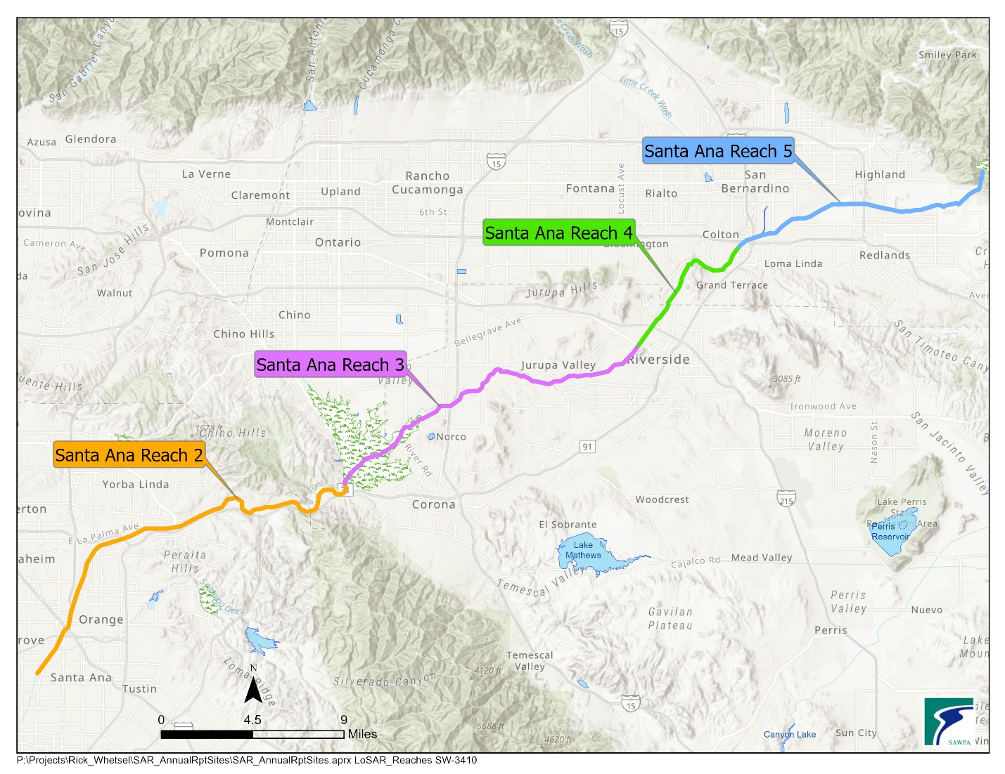

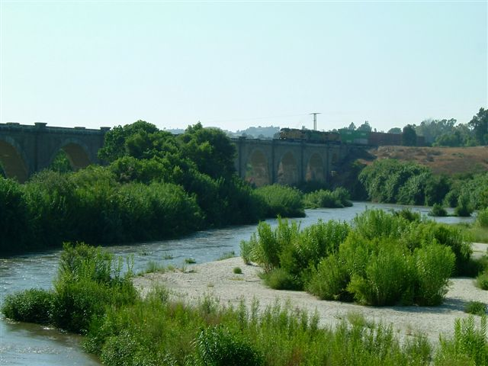

*Prepared by:*

**July 2025**

**TABLE OF CONTENTS**

**1 Introduction 1-1**

**2 Data Collection 2-1**

**3 Analysis of Monitoring Data 3-1**

**3.1 Santa Ana River Reach 2 3-1**

**3.2 Santa Ana River Reach 3 3-5**

**3.2.1 Below Prado Dam 3-5**

**3.2.2 Santa Ana River Mainstem between Riverside**

**Narrows and Prado Wetlands 3-7**

**3.3 Santa Ana River Reach 4 3-9**

**3.4 Santa Ana River Reach 5 3-9**

**4 Conclusions and Recommendations 4-1**

**4.1 Conclusions 4-1**

**4.2 Recommendations 4-3**

**5 Response to Comments 5-1**

**APPENDICES**

**Appendix A Water Quality Trends at Below Prado Dam and**

**MWD Crossing 2003 to Current A-1**

**Appendix B 2024 Water Quality and Flow Data B-1**

**LIST OF TABLES**

Table 2-1 OCWD's Santa Ana River Water Quality Monitoring Locations 2-1

Table 2-2 USGS Stream Gauge Stations 2-3

Table 3-1 Yearly Volume-Weighted Moving Average TDS at Below Prado Dam (SAR Watermaster Report) 3-1

Table 3-2 Monthly Volume-Weighted Moving Average TDS at Below Prado Dam (2024 OCWD, USGS, and Regional Board at Below Prado Dam) 3-3

Table 3-3 Results for 2024 Annual Base Flow Monitoring Program for the Santa Ana

River at Below Prado Dam (Regional Board Data Only) 3-5

Table 3-4a Summary of August, September, and October Base Flow Water Quality Observations for the Santa Ana River at Below Prado Dam (2024 OCWD, USGS and Regional Board at Below Prado Dam) 3-6

Table 3-4a Summary of Annual Base Flow Water Quality Observations for the Santa Ana River at Below Prado Dam (2024 OCWD, USGS and Regional Board at Below Prado Dam) 3-6

Table 3-5a Summary of August, September, and October Base Flow Water Quality Observations for the Santa Ana River Reach 3 (2024 Between Riverside Narrows and Prado Wetlands) 3-8

Table 3-5b Summary of Alternative Analysis Approach Base Flow Water Quality Observations for the Santa Ana River Reach 3 (2024 Between Riverside Narrows and Prado Wetlands) 3-8

Table 3-6 Summary of Water Quality Observations for Santa Ana River Reach 4 3-9

Table 3-7 Summary of Water Quality Observations for Santa Ana River Reach 5 3-9

**LIST OF FIGURES**

Figure 2-1 Surface Water Monitoring Locations 2-2

Figure 3-1 Total Dissolved Solids (TDS) Below Prado Dam 3-4

Figure 4-1 Cumulative Departure from Mean Annual Precipitation San Bernardino County Hospital Station (1884-2018) 4-2

**Acronym and Abbreviations List**

AFY acre-feet per year

COD chemical oxygen demand

EC electrical conductivity

HCMP Hydraulic Control Monitoring Program

mg/L milligrams per liter

umhos/cm micromhos per centimeter

MWD Metropolitan Water District of Southern California

NTU nephelometric turbidity units

OCWD Orange County Water District

RIX Regional Tertiary Treatment Rapid Infiltration and Extraction Facility

RWQCB Regional Water Quality Control Board, Santa Ana Region

SAR Santa Ana River

SAWPA Santa Ana Watershed Project Authority

TDS total dissolved solids

TIN total inorganic nitrogen

TN total nitrogen

USGS United States Geological Survey

# Introduction

In 1996, the Nitrogen and Total Dissolved Solids (N/TDS) Task Force was formed to conduct scientific investigations regarding the then existing nitrogen and TDS water quality objectives of the 1995 Water Quality Control Plan for the Santa Ana River Basin (Basin Plan). The N/TDS Task Force, administered by the Santa Ana Watershed Project Authority (SAWPA) was comprised of 22 water supply and wastewater agencies. The work performed by the Task Force was broken out into several phases. In 2003, the Final Technical Memorandum was completed, which reported the results of this scientific investigation, *The TIN/TDS Study – Phase 2B of the Santa Ana Watershed Wasteload Allocation Investigation*.

As a result of this work (referenced above), the Santa Ana Regional Water Quality Control Board (Regional Board) amended the Basin Plan. The Basin Plan Amendment (hereafter the 2004 Basin Plan Amendment) was adopted by the Regional Board in January 2004, approved by the State Water Resources Control Board in September 2004, and approved by the Office of Administrative Law in December 2004. To implement the 2004 TDS/N Management Plan, local water and wastewater agencies formed the Basin Monitoring Program Task Force (BMPTF), which is administered by SAWPA.

In December 2021, the Regional Board amended the Basin Plan to revise and update limited components of the 2004 TDS/N Management Plan. These updates were approved by the Office of Administrative Law on July 27, 2023. These amendments resulted in the BMPTF updating the Surface Water Quality Ambient Monitoring Program, which may result in future Basin Plan amendments.

Pursuant to the 2004 Basin Plan Amendment (and maintained in the 2021 amendments), certain participants in the BMPTF are required to conduct the following investigations:

* Re-computation of Ambient Water Quality over a 20-year period; and
* Preparation of an Annual Report of Santa Ana River Water Quality.

This report fulfills the second requirement listed above and was prepared in accordance with the *2005* *Santa Ana River Water Quality Work Plan (*approved by the Regional Board in Resolution No. R8-2005-0063) and the *2022 Santa Ana River Total Dissolved Solids and Total Inorganic Nitrogen Monitoring Work Plan (*submitted to the Regional Board on March 30, 2023)*.* Contained within this report are water quality data required to implement the Surface Water Quality Ambient Monitoring Program necessary to determine compliance with the Total Inorganic Nitrogen (TIN) and TDS water quality objectives[1] for the following SAR Reaches (and, thereby, the effectiveness of the wasteload allocations):

* 2 (TDS Only),
* 3,
* 4 and
* 5.

For Reach 2, a TDS objective based on a five-year, volume-weighted, moving average of the annual TDS concentration is defined in Chapter 4 of the Basin Plan. The use of this moving average allows the effects of wet and dry years to be integrated over the five-year period and reflects the long-term quality of water recharged by Orange County Water District (OCWD) downstream of Prado Dam. Compliance with the Reach 2 TDS objective can be determined by the evaluation of data collected by OCWD, the United States Geological Survey (USGS), and others.

Also in Chapter 4 of the Basin Plan, the base flow TDS and total nitrogen objectives for Reach 3 of the SAR are specified. The timing of the sampling at Prado Dam is driven by the Basin Plan definition of “base flow conditions” which is described as when the influence of storm flows and nontributary flows are at a minimum. This typically occurs during August, and September. For context, the measurement of base flow quality has long been used to indicate the effects of recharge of SAR flows on Orange County groundwater. The efficacy of this approach was evaluated as part of the 2004 Basin Plan Amendment for the TDS/nitrogen management plan in the Basin Plan.

Compliance with Basin Plan objectives for Reach 4 and 5 of the SAR can be determined using data collected by the BMPTF and others, as applicable.

This report is organized as follows –

* Section 2 - Describes the data collected.
* Section 3 - Presents the analysis of the surface water quality monitoring data collected. Results are presented by Reach of the SAR.
* Section 4 - Provides conclusions and recommendations.
* Section 5 – Provides SAWPA’s responses to any comments received during the comment review period.
* Appendix B – Includes the complete set of 2024 surface water quality data (available on the SAWPA website).

# Data Collection

Water quality and discharge data used to prepare the 2024 Annual Report of Santa Ana River Water Quality, were collected from a number of regional efforts to monitor surface water quality along the SAR and its tributaries, including in-stream gauges employed by USGS, shown in Figure 2-1.

A detailed description of each of these monitoring efforts, representing the 2024 calendar year, are as follows:

As part of the Surface Water Quality Ambient Monitoring Program and beginning in 2024, the BMPTF conducts quarterly water quality monitoring to assess compliance with TDS and TIN objectives in SAR Reaches 4 and 5. This BMPTF-led monitoring was done per the development of the *2022 Santa Ana River TDS and TIN Monitoring Work Plan* submitted to the Regional Board by the BMPTF on March 30, 2023.

The timeframe for conducting the monitoring within each quarter is determined based upon “sample timing criteria” related to baseflow and storm conditions detailed in the BMPTF’s February 1, 2024 quality assurance project plan (QAPP). BMPTF monitoring stations used in this report are presented in Table 2-1. In later tables and figures, BMPTF stations are referred to by the name of the reach. The complete set of 2024 SAR water quality data collected by the BMPTF and used in this report are included in Appendix B, available on the SAWPA website.

Table : BMPTF Monitoring Stations

|  |  |  |  |
| --- | --- | --- | --- |
| **Station Name** | **Tributary** | **X**  **Coordinate** | **Y**  **Coordinate** |
| SAR-@ Mission | Santa Ana River Reach 4 | -117.394083 | 33.990861 |
| SAR-@ Riverside Ave | Santa Ana River Reach 4 | -117.362800 | 34.024800 |
| SAR-@ E Street | Santa Ana River Reach 5 | -117.293899 | 34.067728 |

Regional Board staff typically conducts annual water quality monitoring of base flow in the SAR exiting Reach 3, below Prado Dam. Monitoring typically extends over a five-week period during the months of August, and September and is used to determine compliance with Reach 3 base flow objectives. In 2024, base flow monitoring consisted of five sampling events between September 5 through October 9, 2024, as shown in Table 3-3. The early October data is representative of base flow conditions that are typical to August and September due to the lack of precipitation prior to collection of the October data. The complete set of 2024 base flow water quality data collected exiting Reach 3 below Prado Dam by the Regional Board is included in Appendix B, which is available on the SAWPA website.

Additionally, OCWD conducts a monitoring program for the SAR to assess the quality of the SAR water recharged into the Orange County Groundwater Basin. OCWD collects monthly and quarterly samples from the SAR at Imperial Highway in Anaheim and other locations along the SAR below Prado Dam and its tributaries. During the month of August monitoring (i.e. during the “base flow conditions” period per the 2004 Basin Plan) was performed with a greater sampling frequency. At sites above Prado Dam, OCWD collects samples from a single monitoring event in August (event took place on August 20, 2024). This OCWD data is used in this report, along with other available data, to evaluate water quality for Reaches 2, 3, 4, and 5 of the SAR. OCWD monitoring locations used in this report are presented in Table 2-1. In later tables and figures, OCWD stations are referred to by the name of the reach. The complete set of 2024 SAR water quality data collected by OCWD and used in this report is included in Appendix B, available on the SAWPA website.

Table 2-. OCWD's Santa Ana River Water Quality Monitoring Locations

|  |  |  |  |  |
| --- | --- | --- | --- | --- |
| **Station ID** | **Station Name** | **Tributary** | **X**  **Coordinate** | **Y**  **Coordinate** |
| 8105 | SAR-BELOWDAM-012 | Santa Ana River Reach 2 | - 117.644996 | 33.883665 |
| 24782 | SAR-BELOWDAM-023 | Santa Ana River Reach 2 | -117.641669 | 33.88683 |
| 8096 | SAR-RIVERRD-01 | Santa Ana River Reach 3 | - 117.666485 | 33.948989 |
| 8111 | SAR-HAMNER-01 | Santa Ana River Reach 3 | - 117.556597 | 33.947337 |
| 9672 | SAR-ETIWANDA-01 | Santa Ana River Reach 3 | - 117.522230 | 33.967365 |
| 8112 | SAR-VANBUREN-01 | Santa Ana River Reach 3 | - 117.465465 | 33.965049 |
| 8113 | SAR-MWDXING-01 | Santa Ana River Reach 3 | - 117.448032 | 33.968027 |
| 8114 | SAR-MISSION-01 | Santa Ana River Reach 4 | - 117.392523 | 33.991576 |
| 8115 | SAR-RIVERSIDEAVE-01 | Santa Ana River Reach 4 | - 117.362809 | 34.026480 |
| 8116 | SAR-LACADENA-011 | Santa Ana River Reach 4 | - 117.335710 | 34.046335 |
| 8117 | SAR-WATERMAN-011 | Santa Ana River Reach 5 | - 117.276721 | 34.071365 |

*1No data reported for this site in 2024.*

*2Site inaccessible due to major construction in 2024.*

*3Site replaced SAR-BELOWDAM-01 during major construction in 2024.*

The Chino Basin Hydraulic Control Monitoring Program (HCMP) is conducted jointly by the Chino Basin Water Master (CBWM) and Inland Empire Utilities Agency (IEUA) as part of their Maximum Benefit monitoring commitment. Water quality data collected through this program is used in this report to evaluate compliance with Basin Plan objectives for Reaches 2 and 3 of the SAR. Through 2012, the HCMP program collected bi-monthly samples from locations along the SAR (both above and below Prado Dam) and its tributaries. In 2013, the HCMP requirements were reduced to quarterly monitoring at two locations, which are presented in Table 2-3. The complete set of 2024 water quality data collected through the HCMP is included in Appendix C on the enclosed CD.

Table 2-2. Chino Basin Hydraulic Control Monitoring Program (HCMP) Monitoring Sites

|  |  |  |  |  |
| --- | --- | --- | --- | --- |
| **Station ID** | **Site Name** | **Tributary** | **X Coordinate** | **Y Coordinate** |
| 1207120 | SAR at River Rd | SAR Reach 3 | - 117.59810654289 | 33.9236262794 |
| 1207118 | SAR at Etiwanda | SAR Reach 3 | - 117.52258200702 | 33.96704204502 |

**Figure 2-1. Surface Water Monitoring Locations**

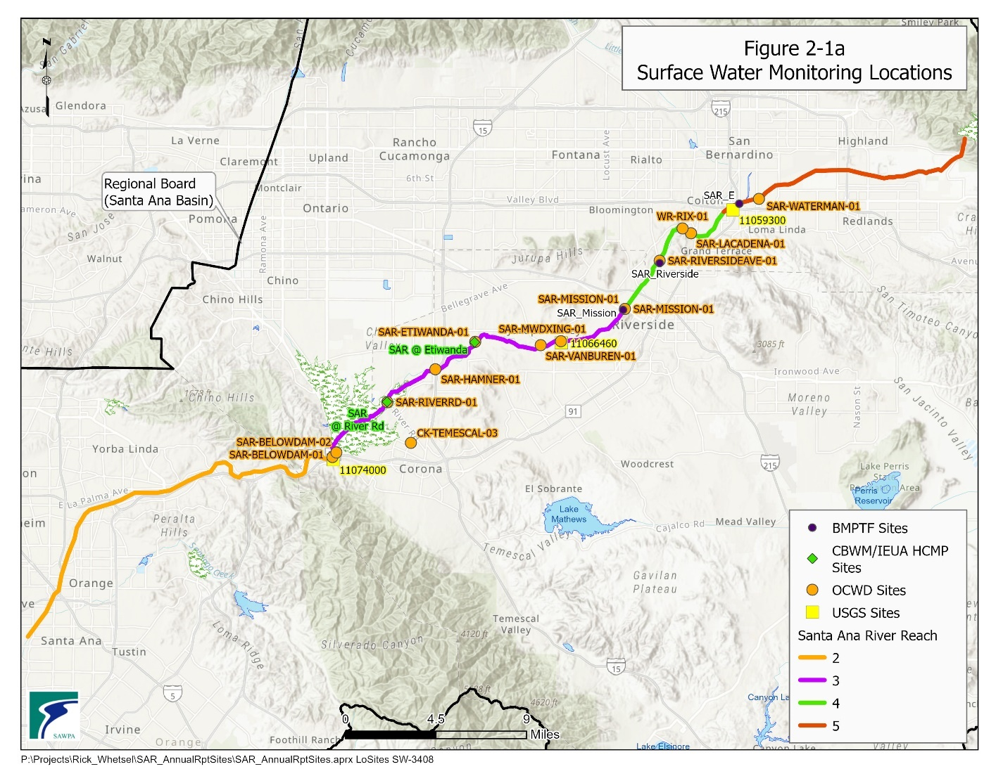

The USGS maintains three active gauging stations to monitor flow and water quality along the SAR. Long-term stream flow and water quality data are available for gauging stations 11074000, located at *Below Prado Dam*, and 11066460, located at *MWD Crossing*. Additionally, stream flow data is available for gauging station 11059300, located at *SAR at E St near San Bernardino*. The list of USGS gauging stations used in this report is presented in Table 2-2. The complete set of 2024 flow and water quality data available from these USGS gauging stations is included in Appendix B, available on the SAWPA website.

Table 2-. USGS Stream Gauge Stations

|  |  |  |  |  |  |
| --- | --- | --- | --- | --- | --- |
| **USGS ID** | **Station Name** | **2024 Flow (AFY)** | **Tributary** | **X**  **Coordinate** | **Y Coordinate** |
| 11074000 | SAR Below Prado Dam | 259,319 | SAR Reach 2 | - 117.644446 | 33.881583 |
| 11066460 | SAR at MWD Crossing | 80,637 | SAR Reach 3 | - 117.447501 | 33.966858 |
| 11059300 | SAR at E St near San Bernardino | 59,625 | SAR Reach 5 | - 117.299444 | 34.065000 |

# Analysis of Monitoring Data

## Santa Ana River Reach 2

Table 4-1 of the Basin Plan specifies a TDS objective (650 milligrams per liter (mg/L)) for Reach 2 of the Santa Ana River. The determination of compliance with the TDS objective for Reach 2 is made by using the mean of the five most recent flow-weighted annual averages as reported by the SAR Watermaster, shown in Table 3-1. In years of normal rainfall, most of the total flow of the river is percolated in the Santa Ana Forebay (see Figure 2-1), and directly affects the quality of the groundwater. For that reason, compliance with the TDS water quality objective for Reach 2 is based on the five-year moving average, which is estimated by computing the arithmetic average of the five most recent annual estimates of flow-weighted TDS for total flow at Below Prado (from the 2023-24 Annual SAR Watermaster Report[2]). Use of this moving average allows the effects of wet and dry years to be smoothed out over the five-year period.

Table 3-1. Yearly Volume-Weighted Moving Average TDS at Below Prado Dam (SAR Watermaster Report)

Table 3-2. Yearly Volume-Weighted Moving Average TDS at Below Prado Dam (Watermaster Report)

|  |  |
| --- | --- |
| **Water Year EndingA** | **Yearly Flow-weighted TDS (mg/L)** |
| 2020 | 468 |
| 2021 | 609 |
| 2022 | 499 |
| 2023 | 354 |
| 2024 | 384 |
| 5 Year Average | 463 |

Note: A Santa Ana River Watermaster data reported for FY 2023-24 water year

**Alternative Method to Determine Compliance with TDS Objective for Reach 2**

In addition to the method prescribed in the Basin Plan, as presented in Table 3-1, the Task Force employs an alternative method to evaluate compliance with the TDS objective for Reach 2 of the Santa Ana River. This alternative method was first employed in 2005 when the Task Force began preparing the Annual Reports of Santa Ana River Water Quality. This method computes compliance with the TDS objective in Reach 2 as a five-year average based on the 60-month volume-weighted[3] dataset. This alternative method was the sole method to evaluate compliance through the first four reports (2005 through 2008). While this method was technically correct, the Task Force became concerned that it might not be legally correct. Additional review of the Basin Plan text indicated that the volume-weighted five-year average should be computed as the arithmetic mean of the five discrete volume-weighted values for each of the five years (as presented in Table 3-1).

While it is true that the 60-month volume-weighted averaging approach implemented by the Task Force more accurately estimates the long-term volume weighted average TDS concentration in Reach 2, the approach, as prescribed in the Basin Plan provides a better estimate of the long-term volume-weighted average of TDS concentrations in the river flow that percolates through the streambed into the underlying groundwater basin. In very wet years, the volume-weighted average TDS concentration is much lower, but some of this high-quality water flows out to the Pacific Ocean rather than percolating to groundwater. By assuming the same volume of water percolates every year, the method specified by the Basin Plan tends to slightly overestimate the TDS concentrations entering the Orange County groundwater basin, whereas the 60-month volume-weighted averaging approach tends to slightly underestimate the TDS concentration.

Beginning with the 2009 Annual Report, the Task Force started applying and reporting both methods and results. The Task Force has continued with this approach because it provides the context for a better understanding of the data. It also helps illustrate how small changes in the assumptions and procedures used to perform the calculations can lead to consequential changes in the subsequent compliance determinations. Regardless of which method is used, the resulting five-year, volume-weighted average has never exceeded the Basin Plan objective of 650 mg/L for the period shown.

**Computation of the 60-month Volume-weighted Average TDS Concentration**

During the 2024 calendar year, 56 samples were collected for TDS at *Below Prado Dam*. These included grab samples collected by the USGS, OCWD, and the Regional Board. From the results of these samples, electrical conductivity (EC) and TDS were graphically plotted. A linear regression of TDS versus EC yielded the following equation:

TDS = (EC x 0.5608) – 34.495

The coefficient of determination (R2) of the linear regression was 0.95, which indicates a strong correlation between TDS and EC; that is, about 95 percent of the variability in TDS is explained by this equation. Using the above equation and daily EC data from a continuous monitoring device operated by USGS, daily TDS values were calculated for 2024 data. Daily stream flow values at *Below Prado Dam* were multiplied by the computed TDS values and summed for each month. This total was divided by the total monthly flow to yield a volume-weighted average for each month. These results are shown in Table 3-2. The 60-month volume-weighted moving average for the period January 2020 through December 2024 was 467 mg/L. This represents an increase of 14 mg/L from last year’s 60-month volume-weighted moving average TDS of 453 mg/L.

Figure 3-1 compares the Reach 2 Basin Plan Objective for TDS to a time history for TDS observations for 2004 to the present at *Below Prado Dam* depicted as the mean TDS concentration of five annual flow-weighted averages, and the flow-weighted, 60-month moving average[4] TDS concentration.

Table 3-2. Monthly Volume-Weighted Moving Average TDS at Below Prado Dam

(2024 OCWD, USGS and Regional Board at Below Prado Dam)

|  |  |  |  |
| --- | --- | --- | --- |
| **Month** | **Monthly Flow (cfs-days)** | **Monthly Volume Weighted TDS (mg/L)** | **Monthly Flow X TDS** |
| Jan-20 | 11,716 | 499 | 5,846,560 |
| Feb-20 | 4,400 | 701 | 3,086,465 |
| Mar-20 | 7,376 | 411 | 3,032,135 |
| Apr-20 | 15,982 | 371 | 5,926,254 |
| May-20 | 8,432 | 489 | 4,120,666 |
| Jun-20 | 6,364 | 615 | 3,911,894 |
| Jul-20 | 1,408 | 729 | 1,026,766 |
| Aug-20 | 2,142 | 694 | 1,487,298 |
| Sep-20 | 2,282 | 688 | 1,570,905 |
| Oct-20 | 2,400 | 698 | 1,673,975 |
| Nov-20 | 3,723 | 653 | 2,429,466 |
| Dec-20 | 3,138 | 680 | 2,133,983 |
| Jan-21 | 4,872 | 568 | 2,764,882 |
| Feb-21 | 6,681 | 423 | 2,826,040 |
| Mar-21 | 7,499 | 534 | 4,004,962 |
| Apr-21 | 5,736 | 657 | 3,770,455 |
| May-21 | 3,220 | 675 | 2,172,964 |
| Jun-21 | 2,481 | 673 | 1,668,541 |
| Jul-21 ** | 1,419 | 687 | 974,212 |
| Aug-21 ** | 1,916 | 678 | 1,298,803 |
| Sep-21 | 2,328 | 689 | 1,604,558 |
| Oct-21 | 2,821 | 670 | 1,891,328 |
| Nov-21 | 3,104 | 682 | 2,115,825 |
| Dec-21 | 18,111 | 291 | 5,266,752 |
| Jan-22 | 13,198 | 433 | 5,714,329 |
| Feb-22 | 3,902 | 694 | 2,707,979 |
| Mar-22 | 4,158 | 636 | 2,645,333 |
| Apr-22 | 3,961 | 651 | 2,577,507 |
| May-22 | 2,702 | 684 | 1,847,520 |
| Jun-22 | 2,458 | 650 | 1,598,610 |
| Jul-22 ** | 1,570 | 696 | 1,092,528 |
| Aug-22 | 1,357 | 751 | 1,018,981 |
| Sep-22 | 2,172 | 662 | 1,438,527 |
| Oct-22 | 2,782 | 679 | 1,889,132 |
| Nov-22 | 8,452 | 419 | 3,540,976 |
| Dec-22 | 7,192 | 515 | 3,706,454 |
| Jan-23 | 26,775 | 220 | 5,883,539 |
| Feb-23 | 11,908 | 368 | 4,376,427 |
| Mar-23 ** | 13,192 | 290 | 3,831,609 |
| Apr-23 ** | 1,992 | 443 | 881,568 |
| May-23 ** | 1,213 | 500 | 606,321 |
| Jun-23 ** | 4,319 | 714 | 3,085,208 |
| Jul-23 ** | 2,339 | 692 | 1,618,809 |
| Aug-23 ** | 5,735 | 299 | 1,716,304 |
| Sep-23 | 7,267 | 531 | 3,856,259 |
| Oct-23 ** | 3,139 | 676 | 2,121,127 |
| Nov-23 | 4,390 | 603 | 2,647,033 |
| Dec-23 | 5,954 | 562 | 3,344,185 |
| Jan-24 | 9,760 | 464 | 4,533,058 |
| Feb-24 ** | 32,472 | 199 | 6,462,173 |
| Mar-24 ** | 2,038 | 449 | 915,543 |
| Apr-24 ** | 2,441 | 447 | 1,092,280 |
| May-24 ** | 4,498 | 595 | 2,678,266 |
| Jun-24 | 6,026 | 707 | 4,259,808 |
| Jul-24 | 2,680 | 718 | 1,924,868 |
| Aug-24 | 2,153 | 725 | 1,561,585 |
| Sep-24 ** | 1,315 | 688 | 904,455 |
| Oct-24 ** | 2,057 | 686 | 1,409,773 |
| Nov-24 | 3,432 | 663 | 2,274,709 |
| Dec-24 | 3,587 | 681 | 2,442,401 |
| **Total** | **344,135** |  | **160,810,874** |
| **60 - Month Volume Weighted Average: 467mg/L** | | | |

*Note:* \*\**Denotes monthly results missing EC readings due to instrumentation issues with USGS equipment only available EC data was used.*

Figure 3-. Total Dissolved Solids (TDS) Below Prado Dam

## Santa Ana River Reach 3

### Below Prado Dam

To determine whether water quality objectives for base flow in Reach 3 are being met, the Regional Board collected a series of grab and composite samples at *Below Prado Dam* during September and October of 2024 when the influence of storm flows and non-tributary flows were at a minimum. Under these conditions there are typically no non-tributary flows and usually no water impounded behind Prado Dam, the volumes of storm flows, rising water, and nonpoint sources discharges tend to be low, and the major component of base flow is municipal wastewater. Water quality objectives specified for Reach 3 of the SAR by the Basin Plan include TDS, hardness, sodium, chloride, Total Nitrogen (TN), sulfate, Chemical Oxygen Demand (COD), and boron. In 2024, base flow monitoring below Prado Dam consisted of five sampling events conducted between September 5 through October 9, 2024. The data collected through this program are presented in Table 3-3.

Table 3-3. Results for 2024 Annual Base Flow Monitoring Program for the Santa Ana River at Below Prado Dam (Regional Board Data Only)

|  |  |  |  |  |  |  |  |
| --- | --- | --- | --- | --- | --- | --- | --- |
| **Parameter** | **Units** | **Basin Plan Objectives**  **SAR Reach 3** | **9/5/2024** | **9/12/2024** | **9/19/2024** | **10/2/2024** | **10/9/2024** |
| Ammonia-Nitrogen | mg/L | **X1** | 0.05 | 0.05 | 0.07 | 0.04 | 0.08 |
| Bicarbonate (as CaCO3) | mg/L |  | 230 | 240 | 220 | na | 230 |
| Boron (dis)3 | mg/L | **0.75** | 0.31 | 0.30 | 0.29 | 0.31 | 0.27 |
| Calcium (dis) | mg/L |  | 90 | 88 | 83 | 95 | 92 |
| Carbonate (as CaCO3) | mg/L |  | <5 | <5 | <5 | na | <5 |
| Chemical Oxygen Demand | mg/L | **30** | 12 | 19 | 17 | <10 | 13 |
| Chloride | mg/L | **140** | 150 | 140 | 150 | 31 | 150 |
| Dissolved Oxygen (field ) | mg/L |  | 8.6 | 8.8 | 8.6 | 9.1 | 9.2 |
| Electrical Conductivity (field) | umhos/cm |  | 1157 | 1131 | 1089 | 1167 | 1122 |
| Hydroxide (as CaCO3) | mg/L |  | <5 | <5 | <5 | na | <5 |
| Magnesium (dis) | mg/L |  | 21 | 20 | 19 | 22 | 21 |
| Nitrate/Nitrite as N | mg/L |  | 4.0 | 4.0 | 3.8 | 4.0 | 3.4 |
| Organic Nitrogen | mg/L |  | 0.6 | 0.4 | 0.4 | 0.7 | 0.7 |
| Potassium (dis) | mg/L |  | 13 | 12 | 13 | 14 | 14 |
| Sodium (dis)3 | mg/L | **110** | 120 | 110 | 110 | 120 | 120 |
| Sulfate | mg/L | **150** | 120 | 120 | 110 | 28 | 130 |
| Total Alkalinity (as CaCO3) | mg/L |  | 230 | 240 | 220 | na | 230 |
| Total Dissolved Solids | mg/L | **700** | 700 | 680 | 680 | na | 690 |
| Total Hardness (as CaCO3) (dis)3 | mg/L | **350** | 310 | 300 | 290 | 330 | 320 |
| Total Inorganic Nitrogen (calc) | mg/L | **102** | 4.1 | 4.1 | 3.9 | 4.0 | 3.5 |
| Total Kjeldahl Nitrogen | mg/L |  | 0.6 | 0.4 | 0.5 | 0.7 | 0.8 |
| Total Nitrogen | mg/L |  | 4.6 | 4.5 | 4.4 | 4.8 | 4.3 |
| Total Organic Carbon | mg/L |  | 3.8 | 3.8 | 3.8 | 4 | 4.4 |
| Dissolved Organic Carbon | mg/L |  | 3.7 | 3.8 | 3.7 | 4.0 | 4.3 |
| Total Suspended Solids | mg/L |  | 50 | 50 | 50 | 50 | 27 |
| Turbidity | NTU |  | 27 | 33 | 33 | na | 18 |
| Turbidity (field) | NTU |  | 38 | 38 | 46 | 40 | 22 |

*Notes: All nitrogen species filtered*

*na not available*

X1 *Santa Ana River Basin Plan specifies an un-ionized ammonia objectives for WARM designated surface water bodies including site specific objectives for the Santa Ana River and certain tributaries including the middle Santa Ana River, Chino Creek, Mill Creek (Prado Area), Temescal Creek, and San Timoteo Creek. Site specific objectives must be computed based upon temperature and pH.*

X2 *Santa Ana River Basin Plan specifies that Total Nitrogen Samples are to be filtered.*

X3 *Dissolved fraction results presented, but Basin Plan reports based upon the Total fraction.*

A summary of all base flow monitoring data collected by the USGS, OCWD, and the Regional Board at *Below Prado Dam* during 2024 along with Basin Plan objectives for base flow conditions for SAR Reach 3 water quality are presented in Table 3-4a. This includes five monitoring events conducted by the Regional Board for their annual water quality monitoring of base flow in the SAR, which occurred during September and October of 2024. OCWD conducted six base flow monitoring events at *Below Prado Dam* in August, September, and October in 2024. However, as the nitrogen species data collected by OCWD was not filtered, it is presented, but was not used to evaluate the water quality objective because the Basin Plan currently states that the water quality objective is based on a filtered sample of Total Inorganic Nitrogen. The USGS conducted eight base flow sampling events at *Below Prado Dam* in August, September, and October 2024. Table 3-4a presents the results of this monitoring.

Table 3-4a. Summary of 2024 Base Flow Water Quality Observations for the Santa Ana River at Below Prado Dam (2024 OCWD, USGS and Regional Board at Below Prado Dam)

|  |  |  |  |  |
| --- | --- | --- | --- | --- |
| **Constituent** | **Units** | **Basin Plan Objectives**  **SAR Reach 3** | **Base Flow Average** | **# of Samples** |
| Ammonia-Nitrogen (filtered) | mg/L |  | 0.05 | 7 |
| Ammonia-Nitrogen (unfiltered) | mg/L | **X1** | <0.1 | 6 |
| Bicarbonate (as CaCO3) | mg/L |  | 240 | 12 |
| Boron (total) | mg/L | **0.75** | 0.29 | 4 |
| Boron (dis)3 | mg/L |  | 0.30 | 5 |
| Calcium (total) | mg/L |  | 91 | 2 |
| Calcium (dis)3 | mg/L |  | 90 | 5 |
| Carbonate (as CaCO3) | mg/L |  | <5 | 12 |
| Chemical Oxygen Demand (filtered) | mg/L |  | 9.3 | 3 |
| Chemical Oxygen Demand (unfiltered) | mg/L | **30** | 12.4 | 8 |
| Chloride | mg/L | **140** | 139 | 13 |
| Dissolved Oxygen | mg/L |  | 9.1 | 2 |
| Dissolved Oxygen (field) | mg/L |  | 8.6 | 11 |
| Electrical Conductivity | umhos/cm |  | 1,152 | 15 |
| Electrical Conductivity (field) | umhos/cm |  | 1,144 | 11 |
| Fluoride | mg/L |  | 0.44 | 5 |
| Hydroxide (as CaCO3) | mg/L |  | <5 | 10 |
| Magnesium | mg/L |  | 22 | 2 |
| Magnesium (dis) | mg/L |  | 21 | 5 |
| Nitrate-Nitrite as N (filtered) | mg/L |  | 3.8 | 5 |
| Nitrate-Nitrogen (unfiltered) | mg/L |  | 3.7 | 6 |
| Nitrite-Nitrogen (filtered) | mg/L |  | 0.024 | 2 |
| Nitrite-Nitrogen (unfiltered) | mg/L |  | 0.038 | 6 |
| Organic Nitrogen (filtered) | mg/L |  | 0.6 | 5 |
| Organic Nitrogen (unfiltered) | mg/L |  | 0.5 | 6 |
| Potassium | mg/L |  | 12.6 | 2 |
| Potassium (dis) | mg/L |  | 13.2 | 5 |
| Sodium | mg/L | **110** | 118 | 2 |
| Sodium (dis)3 | mg/L |  | 116 | 5 |
| Sulfate | mg/L | **150** | 116 | 13 |
| Total Alkalinity (as CaCO3) | mg/L |  | 231 | 14 |
| Total Dissolved Solids | mg/L | **700** | 690 | 19 |
| Total Hardness (as CaCO3) | mg/L | **350** | 318 | 2 |
| Total Hardness (as CaCO3) (dis)3 | mg/L |  | 310 | 5 |
| Total Inorganic Nitrogen (calculated filtered) | mg/L | **102** | 3.9 | 5 |
| Total Inorganic Nitrogen (calc unfiltered) | mg/L |  | 3.8 | 6 |
| Total Nitrogen (calculated filtered) | mg/L |  | 4.4 | 7 |
| Total Nitrogen (calculated unfiltered) | mg/L |  | 4.3 | 6 |
| Total Kjeldahl Nitrogen (filtered) | mg/L |  | 0.6 | 5 |
| Total Kjeldahl Nitrogen (unfiltered) | mg/L |  | 0.6 | 6 |
| Total Organic Carbon | mg/L |  | 4.0 | 13 |
| Dissolved Organic Carbon | mg/L |  | 3.9 | 5 |
| Total Suspended Solids | mg/L |  | 45 | 5 |
| Turbidity | NTU |  | 27 | 12 |
| Turbidity (field) | NTU |  | 37 | 5 |

*Notes: Table summarizes base flow monitoring data collected by USGS, OCWD and the Regional Board at Below Prado Dam during 2024*

X1 *Santa Ana River Basin Plan specifies an un-ionized ammonia objectives for WARM designated surface water bodies including site specific objectives for the Santa Ana River and certain tributaries including the middle Santa Ana River, Chino Creek, Mill Creek (Prado Area), Temescal Creek, and San Timoteo Creek. Site specific objectives must be computed based upon temperature and pH.*

X 2 *Santa Ana River Basin Plan specifies that Total Nitrogen Samples are to be filtered.*

X3 *Dissolved fraction results presented, but Basin Plan reports based upon the Total fraction.*

In addition to the traditional analysis of base flow data (i.e., August and September), an additional analysis of data that is considered to be reflective of base flow conditions was conducted to provide an alternative characterization of Santa Ana River base flow. The alternative approach for calculating base flow is being considered as a potential future Basin Plan Amendment. This analysis included base flow monitoring data collected by OCWD, USGS, and Regional Board at *Below Prado Dam* during 2024 that met the following criteria:

i) monitoring data collected between April 1 and October 31;

ii) no precipitation events or imported water discharge within four days prior to sampling, and

iii) the water level elevation of the conservation pool behind Prado Dam is at or below the level that the Army Corps of Engineers (ACOE) considers empty (472 ft-above mean sea level).

The results of this analysis of monitoring data are presented below in Table 3-4b.

Table 3-4b. Summary of Annual Base Flow Water Quality Observations for the Santa Ana River at Below Prado Dam (2024 OCWD, USGS and Regional Board at Below Prado Dam)

|  |  |  |  |  |
| --- | --- | --- | --- | --- |
| **Constituent** | **Units** | **Basin Plan Objectives**  **SAR Reach 3** | **Base Flow Average** | **# of Samples** |
| Total Dissolved Solids | mg/L | **700** | 692 | 27 |
| Total Inorganic Nitrogen (calculated filtered) | mg/L | **102** | 3.9 | 5 |
| Total Inorganic Nitrogen (calculated unfiltered) | mg/L |  | 3.7 | 8 |
| Total Nitrogen (calculated filtered) | mg/L |  | 4.3 | 10 |
| Total Nitrogen (calculated unfiltered) | mg/L |  | 4.3 | 8 |

*Notes: Table summarizes base flow monitoring data collected by OCWD, USGS, and the Regional Board at Below Prado Dam during 2024*

X 2 *Santa Ana River Basin Plan specifies that Total Nitrogen Samples are to be filtered.*

The USGS also maintains a gauging station, 11074000, located on the SAR below Prado Dam, shown in Figure 2-1. In 2024, this station recorded flows totaling 259,319 AFY.

A long time-history of water quality data has been collected by USGS along with data collected by OCWD, Regional Board base flow monitoring program, and by CBWM/IEUA at *Below Prado Dam* and *MWD Crossing*. These data were plotted for each constituent that has a Basin Plan objective for January 2004 through to current and are included in Appendix A, to show the longer-term trends in base flow data as non-volume-weighted five-year moving averages.

### Santa Ana River Mainstem between Riverside Narrows and Prado Wetlands

Monitoring of Reach 3, above Prado Dam is performed by OCWD for their SAR Water Quality Monitoring Program, the CBWM/IEUA through the HCMP, and the USGS as part of their National Water Quality Program. OCWD typically monitors the following locations: *MWD Crossing, Van Buren Blvd., Etiwanda Avenue, Hamner Road, and River Road*, CBWM/IEUA at *Etiwanda Avenue, and River Road*, and USGS at *MWD Crossing*, as shown in Figure 2-1.

OCWD conducted a single monitoring event for each of the available locations on August 20, 2024. However, as the nitrogen species data collected by OCWD was not filtered it was not used to evaluate compliance with the water quality objective for TIN. The CBWM/IEUA conducts monitoring on a quarterly basis, but no data met the criteria to be used in the traditional baseflow analysis. Additionally, the USGS collects only electrical conductivity and TDS at their *Santa Ana River at MWD Crossing site*. Table 3-5a presents a summary of the results of these monitoring efforts for the months of August, September, and October under base flow conditions.

An assessment of base flow conditions, represented by water quality data collected in August, September, and October of 2024, showed no excursions above water quality objectives specified in the Basin Plan.

The USGS maintains a gauging station, 11066460, located along Reach 3 of the SAR at the MWD Crossing, shown in Figure 2-1. In 2024, this station recorded flows totaling 80,637 AFY.

Table 3-5a. Summary of 2024 Base Flow Water Quality Observations for the Santa Ana River Reach 3

(2024 Between Riverside Narrows and Prado Wetlands)

|  |  |  |  |  |
| --- | --- | --- | --- | --- |
| **Constituent** | **Units** | **Basin Plan Objectives SAR Reach 3** | **Base Flow Average** | **# of Samples** |
| Ammonia-Nitrogen (unfiltered) | mg/L | **X1** | <0.1 | 5 |
| Bicarbonate (as CaCO3) | mg/L |  | 210 | 1 |
| Boron | mg/L | **0.75** | Na | na |
| Carbonate (as CaCO3) | mg/L |  | <1.0 | 1 |
| Chemical Oxygen Demand (filtered) | mg/L |  | 10 | 5 |
| Chemical Oxygen Demand (unfiltered) | mg/L | **30** | 10 | 5 |
| Chloride | mg/L | **140** | 120 | 5 |
| Dissolved Oxygen (field) | mg/L |  | 8.0 | 5 |
| Electrical Conductivity | umhos/cm |  | 1012 | 12 |
| Electrical Conductivity (field) | umhos/cm |  | 1024 | 5 |
| Hydroxide (as CaCO3) | mg/L |  | <1.0 | 5 |
| Nitrate-Nitrogen (unfiltered) | mg/L |  | 5.3 | 5 |
| Nitrite-Nitrogen (unfiltered) | mg/L |  | 0.020 | 5 |
| Organic Nitrogen (unfiltered) | mg/L |  | 0.204 | 5 |
| Sodium | mg/L | **110** | Na | na |
| Sulfate | mg/L | **150** | 110 | 5 |
| Total Alkalinity (as CaCO3) | mg/L |  | 241 | 5 |
| Total Dissolved Solids | mg/L | **700** | 656 | 12 |
| Total Hardness (as CaCO3) | mg/L | **350** | Na | na |
| Total Inorganic Nitrogen (calculated unfiltered) | mg/L | **102** | 5.3 | 5 |
| Total Kjeldahl Nitrogen (unfiltered) | mg/L |  | 0.5 | 5 |
| Total Nitrogen (unfiltered) | mg/L |  | 5.5 | 5 |
| Total Organic Carbon | mg/L |  | 2.5 | 5 |
| Turbidity | NTU |  | 2.4 | 5 |

*Note: Table presents average concentration data*

*NA Not Available*

X1 *Santa Ana River Basin Plan specifies an un-ionized ammonia objectives for WARM designated surface water bodies*

*including site specific objectives for the Santa Ana River and certain tributaries including the middle Santa Ana River,*

*Chino Creek, Mill Creek (Prado Area), Temescal Creek, and San Timoteo Creek. Site specific objectives must be*

*computed based upon temperature and pH.*

*- Site SAR River Road includes data collected by OCWD at "SAR-RIVERRD-01”*

*- Site SAR Hamner includes only data collected by OCWD at "SAR-HAMNER-01”*

*- Site SAR Etiwanda includes data collected by OCWD at "SAR-ETIWANDA-01”*

*- Site SAR Van Buren includes only data collected by OCWD at "SAR-VANBUREN-01”*

*- Site SAR MWD includes data collected by USGS at “Santa Ana River at MWD Crossing” and OCWD at "SAR-MWD Crossing-01”*

X 2 *Santa Ana River Basin Plan specifies that Total Nitrogen Samples are to be filtered.*

A summary analysis of the 2024 base flow monitoring data for Reach 3 above Prado Dam using the alternative assessment approach described above in Section 3.2.1, is presented in Table 3-5b. These data also showed no excursions above the water quality objectives specified in the Basin Plan.

Table 3-5b. Summary of Alternative Analysis Approach Base Flow Water Quality Observations for the Santa Ana River Reach 3

(2024 Between Riverside Narrows and Prado Wetlands)

|  |  |  |  |  |
| --- | --- | --- | --- | --- |
| **Constituent** | **Units** | **Basin Plan Objectives**  **SAR Reach 3** | **Base Flow Average** | **# of Samples** |
| Total Dissolved Solids | mg/L | **700** | 665 | 19 |
| Total Inorganic Nitrogen (calculated unfiltered) | mg/L | **102** | 5.3 | 5 |
| Total Nitrogen (calculated unfiltered) | mg/L |  | 5.5 | 5 |

*Note: Table presents average concentration data*

*- Site SAR River Road includes data collected by OCWD at "SAR-RIVERRD-01”*

*- Site SAR Etiwanda includes data collected by OCWD at "SAR-ETIWANDA-01”*

*- Site SAR MWD includes data collected by USGS at “Santa Ana River at MWD Crossing” and OCWD at "SAR-MWD Crossing-01”*

X 2 *Santa Ana River Basin Plan specifies that Total Nitrogen Samples are to be filtered.*

## Santa Ana River Reach 4

The Basin Plan has specified water quality objectives for SAR Reach 4 for TDS, TIN, and COD. Monitoring of SAR Reach 4 is performed by the BMPTF to assess compliance with TDS and TIN Basin Plan objectives, and by OCWD for their SAR Water Quality Monitoring Program. Along SAR Reach 4, the BMPTF monitors the following locations: SAR-@ Mission, and SAR-@ Riverside Ave; and OCWD monitors at, *SAR-MISSION-01*, *SAR-RIVERSIDEAVE-01, and SAR-LACADENA-01*, as shown in Figure 2-1.

In 2024, the BMPTF conducted quarterly monitoring at the SAR-@ Mission and SAR-@ Riverside Ave sites, and OCWD conducted a single monitoring event on August 20,2024 at the *SAR-RIVERSIDEAVE-01, and SAR-MISSION-01 sites*.

An assessment of this data showed no exceedances of the water quality objectives specified in the Basin Plan. Table 3-6 presents a summary of the results of this monitoring.

Table 3-6. Summary of Water Quality Observations for Santa Ana River Reach 4

|  |  |  |  |  |
| --- | --- | --- | --- | --- |
| **Constituent** | **Units** | **Basin Plan Objective SAR**  **Reach 4** | **SAR Reach 4 Average** | **# of Samples** |
| Ammonia-Nitrogen | mg/L | **X1** | 0.18 | 14 |
| Chemical Oxygen Demand (filtered) | mg/L |  | <3 | 1 |
| Chemical Oxygen Demand (unfiltered) | mg/L | **30** | 5 | 1 |
| Chloride | mg/L |  | 91 | 1 |
| Dissolved Oxygen (field) | mg/L |  | 9.8 | 13 |
| Electrical Conductivity | umhos/cm |  | 850 | 1 |
| Electrical Conductivity (field) | umhos/cm |  | 392 | 13 |
| Hydroxide (as CaCO3) | mg/L |  | <1.0 | 1 |
| Nitrate-Nitrogen | mg/L |  | 4.0 | 14 |
| Nitrite-Nitrogen | mg/L |  | <0.1 | 14 |
| Organic Nitrogen | mg/L |  | <0.1 | 1 |
| Sulfate | mg/L |  | 81.2 | 1 |
| Total Alkalinity (as CaCO3) | mg/L |  | 199 | 1 |
| Total Dissolved Solids | mg/L | **550** | 322 | 14 |
| Total Inorganic Nitrogen | mg/L | **10** | 4.1 | 14 |
| Total Kjeldahl Nitrogen | mg/L |  | <0.2 | 1 |
| Total Nitrogen | mg/L |  | 6.3 | 1 |
| Total Organic Carbon | mg/L |  | 1.87 | 1 |
| Turbidity | NTU |  | 3.2 | 1 |

*Note: Table presents average concentration data*

X1 *Santa Ana River Basin Plan specifies un-ionized ammonia objectives for WARM designated surface water bodies including site specific objectives for the Santa Ana River and certain tributaries including the Middle Santa Ana River, Chino Creek, Mill Creek (Prado Area), Temescal Creek, and San Timoteo Creek. Site specific objectives must be computed based upon temperature and pH.*

*- Site SAR Mission Avenue includes data collected by the BMPTF at SAR-@ Mission, and OCWD at " SAR-MISSION-01”*

*- Site SAR Riverside Avenue includes only data collected by the BMPTF at SAR-@ Riverside Ave, and OCWD at " SAR-RIVERSIDEAVE-01”*

*- Site SAR La Cadena Drive includes only data collected by OCWD at " SAR-LACADENA-01”*

## Santa Ana River Reach 5

The Basin Plan has specified water quality objectives for the SAR Reach 5 for TDS, hardness, sodium, chloride, TIN, sulfate, and COD. Monitoring of SAR Reach 5 is performed by the BMPTF to assess compliance with TDS and TIN objectives, and by OCWD for their SAR Water Quality Monitoring Program. Along SAR Reach 5, the BMPTF monitors a single site: SAR-@ E Street; and OCWD monitors at, *SAR-WATERMAN-01*, as shown in Figure 2-1.

In 2024, the BMPTF conducted three quarterly monitoring events at the SAR-@ E Street site (no flow was detected on August 28, 2024). No data was collected at *SAR- WATERMAN -01,* asduring August 20, 2024 monitoring event no stream flow was present.

An assessment of the available data showed no excursions above the water quality objectives specified in the Basin Plan. Table 3-7 presents a summary of the results of this monitoring.

Table 3-7. Summary of Water Quality Observations for Santa Ana River Reach 5

|  |  |  |  |  |
| --- | --- | --- | --- | --- |
| **Constituent** | **Units** | **Basin Plan Objective SAR**  **Reach 5** | **SAR Reach 5 Average** | **# of Samples** |
| Ammonia-Nitrogen (unfiltered) | mg/L | **X1** | 0.3 | 3 |
| Chemical Oxygen Demand | mg/L | **25** | na | na |
| Chloride | mg/L | **20** | na | na |
| Nitrate-Nitrogen (unfiltered) | mg/L |  | 0.65 | 3 |
| Nitrite-Nitrogen (unfiltered) | mg/L |  | <0.1 | 3 |
| Sodium | mg/L | **30** | na | na |
| Sulfate | mg/L | **60** | na | na |
| Total Dissolved Solids | mg/L | **300** | 213 | 3 |
| Total Hardness | mg/L | **190** | na | na |
| Total Inorganic Nitrogen (calc unfiltered) | mg/L | **5** | 0.95 | 3 |

*Note: Table presents average concentration data*

*NA Not Available*

*X1 Santa Ana River Basin Plan specifies un-ionized ammonia objectives for WARM designated surface water bodies including site specific objectives for the Santa Ana River and certain tributaries including the Middle Santa Ana River, Chino Creek, Mill Creek (Prado Area), Temescal Creek, and San Timoteo Creek. Site specific objectives must be computed based upon temperature and pH.*

*- Site SAR E Street includes data collected by the BMPTF at " SAR-E Street”*

*- Site SAR Waterman Avenue includes data collected by OCWD at " SAR-WATERMAN-01”*

The USGS maintains a gauging station, 11059300, located along the SAR at E Street near San Bernardino, shown in Figure 2-1. In 2024, this station recorded flows totaling 59,625 AFY.

# Conclusions and Recommendations

## Conclusions

In summary, by implementing the work plans[5] associated with the SAR Annual Report, sampling data demonstrated that no objectives were exceeded in 2024. This conclusion is summarized, for TDS and TIN, in Table 2 below. See individual sections on each reach for information on other constituents such as COD and Amonia-Nitrogen.

**Table 2: Summary of TDS/TIN Annual Results**

|  |  |  |  |  |  |
| --- | --- | --- | --- | --- | --- |
| **SAR Reach** | **Units** | **TDS Objective** | **TDS Annual Result** | **TIN Objective** | **TIN Annual Result** |
| 2 | mg/L | 650 | 463 (5-Year Avg.) | NA | NA |
| mg/L | 650 | 467 (Alternative 60-month Avg.) | NA | NA |
| 3 | mg/L | 700 | 690 | 10 | 3.9 (Calculated Filtered) |
| 4 | mg/L | 550 | 322 | 10 | 4.1 |
| 5 | mg/L | 300 | 213 | 5 | 0.95 |

As conveyed in the SAR Annual Reports over time, there are occasions prior to 2024 when Reach 3 of the SAR has had excursions above the base flow water quality objective, or as in years such as 2024, hovers closely to the objective. Based on these results, the BMPTF has undertaken several studies over the last ten years to determine the cause of the increase in TDS in Reach 3.

First, in 2015, the BMPTF commissioned an investigation, *Investigation and Characterization of the Cause(s) of Recent Exceedances of the TDS Concentration Objective for Reach 3 of the Santa Ana River* (2015 TDS Investigation) [6] to determine the cause for the steady increase in the average TDS concentrations measured during the summer base flow conditions since about 2005. The study found that average TDS concentrations were increasing because the POTWs, while still meeting their discharge obligations were discharging less volume of treated wastewater to the Santa Ana River system. Additionally, the watershed was in a long term dry period7, which makes the interpretation of trend data more difficult, as shown in Figure 4-1. During the late summer months of August and September, the combined volume-weighted average TDS concentration for the nine municipal effluents that eventually converge at Prado Dam ranged between 535-570 mg/L.[7] High quality (low TDS) municipal effluent tends to dilute low quality (high TDS) discharges from other sources (e.g. dry weather urban runoff, rising groundwater, etc.) that also contribute flows to Reach 3. In the period from 2005 to 2014, POTWs reduced the total volume of treated wastewater discharged to Reach 3 of the SAR (and its major tributaries) by 45%; from 145 million gallons per day (mgd) down to 79 mgd. Additional modeling revealed that, if the total volume of municipal effluent discharge had remained unchanged, average TDS concentrations at Prado Dam would also have remained stable. The reduction in wastewater flows, and the subsequent loss of dilution, also appears to be a correlation to the long-term rising trend in the average concentration of various individual salt ions (i.e. chloride, sodium, and sulfate) during base flow conditions.

Then, in 2022, the BMPTF engaged consultants to conduct a follow-up investigation, *Volume-Weighted TDS Concentration of POTW Discharges above Prado Dam during August-September* (2022 TDS Investigation) to extend the analysis to cover the years 2015 to 2021. The 2022 TDS Investigation showed the average TDS concentration of base flow sampled at *Below Prado Dam* in August and September exceed the Reach 3 TDS objective in 2017, 2018, 2019, and 2020, which corresponded with years of lower total POTW discharge (about 4,600 to 4,800 million gallons). The results and observations of this investigation are consistent with those in the 2015 TDS Investigation, which indicated that 2004 to 2014 volume-weighted TDS concentration of the total POTW discharge in August and September were relatively low (about 560 mg/L) and remained below the Reach 3 TDS objective of 700 mg/L. The findings of these POTW TDS investigations continue to support previous estimations that the observed August and September increases of the TDS concentration in Reach 3, may be correlated with a decrease in POTW discharges of relatively low TDS concentration. And there are likely other gains and losses of discharge and mass that occur in Reach 3 and Reach 4 (e.g., rising groundwater, streambed recharge, evapotranspiration, dry-weather runoff, etc.) that contribute to the periodically increasing TDS concentration of baseflow in Reach 3 during August and September.[8]

Now, starting in 2025, the BMPTF has engaged a qualified consultant to conduct additional investigation, *Special Study of Total Dissolved Solids for the Santa Ana River Reach 3* (Special Study). Through implementation of the Special Study, the BMPTF is looking to better understand why there are fluctuating TDS concentrations during base flow conditions in Reach 3 and to identify potential long-term monitoring as appropriate.

In 2024, the five-year running average TDS concentration, for samples collected immediately below Prado Dam continued to comply with the water quality objectives established for Reach 2 of the Santa Ana River and the underlying Orange Country Groundwater Management Zone (650 mg/L and 580 mg/, respectively). The average TDS concentration of the 19 samples collected at the same location in August, September, and October of 2024 were in compliance with the water quality objective established for Reach 3 during baseflow conditions (690 mg/L vs. 700 mg/L, respectively).

In 2024, the average base flow concentration of TIN at *Below Prado Dam* was 3.9 mg/L, well below the water quality objective established for Reach 3. Long-term water quality monitoring data confirms that average nitrogen concentrations are continuing to slowly decline over time (see Figure 4-1). This is the result of discharging less volume of treated wastewater into the river system because the average nitrogen concentration in municipal effluent ranges from 8-10 mg/L as well as de-nitrification (N loss) processes through the uptake of nitrogen by plants in Prado wetlands and along the Santa Ana River. NOTE: suggest adding text that some POTWs may operate to produce effluent for discharge that is well below their permit limits, thus improving water quality in the SAR (or words to that effect).

Figure 4-1. Cumulative Departure from Mean Annual Precipitation San Bernardino County Hospital Station (1884-2018)

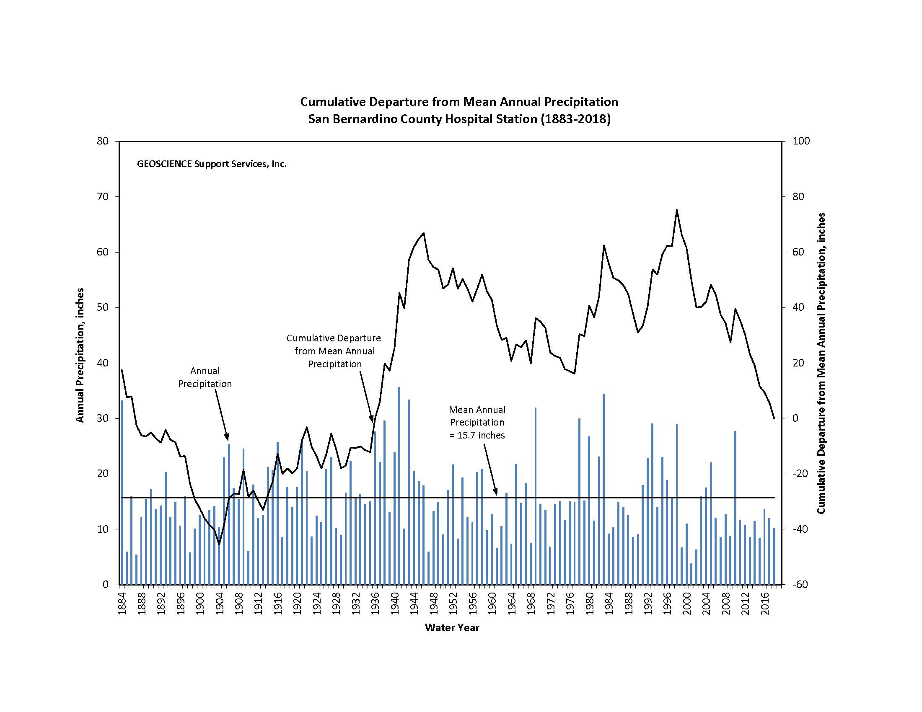

In addition, some of the observed trends toward lower average nitrogen concentrations are likely due to the operation of OCWD's treatment wetlands immediately above Prado Dam.

The average TDS and TIN concentrations, for samples collected within Reach 3 are 656 mg/L and 5.3 mg/L, respectively. These samples were taken between Riverside Narrows and Prado Wetlands. Both averages are below the 700 mg/L for TDS and 10 mg/L for TIN objectives associated with the Reach 3 monitoring station at Prado Dam.

Water quality samples were collected for Reach 4 of the Santa Ana River mainstem. The average TDS concentration of these samples was 322 mg/L and the average TIN concentration was 4.1 mg/L. Both values were in compliance with the water quality objectives for Reach 4 of the SAR.

A water quality sample was collected for Reach 5 of the SAR. The TDS concentration of this sample was 213 mg/L and the TIN concentration was 0.95 mg/L. Both values were in compliance with the water quality objectives for Reach 5 of the SAR.

## Recommendations

The BMPTF has now been implementing *Santa Ana River Water Quality Work Plan,* approved by the Regional Board in Res. No. R8-2005-0063, for almost twenty years. And for this 2024 report, began including the three new BMPTF sites shown in Table 1 per the *2022 Santa Ana River TDS and TIN Monitoring Work Plan*. The following recommendations are summarized by SAR reach -

**Reach 2**

None.

**Reach 3**

Future Basin Plan amendments should update the Reach 3 objective so there is a clear definition of what constitutes "base flow" so it is consistent with the Annual Report and the updated Wasteload Allocation Model. The BMPTF is currently working on a potential updated definition, as described above in Section 3.2 Santa Ana River Reach 3, that could define base flow as including:

i) monitoring data collected between April 1 and October 31;

ii) no precipitation events or imported water discharge within four days prior to sampling, and

iii) the water level elevation of the conservation pool behind Prado Dam is at or below the level that the ACOE considers empty (472 ft-above mean sea level).

**Reach 4 and 5**

None, implementation of the BMPTF monitoring on these reaches began in 2024. There could be recommendations in the future if issues arise via this new sampling.

# Response to Comments

No comments were provided.

# Appendix A

**Water Quality Trends**

**at Below Prado Dam and MWD Crossing**

**2003 to Current**

B-2

B-3

A-2

# 

# Appendix B

**All 2024 Water Quality and Flow Data**

**(Available on the** [**SAWPA Website**](https://sawpa.org/task-forces/basin-monitoring-program-taskforce/#resources)**)**

1. Through the Basin Plan, the water quality objectives are defined as antidegradation objectives (historic ambient water quality).
2. Determination of flow-weighted TDS for total flow at Below Prado for Water Year 2023-24 is based on records from a continuous monitoring device operated by the USGS for EC of the river flow below Prado Dam. This record is supplemented by grab samples for EC collected by the USGS and analyzed for TDS. Using the daily EC data, flow-weighted average daily concentrations for TDS are calculated using the following best fit correlation equation:

   TDS = EC x 0.6068 (where the units of TDS and EC are mg/L and umhos/cm, respectively)
3. 
4. 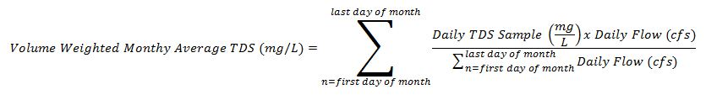
5. The *Santa Ana River Water Quality Work Plan* (approved by the Regional Board in Res. No. R8-2005-0063) and the *2022 Santa Ana River TDS and TIN Monitoring Work Plan* (submitted to the Regional Boardon March 30, 2023).
6. Wildermuth Environmental, Inc. Investigation and Characterization of the Cause(s) of Recent Exceedances of the TDS Concentration Objective for Reach 3 of the Santa Ana River. Feb. 11, 2015.
7. Wildermuth Environmental, Inc. Volume-Weighted TDS Concentration of POTW Discharges above Prado Dam during August-September. June 15, 2015.
8. West Yost Technical Memorandum. 2015 to 2021 Volume-Weighted TDS Concentration of POTW Discharges above Prado Dam during August and September. October 11, 2022.